**Purpose**

To provide a guide for resulting testing performed manually in Blood Order Processing (BOP)

**Policy**

MLS shall follow these grids for resulting manual testing.

|  |  |  |  |  |  |
| --- | --- | --- | --- | --- | --- |
| **Battery** | **Tests** | **Description** | | | **Result Options** |
| **Type and Screen (TSCR)** | **UO** | Units Ordered | | | * Defaults to none * Can be updated for add-on units in the order |
| **HXCK** | Patient History Check | | | * H—Patient history found applies as follows: * Blood type in the system * Antibody Screen in the system * Any information in the BAD file * Q—No patient history found |
| **PI** | Physician Instructions | | | * Semicolon (;) * Enter free text or add appropriate code.  |  |  | | --- | --- | | IRR | Irradiated | | LKR | Leukoreduced | | WS | Washed | | WRBC | Washed RBCs | | RCWS | Red Cells Washed | | RCWSI | Red Cells Washed Irradiated | | RCWSL | Red Cells Washed Leukoreduced | | RCWSIL | Red Cells Washed Irradiated Leukoreduced |  * Free text if code isn’t available |
| **ABR** | ABO/Rh (D) | | | * Use Reaction Grid found under **Blood Type** for results Interpretation * A for Group A * B for Group B * L for Group AB * O for Group O * P for Rh Positive * N for Rh Negative * ;NTD for No Type Determined (for ABO) * ;UNKN for Unknown (use for Rh only) |
| **AS** | Antibody Screen | | | * Use Reaction Grid found under **Antibody Screen** for results Interpretation * N for Negative * P for Positive |
| **EXX** | Crossmatch Expiration Date | | | * Defaults to 3 day outdate from specimen draw date. Extensions are allowed for qualifying Preadmission orders |
| **Battery** | **Tests** | | **Description** | **Result Options** | | |
| **Type and Screen (TSCR)** | **Crossmatch**  **Electronic** | | XM (crossmatch result) | * Leave blank * SAVE * Eligibility Report is viewable; Click OK | | |
| TS (Transfusion Status) |
| **Crossmatch**  **Immediate Spin** | | XM (crossmatch result) | |  |  |  |  |  | | --- | --- | --- | --- | --- | |  | XIS | XINC | XAHG | XCC | | Unit # | 0 | ND | ND | ND |  * Interpretation : ~ **for Compatible** * ND = Not done  |  |  |  |  |  | | --- | --- | --- | --- | --- | |  | XIS | XINC | XAHG | XCC | | Unit # | **\*** | ND | ND | ND |  * **\*** Any agglutination present * Interpretation: **$ for Incompatible** * ND = Not done | | |
| TS (Transfusion status) | * “ **[** “ for OK * “ **]** “ for Not OK | | |
| **Crossmatch**  **AHG** | | LISS | |  |  |  |  |  | | --- | --- | --- | --- | --- | |  | XIS | XINC | XAHG | XCC | | Unit # | ND | 0 | 0 | ≥1 |  * Interpretation: **C for Compatible** * ND = Not done  |  |  |  |  |  | | --- | --- | --- | --- | --- | |  | XIS | XINC | XAHG | XCC | | Unit # | ND | **\*** | **\*** | ND |  * **\*** Any agglutination present at either or both phases * Interpretation: **I for Incompatible** * ND = Not done | | |
| TS (Transfusion status) | * “ **[** “ for OK * “ **]** “ for Not OK | | |
| **Crossmatch AHG** | | PeG | |  |  |  |  |  | | --- | --- | --- | --- | --- | |  | XIS | XINC | XAHG | XCC | | Unit # | 0 | ND | 0 | ≥1 |  * Interpretation: **! for Compatible** * ND = Not done  |  |  |  |  |  | | --- | --- | --- | --- | --- | |  | XIS | XINC | XAHG | XCC | | Unit # | **\*** | ND | **\*** | ND |  * **\*** Any agglutination present at either or both phases * Interpretation: **% for Incompatible** * ND = Not done | | |
| TS (Transfusion status) | * “ **[** “ for OK * “ **]** “ for Not OK | | |
| **Crossmatch AHG** | | Prewarm  Prewarm (continued) | |  |  |  |  |  | | --- | --- | --- | --- | --- | |  | XIS | XINC | XAHG | XCC | | Unit # | ND | ND | 0 | ≥1 |  * Interpretation: **@ for Compatible** * ND = Not done  |  |  |  |  |  | | --- | --- | --- | --- | --- | |  | XIS | XINC | XAHG | XCC | | Unit # | ND | ND | **\*** | ND |  * **\*** Any agglutination present * Interpretation: **^ for Incompatible** * ND = Not done | | |
| TS (Transfusion status) | * “ **[** “ for OK * “ **]** “ for Not OK | | |
| **Crossmatch AHG** | | Saline | |  |  |  |  |  | | --- | --- | --- | --- | --- | |  | XIS | XINC | XAHG | XCC | | Unit # | 0 | 0 | 0 | ≥1 |  * Interpretation: # **for Compatible** * ND = Not done  |  |  |  |  |  | | --- | --- | --- | --- | --- | |  | XIS | XINC | XAHG | XCC | | Unit # | * | * | **\*** | ND |  * **\*** Any agglutination present at any or all phases * Interpretation: & **for Incompatible** * ND = Not done | | |
| TS (Transfusion status) | * “ **[** “ for OK * “ **]** “ for Not OK | | |
| **Unit Test Add-on** | | UR (Unit Tag Reprint) | * Transfusion Tag will reprint for the unit to which test UR is added. | | |
| CM (Unit Tag comment) | * Attach comments to Transfusion Tag. * Used to indicate split RBC * Used to indicate Uncrossmatched RBC * See table C for codes | | |
| AO (Unit Antigen typing | * Enter using appropriate AG code * Limited print on tag to 3 lines * Add additional lines via CM (unit comments) | | |
| **Battery** | **Tests** | | **Description** | **Result Options** | | |
| **Transfuse Products:**   * **TFFP** * **TPLT** * **TCRY** | **UO** | | Units Ordered | * Indicates number of units ordered. * If patient in non-CPOE area, units can be updated for additional orders of same product type | | |
| **HXCK** | | Patient History Check | * H-Patient history found * Q-No patient history found | | |
| **PI** | | Physician Instructions | * ( **;** ) and enter free text. * Defaults to none unless specifically ordered in ORCA.  |  |  | | --- | --- | | IRR | Irradiated | | LKR | Leukoreduced | | WS | Washed | | | |

|  |  |  |  |  |  |
| --- | --- | --- | --- | --- | --- |
| **Battery** | **Tests** | **Description** | | **Result Options** | |
| **Direct Antiglobulin Test (DAT)** | **HXCK** | | Patient History Check | * H-Patient history found * Q-No patient history found |
| **DBS** | | DAT, Broad Spectrum Coombs | |  |  |  |  |  | | --- | --- | --- | --- | --- | |  | DISBS | RTBS | DCCBS | DGEL | | Pt | 0 | ND | ≥ 1 | ND | | C | 0 | ND | ND | ND |   Interpretation: **N for Negative**  ND = Not done   |  |  |  |  |  | | --- | --- | --- | --- | --- | |  | DISBS | RTBS | DCCBS | DGEL | | Pt | **\*** | ND | ND | ND | | C | 0 | ND | ND | ND |   **\*** Any agglutination present  Interpretation: **P for Positive**  ND = Not done   |  |  |  |  |  | | --- | --- | --- | --- | --- | |  | DISBS | RTBS | DCCBS | DGEL | | Pt | **\*** | ND | ND | ND | | C | **\*** | ND | ND | ND |   * Any agglutination Present  ;ICLR for Inconclusive – Needs More Investigation |
| **Add on if DBS is POS** | **DIG** | | DAT, Anti-IgG Coombs | |  |  |  |  | | --- | --- | --- | --- | |  | DIGG | DCC | DGEL | | Pt | 0 | ≥ 1 | ND | | C | 0 | ND | ND |   Interpretation: **N for Negative**   |  |  |  |  | | --- | --- | --- | --- | |  | DIGG | DCC | DGEL | | Pt | **\*** | ND | ND | | C | 0 | ND | ND |   **\*** Any agglutination present  Interpretation: **P for Positive**  ND = Not done |
| **DCD** | | DAT, Complement | |  |  |  |  | | --- | --- | --- | --- | |  | IS | RT | DCC | | Pt | 0 | 0 | ≥ 1 | | C | 0 | 0 | ND |   Interpretation: **N for Negative**  ND = Not done   |  |  |  |  | | --- | --- | --- | --- | |  | IS | RT | DCC | | Pt | 0**/\*** | **\*/**ND | ND | | C | 0 | 0 | ND |   **\*** Any agglutination present  Interpretation: **P for Positive**  ND = Not done |

|  |  |  |  |  |  |
| --- | --- | --- | --- | --- | --- |
| **Battery** | **Tests** | **Description** | | **Result Options** | |
| **Blood Type: ABRH**  **ABRH2**  **BBRH** | **HXCK** | | Patient History Check | * H-Patient history found * Q-Patient history not found |
| **ABR** | | ABO/Rh  **Note:**  Agglutination strength is recordable as:   * 0,1,2,3,4+ * Grade plus M for Mixed Field (i.e. 4M, etc) * See table A * H for Hemolysis * 0R for negative after saline replacement * Result what is seen * Resolve per SOP for MF reactions * Anti-A, Anti-B, and reverse results of wk→1+, hold interpretation until discrepancy is resolved * Rh result of wk→1+, hold Interpretation until Weak D testing complete.   See Neonatal Blood Type for Grid resulting | |  |  |  |  |  |  |  | | --- | --- | --- | --- | --- | --- | --- | |  | A | B | Rh | C | AC | BC | | BT | ≥ 1 | 0 | ≥ 1 | ND | 0 | ≥ 1 |   Interpretation: **A Pos**  ND = Not done   |  |  |  |  |  |  |  | | --- | --- | --- | --- | --- | --- | --- | |  | A | B | Rh | C | AC | BC | | BT | ≥ 1 | 0 | 0 | ND | 0 | ≥ 1 |   Interpretation: **A Neg**  ND = Not done   |  |  |  |  |  |  |  | | --- | --- | --- | --- | --- | --- | --- | |  | A | B | Rh | C | AC | BC | | BT | 0 | ≥ 1 | ≥ 1 | ND | ≥ 1 | 0 |   Interpretation: **B Pos**  ND = Not done   |  |  |  |  |  |  |  | | --- | --- | --- | --- | --- | --- | --- | |  | A | B | Rh | C | AC | BC | | BT | 0 | ≥ 1 | 0 | ND | ≥ 1 | 0 |   Interpretation: **B Neg**  ND = Not done   |  |  |  |  |  |  |  | | --- | --- | --- | --- | --- | --- | --- | |  | A | B | Rh | C | AC | BC | | BT | 0 | 0 | ≥ 1 | ND | ≥ 1 | ≥ 1 |   Interpretation: **O Pos**  ND = Not done   |  |  |  |  |  |  |  | | --- | --- | --- | --- | --- | --- | --- | |  | A | B | Rh | C | AC | B | | BT | 0 | 0 | 0 | ND | ≥ 1 | ≥ 1 |   Interpretation: **O Neg**  ND = Not done   |  |  |  |  |  |  |  | | --- | --- | --- | --- | --- | --- | --- | |  | A | B | Rh | C | AC | BC | | BT | ≥ 1 | ≥ 1 | ≥ 1 | 0 | 0 | 0 |   Interpretation: **AB Pos**  ND = Not done   |  |  |  |  |  |  |  | | --- | --- | --- | --- | --- | --- | --- | |  | A | B | Rh | C | AC | BC | | BT | ≥ 1 | ≥ 1 | 0 | ND | 0 | 0 |   Interpretation: **AB Neg**  ND = Not done |
| **ABRH3** | **ABR** | | ABO/Rh  See above for resulting grid | * Non billable * Does not display result in ORCA/EPIC * Only to be used to retype the same sample due to cancellation * Order using collection and receipt time for sample used to test * Enter ACCN of the sample used |
| **BBCS** | | Suppressed Blood Bank Comment |

|  |  |  |  |
| --- | --- | --- | --- |
| **Battery** | **Tests** | **Description** | **Result Options** |
| **Neonatal Blood Type (TSCR)** | **HXCK** | Patient History check: | * H-Patient history found * Q-Patient history not found |
| **ABR** | ABO/Rh  **Note:**  Agglutination strength is recordable as:   * 0,1,2,3,4+ * Grade plus M for Mixed Field, (i.e. 4M, etc) * See Table A * I for Infant Not Tested * H for Hemolysis * Result what is seen * Resolve per SOP for MF reactions * Rh result of wk→ 1+, hold interpretation until Weak D is complete * Anti-A or Anti-B results of wk→1+, hold interpretation until discrepancy is resolved | |  |  |  |  |  |  |  | | --- | --- | --- | --- | --- | --- | --- | |  | A | B | Rh | C | AC | BC | | BT | ≥ 1 | 0 | ≥ 1 | ND | INT | INT |   Interpretation: **A Pos**  ND = Not done   |  |  |  |  |  |  |  | | --- | --- | --- | --- | --- | --- | --- | |  | A | B | Rh | C | AC | BC | | BT | ≥ 1 | 0 | 0 | ND | INT | INT |   Interpretation: **A Neg**  ND = Not done   |  |  |  |  |  |  |  | | --- | --- | --- | --- | --- | --- | --- | |  | A | B | Rh | C | AC | BC | | BT | 0 | ≥ 1 | ≥ 1 | ND | INT | INT |   Interpretation: **B Pos**  ND = Not done     |  |  |  |  |  |  |  | | --- | --- | --- | --- | --- | --- | --- | |  | A | B | Rh | C | AC | BC | | BT | 0 | ≥ 1 | 0 | ND | INT | INT |   Interpretation: **B Neg**  ND = Not done   |  |  |  |  |  |  |  | | --- | --- | --- | --- | --- | --- | --- | |  | A | B | Rh | C | AC | BC | | BT | 0 | 0 | ≥ 1 | ND | INT | INT |   Interpretation: **O Pos**  ND = Not done |
| |  |  |  |  |  |  |  | | --- | --- | --- | --- | --- | --- | --- | |  | A | B | Rh | C | AC | B | | BT | 0 | 0 | 0 | ND | INT | INT |   Interpretation: **O Neg**  ND = Not done     |  |  |  |  |  |  |  | | --- | --- | --- | --- | --- | --- | --- | |  | A | B | Rh | **C** | AC | BC | | BT | ≥ 1 | ≥ 1 | ≥ 1 | **0** | INT | INT |   Interpretation: **AB Pos**  ND = Not done     |  |  |  |  |  |  |  | | --- | --- | --- | --- | --- | --- | --- | |  | A | B | Rh | C | AC | BC | | BT | ≥ 1 | ≥ 1 | 0 | ND | INT | INT |   Interpretation: **AB Neg**  ND = Not done |
| **Antibody Screen**  **(ABSCR)** | **HXCK** | Patient History check | * H-Patient history found * Q-No patient history found |
| **AS** | Antibody Screen, LISS | |  |  |  |  | | --- | --- | --- | --- | |  | 37 | AHG | CC | | SC1/SC2/SC3 | 0 | 0 | ≥1 |   Interpretation: **N for Negative**   |  |  |  |  | | --- | --- | --- | --- | |  | 37 | AHG | CC | | SC1/SC2/SC3 | **\*** | **\*** | ND |   **\***  Any Agglutination in any of the cells  ND = Not done  Interpretation: **P for Positive** |
| **Battery** | **Tests** | **Description** | **Result Options** |
| **Antibody Screen**  **(ABSCR)** | **HXCK** | Patient History check | * H-Patient history found * Q-No patient history found |
| **AS** | Antibody Screen, TANGO  For use when unable to transmit results across SQ interface | |  |  |  |  | | --- | --- | --- | --- | |  | 37 | AHG | CC | | SC1/SC2/SC3 | ND | 0 | ND |   Interpretation: **N for Negative**   |  |  |  |  | | --- | --- | --- | --- | |  | 37 | AHG | CC | | SC1/SC2/SC3 | ND | **\*** | ND |   **\***  Any Agglutination in any of the cells  ND = Not done  Interpretation: **P for Positive**   * Add BBCS “Testing Performed on TANGO” |
| **ER** | **Emergency Release** | UO (Units Ordered)  Use when there is no sample available, or for RBC transfused by Medic One or ALNW | * Allocate Universal blood type to order and issue * TS **“ [ “** for OK * TS **“ ] “** for Not OK * CM-Add comment “Emergency Release” * For non ALNW or Medic One accessions, add BBC to explain why sample was not received |
| **TNRBC** | **Transfuse Neonatal Red Cells** | UO (Units Ordered)  Patient History Check | * If neonate is Rh positive, issue group O, Rh positive or group O, Rh negative RBCs * If neonate is Rh negative, issue only group O, Rh negative * TS **“ [ “** for OK * TS **“ ] “** for Not OK |
| **ELUT** | **HXCK** | Patient History Check | * H-Patient history found * Q-No patient history found |
| **ELU** | Antibody Eluted | * Enter Results * Results can been seen under comments in BAD * If appropriate; when AB code entered it can be seen under AB/AG in BAD |
| **Transfusion Reaction Work-up (TRRX)** | **HXCK** | Patient History Check | * H-Patient history found * Q-No patient history found |
| **UNO** | Unit Number | * Indicate component type and unit number * Use **“ ; “** and free text |
| **CLCK** | Clerical Check | * C for CLCKP (Clerical check passed) * F for CLCKF (Clerical check failed) |
| **TXPATH** | Pathology consult | * Do not result until final pathology report * Result with consulting Medical Director initials * JRH = Dr Hess * MBP = Dr Pagano * HTC = Dr Tsang * Can be viewed in ORCA as “See final pathology report” |
| **TXRINT** | Biovigilance designation | * Do not result until final pathology report * Result with Biovigilance designation |

**Addable Tests:**

|  |  |  |  |
| --- | --- | --- | --- |
| **Battery** | **Tests** | **Description** | **Result Options** |
| **TSCR**  **ABSCR**  **PREN**  **DAT** | **ABI** | Antibody ID  (Patient sample) | * Enter the code for the specific antibody or “ **;** “ and free text the antibody results: i.e. Anti-Bga * Free text will be seen in Comments. * Codes will be seen in Antigen/Antibodies in BAD file. |
| **ABID 2** | Billing Code used for subsequent panels used to identify the antibody(s) | * Use ABID 2 for billing a 2nd panel * For billing a 3rd panel: * Tab to 2nd line of comment. * Result as **“;2”** |
| **AGI** | Patient Antigen Type | * Enter the code for the specific antigen or **“** **;** **“** and free text the antigen typing results. * Antigen typing from outside facilities is entered directly into the BAD file |
| **ABPATH** | Pathology Consult | * Add only for new antibodies identified. * Result with consulting Medical Director initials listed under TXPATH |
| **PRPATH** | Pathology Consult, prenatal sample | * Add after consult has been performed * Result with consulting Medical Director initials listed under TXPATH |
| **ELU** | Eluate result | * Eluate performed and resulted |
| **TTR** | Titer | * See below for additional titer tests |
| * **DBS** * **DIG** * **DCD** | DAT, Broad spectrum, IgG, C3 | * Reaction result grid same as DAT grids |

|  |  |  |  |
| --- | --- | --- | --- |
| **TRRX** | * **DBS** * **DIG** * **DCD** | DAT, Broad spectrum, IgG, C3 | * Reaction result grid same as DAT grids |
| **PRETX** | Pre-transfusion Sample | * Pre-transfusion sample Accession number |
| **PRESP** | Pre-transfusion Sample appearance | * E for HEM (Hemolysis present) * Y for HEMNO (No visible hemolysis) |
| **POSTSP** | Post Transfusion Sample Appearance | * E for HEM (Hemolysis present) * Y for HEMNO (No visible hemolysis) |
| **ABID** | Multiple addable tests | * Add necessary tests related to antibody ID; Eluate, DAT, etc. |
| **ABR** | ABO/Rh | * Reaction result grid same as for ABO/Rh |
| **AS** | Antibody Screen | * Reaction result grid same as for ABSCR |
| **BBC**  **(microbiology)** | Blood Bank Comment | * Approved/Not approved to receive further blood products * Submitted to Microbiology * Gram stain results _______ * Culture results __________ |

**Addable Tests (continued):**

|  |  |  |  |
| --- | --- | --- | --- |
| **Battery** | **Tests** | **Description** | **Result Options** |
| **ABRH**  **BBRH**  **PREN**  **TSCR**  **TRRX**  **ABRH2**  **ABRH3** | **DU** | Weak D test  BAD file:  WKDP = weak D positive  WKDN = Weak D negative | |  |  |  | | --- | --- | --- | |  | DAHG | DUCC | | PT | 0 | ≥1 | | C | 0 | ≥1 |   Interpretation: **N for Negative**   |  |  |  | | --- | --- | --- | |  | DAHG | DUCC | | PT | **\*** | ND | | C | 0 | ≥1 |   **\*** Any agglutination present  Interpretation: **P for Positive**   |  |  |  | | --- | --- | --- | |  | DAHG | DUCC | | PT | **\*** | ND | | C | **\*** | ND |   * Any agglutination Present  ;ICLR for Inconclusive – Needs More Investigation  Add BAD file comment for patient to receive Rh Negative red cells if meet criteria. |
| **TSCR**  **PREN**  **ABSCR** | * **TTR** * **TTRRP** | Titration | * Add for titrations * Add for Repeat titration of frozen samples |
| **TTR2** | Billing Code used for subsequent titers performed on current sample | * Use ABID 2 for billing a 2nd titer * For billing a 3rd titer: * Tab to 2nd line of comment. * Result as **“;2”** |
| **All Batteries** | **BBC** | Blood Bank Comment | * **“ ; “** Free text comment * Is attached to the Accession number for inquiry * Is visible to hospital/clinic staff |
| **BBCS** | Suppressed Blood Bank Comment | * **“ ; “** Free text comment * Is attached to the Accession number for SQ only * Is only visible in Sunquest |
| **PB** | Problem | * Writes to the BAD file * Examples: IRR, LKR, “attributes reviewed”, etc. |
| **Rh Negative**  **PREN**  **or**  **ABRH/BBRH from pregnant pt** | **BBC** | Blood Bank Comment | * RHNMH * If from a patient with vaginal bleed, perform read-back with provider |
| **PRPATH** | Prenatal Consult | * Result with consulting Medical Director initials listed under TXPATH |

**Table A: Reaction grading defined keys**

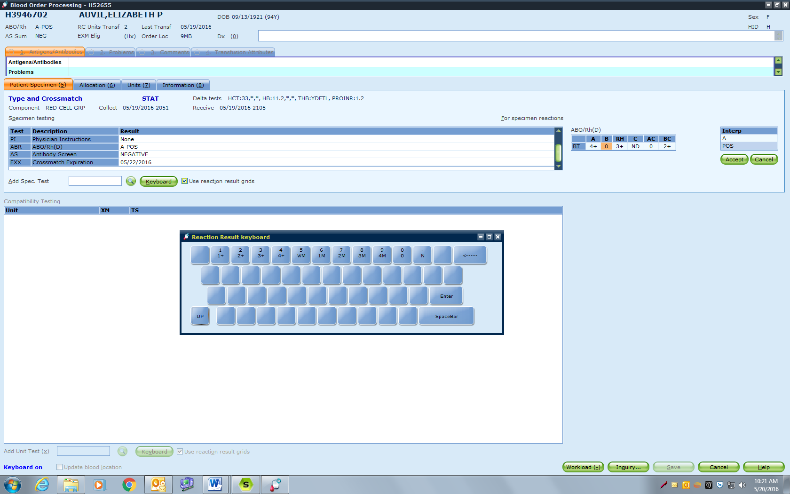

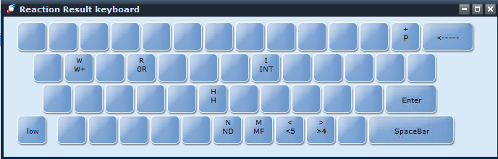

**Table B: Interpretation result defined keys**

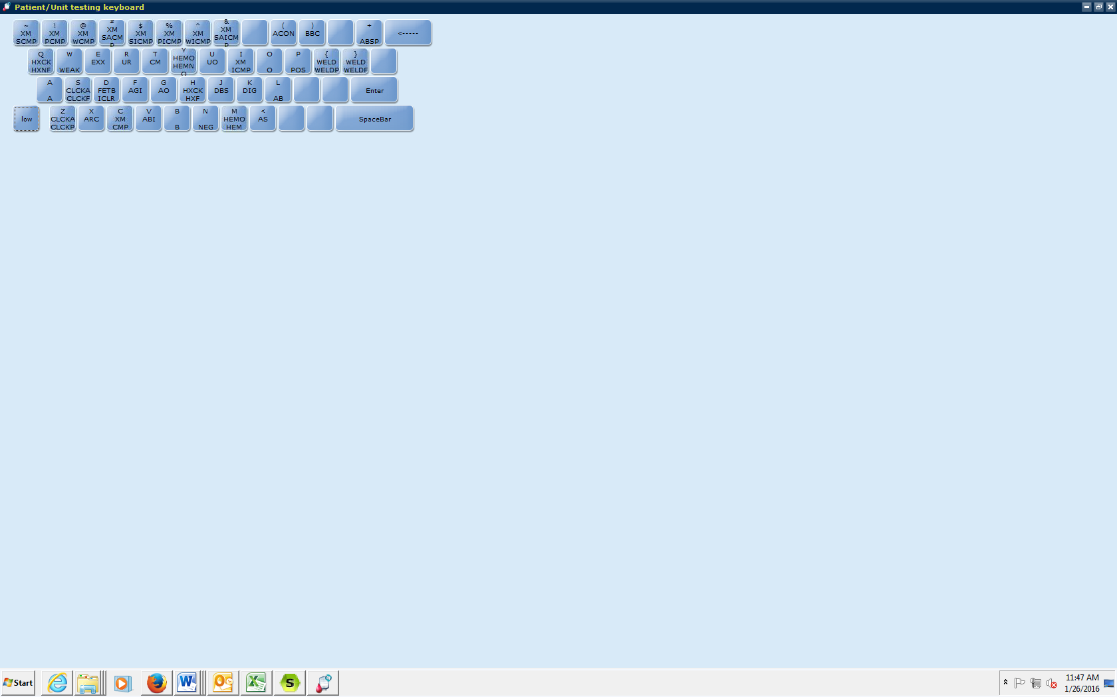

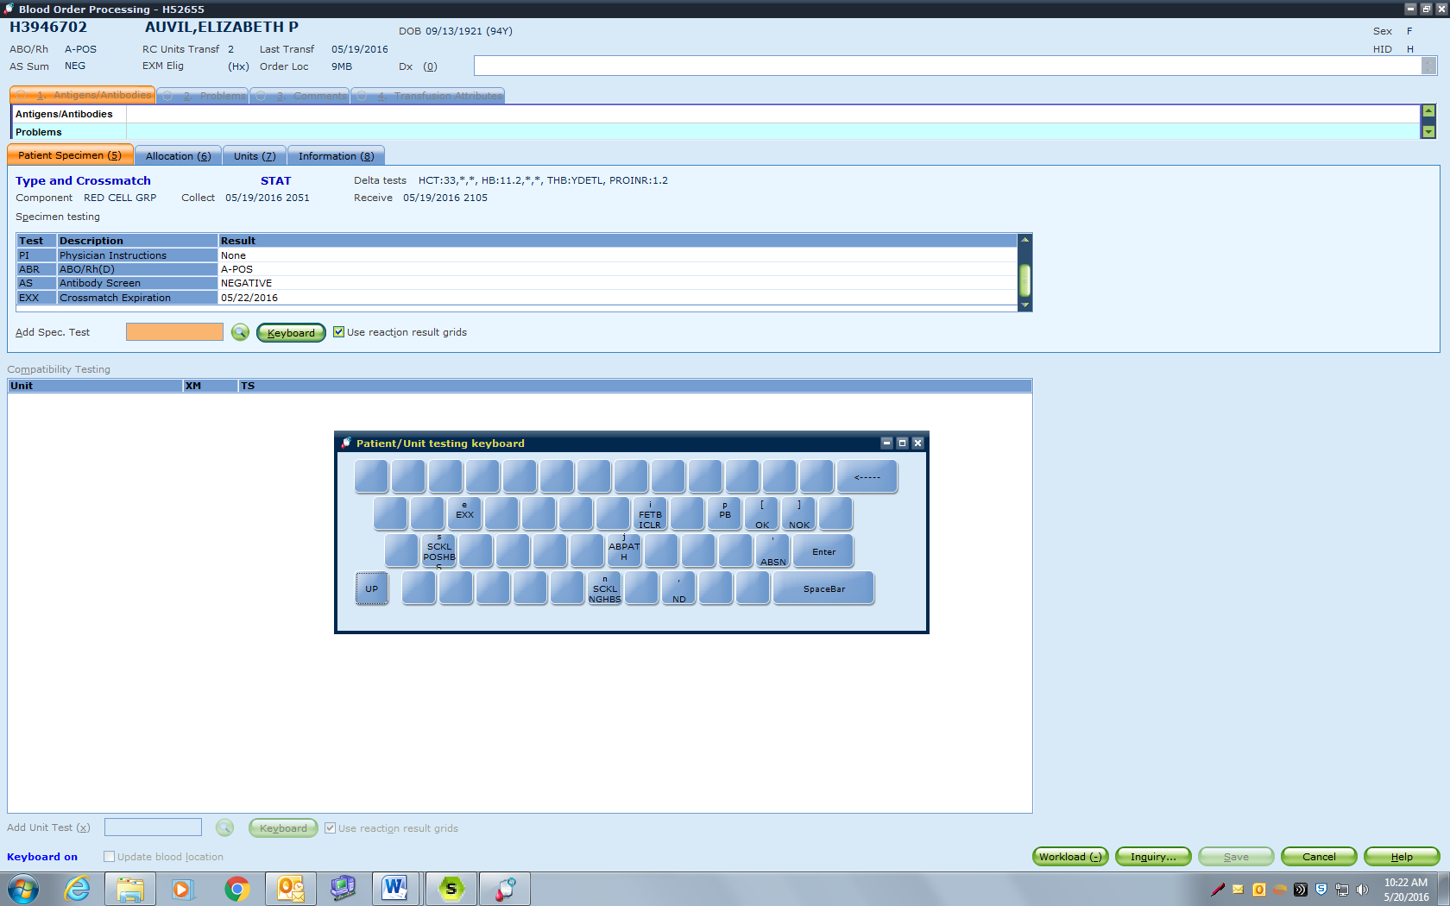

**Table C: CM codes for unit tags**

|  |  |  |
| --- | --- | --- |
| **SQ Code** | **Translation** | **Uses** |
| EMR | Emergency Release, UNCROSSMATCHED | Uncrossmatched product   * Used on all uncrossmatched products * Used on ER Battery products * Used on plasma, platelets, and cryo post transfusion reconciliation |
| QAPTXM | Post transfusion Crossmatch | Used for RBCs during post transfusion reconciliation (remove EMR if entered previously) |
| IXMAPP | Incompatible approved by provider | Incompatible products approved for use by provider, medical director, or resident.   * Example: due to WARM/COLD antibodies |
| RHPAPP | Rh positive approved by provider | Rh positive product given to Rh negative patient |
| Antigen codes | See “Guidelines for Antibody Identification” SOP | Additional antigen typing that doesn’t show up under “Unit Antigens” section of transfusion tag |

**References**

Blood Bank User Guide, Misys Laboratories, 8.1