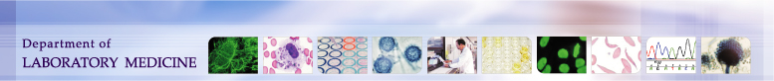

University of Washington,  Harborview Medical Center  325 9th Ave. Seattle, WA, 98104  Transfusion Services Laboratory  Policies and Procedures Manual | Original Effective Date:  July 7, 2011 | Number:  1606-5
 | Revision Effective Date:  11/30/2020 | Pages:  1
QSE: Documents and Records
Title: Current Document Reference List

Policy:

Harborview Transfusion Service Documents are:
- Reviewed as needed or at a minimum, annually, for accuracy.
- As part of review, Document references are validated against any new editions as they are available and the documents are revised if necessary.
- Current References List is updated at review when new editions are available.

Purpose:

To ensure that all references are accurate and current, and avoid revising documents when only the reference edition has changed.

Reference | Current Edition
AABB Standards for Blood Banks and Transfusion Services,  AABB Press | 32nd Edition
AABB Technical Manual  AABB Press | 20th Edition
Judd’s Methods in Immunohematology: Third Edition  AABB Press | 3rd Edition
Practical Guide to Transfusion Medicine,  Marian Petrides, Gary Stack, Laura Cooling, Lanne Y. Maes.  AABB Press | 2nd Edition
Guidelines for Implementing an Electronic Crossmatch  AABB Press | 2003 Edition
Transfusion Reactions, Edited by Mark A. Popovsky  AABB Press | 4th Edition
CFR 21 Parts 200 to 299, parts 600-799 | April 2015
Blood Bank User Guide, Mysis Laboratory | V8.1
Hematrax ZT400 user guide | P106582-003 Rev A

