Administering Self-Swab Procedure

Purpose:

The purpose of this document is to describe the step-by-step instructions on how to provide instruction to patients performing a self-administered COVID-19 specimen collection.

Principle:

It is crucial to provide the patient with complete and thorough instruction of the self-swabbing process. The self-swab process will be observed by the personnel providing the self-swabbing instruction. Inaccurate collection procedure could affect patient results.

Responsibility:

* Site Manager and Supervisors:

Establish and implement this procedure and ensure that all appropriate personnel are duly trained.

* Reviewers:

Check the content of the procedure for accuracy and comprehensibility.

* Personnel:

Read and understand the procedure prior to performing any/all aspects of the procedure

Equipment and Supplies:

* Walkie-Talkie (depending on location may share with the swabbing/observing personnel)
* Cardboard specimen rack
* Plastic specimen bag
* Collection Swabs
* Disinfectant Spray/Wipes
* Hand Sanitizer

Personal Protective Equipment:

* Tie back gown or disposable lab coat
* Goggles, Safety Glasses, or Face Shield
* Surgical Mask (No Cloth Masks)
* Double Gloves

Procedure:

1. Administering self-swab:
2. Ask the patient to hand you their specimen collection tube(site dependent step).
3. Ask the patient to verify that their name and date of birth on the tube is accurate.

NOTE: If there is a group of patients getting tested together, take one patient’s tube and finish the whole collection process with that patient before taking the next patient’s tube.

1. Inform the patient that they will be doing a self-administered test and provide them with the following instructions:
   1. (showing them the swab in packaging) I will hand you this nasal swab. You will place this swab about one inch into one nostril until the white, foam tip can no longer be seen. (See the area of the foam swab tip on **Image 1**)
   2. You will rotate the swab in 10 big circles in one nostril.
   3. Then, you will rotate the swab in 10 big circles in the other nostril. The circles should be big enough so that the outside of your nose moving around with the swab.
   4. Then you’ll hand the swab back to me.

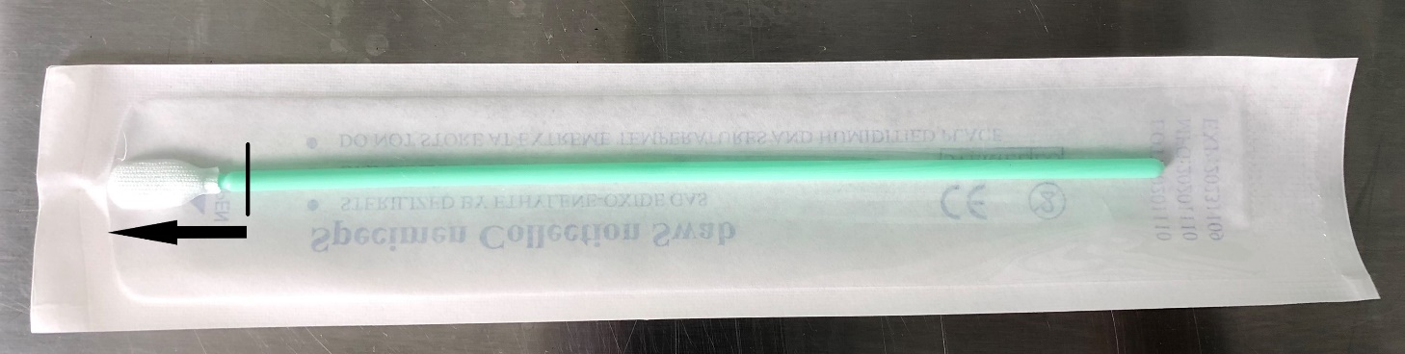

**Image 1**

1. Hand the swab to the patient by puncturing the handle of the swab through the paper side of the packaging as seen in **Image 2**.

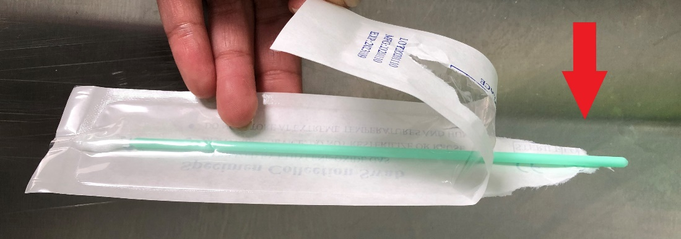

**Image 2**

1. Observe the patient during collection to assure they follow the instructions correctly. Provide assistance or feedback, if/when needed.
2. Obtain the swab from the patient and insert it into the collection tube until it hits the bottom. Swirl the swab in liquid at least 10 times.
3. Toss the swab in the garbage bin. Recap the tube and press fully shut.
4. Store the tube in the next slot on the cardboard specimen rack in a styrofoam cooler with ice packs or refrigerator.
5. Change the top pair of gloves and use hand sanitizer on the base pair of gloves.
6. Put on a new pair of top gloves, before interacting with the next patient.
7. For children, the swab will be inserted far enough into the nostril, so that movement is seen at the top of the nostril during the swabbing process. Children have smaller nostrils, so the entire swab may not go all the way into the nostril.
8. Packaging up the samples for the courier
9. Samples will be stored in a cardboard sample rack kept either in a refrigerator or a styrofoam cooler with ice packs after collection.
10. Before each courier pick up, the cardboard rack will be labeled with the location name, lane number (if applicable) and the current time before being placed into a large plastic specimen bag.
11. After the rack is placed into the large specimen bag, the staff member should press lightly down onto the tops of the tubes in the rack to make sure the tube’s lids are not loose and place the rack back into the refrigerator/cooler until courier pick-up.

Quality Assurance:

Initial training and required retraining is documented on Patient Check-in Procedure Training Checklist (see **Appendix**)

Written by: Justine Villanueva

In Service: June 2021

Updated/reviewed annually since: 2021

Current update/review by: Justine Villanueva and Jennifer Greenwood/ June 2021

**APPENDIX**

**ADMINISTERING SELF-SWAB PROCEDURE**

**Training Checklist**

|  |  |  |  |  |  |  |
| --- | --- | --- | --- | --- | --- | --- |
|  | | | **Employee:** | |  | |
|  |  | | | |  |  |
| **Administering Self-Swab Training:** |  | | | | **Date** | **Initial** |
| 1. Read and understand procedure (RSCS_0003) |  | | | |  |  |
|  | **Observed** | | **Performed/Observed** | | **Performed** | |
|  | Date | Trainer | Date | Trainer | Date | Trainer |
| 1. Verification of Patient Information on the tube |  |  |  |  |  |  |
| 1. Provide proper instruction of the self-administered process |  |  |  |  |  |  |
| 1. Store collected tubes properly |  |  |  |  |  |  |
| Comments: | | | | | | |
| **Reviewed by / Date:** |  | | | | | |

**ADMINISTERING SELF-SWAB PROCEDURE**

**RSCS_0003**

Change Log

|  |  |  |
| --- | --- | --- |
| **Version** | **Summary of Updates** | |
| **v1.0** | * Initial release | |
| **Date:** | **Reviewed By:** |
|  |  | |
| **Date:** | **Reviewed By:** |
|  |  | |
| **Date:** | **Reviewed By:** |
|  |  | |
| **Date:** | **Reviewed By:** |