**Patient Check-in Procedure**

Purpose:

The purpose of this document is to describe the step-by-step instructions on checking-in patients with appointments and creating appointments for patients that arrive without an appointment into Solv.

Principle:

To ensure high quality of data integrity and a positive patient service experience, the patient check-in procedure is critical to ensure that all downstream systems, teams, and the patient experience are complete, accurate, and timely.

Critical pieces of information include: patient demographics, documentation associated with insurance, patient address information, and preferred language.

Insurance documentation is used to continually fund the COVID-19 testing program.

Patient address information is used for contact tracing and making informed testing program decisions.

Inaccurate or incomplete data entry of patient demographics during this procedure will delay patient results and could result in specimen recollection.

Responsibility:

* Site Manager and Supervisors:

Establish and implement this procedure and ensure that all appropriate personnel are duly trained.

* Reviewers:

Check the content of the procedure for accuracy and comprehensibility.

* Personnel:

Read and understand the procedure prior to performing any/all aspects of the procedure.

Equipment and Supplies:

* iPad
* Site-specific on-site registration QR code card
* Clipboard with languages guide or interpreter services guide
* Self-Swab Handouts
* Walkie-Talkie

Personal Protective Equipment:

* Safety Vest or Gown
* Goggles, Safety Glasses, or Face Shield
* Surgical Mask (No Cloth Masks)
* Gloves

Procedure:

1. Use the following link and sign into Solv: [https://](https://manage.solvhealth.com/login)manage.solvhealth.com/login.
2. 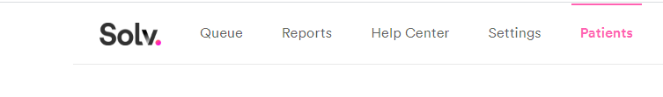Click on the *Patients* tab on the top of the webpage (seen in  ***Image 1*** below).

***Image 1***

1. Ask the patient if they have an appointment.
   1. If they have an appointment, see section “Checking in a patient for their appointment” section.
   2. If they have not made an appointment, ask the patient if they have a smartphone. If the patient has a smartphone, direct the patient to open the camera application on their smartphone. The patient will focus their camera on the site-specific on-site registration QR code card. A link will appear, and the patient should click on the pop-up link to create an appointment.
   3. If the patient does not have a smartphone or if the patient needs assistance making an appointment, see “Creating an appointment for the patient” section.
2. Creating an appointment for a patient.
   1. Creating an appointment for the patient through a previous appointment:
   2. Ask the patient if they have been tested at the site previously. If the patient has been tested at the site previously, ask for their 10-digit phone number. Type it into the Phone search bar seen in **Image 2**. Click “Search”.

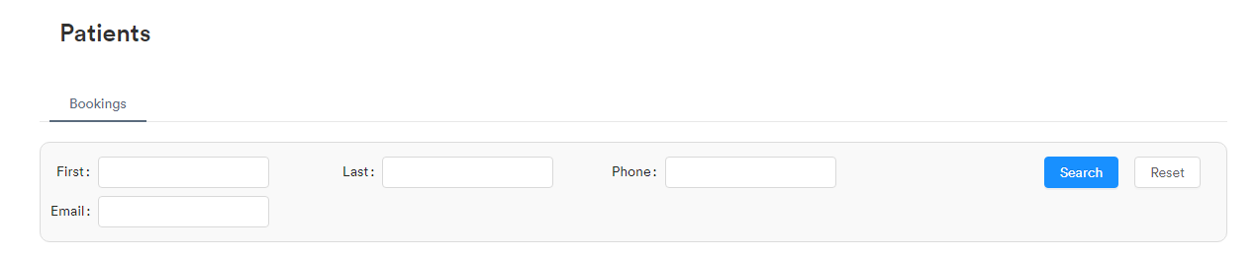

***Image 2***

1. Ask for the patient’s first and last name
2. If the patient is found but the appointment date is a past appointment date, click on that previous appointment.
3. Ask the patient for their date of birth and verify it matches the date of birth listed in Solv.
4. If the date of birth and the patient’s first and last name match, click on the Book Follow-up button circled in red in **Image 3**.

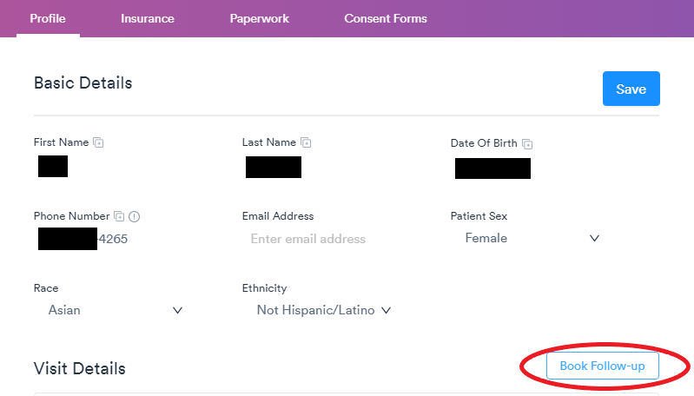

***Image 3***

1. If the patient does not have a previous appointment, see the “Creating appointment for a new patient” of this procedure.
2. A window will pop up; select the testing site’s walk-up or on-site registration queue.
3. Ask the patient the reason for their visit and their birth sex, and enter into Solv.
4. Select Walk-in, seen circled in red in **Image 4.**
5. 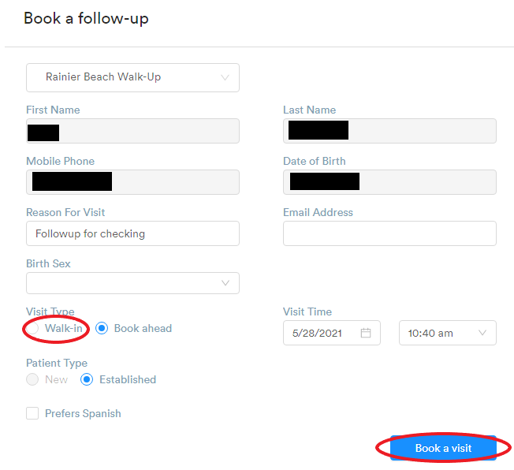Click the blue “Book a visit” button, seen circled in red in **Image 4.**

***Image 4***

* 1. Creating appointment for a new patient
  2. Click on the Queue tab and modify the location to match the site’s walk-up or on-site registration queue
  3. Click on the blue plus button on the right side of the screen circled in red in **Image 5**.

***Image 5***

1. A pop-up for “Add a patient” will appear. Fill out all the fields (seen in **Image 6**) with information provided by patient.
2. Click the blue “Add” button found in the bottom right of the pop-up.

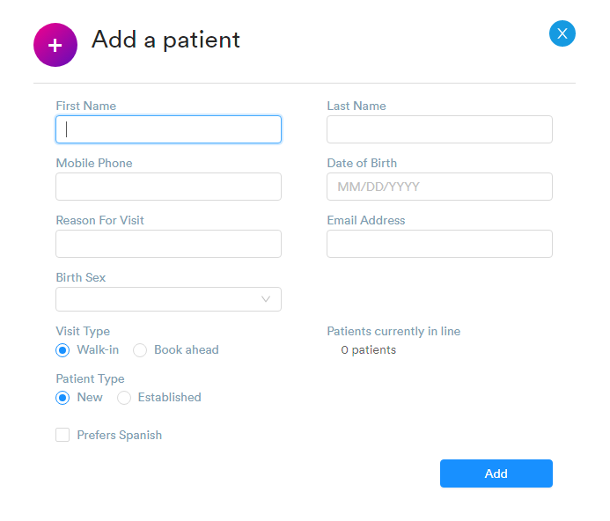

***Image 6***

* 1. Finish filling out the rest of patient information
  2. Reopen appointment by selecting it under Queue tab, and select the “Here Now” queue.
  3. Enter or verify the patient’s address, insurance information, identification card information, and preferred language by following the procedure described in section "Checking a patient in for their appointment" steps 5 through 7.
  4. Click the blue Save button.

1. Checking a patient in for their appointment
   1. Ask the patient if they have been tested at the site previously. If the patient has been tested at the site previously, ask for their 10-digit phone number. Type it into the Phone search bar seen in **Image 2**. Click “Search”.
   2. Verify the first and last name of the patient and check the appointment dates (seen below under the red arrow in ***Image 7***).
   3. Select appointment made for current date.
      1. If there is no appointment date that matches the current date, select a future appointment date.
      2. If there is no appointment for a current or future date, please see section “Creating an appointment for the patient”.

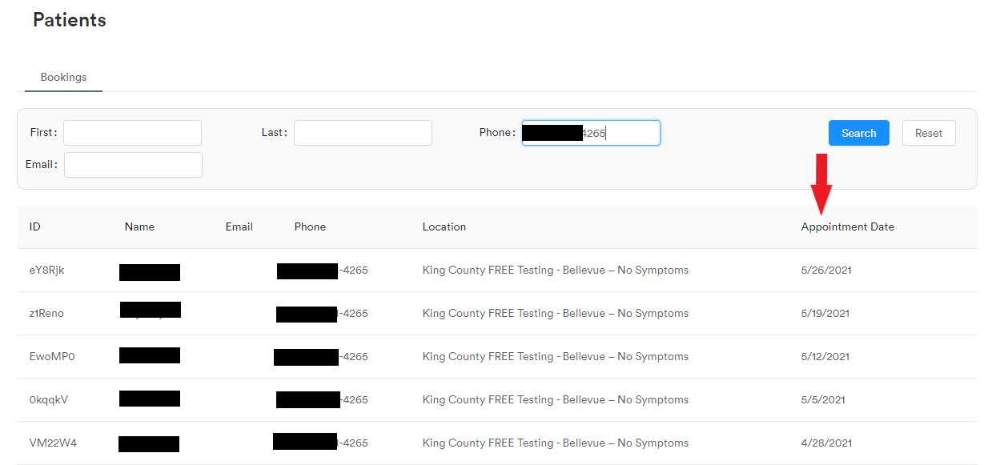***Image 7***

* 1. Ask the patient for their date of birth. Verify that it matches the date of birth in the patient’s record (seen under the red arrow below in ***Image 8***). If the date of birth does not match, tap on the date of birth field, and type in the updated date of birth. Visually verify the date of birth correction with the patient.

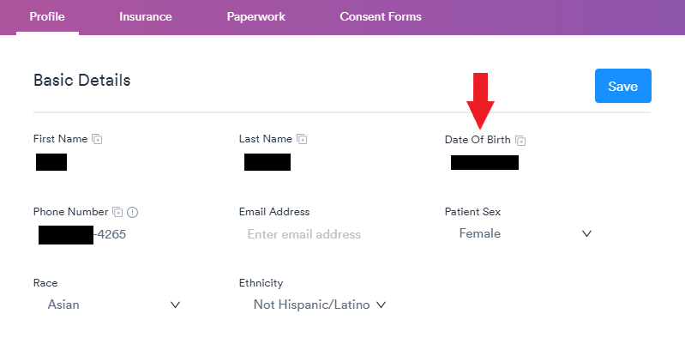

***Image 8***

* 1. Verify if the patient is still at the address in the field under the yellow arrow in ***Image 9***.
  2. If the address information in the record is incorrect, tap in the address fields and update.
  3. If there is no address in this field, ask for their current address and type it into the field.
  4. If the patient does not have an address, leave the address field blank.

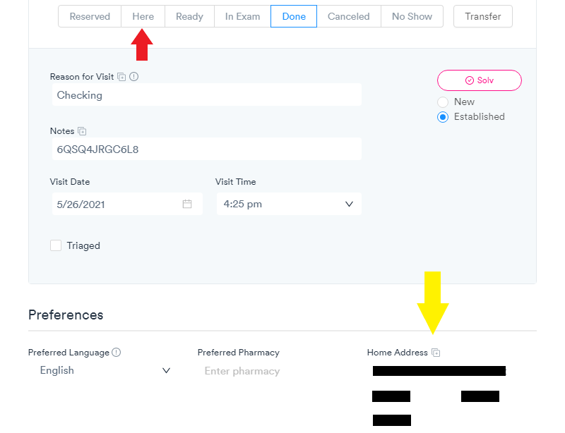

***Image 9***

* 1. 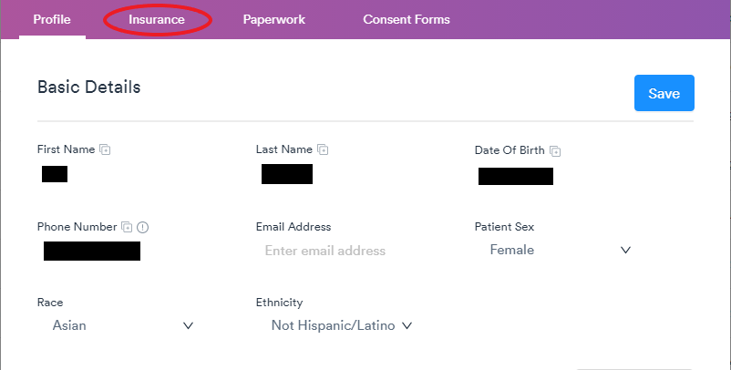Verify the patient has input their insurance information under the “Insurance” tab at the top of the page (circled red in ***Image 10***).

***Image 10***

* + 1. 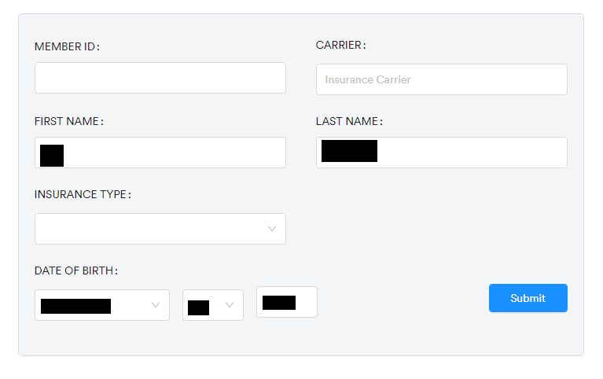If there is no insurance information, ask patient if they have their insurance card and input the information into the fields shown in **Image 11**.

***Image 11***

* + 1. 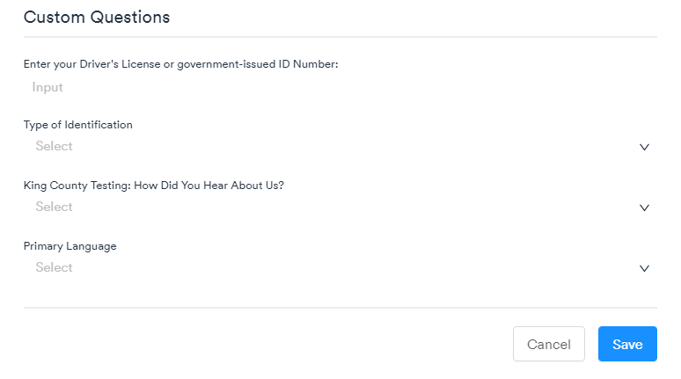If an insurance card is not available, ask patient for an identification card or driver’s license, and input the information into the Enter your Driver's License or government-issued ID Number: field and select appropriate ID type in the Type of Identification field on ***Image 12***.

***Image 12***

* + 1. If no insurance card is available and no ID is available, select “No Documentation” in the Type of Identification field.
  1. Ask patient’s primary language preference and select the patient’s preferred language under Primary Language seen in **Image 12**

.

* 1. 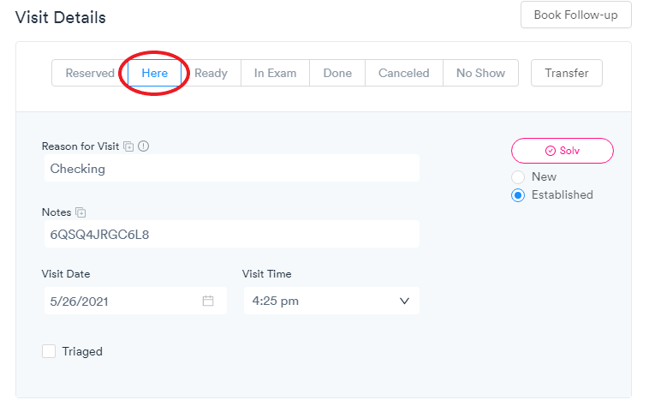Click the *Here* button twice (circled red below in **Image 13**) until a “Status Updated” banner at the top of the screen appears and *Here* is highlighted as blue.

***Image 13***

* 1. Click the blue Save button and direct patient to Registration.

Quality Assurance:

Initial training and required retraining is documented on Patient Check-in Procedure Training Checklist (see Appendix)

Written by: Justine Villanueva

In Service: June 2021

Updated/reviewed annually since: 2021

Current update/review by: Justine Villanueva/Jennifer Greenwood; June 2021

**APPENDIX**

**PATIENT CHECK-IN PROCEDURE**

**Training Checklist**

|  |  |  |  |  |  |  |
| --- | --- | --- | --- | --- | --- | --- |
|  | | | **Employee:** | |  | |
|  |  | | | |  |  |
| **Patient Registration Training:** |  | | | | **Date** | **Initial** |
| 1. Read and understand procedure (RSCS_0001) |  | | | |  |  |
|  | **Observed** | | **Performed/Observed** | | **Performed** | |
|  | Date | Trainer | Date | Trainer | Date | Trainer |
| 1. Creating an appointment for a new patient |  |  |  |  |  |  |
| 1. Booking a follow-up appointment for a returning patient |  |  |  |  |  |  |
| 1. Checking in a patient for their appointment |  |  |  |  |  |  |
| 1. Acquiring all required patient record information |  |  |  |  |  |  |
| Comments: | | | | | | |
| **Reviewed by / Date:** |  | | | | | |

**PATIENT CHECK-IN PROCEDURE**

**RSCS - 0001**

Change Log

|  |  |  |
| --- | --- | --- |
| **Version** | **Summary of Updates** | |
| **v1.0** | * Initial release | |
| **Date:** | **Reviewed By:** |
|  |  | |
| **Date:** | **Reviewed By:** |
|  |  | |
| **Date:** | **Reviewed By:** |
|  |  | |
| **Date:** | **Reviewed By:** |