Patient Registration Procedure

Purpose:

The purpose of this document is to describe the step-by-step instructions to provide the patient with their tube with 12-digit barcode label, name and date of birth, and patient handout with QR code for result access.

Principle:

To ensure high quality of data integrity and a positive patient service experience, the patient registration procedure ensures that the patient’s information in the Solv system and their information on the collection tube is accurate. Additionally, patients are provided with complete, accurate information on how and when they will receive their results.

Inaccurate or incomplete data entry of the QR code or verification of patient demographics during this procedure will delay patient results, causes manual entry accessioning in the laboratory, and potentially result in specimen recollection.

Responsibility:

* Site Manager and Supervisors:

Establish and implement this procedure and ensure that all appropriate personnel are duly trained.

* Reviewers:

Check the content of the procedure for accuracy and comprehensibility.

* Personnel:

Read and understand the procedure prior to performing any/all aspects of the procedure

Equipment and Supplies:

* iPad
* Scanner
* Walkie-Talkie (depending on location may share with the swabbing/observing personnel)
* Clipboard with patient result handouts (See **Appendix A**)
* Clipboard with barcode and QR code labels
* Specimen Collection Tubes (Lingen virus sampling tubes)
* Pens (Ballpoint or ultra fine tip sharpies only; no gel pens)

Personal Protective Equipment:

* Tie back gown or disposable lab coat
* Goggles, Safety Glasses, or Face Shield
* Surgical Mask (No Cloth Masks)
* Gloves

Procedure:

1. Use the following link and sign into Solv: <https://manage.solvhealth.com/login>
2. Click on the *Patients* tab on the top of the webpage (seen in **Image 1**).

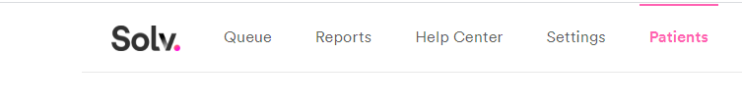

***Image 1***

1. Ask the patient for the 10-digit phone number that they used to create their appointment. Type it into the Phone search bar seen in **Image 2**. Click “Search”.

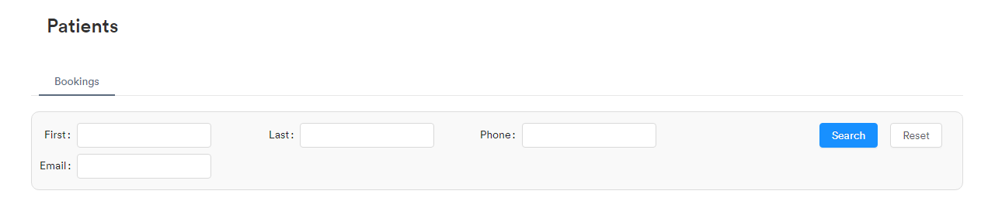

***Image 2***

1. Verify the first and last name of the patient, and check the appointment dates (seen below under the red arrow in **Image 3**) to match the current date. Select appointment made for the current date.

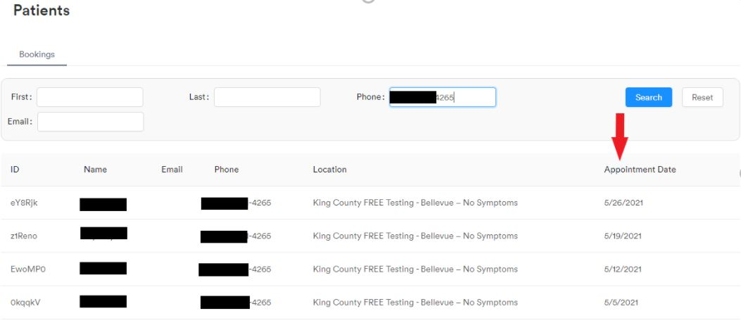

**Image 3**

1. Ask the patient for their date of birth. Verify that the date of birth provided matches the date of birth listed in Solv.
2. Place the cursor into the *Notes* field circled in **Image 4**. Scan the barcode of the next available label into the *Notes* field.

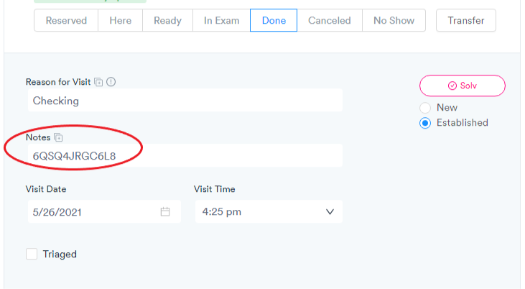

**Image 4**

1. Write the patient’s full first and last name as it appears in Solv on the barcoded label’s blank name field. Write the patient’s date of birth (format: MM/DD/YYYY)on the label’s blank date of birth field.
2. Place the filled out barcoded label on a specimen collection tube. The patient will verify with the swabber/observer that the information on the tube’ is correct.
3. Place the corresponding QR code label on the patient result handout and hand it to the patient.
4. Click the Done button twice until a “Status Updated” banner at the top of the screen appears and Done is highlighted as blue. See Image 4.
5. Click “Save”.
6. Inform patient with the following information:
   1. Use the QR or website listed on this form with the QR code to pull up your results online
   2. Results post in 1-3 days/ 24-72 hours
   3. If test results as positive, patient will receive a phone call.
   4. Patient may receive a text message once the results are available depending on their cell phone carrier
7. Instruct the patient to take the specimen collection tube to the swabber at the next station. Advise the patient where to wait for self swabbing instruction.

Quality Assurance:

Initial training and required retraining are documented on Patient Registration Procedure Training Checklist (see **Appendix B**)

Quality Control:

QR code entry for all the site’s “Done” queues are checked several times daily.

Written by: Justine Villanueva

In Service: June 2021

Updated/reviewed annually since: 2021

Current update/review by: Justine Villanueva and Jennifer Greenwood/June 2021

**APPENDIX A**

**EXAMPLE PATIENT RESULT HANDOUT**

**Get your results**

You will receive an SMS notification when your results are ready. **To find your results either:**

1. Scan the below QR code to access results directly using the camera application on your phone, or
2. Go to the website [https://securelink.labmed.uw.edu](https://securelink.labmed.uw.edu/) to search your results by entering the 12-digit retrieval code below and your date of birth.

**You will receive a phone call if your test results are *positive*.**

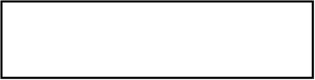

**Acknowledgement**

By receiving this test, I agree to the following:

1. I am consenting on my own behalf, or on the behalf of a minor as the minor’s parent or legal guardian.
2. I understand that the City of Seattle and UW Medicine have partnered to provide for community testing for COVID-19.
3. I authorize UW Medicine employees to perform a nasopharyngeal or anterior nares swab for COVID-19 to collect a specimen for sampling.
4. I understand that the UW Medicine’s role is limited to specimen collection, and that the UW Medicine will process the sample, maintain all data regarding the sample, and provide me with a test result.
5. I authorize test results to be disclosed to the county, state, or to any other governmental entity as may be required by law.
6. I further understand that the information submitted and test results will be kept confidential as required by State and Federal Law.
7. I acknowledge that a positive test result is an indication that a person must self-isolate and seek additional medical guidance as appropriate.
8. I understand that I am not creating a patient relationship with the City of Seattle by participating in testing.  I understand the City of Seattle is not acting as my medical provider.  Testing does not replace treatment by my medical provider. I assume complete and full responsibility to take appropriate action with regards to test results. I agree I will seek medical advice, care and treatment from a medical provider if I have questions or concerns, or if my condition worsens.
9. I understand that, as with any medical test, there is the potential for false positive or false negative test results. I further understand that processing of the specimen and results is not immediate.

**Positive or Negative: Stay home!**

You are testing for COVID-19 today. Your results will help you adjust what you do and protect others.

**If you test positive:**

* This means that you have COVID-19.
* You can still spread COVID-19, even if you don't have symptoms.
* You do NOT need to avoid the people in your house who have already been diagnosed with COVID-19.
* You should NOT test again after completing isolation period.
* 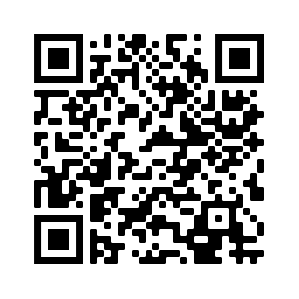Visit the King County Public Health website for more information at

[**https://www.kingcounty.gov/depts/health/covid-19/checkin.aspx**](https://www.kingcounty.gov/depts/health/covid-19/checkin.aspx)**.**

**If you test negative:**

* You may still have COVID-19 even with a negative test. The test does not always identify people who are infected.
* Visit the above King County Public Health website for more information.

**Medical questions related to COVID-19?**

Contact your medical provider or the King County COVID-19 call center between 8 AM to 7 PM PST at 206-477-3977

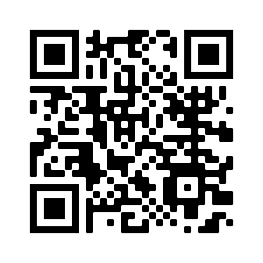**Interested in volunteering for vaccine clinical trials?**

To learn more about opportunities to volunteer for clinical trials

visit: <https://www.coronaviruspreventionnetwork.org/>

**Will I be charged for COVID-19 testing?**

Regardless of whether you have health insurance, you will not be charged for testing and you will not receive a bill. If you are insured, UW Medicine will handle the billing of your private insurance, Medicaid, and Medicare. If you are uninsured, UW Medicine will seek reimbursement directly from the federal uninsured COVID testing fund for the cost of your test. Reimbursement from private insurance, Medicaid, Medicare and the federal uninsured COVID testing fund is necessary in order to offer testing free of charge to you.**Learn more**: <https://www.seattle.gov/covid19testing>

**APPENDIX B**

**PATIENT REGISTRATION PROCEDURE**

**Training Checklist**

|  |  |  |  |  |  |  |
| --- | --- | --- | --- | --- | --- | --- |
|  | | | **Employee:** | |  | |
|  |  | | | |  |  |
| **Patient Registration Training:** |  | | | | **Date** | **Initial** |
| 1. Read and understand procedure (INSERT DOC #) |  | | | |  |  |
|  | **Observed** | | **Performed/Observed** | | **Performed** | |
|  | Date | Trainer | Date | Trainer | Date | Trainer |
| 1. Selection of Correct Patient Appointment and Verification of Patient Information |  |  |  |  |  |  |
| 1. Addition of QR code to the patient record |  |  |  |  |  |  |
| 1. Proper Labeling of the Tubes |  |  |  |  |  |  |
| 1. Proper Labeling of the Patient Result Handout |  |  |  |  |  |  |
| 1. Discharge the patient from Solv. |  |  |  |  |  |  |
| 1. Provide Complete, Accurate Result Information to the Patient |  |  |  |  |  |  |
| Comments: | | | | | | |
| **Reviewed by / Date:** |  | | | | | |

**PATIENT REGISTRATION PROCEDURE**

**RSCS - XXXX**

Change Log

|  |  |  |
| --- | --- | --- |
| **Version** | **Summary of Updates** | |
| **v1.0** | * Initial release | |
| **Date:** | **Reviewed By:** |
|  |  | |
| **Date:** | **Reviewed By:** |
|  |  | |
| **Date:** | **Reviewed By:** |
|  |  | |
| **Date:** | **Reviewed By:** |