Daily Solv Quality Control

Purpose:

The purpose of this document is to provide instruction on how to perform daily quality control procedures, including assuring each discharged patient has been assigned a 12-digit QR code prior to specimen pick-up, problem resolution during mismatched QR codes and an increase in missing patient addresses.

Principle:

To ensure high quality of data integrity and a positive patient service experience, quality control is critical to ensure that all downstream systems and teams receive complete, accurate, and timely information, and the patient receives results in a timely manner.

QR codes are used by the laboratory as a patient identifier and by patient to obtain their results. Missing or inaccurate QR codes will leads to increased manual orders in the laboratory, patient recollection, and delayed patient results

Patient address information is used for contact tracing and making informed testing program decisions. Missing or inaccurate address information will cause incomplete or inaccurate information public health and UWMC uses for data analytics.

Responsibility:

Site Manager and Supervisors:

* Establish and implement this procedure and ensure that all appropriate personnel are duly trained.

Reviewers:

* Check the content of the procedure for accuracy and comprehensibility.

Personnel:

* Read and understand the procedure prior to performing any/all aspects of the procedure.

For non-mobile sites:

* On-site leads, supervisor, or manager will be responsible for performing quality control, unless otherwise assigned.

For mobile sites:

* All on-site staff will be responsible for performing quality control.

Procedure:

1. QR Code Quality Assurance
2. This procedure will be performed at least thirty minutes to one hour prior to the scheduled courier pick-up. For larger sites, QR QC will be performed hourly.
3. Responsible staff should sign into Solv with the following link: <https://manage.solvhealth.com/login>.
4. Click on the site location “Queue” tab at the top left seen in pink font in ***Image 1*** and select one of the site’s queue by clicking the drop-down arrow by the site name and select one of the options.

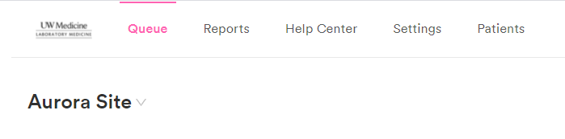**Image 1**

1. There are three status queues for each site location queue: “Reserved”, “Here Now”, and “All Done”.
2. Click on the “All Done” queue.
3. 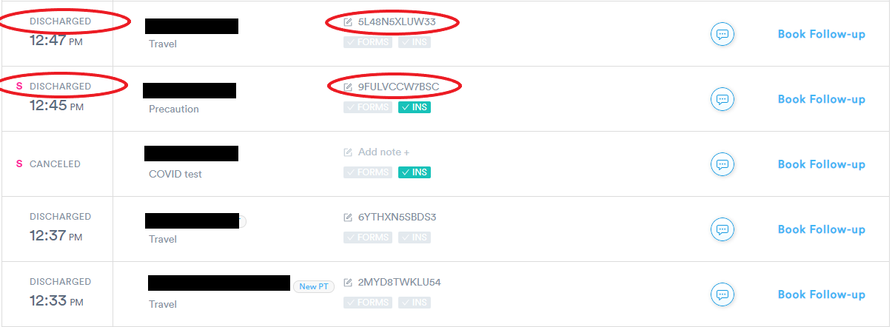Scroll down through the queue and check that each patient has a 12-digit QR code assigned and a status of “DISCHARGED”. See ***Image 2*** the QR code and the patient’s status as “DISCHARGED” circled in red.

**Image 2**

1. In the “Done” status queue, if a patient is missing a QR code, but has a status of “NO SHOW” or “CANCELED”, then no QR code will be assigned to that patient.
2. If a QR code is missing from a “DISCHARGED” patient, locate the collection tube with the full matching name and date of birth from the specimen rack.
   * 1. Click the “Add note +” button associated with the patient’s appointment (***Image 3***), and a window will appear as shown in ***Image 4***.
     2. Scan the barcode from the collection tube into the text field. Verify the last four digits of the tube’s barcode matches the Solv QR code entry.
     3. Click the blue “Save Changes” button and verify that the QR code appears in the patient’s appointment notes field.

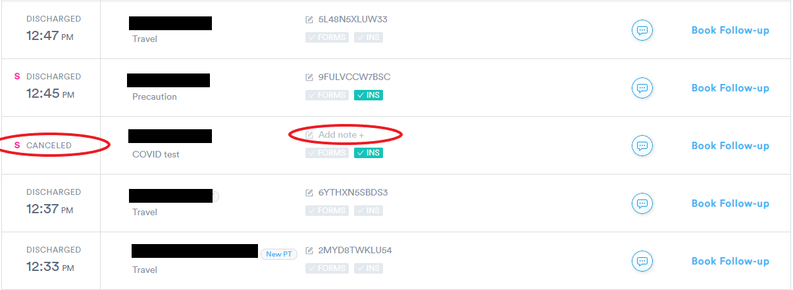

**Image 3**

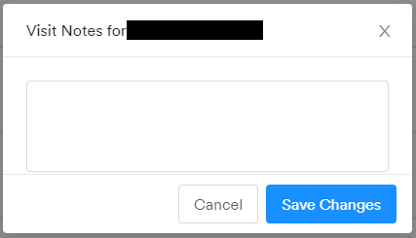

**Image 4**

1. While reviewing for missing QR codes, check for QR codes with less or more than 12 digits. Any QR codes that appear less or more than 12 digits will be counted out to assure a 12-digit QR code. If a QR code with less or more than is identified, the QR code entry will be deleted and re-entered per the procedure outlined for missing QR codes.
2. Any errors found during the quality control procedure, should be traced back to the lane the error occurred in, and the employee will be received immediate feedback.
3. This procedure is repeated for each of the status queues.
4. Problem Resolution for Mismatched QR Codes

NOTE: Use when the barcode sheet becomes uneven, or if there is any possibility for QR code discrepancies.

* 1. Click on the Queue tab and select the correct site location queue.
  2. Select the “All Done” status queue.
  3. Verify the QR code in each patient’s appointment matches the barcode on each of the patient’s tubes.
  4. If there is a QR code in Solv that does not match the QR code on the patient’s tube, follow the next steps to fix this issue:
     1. Click on the patient’s QR code and a window will pop up as seen in ***Image 4***.
     2. Select all the text and delete the QR code.
     3. Scan the tube’s QR codes into the text field.
     4. Verify the last four of the patient specimen tube matches the barcode scanned into Solv.
     5. Click the blue “Save Changes” button.
  5. Send the patient a text to update them with the correct QR code using the text feature through Solv, see **Appendix A**. Use the following script to send to the patient:

|  |  |
| --- | --- |
| Text 1 | Hi (Patient’s First Name), you received the wrong QR code for accessing your results. Please use this QR code to obtain your results: ############ . |
| Text 2 | Please still use the link on your result access sheet to access your results. The QR code in the previous message and your date of birth are needed to view your results in 24-72 hours. Thank you! |

* 1. Repeat the previous steps on the other site’s queues.

1. Problem Resolution for Missing Patient Addresses
2. Click on the Queue tab and select the correct site location queue.
3. Go down the list of patient appointments by clicking into the appointment and scrolling down to verify that the address fields have been filled in.
4. If a patient’s appointment does not have an address, provide feedback to the staff that did not get the patient’s address during the float/greeter step.
5. Note, a blank address field is permitted, if the patient has refused to provide an address or does not have an address to provide.

Quality Assurance:

Initial training and required retraining are documented on Daily Solv Quality Control Training Checklist (see **Appendix B**).

Written by: Justine Villanueva

In Service: June 2021

Updated/reviewed annually since: 2021

Current update/review by: Justine Villanueva/ June 2021

**APPENDIX A**

1. Find the desired patient through the Queue tab in Solv, select the proper site and look under the All Done tab for the correct patient name.
2. Once you find the patient’s name, verify that the correct patient was selected by checking their birthday is a matching second identifier. Click on the appointment to see the patient’s date of birth.
3. Exit out of the patient’s appointment and click on the message button seen in Image 1, circled in red.
4. A window will pop up that will have a text field, seen in Image 2. Type your message into the text field and click on the Send button on the bottom right corner.



**Image 1**

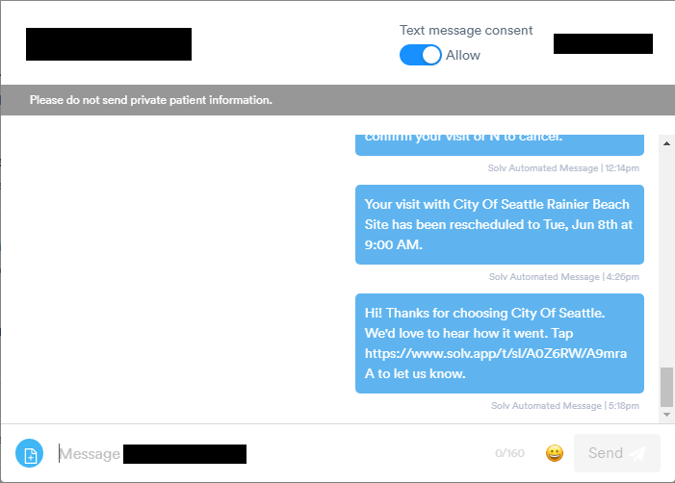

**Image 2**

**APPENDIX B**

**DAILY SOLV QUALITY CONTROL TRAINING CHECKLIST**

|  |  |  |  |  |  |  |
| --- | --- | --- | --- | --- | --- | --- |
|  | | | **Employee:** | |  | |
|  |  | | | |  |  |
| **Patient Registration Training:** |  | | | | **Date** | **Initial** |
| 1. Read and understand procedure (RSCS_0004) |  | | | |  |  |
|  | **Observed** | | **Performed/Observed** | | **Performed** | |
|  | Date | Trainer | Date | Trainer | Date | Trainer |
| 1. Review status queues for QC issues |  |  |  |  |  |  |
| 1. Accurately corrects a patient appointment with a missing QR Code |  |  |  |  |  |  |
| 1. Accurately corrects a patient appointment with a wrong QR Code |  |  |  |  |  |  |
| 1. Adequately performs problem resolution for a mismatched QR Code |  |  |  |  |  |  |
| 1. Adequately performs problem resolution for missing patient addresses |  |  |  |  |  |  |
| 1. Provides accurate and timely communication to patients involved in QC events. |  |  |  |  |  |  |
| Comments: | | | | | | |
| **Reviewed by / Date:** |  | | | | | |

**DAILY SOLV QUALITY CONTROL**

**RSCS - 0004**

**Change Log**

|  |  |  |
| --- | --- | --- |
| **Version** | **Summary of Updates** | |
| **v1.0** | * Initial release | |
| **Date:** | **Reviewed By:** |
|  |  | |
| **Date:** | **Reviewed By:** |
|  |  | |
| **Date:** | **Reviewed By:** |
|  |  | |
| **Date:** | **Reviewed By:** |