Purpose:
To provide instructions for how to use the Terumo Tube Sealer, which uses radio frequency (RF) energy to soften the tubing, which then becomes weldable, and reshapes when cooled under pressure.

Procedure:
Step | Action | Related Documents
1 | Safety Precautions:  - Contact between tissue and Radio Frequency can result in severe burns.  - Keep fingers a safe distance (approximately 2 inches) from sealing jaws when using the tube sealer.
2 | Confirm device is ready for sealing and the LED ring continuously illuminate green.  - Take the tubing and slide it against the front cover of the sealing head into the slit.  - The tubing will be automatically detected and sealed. During the sealing process, the status LED ring will be orange, indicating RF activation. When the RF activation is finished, the status LED ring will flicker once in orange.  - The sealing jaws will release when the process is finished. The status LED ring will automatically turn green again when the entire process is finished.  - Problem with the device will be indicated by red error LED. Follow user manual for possible cause and corrective action.  Caution: Pulling down on the tubing may create enough force to cut through tubing and expose products to non-sterile conditions.
3 | Keep the sealing head dry and free of dirt. Clean sealer as needed.  - Clean the surface of device with a soft cloth soaked in mild detergent or a chlorhexidine gluconate solution of less than 0.5% and well squeezed. Be careful not to spill any cleaning solution inside the instrument.  - Dry and clean the parts immediately with a soft tissue if liquid or dirt is spilled into the sealing head.  - To clean the electrodes and the optical detection sensor:  - Turn off power  - Push sealing head and turn left to remove the head  - Clean the optical electrode, the removable electrode and fixed electrode with a cotton swab  - Insert head by turning it right while pushing in  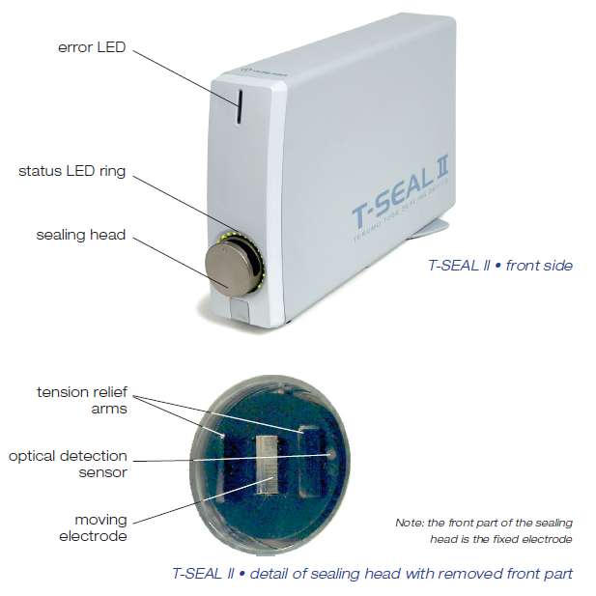

References:
Standards for Blood Banks and Transfusion Services, Current Edition. AABB Press, Bethesda, MD

Terumo Heat Sealer Operator’s Manual

