PURPOSE
To provide instructions for issuing blood components for transfusion

LOCATION
Northwest Lab Transfusion Support Service (TSS)

PRINCIPLE & CLINICAL SIGNIFICANCE
This SOP describes the workflow and inspection process that ensures all necessary testing is complete and blood and blood components meet patient requirements and pass a visual inspection prior to issue for transfusion.

POLICIES
- All blood components must be issued in the LIS system prior to dispensing blood component to clinical team, except in the instance when a downtime log is used.

Exception: Downtime Issue log can be used in lieu of the LIS system for emergency issue of blood components and when the LIS system is not available

- Blood components allocated to a patient should be issued in the following order with shortest date of expiration:
  - Autologous
  - Directed
  - Allogeneic

REAGENTS/SUPPLIES/EQUIPMENT
Reagents | Supplies | Equipment
NA | Blood Product Release Form (BPRF) | Laboratory Information System or Downtime Issue Log

QUALITY CONTROL
The Laboratory Information System (LIS) is validated at implementation and whenever significant changes are made to the system to assure it functions as expected.

INSTRUCTIONS:
Table of Contents
Verifying Blood Components are Allocated
Retrieving RBC Component(s) from the Haemobank
Issuing Blood Component(s) in Sunquest
Issue using Downtime Issue Log

APPENDIX 1: Examples of Transfusion Records
APPENDIX 2: Attaching Haemobank Labels to Transfusion Record and Blood Component
APPENDIX 3: Blood Component Transport Flyer

Verifying Blood Components are Allocated
STEP | ACTION
1 | Receive the completed Blood Product Release Form (BPRF)
2 | - Log into Sunquest at location NW  - Click on Blood Bank Inquiry> (BBI 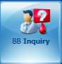)
3 | - Select Lookup by ‘PatientID’  - Manually enter the patient’s MRN from the BPRF
4 | Verify the patient has an order and a component(s) is allocated for issue:  If looking for a Look for the following order  RBC or granulocyte TSCR, TSCREX or TXM  Platelet TPLT  Plasma TFFP  Cryoprecipitate TCRY
5 | If the patient Then  Has an order Verify component is allocated and located in the NW lab - Click and highlight the order row - Click <Show Units> - Click to highlight the unit in status ‘AL’ - Click <Unit Detail> If components is Then Allocated (AL) and located at NW Go to next step Allocated (AL) but not located at NW - Contact Montlake TSL for ETA or resolution - Notify the clinical team if product will be delayed Not allocated but there is an order  Does not have an order Contact the clinical team and request an order be placed
6 | Click on <Blood Product Issue> (BPI )
7 | - Select Lookup by ‘PatientID’  - Manually enter the patient MRN from the BPP
8 | Select the appropriate Billing Account from the Event Selection window (if not already selected) to ensure billing is applied to the correct encounter
9 | - Enter the appropriate component group(s) in the ‘Component’ field for the type of component requested for pickup  - RBCG – Red Blood Cell Group (includes granulocytes)  - PLG – Platelet Group  - PLSG – Plasma Group  - CRYG – Cryoprecipitate Group  - Click <Add>
10 | Click <Select> to see what blood components are allocated to the patient and available for issue  If component is Then  RBC in the Haemobank Go to section Retrieving RBC Component(s) from the Haemobank  RBC in the refrigerator (i.e. in the case of washed RBC) Go to section Issuing Blood Components in Sunquest  Platelet  Plasma  Cryoprecipitate  Granulocyte

Retrieving RBC Component(s) from the Haemobank (does not include Granulocytes)
STEP | ACTION
1 | Log in to the Haemobank by scanning your UWMC ID Badge or entering in your EID# (Employee Identification #)
2 | Touch <Taking Out>
3 | Select the Transport Method  If transporting Then touch  In a cooler <Cooler> NOTE: Selected when issuing more than one refrigerated blood component  Not in a cooler <Room Temp>
4 | Touch <Select Patient>
5 | Enter the patient’s medical record number from the BPP
6 | Touch <Search>
7 | Confirm the patient details by verifying that the name and MRN on the screen matches the name and MRN on the Blood Product Release Form.  If Then  Matches - Touch <Yes> - Go to next step  Does NOT match - Resolve the discrepancy prior to removing any blood components - Contact Montlake TSL for help when needed
8 | Select the type of blood component: <Red Cells>
9 | Open the door when you are prompted to remove component  NOTE: Tray holding the blood component will illuminate in blue
10 | Pull out the blue illuminated tray, gently  If Then  Component is in the tray Remove component from the tray NOTE: A blank Transfusion Record will be attached - refer to Appendix 1 for example  Tray is empty Touch <Tray Empty> on the Haemobank screen
11 | Push the tray back into the slot gently until it stops moving and close the door
12 | Scan the Unit Number from the component label when prompted
13 | Perform a visual inspection and respond to the question “Is the unit suitable for transfusion? - refer to SOP Visual Inspection of Blood Components at Northwest Campus  If Then  Suitable (pass inspection) Touch <Yes>  Unsuitable (does not pass inspection) - Touch <No> - Follow the prompts to return the component to Haemobank
14 | If the component was Then  Remotely allocated from the Haemobank) - Compatibility Label will print - Go to the next step  Allocated at Montlake TSL prior to loading in Haemobank - No label prints. A Transfusion Report with patient information will already be attached to the component - Go to section Issuing Blood Components in Sunquest
15 | Confirm the labels printed correctly  If printing is Then  Successful - Touch <Yes> - Place the Compatibility Label on the back of the blood component bag- refer to Appendix 2 - Go to next step  Unsuccessful Touch <No> to print the compatibility label again If printing Then Is successful - Touch <Yes> - Place the Compatibility Label on the back of the blood component bag - Go to next step Unsuccessful - Touch <Cancel> to abort the process - Follow the prompts to return the component to storage in the Haemobank - Contact Montlake TSL for help
16 | Scan the unit number from the component label followed by the barcode on the Compatibility Label  NOTE: Green check mark and the word “GOOD” will appear and Transfusion Record Label will print
17 | If Transfusion Record Label print is Then  Successful - Touch <Yes> - Place the Transfusion Record Label to the top half of Transfusion Record form  Unsuccessful Touch <No> to print the Transfusion Record Label again If printing Then Is successful - Touch <Yes> - Place the Transfusion Record Label to the top half of the Transfusion Record form. - refer to Appendix 2 - Go to next step Unsuccessful - Touch <Cancel> to abort the process - Contact Montlake TSL for help NOTE: BloodTrack and the Haemobank track the component as issued
18 | Answer the question” Do you want more Red Cells for the same patient?  If Then  NO - Touch <No> - Go to section Issuing Blood Components in Sunquest  YES - Touch <Yes> - Repeat steps 10 thru 17 - Go to Section Issuing Blood Components in Sunquest NOTE: Multiple units on the same patient should be issued in a blood transport cooler. You must complete labeling the Transfusion Record for each unit prior to removal of the next unit

Issuing Blood Component(s) in Sunquest
STEP | ACTION
1 | Select the blood component from the appropriate storage device  NOTE:  - When more than one component is allocated, issue components based on the following:  - Autologous donations before directed, before allogeneic  - Shortest date first  - Contact Montlake Lab with any questions concerning what order to select components
2 | Verify the blood component meets all patient transfusion requirements by reviewing the patient transfusion requirements located under the tabs at the top of the screen  - Antigens/Antibodies  - Problems  - Comments  - Transfusion Attributes  NOTE: Click <More> to review all requirements in one screen. Click <Less> to collapse screen
3 | If the component Then  MATCHES ALL patient requirements Go to the next step  Does NOT MATCH ALL patient requirements Call Montlake TSL to resolve the discrepancy
4 | Scan the following information from the blood component label  Field Scan  Unit # Donor Identification Number  Component Component type (Ecode)  Division Verify the correct Division is selected using the dropdown arrow
5 | Verify the correct unit is automatically selected  If unit is Then  Correct Go to next step  Not correct - Click <Cancel> - Resolve any issues and attempt to rescan the unit. If scanning the unit is not possible, the unit number may be entered manually along with the component type - Select the component from the dropdown menu only after verifying any discrepancies were resolved
6 | Click <Continue>
7 | Perform a visual inspection of the blood component – refer to SOP Visual Inspection of Blood Products at Northwest Campus  - Expiration date has not passed  - Correct labeling  - Intact container  - No clots, turbidity, hemolysis or other abnormal appearance of the component  If visual inspection Then  Passes - Result the visual inspection by selecting the Pass All key - Go to the next step  Fails - DO NOT issue unless the component passes the visual inspection - Select the <Inspect Unit > - Answer the “Visual inspection ok?” by selecting the No - Enter “CQI” as the “Reason for failure” code - Select “Quarantine” for the new status - Click <OK> - Initiate a QI form and quarantine the component following SOP Quarantine and Final Disposition of Blood Components at Northwest Campus
8 | Verify the following information when present is in agreement on all forms and labels  Blood Product Releasep Form Sunquest Transfusion Record Blood Component (ISBT) Label  Name & MRN Name & MRN Name & MRN  Recipient Type Recipient Type  Donor Blood Type Donor Blood Type Donor Blood Type  Unit Number/Div. Unit Number/Div. Unit Number/Div.  Unit Expiration Unit Expiration Unit Expiration  Component Type Component Type Component Type
9 | If Then  Discrepancies - DO NOT issue component when discrepancy between forms and labels exist - Contact Montlake TSL for help resolving the discrepancy - Resolve any discrepancies and correct documents prior to going to the next step  No Discrepancies - Initial the Transfusion Record at the bottom right corner - Go to the next step
10 | Perform the following verification with blood runner/courier:  - Hand the blood product release form and labeled blood component to the blood courier  - Retain the Transfusion Record for read back .  Lab Staff reads the following from the Transfusion Record Courier Staff confirms the following on each blood component  Patient full Name and MRN Patient full Name and MRN Release form and Compatibility label  Patient ABO/Rh Patient ABO/Rh Compatibility label  Donor ABO/Rh Donor ABO/Rh Component face label  Unit Number/Div Unit Number/Div Component face label  Donor Unit Expiration date and time (as applicable) Donor Unit Expiration date and time (as applicable) Component face label  Component Type Component Type Component face label  Crossmatch Interpretation (where applicable) Crossmatch Interpretation (where applicable) Compatibility label  Special transfusion requirement such as irradiation Special transfusion requirement such as irradiation Component face label
11 | If Then  Discrepancies - DO NOT issue component when discrepancy between forms and labels exist - Contact Montlake TSL for help resolving the discrepancy - Resolve any discrepancies and correct documents prior to going to the next step  No Discrepancies - Initial the Transfusion Record at the bottom right corner - Go to the next step
12 | - Click <Continue>  - Tab to accept the default for issue date and time or update if not issuing in real time  - Verify the patient location matches the requested delivery location, or enter the correct location (Search may be used to locate the correct location)  If issuing by Then enter in the ‘Issue to” field  Transporter Scan the blood transporters badge or enter their first and last name  Portable Coolers Enter the blood transport cooler ID#
13 | If a QA Failure Then  Does NOT occur Go to next step  Occurs Call Montlake TSL prior to issue. NOTE: If the issue cannot be corrected and the product is acceptable for issue, Montlake may direct you to issue the blood component using the Downtime Issue Log – go to section Issue Using Downtime Issue Log
14 | - Click <Save> and the “Add Billing” window will open  - Click <Cancel>  CRITICAL: If the ‘Add Billing window ‘is not canceled, the window will timeout and documentation of the issue process will be lost. When this occurs, it is considered a Biological Product Deviation requiring report to the Food & Drug Administration (FDA)
15 | If transporting via Then  Transporter - Place blood component(s) with attached transfusion record in a plastic bag - Give to the transporter for delivery to the patient’s transfusionist - Hand the transporter a Blood Component Transport flyer-refer to Appendix 3: Blood Component Transport Flyer  Cooler Go to SOP Issuing Blood Components in a Blood Cooler at Northwest Campus

Issue Using Downtime Issue Log
STEP | ACTION
1 | Document the Today’s Date and select NW as the location at the top of the Downtime Issue Log
2 | Document the following:  - Patient Name  - Patient MRN  - Patient Location – where the component will be transfused  - Unit Number/Division – Donor identification number and container or division number  - Ecode
3 | Document outcome of steps 7, 8,9, 10 of section Issuing Blood Components under “Pass Visual Inspect”.  NOTE: Step 10 verification process of Section: Issuing Blood Components DOES NOT apply for MTP and emergency issue of blood components.  If all Then  Passed (acceptable) Document ✓ in the Pass Visual Inspect field  Failed (unacceptable) Do not continue If Then Component fails visual inspection Quarantine component following SOP Quarantine of Blood and Blood Components at Northwest Campus Any other information is unacceptable Contact Montlake TSL to help resolve discrepancy
4 | Document the following:  - Issue by (Tech) - document 4-digit tech ID  - Issued to – Employee ID number or name of person picking up component or cooler
5 | Perform verification with the blood runner/courier:  - Have the runner/courier read the patient name and MRN from the patient label or blood product release form while tech compares to the downtime log.  If Then  No discrepancy Go to next step  Discrepancy Resolve discrepancy before going to next step
6 | Hand the transporter a Blood Component Transport flyer- refer to Appendix 3:Blood Component Transport Flyer
7 | Fax a copy of the form to Montlake for computer entry in SQ of issue

PROCEDURE NOTES/LIMITATIONS
- You will have only 60 seconds to attach the compatibility label to the component and scan the unit number from the component tag and the barcode from the compatibility label

REFERENCES:
- Technical Manual. Bethesda, MD; AABB, current edition
- Standards for Blood Banks and Transfusion Services. Bethesda, MD; AABB, current edition

RELATED DOCUMENTS:
FORM Blood Product Pickup Slip
FORM UH3363 UW Medicine Transfusion Record
FORM UH3919 UW Medicine Transfusion Record (Haemobank)
FLYER Blood Component Transport
SOP Visual Inspection of Blood Components at Northwest Campus
SOP Quarantine and Final Disposition of Blood Components at Northwest Campus
SOP Issuing Blood Components in a Blood Cooler at Northwest Campus

UWMC SOP Approval:
UWMC CLIA Medical Director
 | Mark H. Wener, MD | Date
Transfusion Service Manager |  | Date
 | Nina Sen
Compliance Analyst |  | Date
Transfusion Service  Medical Director |  | Date
 | Monica Pagano, MD
UWMC Biennial Review:
 |  | Date
 |  | Date

10/18/21- Updated to include Blood Transport Flyer and process

APPENDICES:

APPENDIX 1: Examples of Transfusion Records

Components remotely allocated from Haemobank  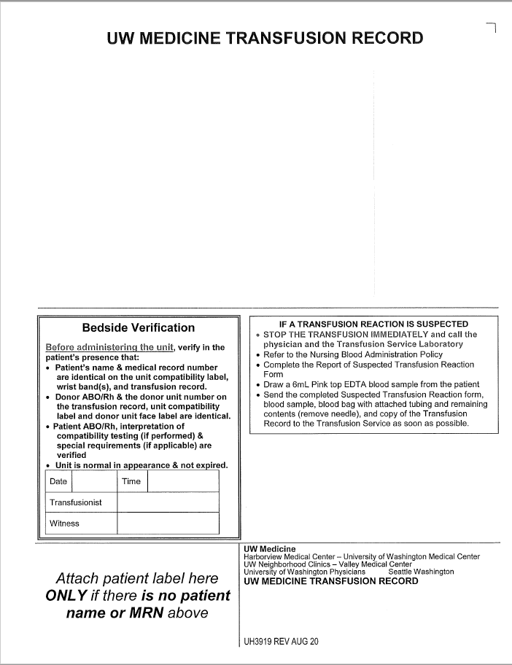 | Used for thawed plasma, thawed cryoprecipitate, and RBC components allocated from Montlake stock  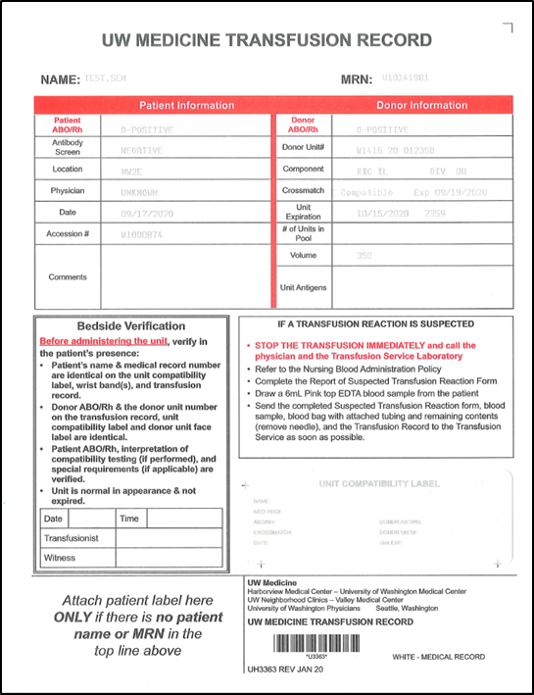

APPENDIX 2: Attaching Haemobank Labels to Transfusion Record and Blood Component

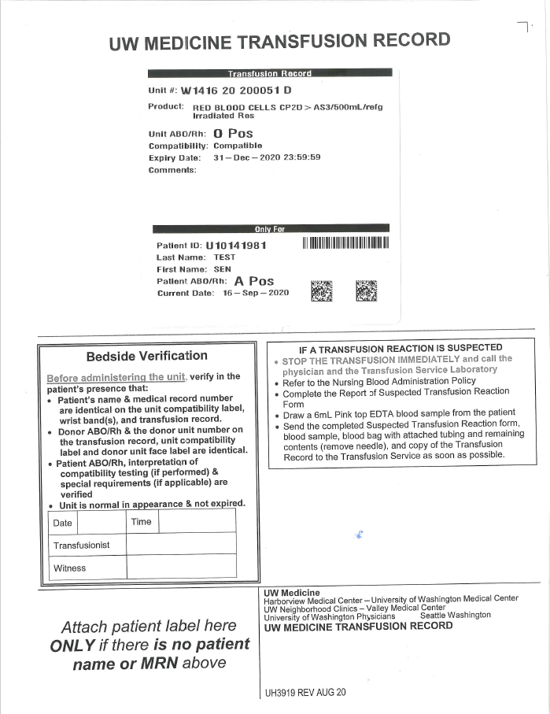 | 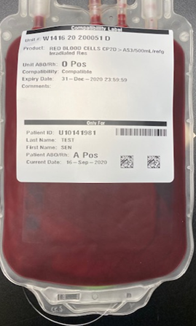

APPENDIX 3: Blood Component Transport Flyer

Blood Component Transport

- Deliver blood component(s) promptly to the location of the patient and hand-off directly to a clinical team member.
- Confirm the full name of the patient with the person receiving the blood.
- Do NOT leave unattended at the patient location.
- Do NOT open storage container during transport.
- Do NOT place blood component in any other storage container.
- Do NOT place the components on heated or cooled surfaces.
- Do NOT transport blood components for multiple patients at the same time.

