**LABORATORY REFRIGERATOR AND FREEZER MONITORING POLICY**

**1. Purpose:** Pathology and Laboratory Medicine Program defines the policy for the daily monitoring and recording of temperatures in all refrigerators and freezers.

2. **Background:** CheckPoint is a wireless and computerized system to automate the temperature monitoring of equipment and the environment in which patient testing occurs. A central computer, or server, records and monitors the temperature continuously at every 15 minutes interval, and immediately notifies the staff if an alert condition should occur.

**3. Policy:** It is policy that each laboratory section monitors temperatures in refrigerators and freezers utilizing CheckPoint Wireless Temperature System or record the temperatures on a paper chart.

**4. Procedure:** Temperature recording is automatic and continuous for each equipment and room wherever a temperature sensor is installed, and can be viewed from the designated computer in each laboratory section. Staff must log into the system daily.

1. During Mon-Fri 7AM-3PM, department Supervisors or designees will be responsible for monitoring CheckPoint for their departments.
2. During off tours, weekends, and holidays, the Core Lab Supervisor will assign a person or particular bench the duty of logging into CheckPoint within one hour of the beginning and one hour prior to the end of their shift.

**5. Action:**

A. CheckPoint will notify the users via email or pop-up alerts.

B. It is important to clear alerts in a timely manner. The program will not repeat an alert for the same equipment for the same reason, such as for a high temperature, if such an alert already exists (flashing red or yellow alert). If an alert is neglected, many hours may pass before corrective action may be taken, thereby subjecting the products or samples to further risk.

C. In the event of a refrigerator/freezer failure, staff should first check to see if the alert is due to an easily rectified situation, such as an open door, unit is unplugged, etc… In the event of a failure during off tours, Saturday, Sunday, or holiday, the staff will contact the area Supervisor or appropriate contact by telephone or pager if the situation cannot be immediately resolved.

D. In the event of a failure, all reagents and/or patient specimens must be removed from the refrigerator/freezer and transferred to a functional unit. All reagents must be marked with an indelible marker and sequestered until they can be assessed for reactivity through appropriate quality control measures. The supervisor is responsible for monitoring the quality of any reagent put into service after a refrigerator/freezer failure. Patient specimens must be sequestered until they can be assessed for integrity. The testing of each specimen will depend on the analyte and the conditions required to maintain specimen integrity.

E. The section Supervisors, QA Technologists and/or Chief Medical Technologist are responsible for generating an electronic work order to have the refrigerator/freezer repaired. After repair, the temperature of the refrigerator/freezer will be monitored for several days prior to being placed in service.

F. The Supervisor/QA Technologist or designee must review the temperature charts monthly to determine if the temperatures were in the appropriate range for the assays or if the reagents/controls were stored properly. In compliance with the standards of the College of American Pathologists and VHA Handbook 1106.1, all refrigerator and freezer temperature monitoring records are retained for a period of two years. Any documentation of corrective action for refrigerator/freezer failure is also retained for two years.

**6. Contingency Plan:**

In the event that CheckPoint is offline or otherwise unavailable, daily temperatures will be recorded on paper temperature charts that are hung on the front of the instrument or kept in a log book.

**7. Contact Information:**

* Histology/Cytology: Anatomic Path Supervisor
* Microbiology/Immunology: Micro Supervisor
* Core Lab: Core Lab Supervisor
* HZ Morgue/HZ Fridges: Boiler Plant 22-3217
* UD Morgue/Surg Fridge (3N115): Boiler Plant 60-6139
* CritCare (3A130): Charge Therapist 60-6231

**8. Attachments**

1. CheckPoint User Information (Attachment)

**CheckPoint User Information**

**Procedure**

To log into CheckPoint:

1. Click the Checkpoint icon and enter login name and password to open the program.

2. User name, date and time are automatically recorded in User Login History as a digital signature evidencing daily temperature check.

3. If no alerts exist, close the program.

If alerts do exist, take Corrective Action as prompted by the program.

1. Alerts will appear in the top box highlighted by a blinking red border.

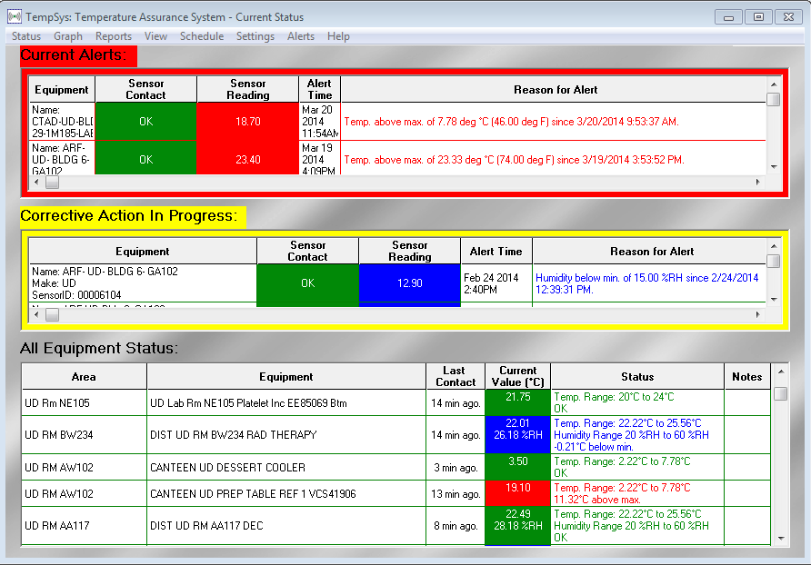

a. Right click on the appropriate alarm and click Take Corrective Action tab

2. As prompted, select the most appropriate cause of the temperature deviation and click Next.

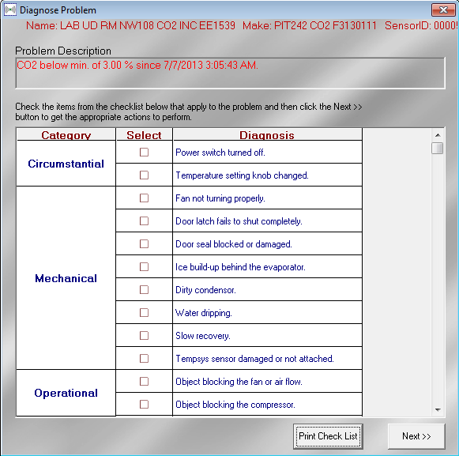

3. CheckPoint will then generate a potential course of corrective action, click Next.

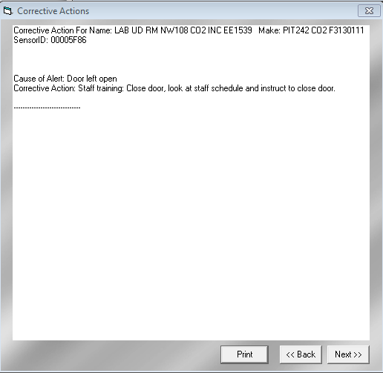

4. A dual corrective action window will pop up.

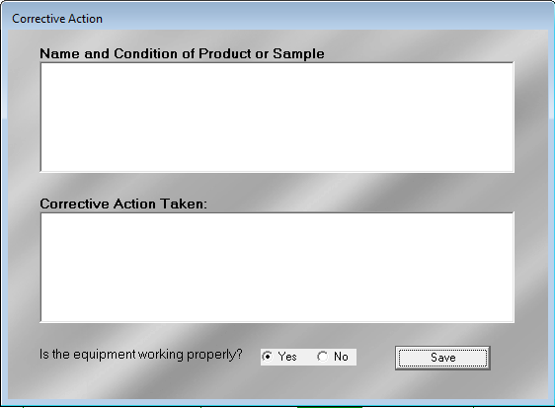

a. Under Name and Condition of Product or Sample, enter the names of the reagents, patient samples or other items which may be affected and evaluation of their fitness for use.

b. Under Corrective Action Taken, enter what actions were taken to address the alert.

c. Select whether the equipment is working properly or not.

i. If yes, action is complete

ii. If no, alert will be placed in a hold file for later follow up.