HEMOCCULT

Intended Use: The Hemoccult® SENSA® test is a rapid, convenient and qualitative method for detecting fecal occult blood which may be indicative of gastrointestinal disease. It is not a test for colorectal cancer or any other specific diseases. Hemoccult is a screening test for stool specimens only, do not use gastric specimens.

Policy: Ancillary Testing Policy PE-2 is on line at Sharepoint/ Service Line Clinical Support/ Pathology and Lab Medicine/ Ancillary Testing/ Shared Documents.

Procedure Manual: A Procedure Manual is located at each testing site in a binder, and on line at Sharepoint, as noted in Policies above. A Package Insert is included in the procedure.
Do not use cards or developer after expiration date which appears on each test component.
Because this test is read visually and requires color differentiation, it should not be interpreted by individuals with blue color blindness.

Reporting Results: Results are to be entered into the patient record using the CPRS electronic medical record “Point of Care Clinician Performed Test” Template, Fecal Occult Blood.

Hemoccult Testing Highlights:
1. Apply a THIN smear of stool to each box.
2. Wait 3-5 minutes after sample application before developing the test.
3. Open back flap and apply TWO DROPS of developer to each smear.
4. Interpret within 60 seconds.
5. Any trace of BLUE on or at the edge of the smear is POSITIVE
6. Develop the *Onboard Controls with ONE DROP of developer. Interpret within 10
seconds.
7. Use the CPRS template POC, Fecal Occult Blood to enter your results into the
Patient’s medical record.

SAMPLE CARD

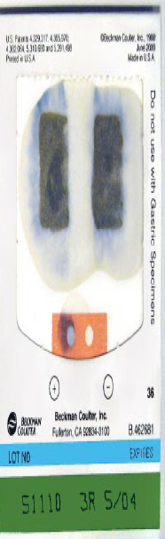

Positive Patient Sample →
(note the blue color)

* Onboard *Onboard
Positive Control → ←Negative Control

←Expiration Date
CPRS TEMPLATE
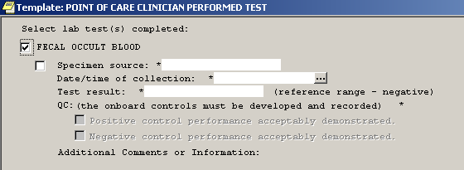
2012 VAPHCS

