**Gastroccult Testing**

***Gastroccult is a screening test for gastric specimens only.***

**Procedure Manual:** A Procedure Manual is located at each testing site in a binder, and online under Sharepoint, Clinical Support Services, P & LMS, Ancillary Testing, Gastroccult Testing.

**Package Insert:** A copy of the package insert is available in the Procedure manual .

**Supplies:** Gastroccult supplies are available from Ancillary Testing. There is a separate developer for this test. *Do not* *use the Hemoccult developer*.

**Gastroccult Testing Highlights:**

1. Apply one drop of gastric sample to the **pH** test area and one drop to the Gastroccult test area.
2. Determine the pH of sample by visual comparison to color chart within 30 seconds of applying sample.
3. Apply TWO DROPS of Gastroccult developer over the Gastroccult Test area.
4. The development of any trace BLUE color is regarded as positive. Interpret within 60 seconds.
5. Add ONE DROP of Gastroccult Developer to the performance monitor. Interpret within 10 seconds.
6. Use the CPRS template PPT-POC for Gastroccult to enter your results into the progress

notes of the electronic medical record.

[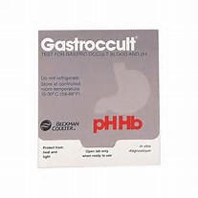](http://www.bing.com/images/search?q=gastroccult+picture&id=0E6008FDC377E8EBF1C67E066340065C9BAF9311&FORM=IQFRBA)[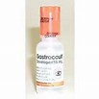](http://www.bing.com/images/search?q=gastroccult+picture&id=A367B4F7A474E8FD29007AE5F7C4261DAC23DADA&FORM=IQFRBA)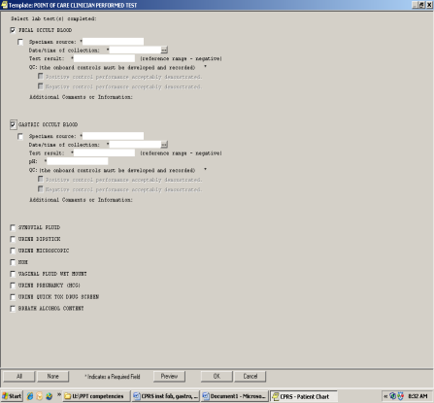

**\*You CANNOT perform this test if you are colorblind** 2012 VAPHCS