UA Dipstick (Bayer Multistix 10SG)

Policy

Ancillary Testing Policy PE-002 is online under Sharepoint, Clinical Support, P&LMS, and Ancillary Testing.

Procedure Manual

A Procedure Manual is located at each testing site in a binder and online under Sharepoint, Clinical Support, P&LMS, and Ancillary Testing.

Package Insert

A copy is with each box of strips.

Notes

- Always keep the cap on the strips.
- Do not use strips after the expiration date.
- Do not store in sunlight.
- Timing is very important. Adhere to the guidelines on the vial.
- Required Quality Control testing is performed by the lab.
- Use Universal Precautions in handling all specimens as biohazardous.
- Use the CPRS electronic medical record template PPT-POC for Urine Dipstick to enter your results as it contains the parameters required by the JCAHO.
- If you are colorblind, you cannot perform this test.

Testing Procedure
- Collect a fresh urine specimen in a clean, dry container. Mix well immediately before testing. Do not centrifuge the specimen. Label the specimen with the patient’s full name and full social security number.
- Remove one strip from the bottle and replace the cap. Completely immerse reagent areas in the fresh urine and remove immediately to avoid dissolving out reagents. While removing, run the edge of the strip against the rim of the urine container to compare the reagent areas to the corresponding Color Chart on the bottle label at the time specified. Hold strip close to the color blocks and match carefully. Avoid laying the strip directly on the Color Chart, as this will result in urine soiling the chart. Unusual or unexpected results should be followed up with lab testing.
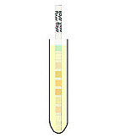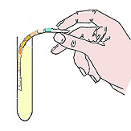
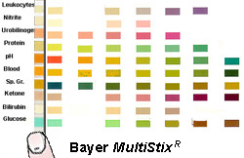
- Color Chart. Read the following tests at the specified time periods after dipping:
- Glucose and Bilirubin – 30 seconds
- Ketone – 40 seconds
- Specific Gravity – 45 seconds
- pH, Protein, Urobilinogen, Blood, and Nitrite – 60 seconds
- Leukocyte – 2 minutes

- Instructions on how to enter results into a medical record using CPRS Template Note:
  - Enter CPRS
  - Enter patient name/SS#/Location
  - Select “New Note”
  - When Progress Notes Title Box appears:
    - Type POINT OF CARE CLINICIAN PERFORMED TEST (you don’t have to type the whole thing)
    - Select template(s):
    - Enter results and sign note.
