**purpose:** To outline ED Lab label process at EMCP and describe the duties and responsibilities of the Central Processing Staff when Add On orders are received from the Emergency Department.

**PRINCIPLE: n/a**

**PROCEDURE:**

**Emergency Department (EMCP only):** Tubes that arrive from the E.D. that do not yet have orders will have zebra printed labels with the words ED Lab blue, ED Lab SST, ED Lab Lav, etc. The screen shots below demonstrate the CP clerk processes of the ED Lab label system.

* 1. Depending on the work performed by the ED staff, CP staff will see one or more entries when looking at the patient in Order Results Viewer (ORV). CP staff will ‘In Lab’ the ED Lab Label orders which will result with a status of Collected.

**ORDERS IN ORV**



**Open Specimen Login by clicking the Specimen Login icon**

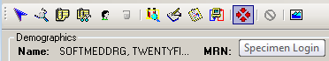

**Log the specimen into the proper location**

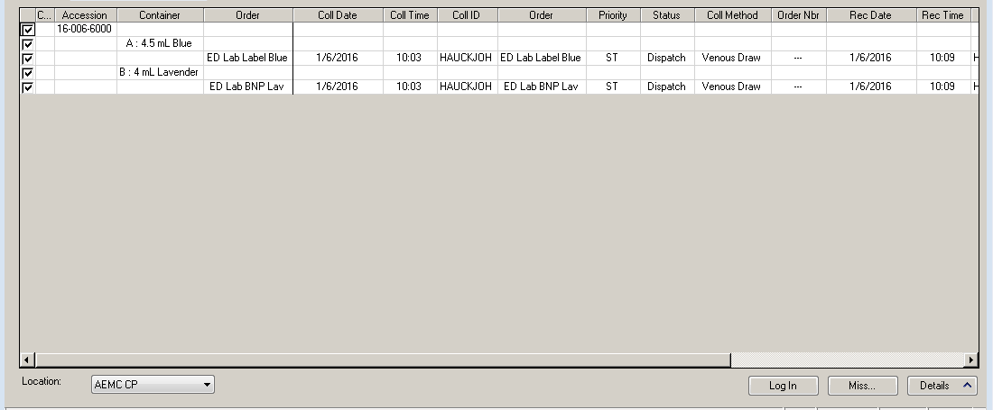

**In the Receive Specimen dialogue box check only the specimens that have been collected. (i.e. in this case BNP Lavender and Blue.**

**Refresh the ORV screen and the orders go to Completed**

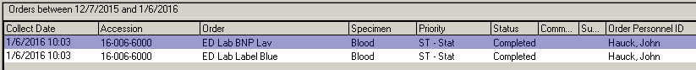

**When an Add On order is placed, the requisition will print on a printer the Central Processing area and the order will appear in ORV**

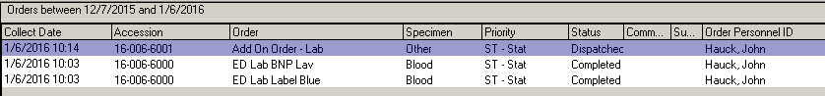

**Open Specimen Login and log the specimen into the proper location**



**The Add On order is now in Completed status**

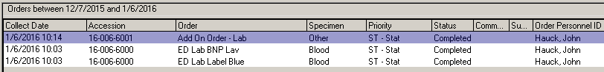

**Double clicking the order in ORV will open the order to display the tests to be ordered in Department Order Entry** **(DOE). This will be the same information that will appear on the printed requisition**

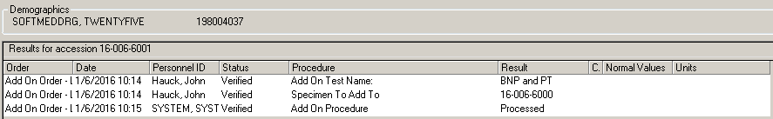

**In DOE select the Accession Add On icon**

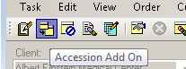

**Enter the Accession Number to which the tests will be added.**

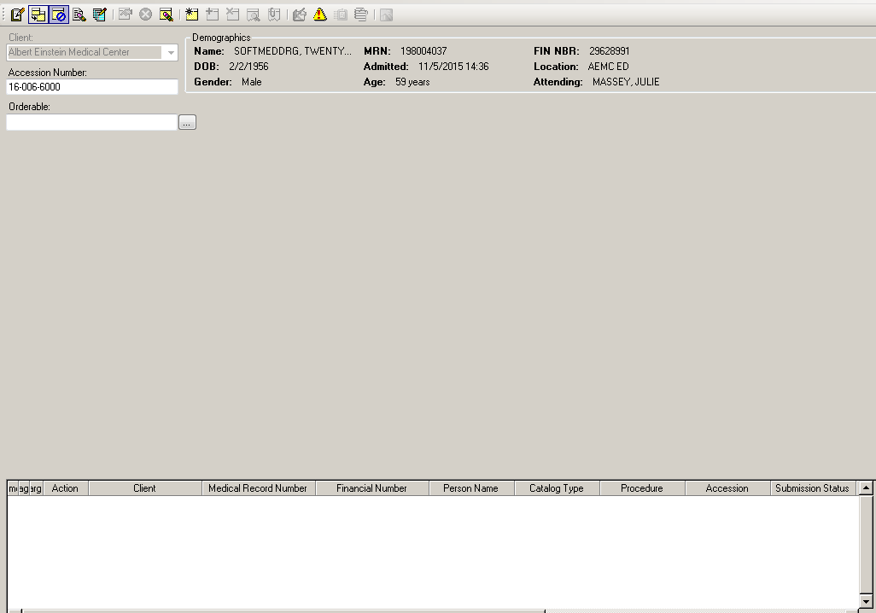

**Enter the name of the Orderable to be added to the accession number.**

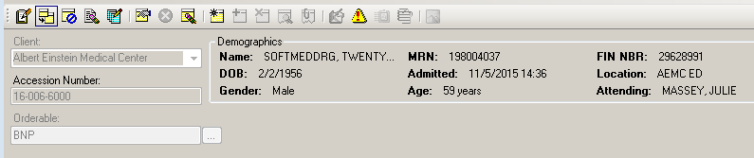

**A screen will open to select the container (specimen). Click OK**

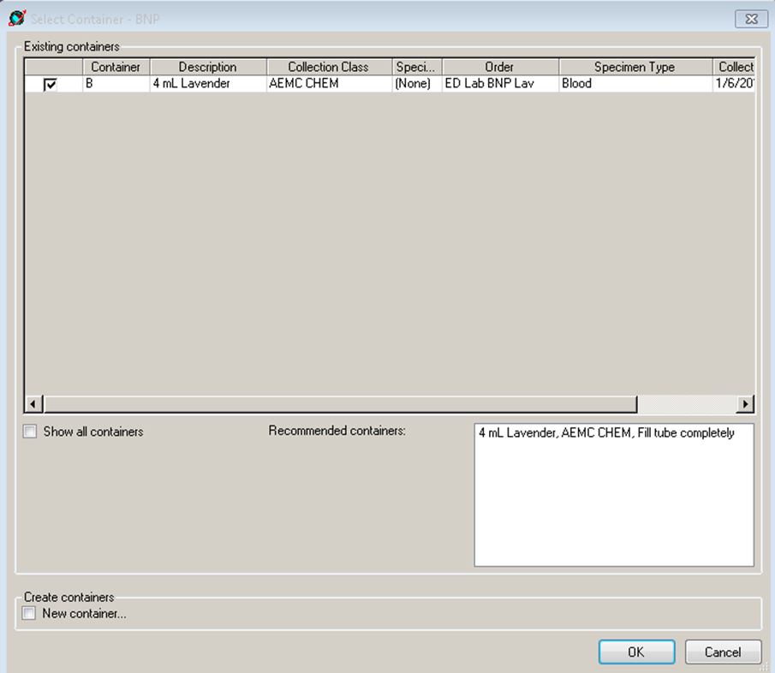

**The order will display.**

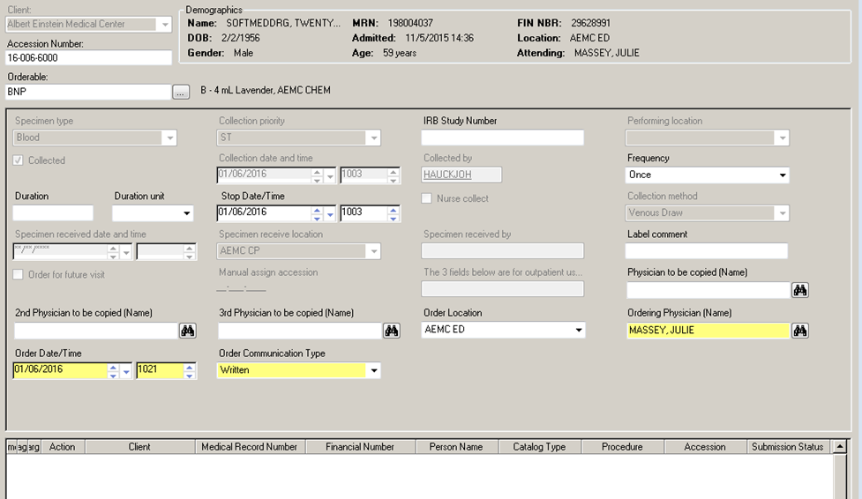

**Click the Add Order to scratchpad icon**

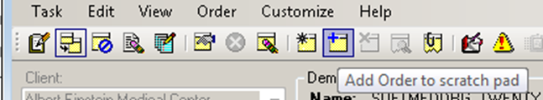

**The order moves to the scratchpad**

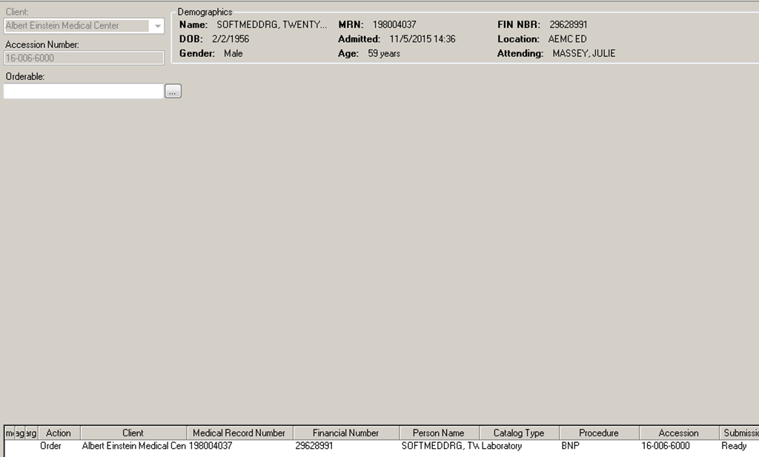

**Enter the next order to be added**

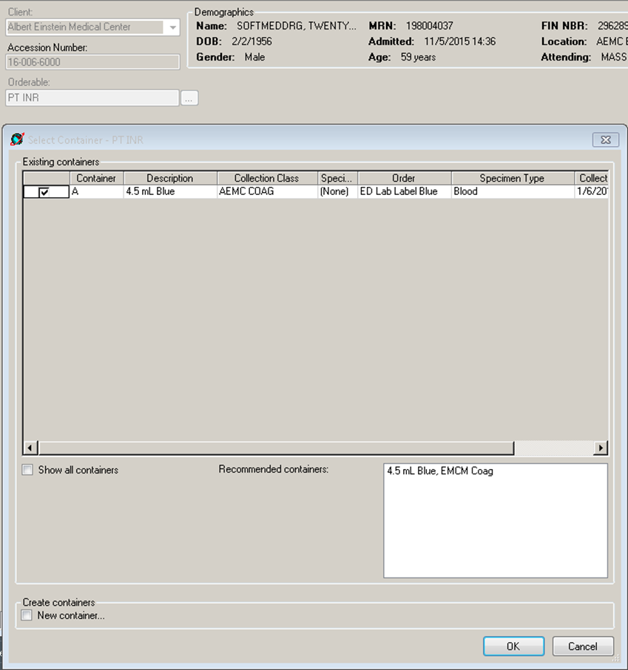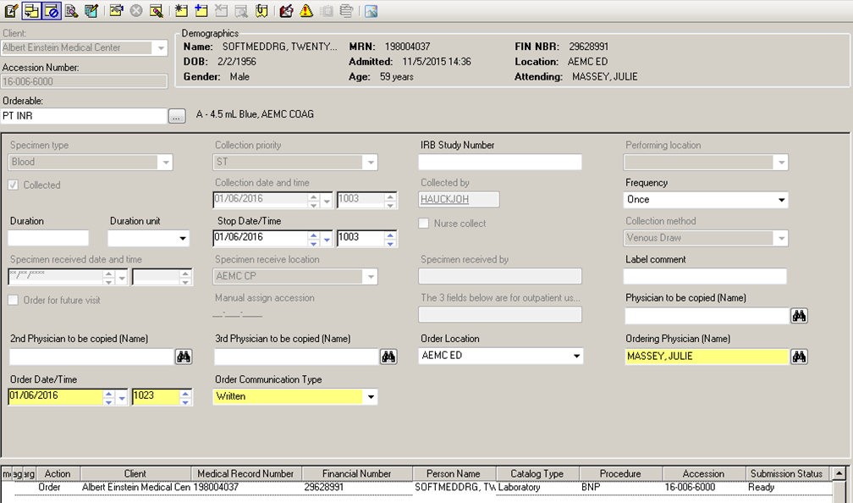

**After adding the order to the scratchpad, click the submit orders icon to place the orders.**

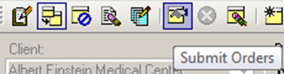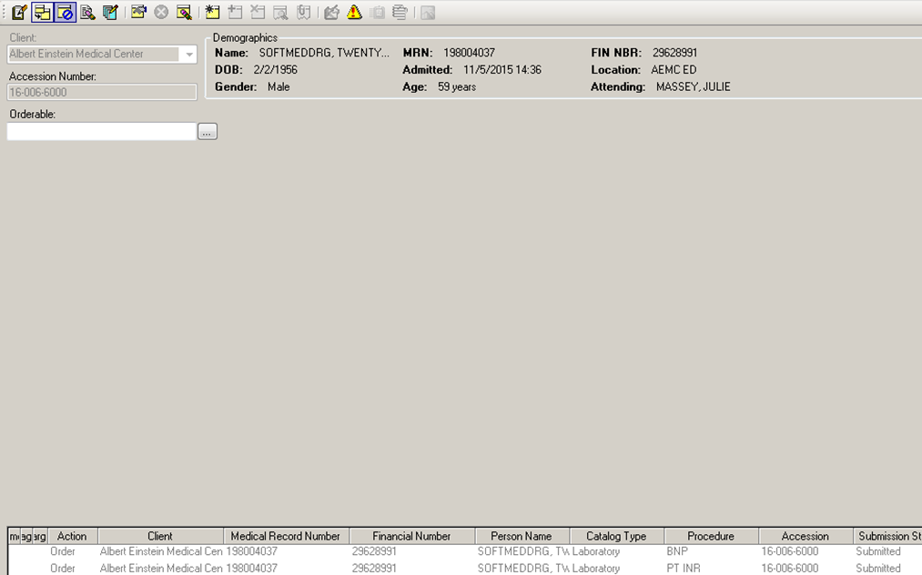

**The orders appear in ORV with an In Lab status**

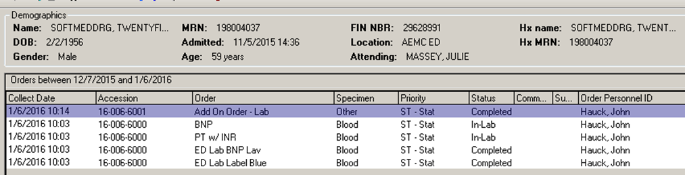

**Pending lists for the appropriate bench(s) or analyzer(s) will show the order is present and available for resulting.**

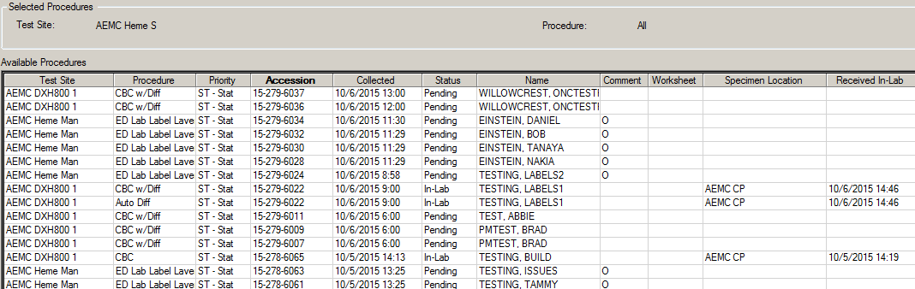

**Approval Signatures:**

|  |  |  |
| --- | --- | --- |
| Date | **Printed Name** | **Signature** |
|  | Peggy Wachowski, MLT(ASCP)  Central Processing Supervisor |  |
|  | Vanessa Rawlings, MT(ASCP)  Laboratory Supervisor, Elkins Park |  |
|  | Nancy A. Young, MD  Medical Director |  |

## History Review

|  |  |  |
| --- | --- | --- |
| **Date**  **Reviewed** | **Reviewed By** | **Revisions** |
|  |  |  |
|  |  |  |
|  |  |  |
|  |  |  |
|  |  |  |
|  |  |  |
|  |  |  |
|  |  |  |
|  |  |  |
|  |  |  |
|  |  |  |
|  |  |  |
|  |  |  |
|  |  |  |
|  |  |  |
|  |  |  |