1.0 Purpose

To provide red blood cells for emergency transfusion needs.

2.0 Scope

This procedure directs the selection and issue process for blood transfusion in emergency situations

3.0 Specimen

3.1 Patient samples must be preserved in EDTA anticoagulant

3.1.1 Patient samples are eligible for testing up to 3 days from collection

3.2 All required testing must be preformed on the sample as per standard operating procedure

- Equipment

  - Equipment requirements are described in the procedures specific to the tests to be performed
  - LIS Computer system
  - Blood Bank Transfusion Record Tag (Attachment 1)

5.0 Quality Control

5.1 Equipment quality control standards are established and maintained by the procedures specific to the equipment in use. Refer to the specific equipment quality control procedures where applicable.

5.2 Reagent quality control standards are established and maintained by the procedures specific to the reagents in use. Refer to the specific reagent quality control procedures where applicable.

- Procedure

6.1 Upon notification of an emergency transfusion, check the LIS system (Order Result Viewer) for evidence of a current acceptable specimen which has been tested and verified within this admission.

6.1.1 If an acceptable specimen is available and the patient has a historical blood type in the LIS, issue type specific, uncrossmatched RBCs.

6.1.2 If an acceptable specimen is not available, continue with the following steps.

6.2 Select red cells:

6.2.1 O Negative units are to be given to the following:

6.2.1.1 Females <50 years old if the ABO/Rh type is unknown, if an acceptable specimen is not available, and there is no documented historical type.

6.2.1.2 Children <15 yrs of age

6.2.1.3 Patients whose sex is unknown

6.2.2 O Positive units are to be given to males and female >50 years old if the ABO/Rh type is unknown, if an acceptable specimen is not available, and there is no documented historical type.

6.3 Generate Tags from the LIS:
6.3.1 Open the “Dispense and Assign Products” application 

6.3.2 Enter MR# (if you do not have an MR#, click the ellipse button and enter the FIN number)

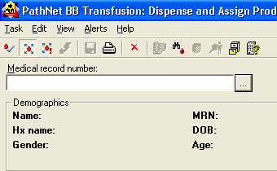

6.3.3 Enter/scan unit number to be emergently released

6.3.4 You will get the following message:

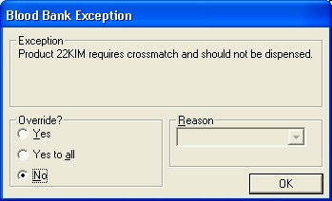

6.3.5 Click “Yes to All” and select an appropriate reason from the drop down choices

6.3.6 A second warning box will warn of unmatched group and type. Repeat step 6.3.5

6.3.7 Click “Save”

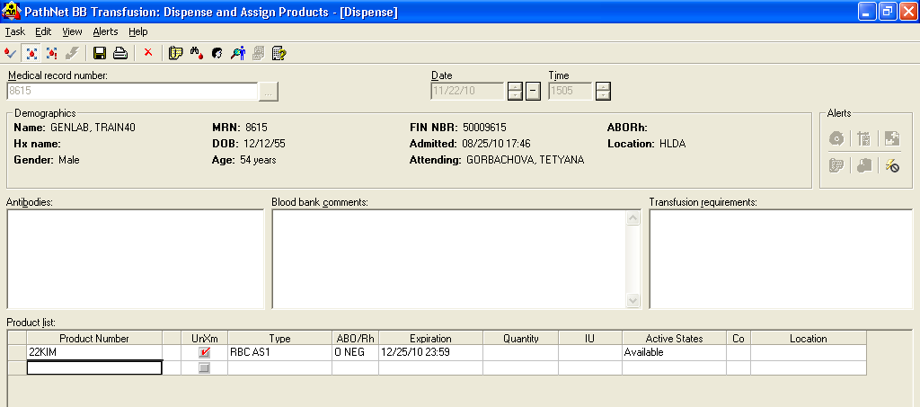

6.3.8 A “Save” box populates
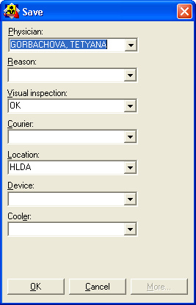
6.3.9 Fill out “Reason” and “Courier”

6.4.0 Click “OK”

6.4.1 A transfusion tag will generate

6.4 Remove one (1) segment from each unit and place them in a tube labeled with the donor number.

6.5 Issue the units as directed by the Issue, Return and Reissue of Blood and Blood Components procedure (BB08-002).

6.6 Receive specimen as directed by the Specimen Receipt and Accession
procedure (BB005-008).

6.6.1 Immediately perform a forward ABO/Rh type on the patient sample before centrifugation.

6.6.2 A complete ABO/Rh type will be performed following centrifugation.

6.7 Exchange non-transfused non-ABO/Rh specific units with ABO/Rh specific or compatible units as soon as the patient’s ABO/Rh type is determined AND CONFIRMED.

6.7.1 Red cells given according to the following chart:

Patient Type | 1st Choice | 2nd Choice | 3rd Choice | 4th Choice
O | O | No other choices are appropriate
A | A | O | No other choices are appropriate
B | B | O | No other choices are appropriate
AB | AB | A | O | B

6.7.2 In the event that Massive Transfusion is indicated, Rh negative patients not demonstrating Anti-D may be given Rh positive units until the patient is stabilized. *NOTE: For females <50 years old notify MEDICAL DIRECTOR/DESIGNEE FOR APPROVAL. Document approval in Patient Product Inquiry in comments.

6.8 Perform required testing:

6.8.1 Perform all appropriate pre-transfusion testing: ABO/Rh type, Antibody Screen, (Antibody Identification as applicable) Routine Crossmatch as directed by the procedures specific to the tests performed.

    - Compatibility of issued blood must be determined immediately.

    - The transfusion service medical director and the recipient’s physician shall be notified immediately of abnormal test results that may affect patient safety.

6.9 “BB08-006 Form B”: Emergency Request for Blood” will accompany the units to be signed by the Physician.

7.0 Interpretation

Test results are interpreted as directed by the procedure specific to the test performed.

8.0 Reporting Results

Test results and interpretations are reported as directed by the procedure specific to the test performed.

- Procedure Notes

  - Remember to keep the physician aware of progress of any product that may take a while to prepare. This includes all plasma orders.

  - ABO /Rh specific blood must be given as soon as possible.

10.0 Limitations of the Procedure

  - Minimum inventory levels must be maintained at all times.

10.2 After a patient has received large quantities of RBCs they should be monitored for possible coagulopathies

11.0 References

  - Roback, John D., ed. Technical Manual, 18th ed. Bethesda, MD: American Association of Blood banks, 2014
11.2 Standards for Blood Banks and transfusion Services, 30th ed. Bethesda, MD: American Association of Blood Banks, 2016

12.0 Records

12.1 The “Emergency Request for Blood” BB08-006 FORM B must be signed by a physician and returned within 24 hours of event to the Blood Bank. This document is retained by the Blood Bank for a minimum of ten years. If signature is illegible, please clearly print the doctor’s name on the Form.

12.2 Test records are retained as directed by the procedure specific to the test performed.

  - Blood and Blood component final disposition records are retained indefinitely.

13.0 Attachments/Appendix/Forms/Documents

  - Attachment 1: Blood Bank Transfusion Record Tag
13.2 BB08-006 FORM B: Emergency Request for Blood

Approval Signatures:

Date | Printed Name | Signature
3/8/16 | Pettina Walton  Blood Bank Supervisor
3/8/16 | Vanessa Rawlings  Laboratory Supervisor Elkins Park
3/8/16 | Manjula Balasubramanian, MD  Section Director, Blood Bank
3/8/16 | Nancy A. Young, MD  Medical Director

History Review

Date Reviewed | Reviewed By | Revisions

