PRINCIPLE

The Laboratory Director, in collaboration with the section directors of each laboratory and in conjunction with the wishes of the Medical Staff, develops the criteria and communication policy for the notification of a physician or other clinical personnel responsible for patient care when results of certain tests fall within established “Critical” ranges in the clinical laboratory or are non-numerical immediately life threatening results in the clinical laboratory or urgent results in Anatomic Pathology. In addition, criteria and a communication policy is established for courtesy communication in the Anatomic and Clinical Pathology laboratories for the unexpected clinically significant findings that are not immediately life- threatening.

Critical Values in Clinical Pathology

1. Definition: Critical values in Clinical Pathology are unexpected results that may indicate an immediate life-threatening situation.

2. Critical Values List: See Critical Values List attached for Clinical Pathology (Attachment A)

3. Procedure: Critical Values for the Clinical Pathology are handled as follows:

Immediately upon the confirmation of a critical value, the laboratorian will:

- For in-patients, the nursing unit is called by laboratory personnel for critical clinical laboratory results. The result is given to a licensed caregiver. The individual receiving the result is asked to read back the result to ensure correctness. The first initial and last name of the individual receiving the result and the time of receipt and read-back are documented in the Laboratory Information System (LIS). If nursing cannot be readily contacted, the laboratorian will invoke the Hospital Escalation Policy (Attachment B2).

b. For out-patients, laboratory personnel call the critical value to a licensed health care provider in either the outpatient clinic or private physician office where the patient was seen. The licensed caregiver receiving laboratory results is asked to read back the result to ensure correctness. The first initial and last name of the individual receiving the result, along with the time of receipt and read-back, is documented in the LIS. After the above steps, if the licensed health care provider still cannot be readily contacted, the laboratorian will invoke the Hospital Escalation Policy. (Attachment B2)

- For outpatients when the office is Closed:
- If patient is being followed by an Einstein clinic, call the operator to connect you to the on-call provider for that service. For certain clinics or service lines such as kidney and liver transplant, you will be directed to another answering service that is specially trained to field calls for their specific patient population. You may call these answering services directly or the on call coordinator of that service rather than going through the operator.

- If patient is seen in an Einstein private physician office (for example a practice in the Klein Building), call the operator to connect you to the on call physician for that practice.
- If patient is seen in a Non-Einstein private physician office (an outside physician) call the operator who can help you locate the physician’s office number/answering service.

After the above steps, if the physician still cannot be readily contacted within a reasonable time frame (i.e. 2-3 attempts within an hour), the laboratorian will invoke the Hospital Escalation Policy. (Attachment B2)

d. For recently discharged patients, the laboratory personnel calls the hospital operator and requests that the resident-on-call for the service of the patient’s attending be paged. The licensed caregiver receiving the result is asked to read back the result to ensure correctness. The first initial and last name of the individual receiving the result and the time of receipt and read-back are documented in the Laboratory Information System (LIS). If the physician does not return the page, the laboratorian invokes the Hospital Escalation Policy (Attachment B2)
- For Einstein Philadelphia Emergency Department Patients call all critical laboratory results to the Emergency Room Attending Physician (****Beeper #2-2720 Monday through Friday 8:30 am to 4:30 pm only***) or calling the Resident in POD A, B, C or D (X6666) or by dialing the VOCERA system at ext. 61799. Speak into the phone clearly and normally by stating the physician’s name or enter the physician’s ext. (see attached list). Give to the physician the patient’s full name and identifier (DOB and/or medical record number) along with the reported result. The physician taking the result must read back the result, the patient’s full name, and the patient’s identifier (DOB and/or medical record number) to verify the clerical accuracy of the report.
- For results on discharged ED patients on off hours call all critical laboratory results to X6666 and ask for the C Pod attending (not resident) first followed by the A Pod attending (not resident) if the Pod C attending is unavailable.
f. Elkins Park Emergency Department critical results are called to 6091(81-6091 if calling from EMCP) and given to the physician or other licensed caregiver on duty.

IMPORTANT!
When communicating any patient information, 2 forms of identification MUST always be used.

NOTE:
- DO NOT LEAVE MESSAGES PERTAINING TO CRITICAL VALUES OR SPURIOUS RESULTS ON VOCERA OR VOICEMAIL
- UPON CALLING A CRITICAL VALUE AND YOU ARE TOLD A PATIENT HAS EXPIRED CONTINUE TO FOLLOW THE “READ BACK” PROCEDURE: The first initial and last name of the individual receiving the result and the time of receipt and read-back are documented in the Laboratory Information System (LIS). If the caregiver does not take the result contact the nurse manager

URGENT “CRITICAL” Diagnoses in Anatomic Pathology
1. Definition: The Pathology department has developed a list of morphologic findings and or diagnoses to be considered immediately life threatening and therefore of urgent or “critical” quality. Since there are no well-defined guidelines in the literature, it is neither an all inclusive nor an exclusive list. It is inspired by the document of the Associations of Directors of Anatomic and Surgical Pathology services (1) and aims to meet the need of our Institution. See Critical Diagnoses List in Anatomic Pathology (Attachment D).

2. Procedure: Urgent or “critical” diagnoses need to be communicated to the physician (or other licensed care provider) in a timely manner no later than 24 hours after concluded. Common sense, the personal experience and judgment of the pathologist determine when an immediate contact of the physician is needed; in such cases, there will be verification that the critical diagnosis has been received and acknowledged by the physician by written documentation with the date and time. Note: Consultative dialogue between a pathologist and the patient’s physician does not require a read-back.

If the primary physician is not reachable follow the Algorithm below:
- OB/GYN—On call OB/GYN Resident (#2-4963) or ( #2-GYNE). Send an FYI e-mail to Dr. Jaspan as well (jaspanD@einstein.edu)
- Surgery- On call Surgical Chief Resident through the operator
- Medicine and related subspecialties- Through the operator:
- First try to reach the physician on call for that practice/service.
- Second choice is to reach the on-call fellow covering the applicable subspecialty service.
- Last resort is to reach the Administrative Chief Resident on call for Medicine.

UNEXPECTED CLINICALLY SIGNIFICANT FINDINGS IN CLINICAL AND ANATOMIC PATHOLOGY

Unexpected clinically significant findings that are vital but not urgent or immediately life threatening are to be communicated directly by the Pathologist to the clinician as a courtesy. The goal in anatomic pathology is to ensure that the clinician knows about the results in a reasonable time period according to the clinical context, but there is not the urgency or issue of immediacy that there is with a critical diagnosis. In clinical pathology, the call to the clinician must be made by the end of the shift. See Attachment E1 for the list of diagnoses that require a courtesy communication.

IMPORTANT!
When communicating any patient information, 2 forms of identification MUST always be used.

NOTE: DO NOT LEAVE MESSAGES PERTAINING TO CRITICAL VALUES OR SPURIOUS RESULTS ON VOCERA OR VOICEMAIL

Reference

“Consensus statement on effective communication of urgent diagnoses and significant, unexpected diagnoses in surgical pathology and cytopathology from the College of American Pathologists and Association of Directors of Anatomic and Surgical Pathology.” Arch Pathol Lab Med. Vol 136, February 2012.
Nakhleh RE, Myers JL, Allen TC, DeYoung BR, Fitzgibbons PL, Funkhouser WK,
Mody DR, Lynn A, Fatheree LA, Smith AT, Lal A, Silverman JF.

Approval Signatures:

Date | Print Name | Signature
2/29/2016 | Jaclene Kokoszka  QA Manager
2/29/2016 | Nancy A. Young, M.D.  Medical Director

History Review

Date: | Reviewed by: | Revisions:
 |  | .

Attachment A
Numerical Critical Values Clinical Pathology

Blood Tests | Critical Low | Critical High | Comments
Acetaminophen |  | >=50 mcg/mL
Alcohol |  | >=400 mg/dL
Calcium | <=6.0 mg/dL | >=12.0 mg/dL
CO2 | <=10mmol/L | >=40 mmol/L
Cyclosporine |  | >=300 ng/mL
Digoxin |  | >=2.5 ng/mL
FK506 |  | >=20.0 ng/mL
Gentamycin Peak and Random |  | >=12.8mcg/mL
Gentamycin Trough |  | >=2.0 mcg/mL
Glucose | <=40 mg/dL  <=30 mg/dL | >=500 mg/dL  >=300 mg/dL | <31 days old
Hgb | <=6.0 g/dL  <=8.0 g/dL | >=20.0 g/dL | Adult  <31 days old
Ionized Calcium | <=0.78 mmol/L | >= 1.58 mmol/L
Lithium |  | >=1.5 mmol/L
Magnesium | <=1.0 mg/dL | >= 4.3 mg/dL  >=8.0 mg/dL | Non L&D patient  L&D patient
Neonatal Bilirubin |  | >=15.0 mg/dL
Osmolality, serum | <=250mosm/kg | >=335 mosm/kg
Phenobarbitol |  | >=40 mcg/mL
Phenytoin |  | >=27 mcg/mL
Phosphorous | <=1.0 mg/dL  <=1.0 mg/dL | >=9 mg/dL | Adult  Peds (0-18 years old)
Platelet | <=20 X 10^3  <=50 X 10^3 | >= 900 X 10^3  >=900 X 10^3 | Adult  <31 days old
Potassium, serum | <=2.8 mmol/L | >=6.5 mmol/L
Potassium, plasma | <=2.7 mmol/L | >=6.0 mmol/L
PT INR |  | >=5.0
Salicylate |  | >=40 mg/dL
Sodium | <=120 mmol/L | >=155 mmol/L
T4 Total |  | >=19.0 mcg/dL
Tegretol |  | >=12.0 mg/L
Theophylline |  | >=20.0 mcg/mL  >=11.0 mcg/mL | <=31 days old
Tobramycin Peak and Random |  | >=12.0 mg/L
Tobramycin Trough |  | >=2.0 mg/L
Valproic Acid |  | >=150 mcg/mL
Vancomycin Peak and Random |  | >=50.0 mcg/mL
Vancomycin Trough |  | >=30.0 mcg/mL
WBC | <= 2.0 X 10^3 | >=100.0 X 10^3

Attachment B2

Escalation Algorithm
(when Lab cannot reach ordering physician or a licensed health care provider with critical results)
ESCALATION POLICY
INPATIENT FLOW OUTPATIENT FLOW
REFER TO UPDATED HOSPITAL PHONE LIST FOR OUTPATIENT AFTER HOURS ON CALL CONTACTS

CALL HOSPITAL OPERATOR FOR NURSING SUPERVISOR BEEPER NUMBER

Technologist acquires test result, patient name and home phone number, ordering physician name and phone number, and patient MR# from LIS.

CALL NURSING OFFICE X6075

Tech contacts the Pathologist on call after a reasonable attempt (i.e. 2-3 tries within an hour time frame) to contact the licensed caregiver. Tech documents all attempts to contact physician in the LIS.

CALL RESIDENT ON CALL

The on call pathologist will make one attempt to contact the ordering physician and if unsuccessful will then contact the patient directly, inform them of the critical value, and suggest, if appropriate, that they go to the emergency department for treatment.

CALL
SUPERVISOR/MANAGER/
ADMINISTRATIVE DIRECTOR OF LAB DEPARTMENT

If patient cannot be reached directly, a message will be left on the patient’s home answering machine by Pathologist requesting a call back without mentioning any confidential clinical information.

ADMINISTRATIVE LAB DIRECTOR OR LAB SUPERVISOR TO CALL HOSPITAL ADMINISTRATOR ON CALL
with patient demographics (patient name, MR#, unit) if ordering physician, physician on call, floor nurse or nursing supervisor cannot be reached
(Off Hours & Weekends Only)

The Pathologist on call will contact the tech to document the attempts to contact the patient and the physician as a non-chartable comment in the LIS.

Regardless of whether or not the patient was spoken to directly (or a message was left on an answering machine) the pathologist on call will contact the ordering physician in the early morning hours of the following day and apprise them of the situation.

Pathologist to follow up with the Department Chair in an email explaining the difficulty in contacting the physician. The pathologist will provide Chair with the critical result along with the patient’s information.

Screen shots for obtaining patient information in Powerchart to provide the Pathologist:

Open the Chart menu and select Patient Information

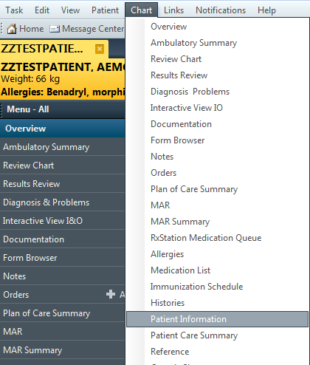

The following window will appear

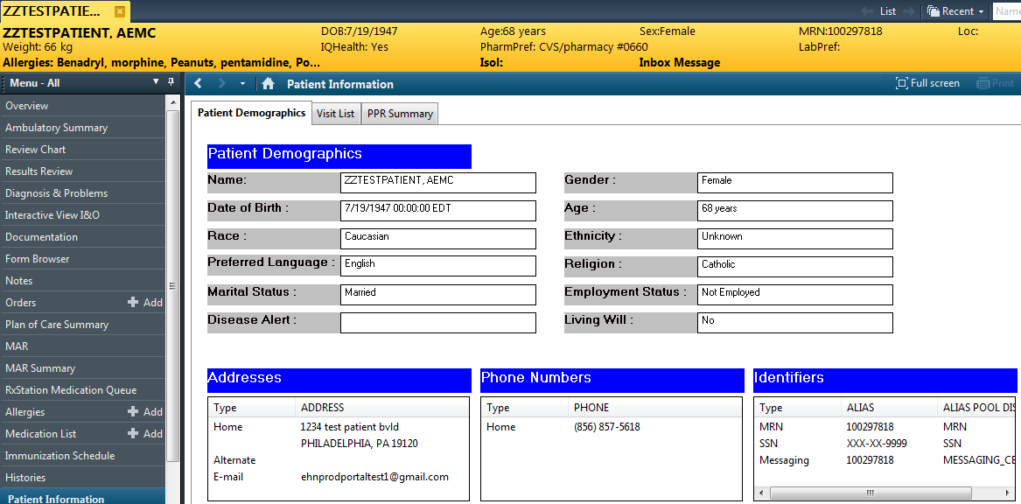

Attachment C1
Non-Numerical Critical Results Clinical Pathology
MICROBIOLOGY
Positive Blood Culture
Positive CSF gram stain, Culture
Positive Intrapartum Rapid GBS by PCR
Positive molds from surgical and/or IR Cultures

HEMATOLOGY
Blood Parasite-Any
Blasts-first time event
BLOOD BANK
Positive Bacterial Testing results on platelet unit
Positive Direct Coombs test on cord blood work-up
Positive Transfusion Reaction work-up
Hemolysis noted in post transfusion sample while clear in pre-transfusion sample
Positive DAT in post transfusion sample while pre-transfusion sample was negative
Blood Issuing Error (wrong patient/ wrong unit)
CHEMISTRY
Positive HIV 1/2 antibody (ONLY for lifter and Labor and delivery areas)

Attachment D
Anatomic Pathology Urgent (“Critical”) Diagnoses

1. Cases with immediate clinical consequence:
- Crescents in >50% of glomeruli in a kidney biopsy specimen
- Leukocytoclastic vasculitis
- Uterine contents without villi or trophoblasts
- Fat in endometrial curettage specimen
- Mesothelial cells in a heart biopsy specimen
- Fat in colonic endoscopic polypectomy specimens
- Transplant rejection
- Malignancy in superior vena cava syndrome
- Neoplasms causing paralysis
- Significant disagreement between FS and final diagnosis or on site adequacy reading and final cytologic diagnosis when there are immediate treatment implications (i.e. change in diagnosis for patient to be treated for SVC syndrome)

2. Infections with immediate clinical consequence:
- Bacteria or fungi in CSF cytology in immunocompromised or immunocompetent patients
- PCP, fungi or viral cytopathic changes in BAL, bronchial washings or brushing cytology specimens in immunocompromised or immunocompetent patients
- AFB in immunocompromised or immunocompetent patients
- Fungi in FNA specimens of immunocompromised or immunocompetent patients
- Bacteria in heart valves or bone marrow
- Any invasive organism in surgical pathology specimens of immunocompromised patients

Attachment E1

COURTESY COMMUNICATION

Courtesy Communications FOR SignIficant, UNEXPECTED DIAGNOSES IN Anatomic Pathology

Clinically significant unexpected or discrepant findings that are vital but not immediately life threatening are to be communicated directly to the clinician as a courtesy. The goal is to ensure that the clinician knows about the results in a reasonable time period according to the clinical context, but there is not the urgency or issue of immediacy that there is with a critical diagnosis. Courtesy communications are made for the following Unexpected or discrepant findings:

- Significant disagreement between FS and final diagnosis when there are no immediate treatment implications
- Unexpected malignancy (e.g., malignancy in hernia sac, intervertebral disc, tonsil, etc.)
- Significant disagreement and/or change between diagnoses of primary pathologist and outside pathologist consultation (at the original or consulting institution)

Courtesy Communication in Clinical Pathology

Certain clinically significant but not immediately life-threatening findings in clinical pathology are called as a courtesy at the end of the shift during which testing was performed. The following is a list of findings called to the caregiver as a courtesy.

- Enteric Pathogens Salmonella, Shigella, E. coli 0157, Vibrio, Campylobacter, Yersinia when isolated from culture
- Positive Acid-fast stain or culture identification ( when reported by send-out lab)
Note: Positive acid-fast stain done in-house, positive culture done in-house, identification from reference lab
- Positive Cryptococcal antigen
- Positive FTA or reactive RPR on babies or pregnant women
- Positive Legionella pneumophila antigen
- Positive Streptococcus pneumoniae antigen
- Positive RSV screen (Respiratory Syncytial virus antigen)
- Positive screening test for influenza A/ or influenza B viral antigen
- Positive C. difficile toxin assay by EIA or PCR
- Positive stain or culture from normally sterile body fluid
- Positive Hepatitis C antibody

