## PURPOSE

To detect the presence of parasites circulating in the bloodstream of individuals who present signs and symptoms for infection.

## PRINCIPLE

Giemsa-stained thin and thick peripheral blood films are examined microscopically for the presence of the following parasites: *Plasmodium* spp., *Babesia* spp., trypanosomes, microfilariae, and agents of visceral leishmaniasis. If malaria is present, the patient’s blood is analyzed qualitatively using the BinaxNOW Malaria test.

**A.Malarial Parasites and Babesia spp:**

* 1. Whole blood, or unstained blood films, may be received in the laboratory for examination.
  2. Positive thin blood films allow speciation of *Plasmodium* and *Babesia*, but low parasitemia may be missed if only thin films are examined.
  3. Thick blood films are more sensitive than thin films for the detection of all blood parasites, because they allow the examination of a greater volume of blood per scope field.

**B. Trypanosomes, microfilaria and Leishmania spp.**

1. Examination of thin and thick blood films for trypanosomes is useful only during the acute invasive phase of infection. *T. cruzi* is often distorted in thick smears.
2. Thick films are useful for the detection and speciation of microfilariae. In thin films, microfilariae show up well, but may be missed due to the small blood volume. Concentration of the specimen may be necessary to detect microfilariae.
3. Microfilariae that migrate in the skin instead of in the blood, such as *Onchocerca volvulus*, are better diagnosed through skin snip biopsies.
4. Leishmaniasis is generally detected using Giemsa-stained impression smears (touch preparations) or cultures of skin punch biopsies or spleen tissue. *Leishmania amastigotes* are occasionally found within monocytes (i.e., *L. donovani*) in thin and thick films of buffy coat preparations of peripheral blood.

The BinaxNOW Malaria Test is an *in vitro* immunochromatographic assay for the qualitative detection of *Plasmodium* antigens circulating in human venous and capillary EDTA whole blood of individuals with signs and symptoms of malarial infection.

The test targets the histidine-rich protein II (HRPII) antigen specific to *Plasmodium falciparum* (P.f.) and a pan-malarial antigen, common to all four malaria species capable of infecting humans – *P. falciparum, P.* vivax (P.v.), *P.* ovale (P.o.), and *P. malariae* (P.m.). These antibodies, and a control antibody, are immobilized on a membrane support as three distinct lines and are combined with a sample pad, which is impregnated with visualizing particles conjugated to control and anti-malaria antibody. This test is intended to aid in the rapid diagnosis of human malaria infections and to aid in the differential diagnosis of *Plasmodium falciparum*infections from other less virulent malarial infections.

1. **SPECIMEN SPECIFICATIONS**

**A. Blood Films**

1. Collection Tubes:

* 1. EDTA-anticoagulated whole blood is the acceptable specimen.
  2. The EDTA tube must be filled to its vacuum capacity and transported immediately to the laboratory.
  3. Smears must be made within one hour of venipuncture. After this time, thick films may not adhere to the slide, and the intensity of Giemsa staining of malarial parasites (e.g., Shuffner’s Dots), decreases with the length of exposure to EDTA.
  4. **Request a NEW specimen from the ordering physician if smears were made more than one hour after venipuncture for EDTA-anticoagulated whole blood.**
  5. Citrate and heparin are not acceptable anticoagulants.

2. Timing of Specimen Collection:

a. Collect blood immediately upon the first suspicion of **malaria** (i.e., prepare blood films upon admission of the patient).

i. Collect blood samples before any antimalarial drugs are used.

ii. A fever pattern may not be apparent early in the course of the infection.

b. If needed for identification, collect additional specimens at various times during the day, e.g., every 6, 12, or 24 hours:

i. The optimum collection time is midway between chills, to obtain the developmental stages of the parasite, which are useful for identification purposes.

ii. Developmental stages of the parasite in peripheral blood are cyclic and may be present only intermittently.

3. For **other blood parasites**, note the following:

* 1. Trypanosome parasitemia is intermittent. Collect blood specimens as for malaria.

b. If filariasis is suspected, collect blood specimens when the parasite circulates in the peripheral blood. The timing coincides with the feeding time of the parasite's arthropod vector (see **Table 1** below):

**Table 1**

|  |  |  |
| --- | --- | --- |
| **Organism** | **Periodicity** | **Optimum collection time** |
| *Wuchereria bancrofti* | Nocturnal | 11 p.m. to 2 a.m. |
| *Brugia* *malayi* | Nocturnal | 11 p.m. to 2 a.m. |
| *Loa loa* | Diurnal | 11 a.m. to 2 p.m. |
| *Mansonella* spp. | None | Anytime |
| *Onchocerca* *volvulus* | None | *Do not collect blood.* Specimen of choice is skin snips. |

**4.** Worksheet:

Record all results on form **HEM30-007/HEM30-008/HEM30-010 Form A.**

**B. BinaxNOW**

1. Collection Tubes:

1. Becton Dickinson (B‑D) #367861 purple‑top tube containing 7.2 mg EDTA (K2). Approximate draw 4 ml
2. Becton Dickinson (B‑D) #365974 Microtainer, purple top, containing EDTA (K2). Approximate draw 250‑500 microliters, capillary collection.

2. Specimen Handling:

a. Ensure that all specimens are well mixed before sampling. Place tubes on rotary mixer for at least 5 minutes; mix Microtainer capillary specimens by hand, inverting at least 10 times.

b. Stability:

Whole blood specimens should be tested as soon as possible after collection. Stable refrigerated for 72 hours.

3. Worksheet:

Record all results on form **HEM30-007/HEM30-008/HEM30-010 Form A.**

1. **STANDARDS AND CONTROLS**

**A. Blood Smears:**

1. A premade positive blood parasite QC slide (ordered from Fisher Healthcare) is stained each time the procedure is performed. The staining reactions should be appropriate for the organisms described on the slide, i.e. malarial ring and trophozoite forms should exhibit a pink/reddish nucleus and blue cytoplasm.

2. A thin film from “normal” blood should also be stained as a negative control to evaluate the staining reactions of the RBCs, platelets, and WBCs:

* + 1. Macroscopically, blood films appear purplish. If blue, the buffered water was too alkaline; if pink to red, the buffered water was too acid.
    2. Microscopically, RBCs appear pinkish gray, platelets appear deep pink, and WBCs have purple-blue nuclei and lighter cytoplasm. Eosinophilic granules are bright purple-red, and neutrophilic granules are purple. Basophilic stippling within uninfected RBCs is blue.
    3. Slight variations may appear in the colors described above, depending on the batch of stain used and the character of the blood itself, but if the various morphological structures are distinct, the stain is satisfactory.

3. Document QC results on appropriate QC sheet (**HEM30-010 Form B**).

**B. BINAXNOW Test:**

**Warning: This test should only be used by laboratories that have or can acquire blood samples containing *Plasmodium falciparum* for use as a positive control. It is recommended that the level of the positive control used challenge the assay cutoff.**

1. Daily Quality Control:

1. The BinaxNOW Malaria Test has built-in procedural controls. For daily quality control, the manufacturer recommends that you record these controls for each test run.
2. The pink-to-purple line at the “C” (Control) position in a tested device can be considered an internal positive procedural control. This line will always appear if the sample flows and the reagents work.
3. The clearing of background color from the result window is a negative background control. The background color in the window should be light pink-to-white at 15 minutes. Background color should not hinder reading of the test.
4. Record all QC results on form **HEM30-010 Form C**.

**Note: If positive or negative control are not acceptable, repeat with new test and**

**record on QC sheet HEM30-010 Form C.**

2. External Positive and Negative Controls

1. In accordance with CAP and CLIA guidelines Positive and Negative controls will be run each day of patient testing to assure:

* Test reagents are working
* The test is being performed correctly

1. For a negative control, a pool of 3-5 EDTA whole blood samples from presumed

Malaria-negative individuals can be used.

1. For a positive control, an aliquot of the frozen BinaxNOW positive control kit should be used.
2. Record daily QC results on form **HEM30-010 Form D**.
3. **BINAXNOW REAGENTS**
4. The BinaxNOW Malaria Test Kit and reagents are stable until the expiration dates marked on their outer packaging and containers when stored as specified:

1. Storage:

Store at room temperature.

2. Preparation:

No preparation required.

3. Stability:

Through dating period.

4. Precautions:

1. Do not use kit past its expiration date.
2. Do not mix components from different kit lots.
3. Patient samples and test devices should be handled as though they are capable of transmitting disease.
4. Reagent A contains sodium azide as a preservative. Sodium azide is toxic and should be handled carefully, avoiding ingestion or skin contact.
5. **EQUIPMENT AND MATERIALS**

**A. Blood Film Equipment:**

1.Microbiologics Blood Parasite Control Slide

2. Microscope, oil immersion lens

3. Cell Tabulator

4. Wescor Aerospray Hematology Slide Stainer/ Cytocentrifuge

1. **BinaxNOW Equipment:**

Timer

**C. Materials:**

1. Plastic tube with cap

2. Transfer pipette tubes

3. Glass slides

4. Immersion oil

5. Applicator sticks

6. Blood stain – Azure B type – To prepare fresh staining solution, mix 1 mL of Giemsa stain with 19 mL(1:20 dilution is optimum) of buffered water.

7. Buffered Water pH 6.8-7.2 (checks pH of buffered water with pH strips and document on QC form **HEM30-010 Form B**)

**VII. BLOOD FILM PROCEDURE**

A. Label ten slides with the patient’s name using a pencil (do not use markers or wax pencils).

B. **Prepare five thick blood films**.

1. Place 2 or 3 drops (each 10 microliters) of blood in the center of a microscope slide.

2. Spread blood into a circle about the size of a dime (use pipette tip, or applicator stick).

The objective is to have one smooth, homogenous circle several cells thick in the middle, and slightly thinner at the edges. **Printed material on paper should be just discernible (visible) through the film.**

3.Allow the slide to air dry in a horizontal position for 45 minutes.

4. Do not fix thick films in methanol, or expose to any heat source or incubation.

C. **Prepare 5 thin blood films**.

1. Place one drop of blood near the end of a microscope slide.

2. Hold a "spreader" slide at a 45 degree angle to the drop and back the spreader slide into the drop.

3. Move the spreader slide along the specimen slide, pulling the drop of blood along behind it (objective is to have a large area of the smear one cell thick).

4. Air-dry slides (slides will dry in a few minutes).

5. Store original EDTA tube in the specimen rack. Once blood films have been made, the original EDTA tube can be discarded after 24 hours.

6. Off hours (after 5pm weekdays and weekends), the hematology technologists will stain 1 thin film using the Wescor Aerospray Hematology Slide Stainer **and review the slide for presence or absence of parasites.**

7. During routine hours, stain 4 slides (2 thin films, 2 thick films) with the Wescor Aerospray Hematology Slide Stainer and the Giemsa Stain (thick).

a. Thin Blood Films:

* Stain the slides using the Wescor Aerospray Hematology Slide Stainer:
* Allow slides to air-dry in vertical position.

b. Thick Blood Films:

* + - Stain the slides in a 1:20 Giemsa stain dilution for 45 minutes.
      * Wash slides briefly in buffered water for 3-5 minutes. (Lack of methanol fixation for the thick slides allows lysis of red cells by aqueous solution.
    - Allow slides to air dry in vertical position.

8. Examine the stained slides (refer to section IX below, “Identification”).

D. Buffy Coat Preparation (for visceral leishmaniasis, trypanosomes, microfilaria, and *Histoplasma*)

1. Obtain buffy coat preparation using centrifuged (100 X g for 30 min), whole blood containing EDTA anticoagulant (Wintrobe tube). After centrifugation, the tube will contain 3 layers: plasma on top, a layer of white cells (buffy coat), and RBCs on the bottom.
2. Using a pipette, remove the plasma. Obtain 1 drop of buffy coat layer, and mix with 5 drops of saline on a glass slide and add coverslip. Examine under low power (10X), for motile trypanosomes, microfilaria, etc. Using additional buffy coat, prepare 5 thin smears as described in step 4 above.

# VIII. PARASITE IDENTIFICATION

A. Examine all blood films microscopically under low power (10X) first to detect microfilaria (dual malarial and microfilarial infections are rare but possible).

B. Examine 100 oil immersion fields before each blood film (thin or thick) is considered negative.

C. Increase the number of oil immersion fields examined if the patient received prophylactic medication within 48 h of specimen collection (i.e., the number of infected cells may be decreased).

D. Quantitate organisms from every positive blood specimen and note quantity in the LIS work-up.

1. Using the thin smear, if parasitemia appears high, examine 2 high power fields where RBCs completely fill the field, but are not stacked upon one another (about 600 cells), and report the number of infected RBCs as a percentage:

**%** **parasitemia** = (parasitized RBCs observed / 600 total RBCs counted) × 100

2. If Parasitemia appears low, examine 7 high power fields where RBCs fill the field, but are not stacked upon one another (about 2100 cells), and report the number of infected RBCs as a percentage:

**%** **Parasitemia** = (parasitized RBCs observed / 2100 total RBCs counted) × 100

3. Regardless of the number of fields examined, count asexual blood stage parasites and gametocytes separately. Only asexual blood stages are used in the parasitemia calculation above.

E. Refer to **Table 2**, and **Figures 1 & 2** to assist in identification and speciation of malaria and *Babesia.*.

F. No morphologic stages other than ring forms will be seen in *Babesia* infection. The classic arrangement of 4 rings (Maltese Cross) is not always seen. Most cases of infection have had a low level parasitemia.

**IX. REPORTING RESULTS**

***NOTE: ALL POSITIVE BLOOD FILMS ARE TO BE SENT TO THE CDC FOR COMFIRMATION (SEE PROCEDURE HEM30-011).***

A. Enter a PRESUMPTIVE result based on what is observed in the thin and thick blood films. The following phrases could be used as example.

|  |
| --- |
| **Report** |
| No malarial parasites seen. One negative malaria smear does not rule out malaria infection. |
| *Plasmodium* spp., unable to speciate.  Parasitemia is X% (where X is the quantity) |
| *Plasmodium* spp. consistent with “Y”. Parasitemia is “X”% (where Y is one of the four *Plasmodium* species and where X is the quantity). |
| *Babesia* spp. identified. Microfilalria identified. *Trypanososma* spp. identified. |

B. Record Positive or Negative for parasites on Parasite Worksheet **HEM30-007/HEM30-**

**008/HEM30-010 Form A.** If positive, record ID or possible ID on form next to positive box.

**X. PROCEDURE NOTES**

1. Disposal of materials: Discard materials into the appropriate sharps and/or biohazard containers as needed.
2. Slides must be scrupulously clean if thick smears are to adhere to the slide. Pre-clean slides with alcohol and dry with Kimwipes if slides seem to have oil film, fingerprints, etc.
3. Protect slides from dust while drying. Store stained slides in a slide box.
4. Prolonged storage of slides before staining may give erratic stain results.

**XI. LIMITATIONS OF PROCEDURE**

1. If smears are prepared from anticoagulated blood that is more than 1 hour old, morphology of both parasites and red blood cells may be atypical.
2. Wright‑Giemsa, or Giemsa stains can be used, but Giemsa is the stain of choice.
3. Parasitemia in light infections may be too low to be detected in thin films.
4. Parasite morphology is often distorted in thick films.
5. Malarial parasites may be missed with the use of hematology automated differential instruments. Even with tech­nologist review of the smears, a light parasitemia is likely to be missed.
6. The number of oil immersion fields examined may have to be increased if the patient has had any pro­phylactic medication during the past 48 h (the num­ber of infected cells may be decreased).
7. One negative set of blood smears does not rule out malaria, *Babesia*, or other blood parasites.

**XII. BINAXNOW TEST PROCEDURE**

***NOTE: (ONLY PROCEED IF BLOOD SMEAR POSITIVE FOR MALARIA)***

**A. Slowly** add 15 mL of blood from an EDTA tube (or from an EDTA capillary tube) to the purple sample pad (See Figure 1 A and B), on test device.

**IMPORTANT**:  **Incorrect addition of sample may lead to an invalid or un- interpretable test.**

B. Hold the Reagent A bottle vertically and add two free-falling drops of Reagent A to the white pad immediately below the purple sample pad. Allow the first drop to absorb into the pad before adding the second drop. See Figure 1A on test device.

C. Allow the blood sample to run up the full length of the test strip. See Figure 3 on test device. **Note:** If blood flow up the test strip appears to stall or is less than halfway up the strip after one minute, add one additional drop of Reagent to the white pad at the bottom of the test strip.

D. Just before the blood sample reaches the base of the white pad at the top of the test strip, **SLOWLY** add four free-falling drops of Reagent A to the wash pad on the top left-hand side of the device (See Figure 1 B) on test device.

E. When the sample just reaches the base of the absorbant pad at the top of the test strip, remove the adhesive liner from the right edge of the device, and close the device. Press firmly along the entire edge to the right of the result window. See Figure 5 on test device.

F. Read the test result 15 minutes **after closing the test device**.

G. Record all results on form **HEM30-007/HEM30-008/HEM30-010 Form A.**

**XIII. RESULT INTERPRETATION**

1. T1 positive: Positive result for *P. falciparum*.
2. T2 positive: Positive result for *P. vivax* (P.v.) or *P. malariae* (P.m.), or *P. ovale* (P.o.). In some cases the appearance of only the T2 Line may indicate a mixed infection with two or more of P.v., P.m., and P.o.
3. T1 & T2 positive: Positive result for *P. falciparum* (P.f.). In some cases the appearance of both the T1 and T2 Lines may indicate a mixed infection of P.f. with another species.
4. No T1 or T2 lines: Negative result (no malaria antigens were detected).
5. Invalid and/or uninterruptable test results: The test is invalid if the Control (C) Line does not appear, whether a Test Line(s) is present or not, or if the background color hinders reading of the test result at 15 minutes.

## XIV. REPORTING OF RESULTS

|  |  |
| --- | --- |
| **Result** | **Suggested Report** |
| T1 Positive | Positive for *P. falciparum* protein antigen only |
| T2 Positive | Positive for malaria protein antigen, representing *P. vivax* or *P. malariae* or *P. ovale* or a mix of these. Differentiation of the species is not possible. |
| T1 & T2 Positive | Positive for *P. falciparum* protein antigen. In some cases this may represent a mix of *P. falciparum* antigen with P*. vivax, P. malariae*, or *P. ovale* antigen. Differentiation between malaria species is not possible with this test. Microscopy must be performed to make this determination. |
| Negative | Presumptive negative for malaria antigens. Infection due to malaria cannot be ruled out. |

**XV. LIMITATIONS OF PROCEDURE**

1. This procedure does not apply to Elkins Park campus.
2. A negative test does not exclude infection with malaria, particularly at low levels of parasitemia. Therefore; the results obtained with the BinaxNOW® Malaria Test should be used in conjunction with other laboratory and clinical findings to make an accurate diagnosis.
3. Samples with positive rheumatoid factor (Rf) titers may produce false positive results. Rheumatoid factors are autoantibodies, and positive Rf titers are associated with acute auto-immune disorders as well as chronic viral infections and parasitic infections.

**XVI. REFERENCES**

1. Inverness Medical [package insert]. BinaxNOW Malaria Test Kit. Binax Inc., Scarborough, ME; 2009.
2. Kottke-Marchant, K and Davis, B., 2012, *Laboratory Hematology Practice,* Wiley-Blackwell Publishing, Chichester, West Sussex, UK, p. 626-635.

3. Garcia, Lynne S., 2001. *Diagnostic Medical Parasitology*. 4th Edition. ASM Press, Washington, D.C.

Table 2. Identification and Speciation of Malaria and Parasites.

|  |  |  |  |  |
| --- | --- | --- | --- | --- |
| **Characteristic** | ***Plasmodium vivax*** | ***Plasmodium ovale*** | ***Plasmodium falciparum*** | *Plasmodium malariae* |
| Main criteria | Large pale RBC.  **Trophozoites are irregular (amoeboid).**  **Pigment is usually present.**  *Schuffner's dots* (stippling)are *not* always present.  *Several phases of growth are seen in one smear.*  Gametocytes appear as early as 3rd day. | Large pale RBC, oval shape with fimbriated edges.  *Schuffner's dots*  *seen in all stages*.  Gametocytes appear after  4 days or as late as 18 days. | RBC normal in size and color.  Delicate ring forms and crescent-shaped gametocytes are *only* forms normally seen.  No stippling of RBCs.  Gametocytes appear after  7-10 days. | RBC normal in size and color.  Trophozoites compact, stain  intensely. Band forms not always seen. Coarse pigment.  No stippling of RBCs.  Gametocytes appear after  a few weeks. |
| Size and shape of  parasitized RBCs | 1.5 - 2 times larger than normal.  Oval to normal shape.  May be normal size until ring fills 1/2 of cell. | 60% of cells larger than  normal and oval.  20% have irregular, frayed edges. | Both normal. | Normal shape.  Size may be normal  or slightly smaller. |
| Color of cytoplasm | Decolorized, pale | Decolorized, pale | Normal, bluish tinge at times | Normal |
| Multiple rings/cell | Occasional | Occasional | Common | Rare |
| Developmental stages  present in peripheral  blood | All | All | Young ring forms and no older  stages; few gametocytes. | Ring forms few, as ring stage is brief.  Mostly growing and mature  trophozoites and schizonts |
| Appearance of parasite  and young trophozoite  (early ring form) | Ring is 1/3 diameter of cell.  Heavy chromatin dot.  Cytoplasmic circle around vacuole. | Ring larger and more ameboid than in *P. vivax*,  Otherwise similar to  *P. vivax.* | Delicate, small ring with small chromatin dot (frequently 2 rings). May have multiple rings per cell. Sometimes ring is at edge of red cell (applique form) or is slender and filamentous in form. Scanty cytoplasm around small vacuoles | Ring often smaller than in *P. vivax,* occupying 1/8 of cell;.  Heavy chromatin dot.  Vacuole at times filled in.  Pigment forms early. |
| Mature trophozoite | Irregular ameboid mass.  One or more small vacuoles retained until schizont stage; fills almost entire cell; fine brown pigment. | Compact; vacuoles  disappear; pigment dark  brown, less so than in  *P. malariae.* | Not seen in peripheral blood (except in severe infections).  Development of all phases following ring form occurs in capillaries of viscera. | Vacuoles disappear early.  Cytoplasm compact, oval, band shaped, or nearly round, almost filling cell; chromatin may be hidden by peripheral coarse dark brown pigment. |
| Schizont (presegmenter) | Progressive chromatin division.  Cytoplastic bands containing  clumps of brown pigment. | Smaller and more compact than in *P. vivax* | Not seen in peripheral blood (see above). | Similar to *P. vivax* schizont except smaller; darker, larger pigment granules peripheral or central. |
| Mature schizont | Merozoites average 16  in number (range 12-24);  each with chromatin and cytoplasm, filling entire RBC, which can hardly be seen. | 75% of cells occupied by  8 (8-12) merozoites in  rosettes or irregular  clusters. | Not seen in peripheral blood. | Merozoites average 8  in number (range 6-12) and are difficult to see individually;  form rosettes or irregular clusters filling normal-size cells; central arrangement of brown-green pigment. |

**Figure 1. Malaria Species**

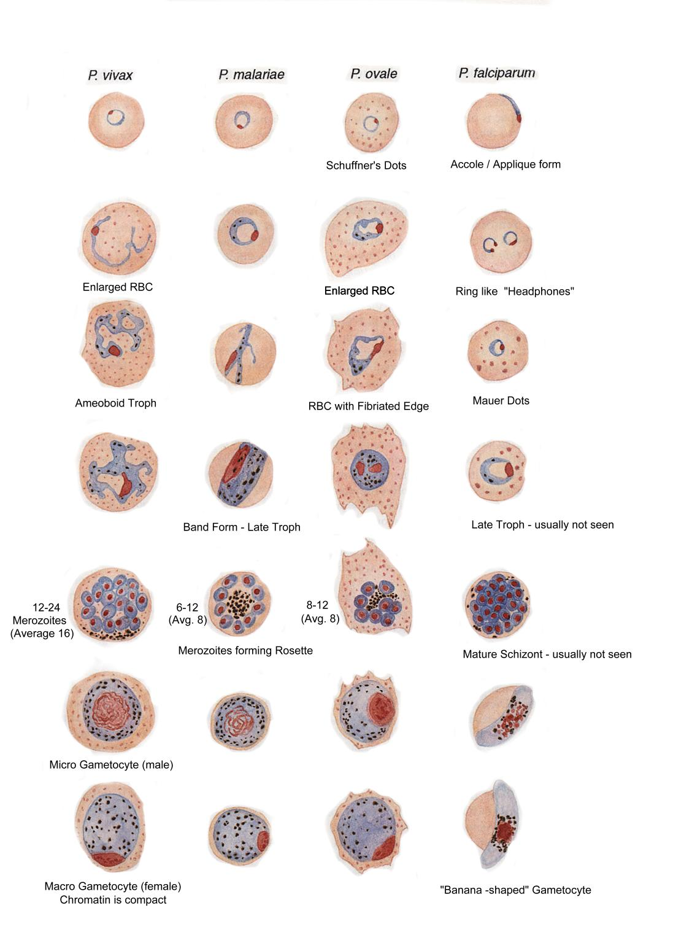

**Figure 2. *Babesia* spp.**

**A. Only small ring forms are observed.**

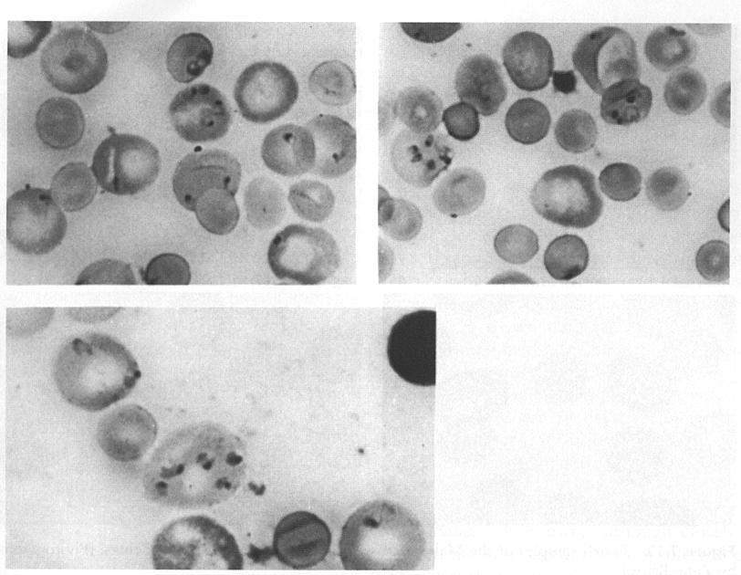

**B. Sometimes 4 rings will form a tetrad “Maltese Cross”**

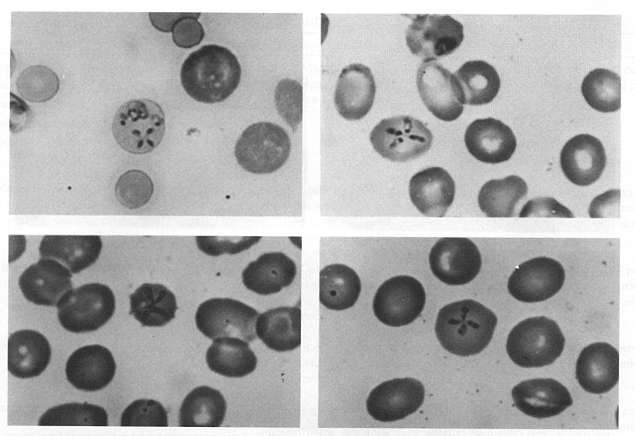

**Approval Signatures:**

|  |  |  |
| --- | --- | --- |
| **Date** | **Printed Name** | **Signature** |
| 12/30/2015 | David Hinkle, MT, ASCP  Hematology Supervisor |  |
| 12/30/2015 | Vivian Arguello, MD Section Director of Hematology |  |
| 12/30/2015 | Nancy A. Young, MD, FCAP  Medical Director |  |

**History Review**

|  |  |  |
| --- | --- | --- |
| **Date Reviewed** | **Reviewed By** | **Revisions** |
| 5/01/2014 | Jaclene Kokoszka | Added Lot to Lot form HEM30-010 Form D. |
| 6/30/2014 | Jaclene Kokoszka | No Revisions. |
| 10/6/2014 | Christine Eagle | New Leadership-NA |
| 5/15/2015 | Christine Eagle | No Revisions. |
| 9/24/2015 | Jaclene Kokoszka | Updated section VII.6- clarified off shift responsibility. |
| 10/29/2015 | David Hinkle | New Leadership-NA |
| 12/16/2015 | David Hinkle | Major Revision to include the use of purchased positive QC. |
|  |  |  |
|  |  |  |
|  |  |  |
|  |  |  |
|  |  |  |
|  |  |  |
|  |  |  |