1.0 Purpose

To provide an efficient and aseptic technique for providing small quantities of red cells for infant transfusions.

2.0 Scope

2.1 This procedure provides direction in pre-transfusion testing of infants equal to or less than four (4) months of age.

2.2 This procedure provides direction in preparing small aliquots of red cells for transfusion to infants.

2.3 This procedure is performed after the required pre-transfusion testing is performed. Refer to the Infant Transfusion procedure (BB06-020) for direction in performing the required pre-transfusion testing.

3.0 Equipment

3.1 Hemostats
3.2 Tube sealing device
3.3 Scissors
3.4 150 micron Pediatric Transfusion Filter set (syringe)
3.5 ISBT Product Labels
3.6 Red cells designated for pediatric use
3.6.1 Infants must receive red cells that are Hemoglobin S negative and irradiated
3.7 SDP designated for pediatric use
3.7.1 Infants must receive sdps that are irradiated.
3.8 Sterile connecting device

4.0 Quality Control

4.1 Equipment quality control standards are established and maintained by the procedures specific to the equipment in use. Refer to the specific equipment quality control procedures where applicable.

5.0 Procedure

5.1 Red blood cells: Select unit:

5.1.1 Select ONLY Group O Negative leukoreduced AS red cell unit that is Hemoglobin-S negative and irradiated.
5.1.2 If needed, Attach pediatric transfer quad bags using sterile connecting device. (See procedure BB04-011)

5.2 Reserve original unit for infant
5.2.1 Using the “Dispense and Assign” function,  reserve entire unit for infant. (Unit will continue to be used up until expiration date for the same infant).

5.3 Aliquot Syringe

5.3.1 Using the “Modify Products” function in LIS 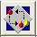, select “Codabar Pediatric Syringe” from the drop down menu

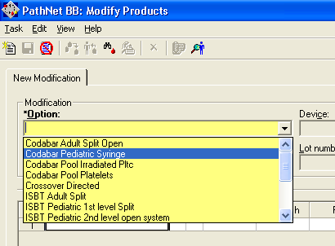

5.3.2 Click in the product field in “Original Products” window and scan unit number. The “Ad Hoc Split” window opens.
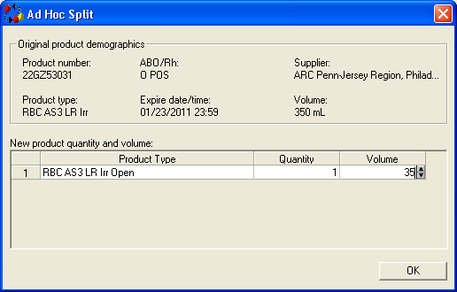

5.3.3 In Quantity, enter 1. In volume, enter the number of cc’s requested. Click “OK”

5.3.4 Click in the “Sub ID/Div” the computer assigns the next subunit (A, B, C, etc)

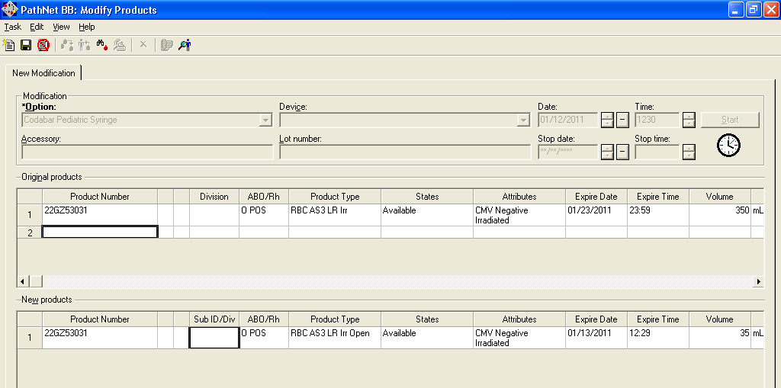

5.3.5 Click Save and a box will pop up called “Label Printing Options”
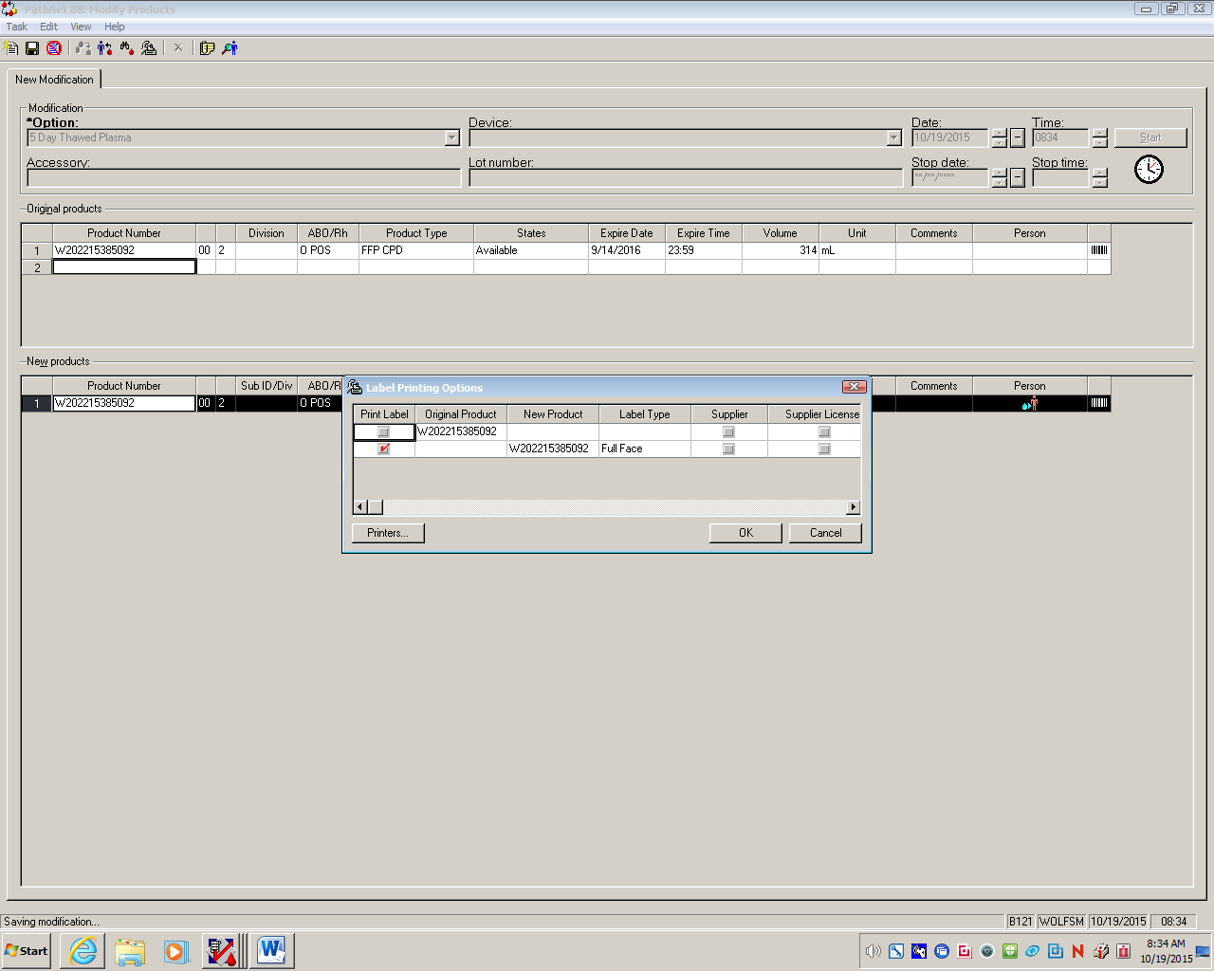

5.3.6 You will see a row with: “a red check mark, product number, full face:
See diagram below:

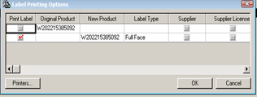
5.3.7 Click “Ok”

    - A label will print from the digitrax printer.

5.3.9 Pull label off, then verify that all information is correct on the label before sticking the label onto the product. Place entire label onto the syringe, leaving the measurement lines on syringe visible.
5.3.10 Go to Dispense and Assign Products icon in Cerner and assign product(s) to patient.

    - Go to Generate Tags and Labels icon in Cerner and select “Component” and print tag.

5.5.12 All Modified products must be label verified before it can qualify to be dispensed. Refer to SOP BB01-037 Label Verify.

5.4 Making the Blood Syringe:

5.4.1 MIX THE UNIT THOROUGHLY. Break the in-line cannula between the primary blood bag and the first satellite transfer bag.

5.4.2 Transfer the desired amount requested to the satellite bag. Allow extra for tubing wastage.

5.4.3 Seal the tubing approximately 2 inches above the first satellite bag.
If the port seals of both the original unit and any of the satellite bags remain intact, each satellite bag retains the original expiration date assigned to the unit. The red cells can be divided into the attached satellite bags without altering the shelf life of the cells.
NOTE: If the port seal is entered, the aliquot expires 24 hours from the date/time of entry.

5.4.4 Immediately prepare aliquot syringe from the satellite unit
5.4.4.1 Syringes will have 4 hour expiration from this time.

5.4.5 Close the clamp on the pediatric filter and insert the spike into a port on the satellite bag

5.4.6 Invert and suspend the satellite bag

5.4.7 Open the slide closure on the Pediatric tubing and prime the filter.

5.4.8 Gently draw on the syringe plunger until the blood has saturated the filter.

5.4.9 Slowly draw on the syringe plunger until the desired volume is reached

5.4.10 Heat seal tubing between satellite bag and syringe

5.4.11 Discard the empty satellite bag into biohazard trash

5.5 Designate (label) the original unit for the intended baby and store blood components 1-6° C until subsequent aliquot syringes are prepared from the unit bag.

5.5.1 Place the labeled syringe, along with the patient’s component transfusion tag, into a zip-lock bag. Store at 1-6° C until issued.

5.6 Prepare subsequent aliquot syringes

5.6.1 Remove the reserved unit from the refrigerator

5.6.2 Verify that the expiration date and product label are correct.

5.7 Single donor platelets: Select unit

5.7.1 Select AB Rh matched or type specific irradiated single donor platelet.
5.7.2 Reserve original unit for infant
5.7.3 Using the “Dispense and Assign” function, reserve entire unit for infant. (Unit can be used for another infant, not adults).
5.7.4 Aliquot Syringe

5.7.5 Using the “Modify Products” function in LIS , select “Platelet Split” from the drop down menu.

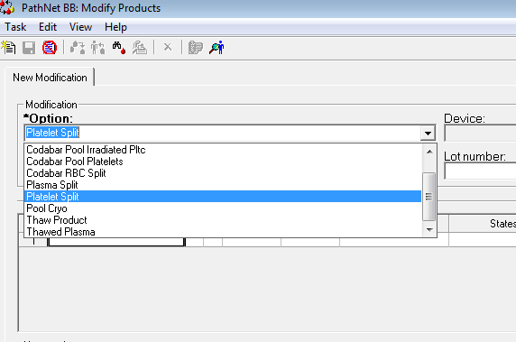

5.7.6 Follow steps for Red blood cells: Section 5.3.2 to 5.5.12.

5.8.6 Making the Platelet Syringe:

5.8.6.1 Mix the unit gently.

5.4.2 Sterile Dock the desired amount requested directly to the syringe: Refer to BB04-011 TCD for sterile dock procedure
5.4.3 Syringes will have 4 hour expiration from this time.

6.0 Reporting Results

Patient and product preparation and modification records are recorded as directed by the procedures specific to the operation.

7.0 Procedure Notes

7.1 The uniquely small transfusion requirements of infants make it possible to provide several aliquots from a single donor unit, thus limiting donor exposure.

7.2 In a quadruple bag pack system, a single unit of blood can be apportioned into integrally attached satellite transfer bags. As long as the original seal has not been broken, each aliquot bag will retain the original expiration date. Once the filter has been inserted into the aliquot, the aliquot bag expires in 24 hours. All syringes expire 4 hours after prep.

7.3 If a label did not print, go to Generate Tags and Labels icon and select “ISBT label” and reprint label.

8.0 Limitations of Procedure

8.1 Only split one aliquot at a time.

8.2 Aseptic technique is critical; do not touch the cap or the tip of the syringe to any surface.

8.3 This blood is pre-filtered and does not require a standard administration filter set.

8.4 Communication between NICU and Blood Bank is vital. Orders should indicate time needed. Blood Bank staff must prepare syringe as close to transfusion as possible to avoid wastage. Blood Bank staff will communicate expiration date/time to floor after syringe is ready.

- References
9.1 Roback, John D., ed. Technical Manual, 18 th ed. Bethesda, MD: American Association of Blood Banks, 2014

  - Standards for Blood Banks and Transfusion Services, 30th ed. Bethesda, MD:
American Association of Blood Banks, 2016.

10.0 Records

Final disposition records of all component units and subsequent aliquots are retained indefinitely.

11.0 Attachments/Appendix/Forms/Documents
11.1 Attachment 1: EXAMPLE ISBT labels full face label
11.2 BB01-036 Form A: Product Labeling Verification Worksheet (FOR DOWNTIME)

Approval Signatures:

Date | Printed Name | Signature
4/7/16 | Pettina Walton  Blood Bank Supervisor
4/7/16 | Manjula Balasubramanian, MD  Section Director, Blood Bank
4/7/16 | Nancy A. Young, MD, FCAP,  Medical Director

History Review

Date Reviewed | Reviewed By | Revisions

Attachment 1: EXAMPLE Full Face Label

