- PURPOSE

To ensure there is no delay or compromise in reporting patient’s laboratory results when AeCIS is not functional. Scheduled downtime requires prior administrative approval and is scheduled. Unscheduled downtime is reported ASAP. Immediate implementation of the procedure is required for STAT specimens. It is acceptable to wait up to 1 hour before implementing the downtime procedure for receipt of routine specimens in the Laboratory.

PROCEDURE

The following downtime procedure is to be implemented when downtime is encountered.

A. COMMUNICATION – UNSCHEDULED DOWNTIME

    - Report unexpected downtime immediately to the Help Desk 68033. A ticket number is issued. Unscheduled downtime is reported ASAP by the LIS Manager.
    - When available, Laboratory Administrative staff meet briefly to discuss strategy and coordination plans for the downtime.
    - Each section should assign a “downtime tech-in charge” to manage communication and processing of tests for the duration of the downtime.
    - The Laboratory Supervisor-on call must be contacted when the unplanned downtime exceeds 2 hours. At that time, the Supervisor on call communicates with the LIS Manager and Pathologist on call. Staffing adjustments are coordinated with the Laboratory Supervisor-on call.

B. COMMUNICATION- SCHEDULED DOWNTIME

1. Scheduled downtime includes those events that must be coordinated as part of a project, hardware upgrade, software upgrade, anti-virus software upgrade/patch, application upgrade or server relocation.

2. Regularly scheduled downtime events include routine maintenance, firewall maintenance, and server reboots. There is an established schedule for these events and is maintained in the LIS Department.

a. A ticket is opened by the Laboratory if connectivity is not restored in the anticipated timeframe.

- GENERATING DOWNTIME LABELS

Generating downtime labels is a function for the core lab, microbiology, and blood bank sections

  - Access PathNet Collections Label Pre-Print by clicking the Label PrePrint icon on the App Bar or access labelpreprint.exe from the support folder.



  - Enter the Number of Accession Label sets to print in the Number of Accessions field.
  - Enter the accession number of the first label to print in the Starting Accession Number field.
NOTE: A log needs to be maintained to track the accession numbers that have been printed. Care must be taken to avoid re-using the same accession number in AeCIS
  - Enter 8 in the number of labels to print per accession field. This prints 8 labels for each accession number.
  - Enter a Free text comment in the Free text comment field if applicable.
  - Select the printer to be used by selecting the printer from the drop down menu in the Label Printer field.

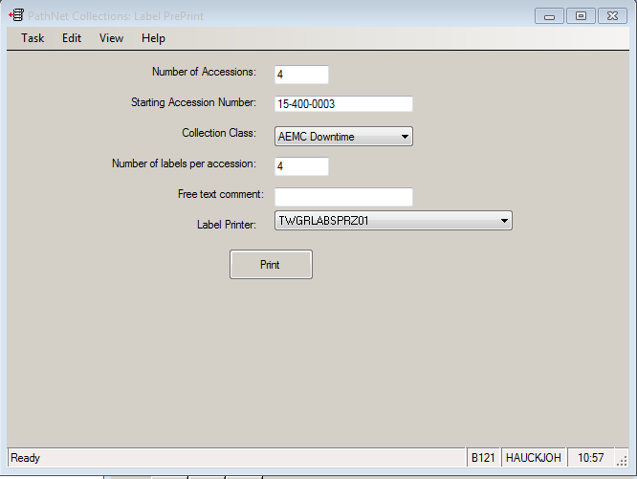

    - CENTRAL PROCESSING-INPATIENT ORDERS

- Support staff utilizes Cerner downtime labels on specimens received in the Laboratory during the downtime period when a Cerner label is not available.
- Downtime labels are available in CPA area for the core lab. The labels for micro and Blood bank are kept in those sections. The labels for Elkins Park are kept in Central Processing area underneath the IBus next to the label printers.
- The following numbers are utilized: 400 is used by EMCM, 500 by EMCP core lab, 575 by EP, 525 EMCP Micro, and 550 EMCP Blood Bank. These numbers have been reserved in Cerner and are utilized by everyone during the Downtime.
- All specimen requests come to the Laboratory on a laboratory downtime specimen collection form. Nursing personnel must complete the Laboratory Downtime Specimen Collection forms for new orders in a collection round that were not entered into AeCIS prior to the downtime.
- STAT, Trauma, and Stroke specimens must be labeled with the appropriate STAT, TRAUMA or Stroke stickers
- Record the patient name, location, and tests on the labels prior to labeling the sample.
- Make a copy of the requisition to distribute to section of the lab; Chemistry, Hematology.
- Central processing takes Microbiology samples to their respective departments for processing.
- Samples for Blood Bank are brought directly to Blood Bank by the floor.
- The technologist will use the downtime accession number as sample ID for the analytical instruments and other methods as deemed by the laboratory department and files a copy of the requisition in the downtime folder.
- A photocopy of the ED results (instrument printouts) is delivered to the ED Departments via the pneumatic tube or manual delivery. A copy of the most recent normal values tables must be sent to the units for reference during the downtime.
- The Central Processing, Chemistry, Hematology, Microbiology, and Blood Bank lead techs are responsible for making sure that Cerner downtime labels are always available and monitor the frequency. They should keep track of labels utilized for each downtime and print more as necessary.

    - CENTRAL PROCESSING-OUTPATIENT ORDERS (EMC-P and EMC-EP)

There will be no AeCIS labels at the time of collection. Outpatient registration will use downtime registration numbers. Everything is written on paper until the system comes back up.

Phlebotomists will write patient’s name and date of birth on tubes.

Specimens can be delivered to the lab accompanied by the patient’s script.. The process for handling downtime specimens in the lab will be implemented.

Once the system is up, orders will be placed in Aecis using a current registration number.

F.CHEMISTRY and HEMATOLOGY DOWNTIME PROTOCOL

- Central processing brings to Chemistry and/or Hematology a copy of the original requisition along with a designated downtime accession number that is affixed to the specimen. Core Lab downtime labels begin with the number 500. Elkins Park downtime labels begin with the number 575. Test (s) requested are written on the label.
- Core Lab downtime labels will be preprinted by a lead tech. Lead techs will check the preprinted labels monthly to assess the amount on hand for an unannounced downtime. If any additional labels need to be printed the lead techs will print the labels and record the numbers on AD02-036 Form A. Downtime labels will be kept in the top of the Central Processing cabinet on the back wall.
- Designated downtime technologists in each area verify that the written test on the label matches the requisition slip.
- Process specimen as requested
- Call back all necessary and critical results to the appropriate location. Document personnel notified, date, and time, and tech code/initials on the instrument printout making sure the result is read back to you.
- After testing has been completed, each section will have a designated downtime tech for the department. This individual will attach the result from the analyzer to the requisition and file in a box by the patient name for future reference if needed.
- Manual results (i.e.) WBC differential, are recorded on the instrument printout prior to filing; all other manual tests (ESR, cell counts, sickle screen, etc. are recorded on the appropriate form.

    - MICROBIOLOGY DOWNTIME PROTOCOL

- Central processing brings to Microbiology the original requisition along with specimens.
- Microbiology staff processes specimens using Cerner Downtime labels that begin with the number 525.
- Each Microbiology specimen requires a Downtime form AND a DOWNTIME LABEL. Accessioning personnel attach 1 LABEL to each specimen for each test ordered. Each test must have an associated accession number; routine specimens such as C Sputum, C Fungus, and C AFB can have the same accession number as long as they are all ordered on the same specimen.
- Place the accesstion number with barcode on the original Downtime requisition form
- If more than one test is ordered on a specimen, write the name of the test on the accession number with barcode label. Place original downtime form in alphabetical order in the Downtime Binder on the Culture Bench Desk file in Microbiology for recovery processing by Microbiology personnel.

    - BLOOD BANK DOWNTIME PROTOCOL

- Central processing or hospital personnel brings to Blood Bank the original requisition along with specimens.
- Blood Bank staff processes specimens using Cerner Downtime labels that begin with the number 550. Blood Bank staff at Elkins Park processes specimens using Cerner Downtime labels that begin with the number 575.
- Refer to BB01-006 LIS (lab Information System )

    - ELKINS PARK DOWNTIME PROTOCOL

- Central processing brings to Chemistry and/or Hematology a copy of the original requisition along with a designated downtime accession number that is affixed to the specimen. Core Lab downtime labels begin with the number 500. Elkins Park downtime labels begin with the number 575. Test (s) requested are written on the label.
- Core Lab downtime labels will be preprinted by a lead tech or Supervisor. Lead techs or Supervisor will check the preprinted labels monthly to assess the amount on hand for an unannounced downtime. If any additional labels need to be printed the lead techs will print the labels and record the numbers on AD02-036 Form A. Downtime labels will be kept on the shelf underneath the IBUS next to the label printers in Central Processing.
- Clerk Phlebotomy staff or Technologists will verify that the written test on the label matches the downtime requisition slip.
- Process specimen as required.
- Call back all necessary and critical results to the appropriate location. Document personnel notified, date, and time, and tech code/initials on the instrument printout making sure the result is read back to you.
- After testing has been completed, laboratory staff attaches the downtime results from the analyzer to the requisition and file in box by patient name for future reference if needed.
- Manual results (i.e.) WBC differential, are recorded on the instrument printout prior to filing; all other manual tests (ESR, cell counts, sickle screen, etc. are recorded on the appropriate form.

    - DOWNTIME RECOVERY CORE LAB

- LIS staff notifies all appropriate departments when AECIS is up and functional.
- Results Downtime filing: A filing system has been established in the Core Lab to include accordion files for Inpatients, Outpatients, and ER samples. Results are filed upon completion and utilized for report delivery purposes. Note: Inquiry for results during downtime are forwarded to the appropriate Laboratory Department performing the testing.
- Each Laboratory department is responsible for performing all critical and STAT calls upon resulting. Record the call back information on the downtime collection form: Who was called, date and time and tech.

- ED results (photocopy of the instrument printouts) are delivered to the ED Departments via the pneumatic tube and faxed at Elkins Park.
- Once the AeCIS system is back up and operational, central processing, designated downtime techs, Microbiology staff, Blood Bank staff and available laboratory personnel place the orders by ordering each patient in the system using the assigned downtime number.

Overview of Manual Accession Assignment

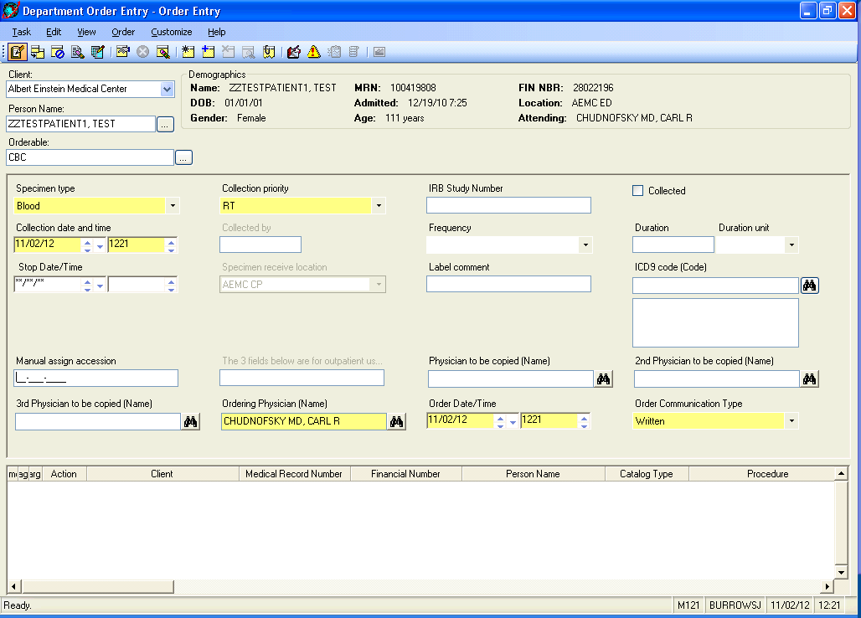

New field in DOE Manual assign accession from Downtime requisition

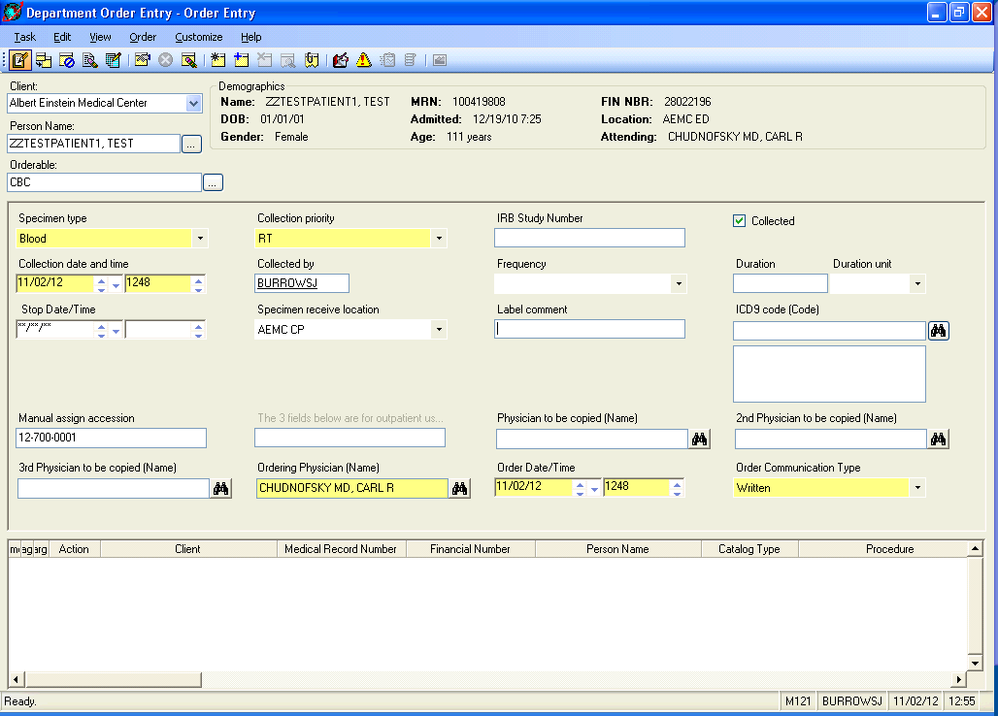

Must fill in Collected By, Manual assign accession, and check Collected.

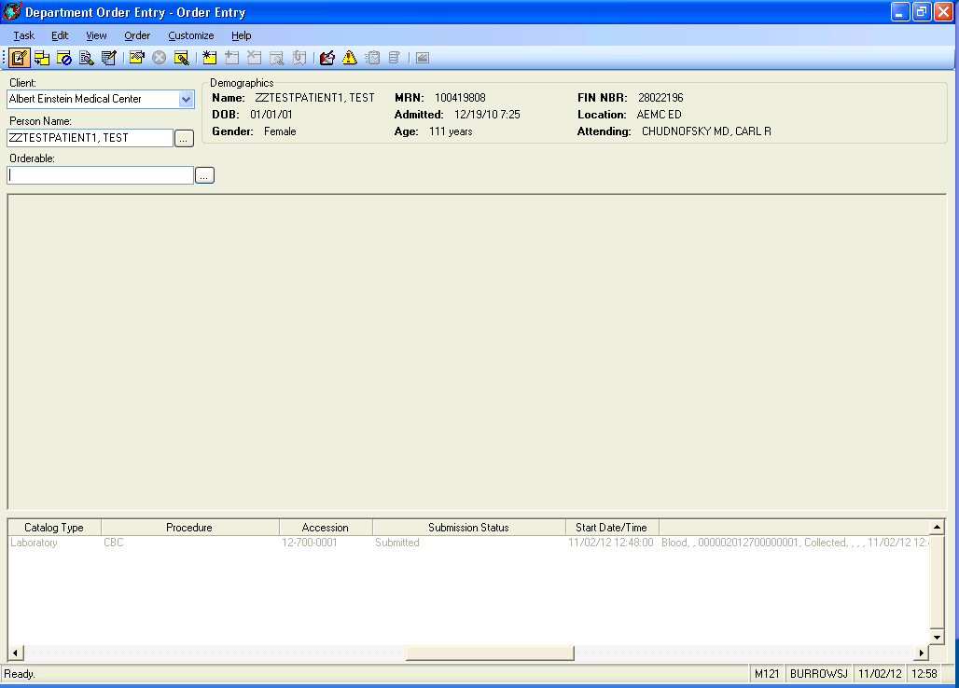

Note order is now active and has the downtime accession number.

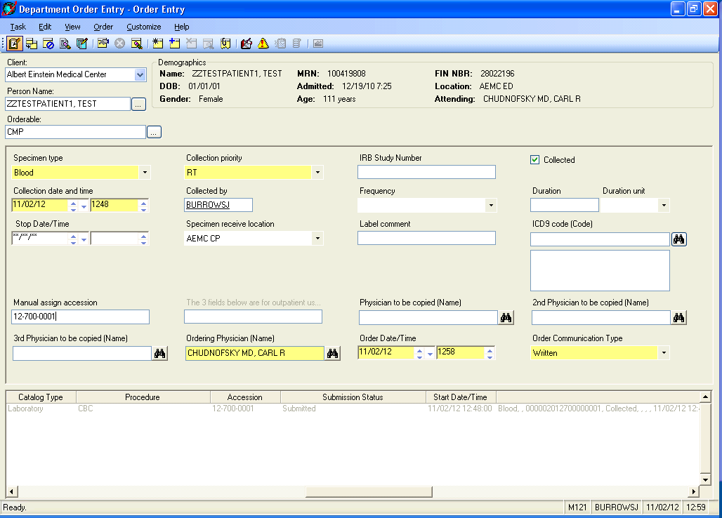

Once submitted, you can not add new orders through order entry or you will get an error.
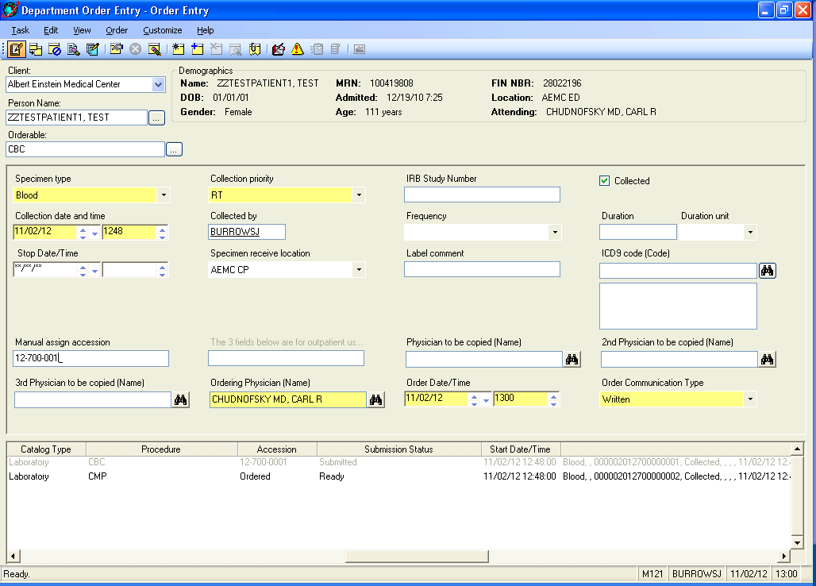
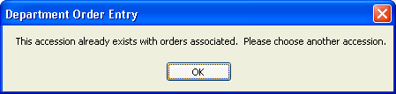

At this point you have to add them in Accession Addon Mode.

You can place multiple orders on the same accession number. As long as you select the + at top.

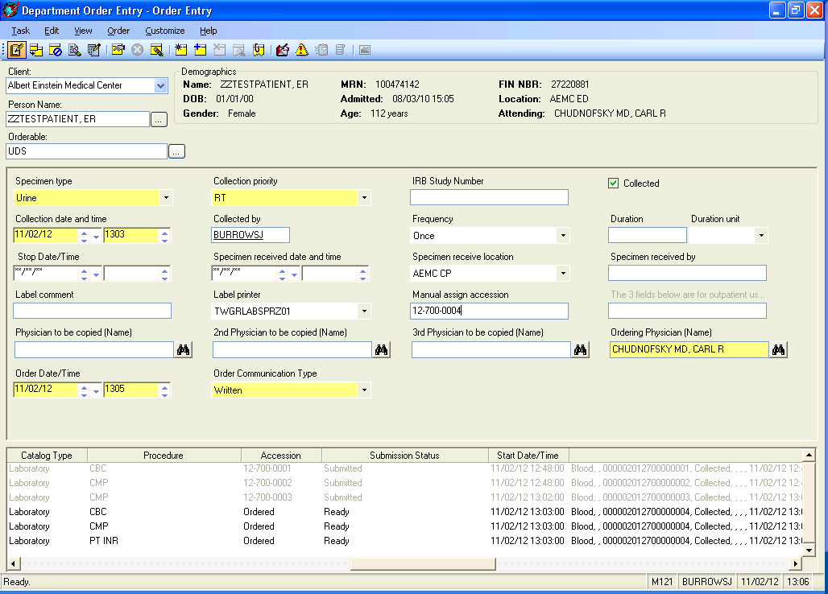

Orders will continue to “queue” on scratchpad until the submit button is clicked.
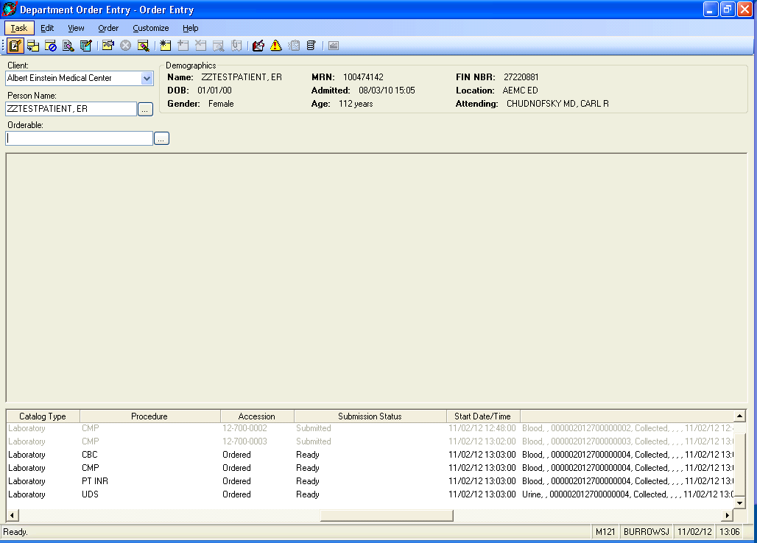

Once all orders are placed, select Submit at top.
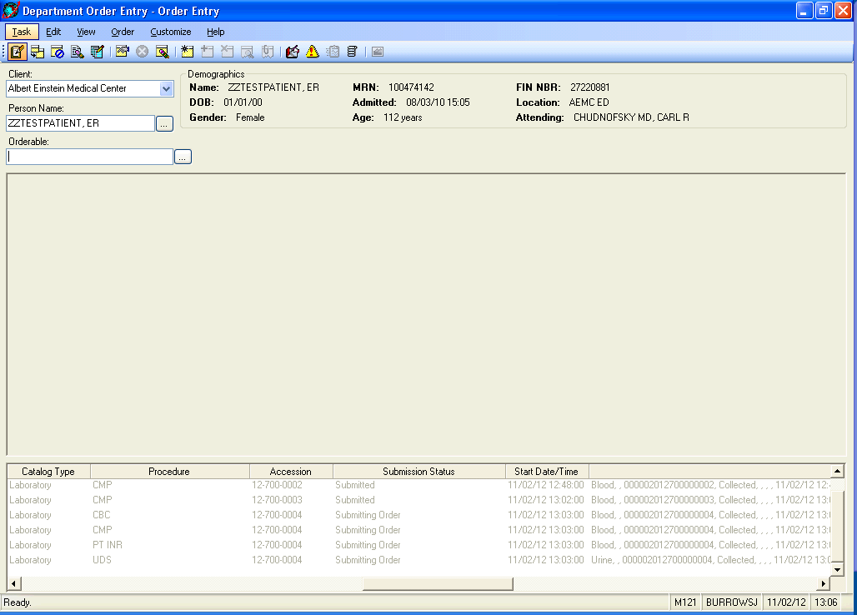

Orders will process (Submitting Order) and add to the same accession number
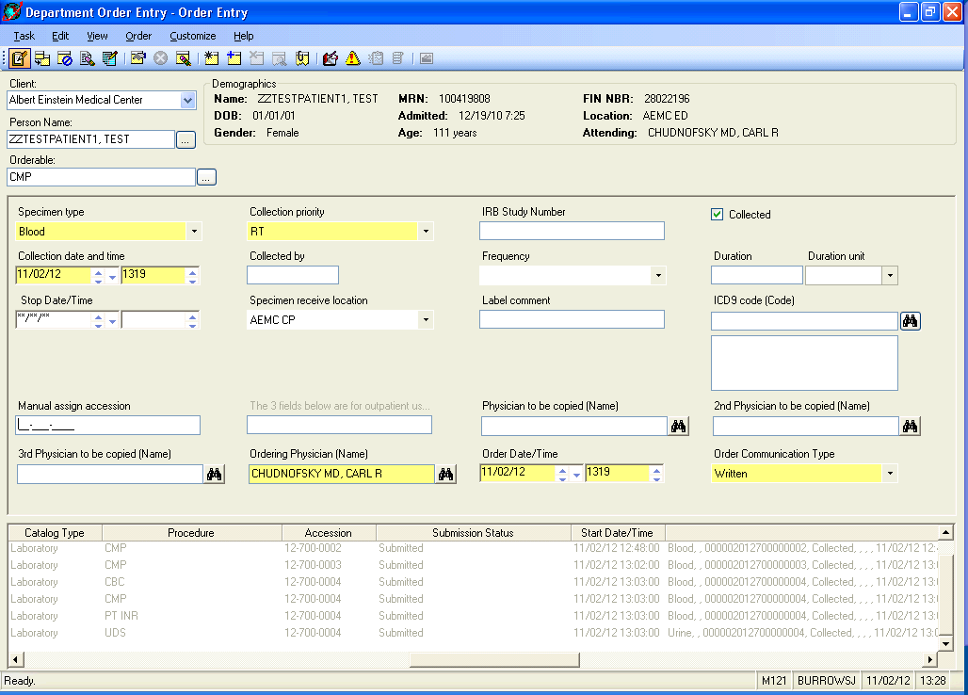

Note, there is no accession class checking. Therefore, urine and blood can be on the same accession number.

- Central processing notifies Hematology and Chemistry when the orders are entered so the tests can be resulted. The Laboratory sections are responsible for entering results in the LIS, this includes following the resulting procedure for result entering.
- Once the orders are entered, the results can be transmitted to AeCIS by following the required procedures for each instrument or department. See table below for instruments.
- Each department performs all Critical, STATS and calls as specimens are resulted. Record all calls on Laboratory Downtime Specimen Collection form. Technical staff are responsible for entering called messages into AeCIS during recovery.

J. TRANSMISSION OF RESULTS-CHEMISTRY

Instrument | Process for transmission of results
Abbott Architect C8000; C4100; CI4100; I2000 | - Print downtime labels from Cerner workstation  - If ARCHITECT LIS is enabled  - Program order into ARCHITECT software  - Run specimen on ARCHTECT  - ARCHITECT send s10 messages before DISABLING connection.  - After the above, ARCHITECT automatically DISABLEs connection. See step “c” below to resolve.  - Press RESULTS tab  - Press STORED RESULTS  - Filter or select desired results  - Press TRANSMIT TO HOST  - If ARCHITECT is disabled  - Program order into ARCHITECT software  - Run specimen on ARCHTECT  - Press LIS button (when LIS is available)  - Click ENABLE connection  - Press RESULTS tab  - Press STORED RESULTS  - Filter or select desired results  - Press TRANSMIT TO HOST
Siemens AUWI/UF-1000 | - Label specimen with downtime label  - Run specimens on instrument  - Open the WAM icon  - Click on Barcode Error  - Fix the barcode error immediately by removing the Error code and tying in the correct accession number.  - You will need to do this for both the Atlas Error and the UF1000 Error.  - When LIS is back up perform the following steps  - Got Inquiry in the WAM software  - Double check the date is correct at the top of the inquiry screen that corresponds with the downtime  - Click “All Orders” down at the bottom  - Find the sample ID numbers that need to be sent to the LIS  - Click all the orders at once or select one order at a time  - On the right side of the screen click “Resend Selection to LIS”  - A pop up box will appear asking if you are sure you want to resend the results, Click “Yes”

- TRANSMISSION OF RESULTS-HEMATOLOGY

Instrument | Process for transmission of results
Coulter DxH 800 | - Delete all orders from Pending Tab  - Next Click Review Tab→ highlight one downtime run in folder an select details  - Bottom of screen select Edit  - Type LIS assigned barcode into Specimen ID field click OK to save  - Select OK to pop up  Now results can be released in LIS
ACL TOP-500 | - Check left-most column next to sample ID  - Select Upload Icon on toolbar OR Actions→ Results→ Upload from Menu  When operation complete a black check appears in Upload Status column
EP LH-500 | - Select Patient Results at the bottom left of the screen (picture of bed)  - Use right side tool bar arrows to select the downtime patient accession number to transmit.  - Use right side tool bar “Select Edit this Sample”, (picture of a pencil)  - Under Patient ID, use the drop down arrow to select the appropriate patient MR#, check to make sure the name and demographics populate.  - On the top tool bar to the left, hit Transmit Results. (picture of a computer)

- DOWNTIME RECOVERY MICROBIOLOGY

  - LIS staff notifies all appropriate departments when AeCIS is up and functional.
  - Results Downtime filing: A filing system has been established in the Microbiology Lab with a Downtime Binder to include accordion files for Inpatients, Outpatients, and ER. Results are filed upon completion and utilized for report delivery purposes.

- DOWNTIME RECOVERY BLOOD BANK

LIS staff notifies all appropriate departments when AeCIS is up and functional.

Approval Signatures:

Date | Printed Name | Signature
June 1, 2015 | Sasha Voce  Administrative Lab Director
June 1, 2015 | Nancy A. Young, M.D.  Medical Director

History Review

Date | Reviewed by | Revision
4/1/2016 | SV | Reviewed no changes

