1.0 Purpose

To define the mechanism for the timely transfusion of trauma patients.

2.0 Scope

This procedure directs the response of the Blood Bank to trauma cases, including transport and issue of emergency released units and the procurement and testing of patient blood samples.

3.0 Specimen

3.1Patient specimens are required:

3.1.1 Specimen collection and labeling complies with the Specimen Requirements and Labeling and Blood Bank Requisition operating procedures

4.0 Equipment

4.1 Transfusion Record Tag (Attachment 1)
4.2 BB08-006 Form B (BB01-014A1): Emergency Request for Blood
4.3 Trauma beeper
4.4 Transport Cooler and coolant
4.5 Red cell units eligible for trauma designation

5.0 Quality Control

Equipment shall be maintained as directed by the Quality Assurance procedures specific to the equipment in use.

6.0 Procedure

6.1 Reserve 2 units of O Negative and 2 O Positive red cells for trauma use at all times:

6.1.1 Maintain units dedicated for trauma on a clearly marked designated shelf in the Blood Bank refrigerator.

6.1.2 Pre-tag units with an emergency transfusion tag.

6.1.2.1 Using the Dispense and Assign application,  select “Emergency Dispense”

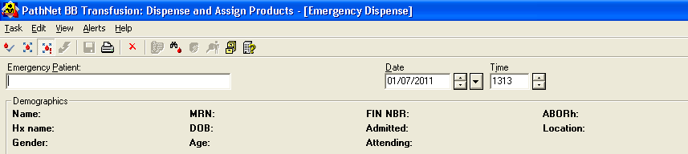

6.1.2.2 Type “Trauma” in the Emergency Patient field

6.1.2.3 Double click white box under Product Number

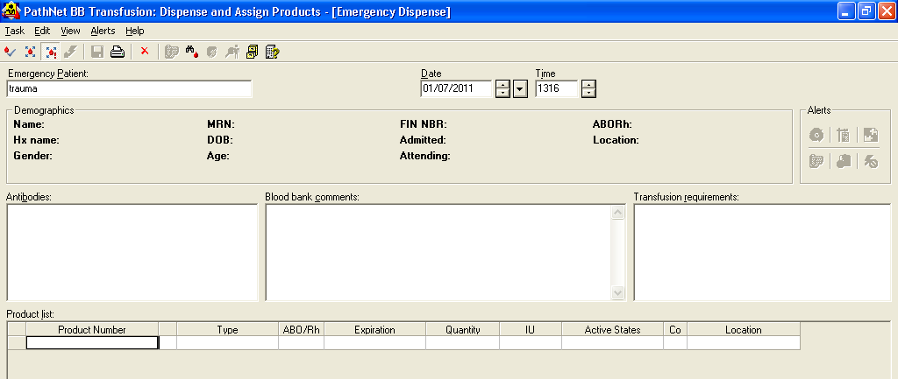

6.1.2.4 Scan units and click Save

6.1.2.5 Fill out the Dispense Box using the following information:
Physician- Kaplan, Mark
Reason- Emergency
Courier- RN
Location- EMC Emergency room
Click OK

6.1.2.6 A tag generates – you must then IMMEDIATELY return the units.

6.1.2.7 Using the Return Products application,  select a return reason from the drop down menu.

6.1.2.8 Enter RN for courier.

6.1.2.9 Scan unit number and enter “N/A” for the temperature.

6.1.3.0 Click Save.

6.1.3.1 Attach Transfusion Record Tag to the unit. Clearly label the tag and unit as “Uncrossmatched” using the “Uncrossmatched” labels. (Attachment 3)

6.1.3 Label segments with the complete donor identification number provided on the back of the unit.

6.1.3.1 Place all segments, together, in a zip-lock bag.

6.2 At the beginning of each shift, ensure that the required number of units are reserved and prepared for trauma.

6.2.1 Reserve units and prepare documents and segments for trauma as necessary.

6.3 Respond to Trauma beeper:

6.3.1 Blood Bank has been assigned a trauma beeper by the Emergency Department. The beeper must remain in the Laboratory at all times.

6.3.2 A technologist must respond immediately to all LEVEL ONE Trauma pages and report directly to the Trauma bay.

6.3.2.1 Remove 2 units of O Negative and 2 units of O Positive red blood cells from the trauma shelf of the refrigerator.
6.3.2.2 Place the 2 units of O Negative and 2 O Positive red blood cells in a transport cooler. Add a frozen coolant pack. Do not let the frozen pack touch the units directly. This can cause hemolysis. Place cloth material between the units and the frozen pack.
6.3.2.3 Deliver the cooler to the Emergency Trauma Room immediately.

6.4 Swipe the red proximity reader labeled “SIGN IN FOR TRAUMA TEAM USE ONLY” in the Trauma Room.
6.4.1 Blood bank staff will wait in the trauma bay to give the attending time to determine if uncrossmatched blood is needed from the cooler.
6.4.2 After about 5-10 mins after the patient has entered the trauma bay, ask the attending if blood is needed (if blood has not been requested within 10 minutes). If the attending is unsure or says yes. Refer to section 6.4.6. Blood bank staff is permitted to leave after 5 mins, sign out blood, and leave the cooler in order to report back to the blood bank for any reason.
Note: Patient care should not be compromised therefore blood bank staff must always use sound judgment when leaving the trauma bay. Clear communication with the trauma team is vital.
6.4.3 If the attending says that blood is not needed from the cooler, notify the attending that you will be reporting back to the blood bank with the blood in the cooler.
6.4.4 The blood bank will transport the trauma specimen back to the blood bank, if, the specimen is ready when the blood bank tech is ready to leave the trauma bay. NOTE: The blood bank staff is not permitted wait solely for a specimen.
6.4.5 If the trauma cooler is needed after the blood bank tech returns back to the blood bank, the blood bank tech will return to the trauma bay with a trauma cooler. NOTE: Blood bank staff is permitted to transport “trauma blood” to trauma bay only. Blood bank staff is not permitted to transport blood to any other area in the hospital.

6.4.6 If Uncrossmatched blood is Needed:

6.4.6.1 Request the patient’s identification labels from the recording nurse at the foot of the bed.
6.4.6.2 Request that the recording nurse verify the patient’s identification with an employee of the trauma team who will read the patient’s armband aloud. As the label is read aloud, verify that the information matches what is written on the patient’s identification label in hand.
6.4.6.3 Only if all information matches, label the requested red cell units from the trauma cooler.
6.4.6.4 If the patient verification fails, notify the recording nurse that the information does not match and request the correct labels. Repeat the verification process. Upon returning to the blood bank document the error on an occurrence report for supervisor review.
6.4.6.5 Obtain the recording nurse’s signature on the Emergency Release form where indicated and sign where indicated for the blood bank tech. This verifies that the patient information labels matches the intended recipient’s armband.
6.4.6.6 Place patient identification label on the emergency transfusion tag and label. Remove the patient identification label from the tag and attach it to the back of the unit. NOTE: Patient information may be written if labels are limited. NOTE* All blood must be labeled by a blood bank tech only.
6.4.6.7 Issue the labeled packed red blood cells from the cooler
[type is based on the age and sex of the patient], and take the remaining unlabeled packed red blood cell units and the signed Emergency Release form back to the blood bank.
6.4.6.8 The trauma bay will be responsible to return the cooler back to the blood bank within 1 hour. –*Blood bank will call the ED if the cooler is not returned within 1 hour.

O Negative units are given to females < 50 years old

O Positive units are given to all males and any female 50 years old or greater.

6.5 The Technologists remaining in the Blood Bank (when present) prepare for the trauma specimen.

6.6 Upon receipt of the trauma specimen into the Blood Bank, perform a forward ABO/Rh type on the patient specimen prior to centrifugation.

6.7 Request a confirmatory sample (2ABO) immediately if the patient does not have a historical blood type in LIS and if the ED or Trauma attending does not sign the Blood Bank lab slip. If the one tube process is not followed for trauma patients, the standard confirmatory process is followed (see algorithm standard confirmatory process). If type-specific blood is requested after a four (4) hour time period a second sample is required to confirm ABO/Rh
TRAUMA patients are permitted to have a single (1) sample collected to expedite the process of receiving type-specific blood products.

One sample is acceptable for trauma patients if the ED or trauma attending is available to witness and verify the blood draw process. This is verified on the Blood Bank lab slip. The bottom portion of the trauma form is signed by the attending physician. (see algorithm one tube process).

**NOTE IF THE ONE TUBE PROCESS IS USED AND THERE IS NO HISTORICAL TYPE ON THE PATIENT, THE LIS SYSTEM GENERATES AN OVERRIDE BOX. CHOOSE FROM THE DROP DOWN MENU “TRAUMA ONE TUBE PROCESS.”**

6.8 Exchange any non-transfused, non-ABO specific units with ABO/Rh specific or compatible units as soon as the patient’s ABO/Rh type is determined and confirmed.

6.8.1 All red cell products that are not ABO group-specific must be given as packed cells according to the following chart:

Patient Type | First Choice | Subsequent choices
O Positive | O Positive | O Negative
O Negative | O Negative
A Positive | A Positive | O Positive
A Negative | A Negative | O Negative
B Positive | B Positive | O Positive
B Negative | B Negative | O Negative
AB Positive | AB Positive | A Positive, O Positive, B Positive
AB Negative | AB Negative | A Negative, O Negative

6.8.2 In the event that Massive transfusion is indicated, Rh negative patients not demonstrating Anti-D may be given Rh Positive units until stabilized. Only the Medical Director/Designee can make this decision.

6.8.2.1 Document authorized changes using an Occurrence Report.

6.9 Complete ABO/Rh typing, antibody screen and crossmatches as directed by the specific test procedures as soon as possible. Indicate in the LIS transfusion record that the units were issued uncrossmatched.

6.9.1 After completion of the crossmatch, inform the ER of the results.

6.9.2 Immediately notify the patient’s physician, the Blood Bank Supervisor and Medical Director (or designees) of any incompatible crossmatches.

6.10 Back issue the applicable units into the LIS.

6.10.1 Transpose the issue information from the Request for Emergency Transfusion to the LIS as directed by the applicable computer entry procedure.

6.11 Replenish the trauma inventory as required. Repeat steps described in section 6.1 of this procedure for each unit reserved for trauma cases.

6.12 Trauma staff notifies Blood Bank if any additional unit of red cells/components is needed. (example: exsanguination protocol)

6.12.1 Blood Bank prepares and issues products according to specified procedures

6.13 Replenish Blood Bank Inventory as required.

6.13.1 Refer to Emergency Blood Ordering procedure when inventory levels reach minimum levels.

7.0 Interpretation

7.1 Tests performed in conjunction with this procedure are interpreted as directed by the specific test procedure performed.

8.0 Reporting Results

8.1 Tests performed in conjunction with this procedure are reported as directed by the specific test procedure performed.

9.0 Procedure Notes

  - Try to obtain the specimen before any units are transfused. If the specimen was drawn after the transfusion, comment that Patient Product Inquiry.

9.2 Trauma patients have priority over all other patient testing and product preparation.

9.3 ABO and Rh specific blood and/or crossmatched blood are made available as soon as possible.

9.4 If a confirmatory sample is unobtainable, continue to support with Group “O” packed cells (O negative for child bearing females) and “AB” FFP until such a time that a confirmatory sample can be retrieved.

10.0 Limitations of Procedure

10.1 The requesting physician assumes responsibility for any adverse patient transfusion reaction resulting from transfusions that may have been prevented by pre-transfusion testing, provided the BB08-006 Form B :Request for Emergency Transfusion Form is signed by the physician.

10.2 Minimum inventory levels of products must be maintained. Refer to Emergency Blood Ordering procedure when inventory reaches minimum levels.

- References
11.1 Roback, John D., ed. Technical Manual, 18 th ed. Bethesda, MD: American Association of Blood Banks, 2014

  - Standards for Blood Banks and Transfusion Services, 30th ed. Bethesda, MD: American Association of Blood Banks, 2016.

12.0 Records

12.1 Emergency Transfusion Records are retained for 10 years

13.0 Attachments/Appendix/Forms/Documents

13.1 Attachment 1: Transfusion Record Tag (labeled with Uncrossmatched Labels)
13.2 BB08-006 Form B (BB01-014 Form A1):Emergency Request for Blood Form
13.3 Attachment 3: Uncrossmatched Labels

Approval Signatures:

Date | Printed Name | Signature
9/19/16 | Pettina Walton  Blood Bank Supervisor
9/19/16 | Manjula Balasubramanian, MD  Medical Director, Blood Bank
9/19/16 | Nancy A. Young, MD, FCAP  Medical Director

Review History

Date Reviewed | Reviewed By | Revisions

Attachment 3: Uncrossmatched Labels

