**1.0 PURPOSE**

The handling of urinalysis specimens that exhibit gross appearance of red blood cells in the urine.

**2.0 PRINCIPLE**

Large amounts of blood will obscure the color change on the urine dipstick. Specimens that are bloody in appearance should not be tested using the Multistix 10SG Reagent Strips.

**3.0 INSTRUMENTATION**

Centrifuge

Microscope

**4.0 QUALITY CONTROL**

Refer to Siemens AUWI Urinalysis UA01-016 and Siemens UF 1000 Procedure UA01-017 (EMCP) UA01-002 (EMCP) or Chemical Examination: Multistix 10SG for Clinitek Status Plus UA01-003-EP or Manual Urinalysis Procedure UA01-004

1. **PROCEDURE**
   1. Specimens should be at room temperature for testing.
   2. Mix each specimen thoroughly.
   3. Visually inspect the urine specimen.
      1. Any specimen submitted with the following COLOR and/or APPEARANCE should not be placed on the analyzer. Instead these results must be entered manually in the LIS and require a Microscopic Exam to be performed.
      2. Color: Green, Orange, Red
      3. Appearance: Bloody, Mucoid
   4. Enter the COLOR and/or APPEARANCE results listed above (5.3.2 and 5.3.3) into the LIS system.
   5. Complete the remaining of the Urine Dipstick results using the drop down box and selecting “Not Performed” for urines meeting the criteria in 5.3.2 and 5.3.3
   6. Footnote the COLOR parameter “Test not performed due to color interference.”
   7. To perform the microscopic exam: Pour off an aliquot of the bloody urine into a centrifuge tube.
   8. Centrifuge this specimen at 400 RCF’s for 5 minutes
   9. After centrifugation, carefully remove the tube from the centrifuge; use care not to disturb the cells on the bottom.
   10. Microscopic:
       1. Manual: Use the sediment from the centrifuged specimen. Take off the supernatant leaving a small amount of liquid to re-suspend the sediment. If the field is too thick with RBCs, use saline to dilute. When using dilutions, remember to adjust the result for the dilution used. For example; if you use 1 drop of urine and 4 drops of saline, multiply the results by 5.

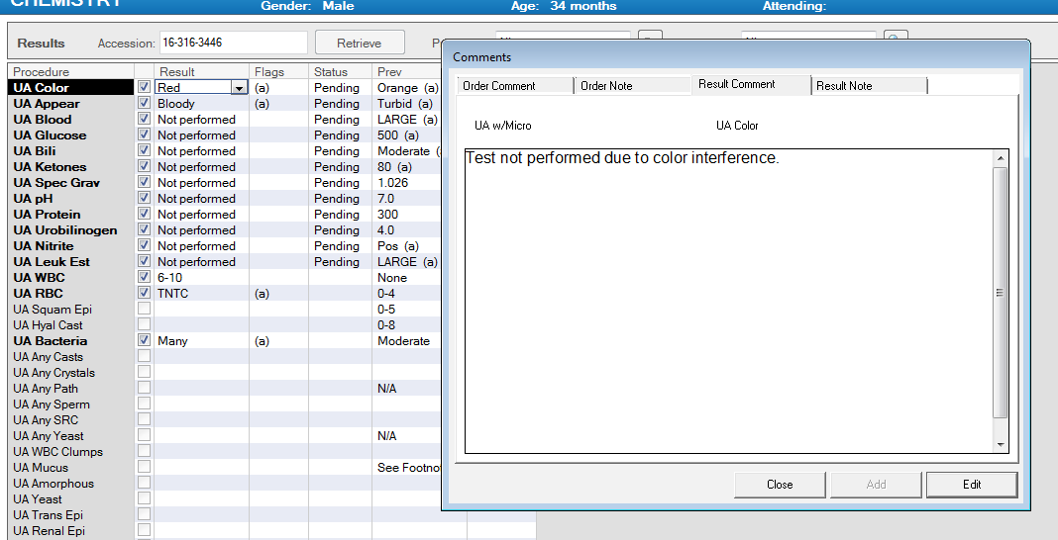

1. **EXPECTED RESULTS**

Normal clean catch urines should have fewer than 5 RBCs/HPF. Catheterized specimens may have slightly more and menstruating women may have small amounts of blood in the urine.

1. **REFERENCES**

Miles Diagnostics Division, Clinitek 200+ Operating Manual, Miles Inc., 1993.

**Approval Signatures:**

|  |  |  |
| --- | --- | --- |
| **Date** | **Printed Name** | **Signature** |
| 11/11/2016 | Vanessa Rawlings, MHA, MT  Elkins Park Supervisor |  |
| 11/11/2016 | Jennifer Lore, MFS, MT  Chemistry Supervisor |  |
| 11/11/2016 | Nancy A. Young, M.D., FCAP  Medical Director |  |

**History Review**

|  |  |  |
| --- | --- | --- |
| **Date Reviewed** | **Reviewed By:** | **Revisions** |
|  |  |  |
|  |  |  |
|  |  |  |
|  |  |  |
|  |  |  |
|  |  |  |
|  |  |  |
|  |  |  |
|  |  |  |
|  |  |  |
|  |  |  |
|  |  |  |
|  |  |  |
|  |  |  |
|  |  |  |
|  |  |  |