1.0 Purpose

1.1 This procedure provides guidelines for performing daily test processing as well as reagent, diluent and gel card quality control testing on the Provue.

2.0 Scope

2.1 This procedure provides a means of ensuring that routinely used blood bank reagents have not deteriorated or become contaminated in such a way as to yield weak, false positive, or false negative results.

3.0 Specimen

  - Previously tested. A Negative / Negative antibody screen sample (QC 1)
  - Previously tested B positive sample (QC 2)
  - Previously tested antibody positive sample (QC 3)

4.0 Equipment

  - A/B/D (Monoclonal) and Reverse Grouping gel cards, A/B/D Gel Card

4.2 Anti-IgG gel cards

4.3 Ortho Provue Wash Solution A

4.4 Ortho Provue Wash Solution B

4.5 0.8 % Affirmagen Reagent Red Cells

4.6 0.8 % Selectogen Reagent Red Cells

4.7 MTS Diluent 2 Plus

5.0 Quality Control
5.1 Each lot of gel cards will be tested each day of use with known antigen positive and antigen negative red blood cells.
5.2 Reagents are quality control tested each day of use

6.0 Procedure

Pre-testing Preparation

  - Verify the following

    - Provue is powered ON. (The green indicator lamp is lit)

    - The “Results” window is open

    - The “Data Management” window is open

  - Click the “Open Door” icon to open Provue upper door
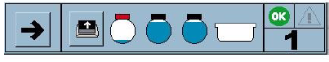

  - Remove stoppers from samples and load, starting in position 1.

  - Close the upper door

Test Processing

  - Click on the black arrow on the Provue main window
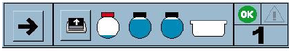

  - The “Waste Tray” information message displays. Click “OK” to confirm that the waste container is empty.

  - On the “Test Tab”:

6.7.2 Check “Fixed tube size”, enter 12 from the drop down menu

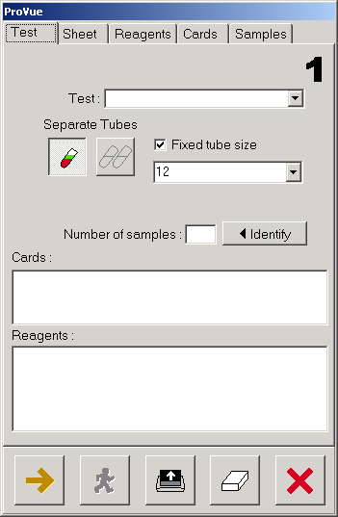

  - Click on the “Samples Tab”

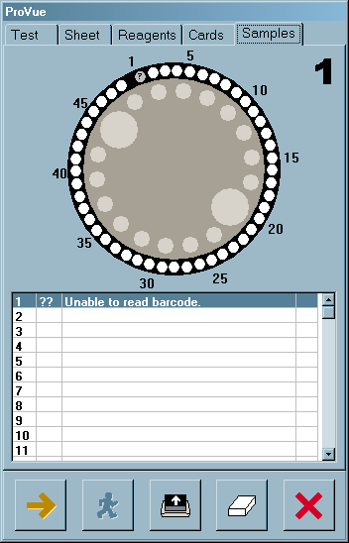

    - Double click on position 1 of the pictured reagent carousel

    - Manually enter “qc1” in the “Prerunning identification of samples”

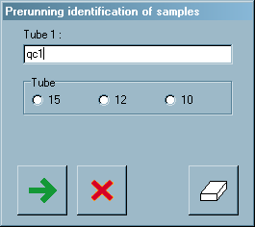

    - You will be prompted to enter “qc1” again for confirmation

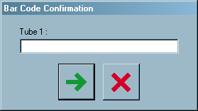

    - Enter qc1, qc 2, and qc 3 following steps 6.8.1 – 6.8.3

6.9 Click on the “Sheet Tab”

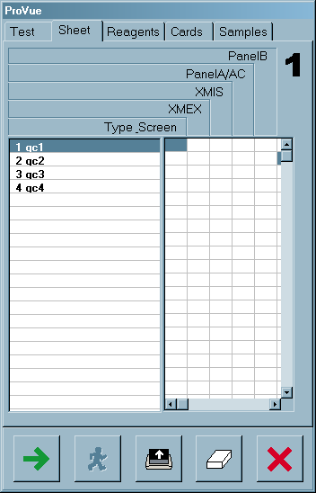

    - Select the tests to be performed for each sample displayed by clicking the corresponding box:

    - qc1 = Type and Screen

    - qc2 = ABORh

    - qc3 = ABSC

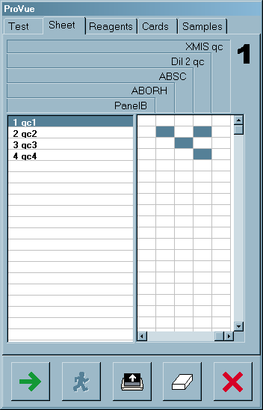

6.10 Click on the “Reagents” Tab

6.11 Obtain the reagents listed

    - Click the “Open Door” icon

    - Gently resuspend red cells so that air bubbles do not accumulate on the top of the cells

    - Remove caps and place reagents in carousel with barcodes facing open slot in carousel

    - Load appropriate Diluent as listed on the “Reagents” tab

  - Click on the “Cards” tab

    - Obtain gel cards for testing as indicated on the “Cards” tab

    - Place gel cards in the appropriate incubator so the extended tab is flat and facing operator

A/B/D gel cards are placed in the 24ºC incubator

IgG gel cards are placed in the 37º incubator

NOTE: Do not place more cards than needed in the 37º incubator

    - Close the door

    - Click on the Green Arrow to initiate processing

    - A confirmation windows appears. Follow instructions and click “OK”

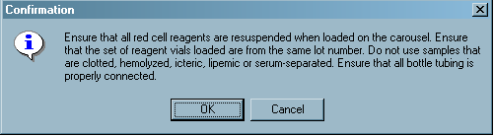

6.13 Provue will test samples and alarm when the last batch is sent to the centrifuge

Print QC Results

  - From the “Data Management” window, click on the “Batch Listing” icon

  - Select the QC batch and print the report
    - Write the accession number of each specimen used for QC1, QC2, and QC3 on the printed provue report, initial and date.

    - File report in “Provue QC” binder

    - Press the “Speed Button” to change the status to “Accept”

7.0 Interpretation

7.1 If the report reads “QC pass” – all testing performed and routine processing may be initiated

  - If report reads “QC fail” – investigate the problem, take corrective action and repeat failed testing. Patient results will not be reported until QC has passed.

7.3 Troubleshooting:

If… | Then…
There is a well incident error | Repeat QC
E displays | Repeat QC on a new sample, verify adequate plasma volume for testing, verify proper red cell re-suspension.
! displays with a well reaction indicated (e.g. 4+, -, etc.) | Verify reagent and sample volumes and repeat QC
! displays with ~ as the well reaction | Verify reagent and sample volumes and repeat QC
? displays | Repeat QC
Sample hemolyzed | Obtain new sample and repeat QC
Some wells must be reviewed | Accept QC based on laboratory acceptance criteria

8.0 Reporting Results

  - ProVue QC Report is completed and reviewed weekly by Lead Technologist

8.2 Results are reported on the Provue QC Report and maintained within lab.

9.0 Procedure Notes

9.1 Interpretation of mixed-field reactions must be done with caution. The clinical history of the patient and the type of testing being performed should be considered before concluding a reaction is mixed field. Mixed-field reactions are generally only observed in tests containing a dual population of red cells, such as a transfused patient or bone marrow recipient

9.2 Do not use gel cards if the gel matrix is absent or if the liquid level in the microtubes is at or below the gel matrix. Do not use gel cards that show signs of drying, discoloration, bubbles, crystals, or other artifacts.

10.0 Limitations of the Procedure

10.1 False positive or false negative results can occur from bacterial or chemical contamination of test materials, inadequate incubation time or temperature, improper centrifugation, improper storage of materials, or omission of test samples

10.2 Red cells must be suspended in MTS Diluent 2 or be a commercially prepared 0.8% red cell in a low ionic strength diluent

  - Variations in cell concentration can markedly affect the sensitivity of test results. When cells are too concentrated they can give weaker results due to the increase in the antigen/antibody ratio. In addition, cells may fail to completely migrate to the bottom of the microtube and could cause a false positive interpretation. When cells are too low in concentration they become difficult to visualize and in extreme cases a weak positive can fail to be detected.

- References

11.1 Roback, John D., ed. Technical Manual, 18 th ed. Bethesda, MD: American Association of Blood Banks, 2014

  - Standards for Blood Banks and Transfusion Services, 30th ed. Bethesda, MD: American Association of Blood Banks, 2016.

  - ID-Micro Typing System Procedure Manual, Version 4.0, 2005-05-02

  - Package Insert - A/B/D (Monoclonal) and Reverse Grouping gel cards, A/B/D Gel Card

  - Package Insert - IgG (Rabbit) gel cards

  - Package Insert – Reagent Red Blood Cell 0.8% AFFIRMAGEN, current revision

  - Package Insert – Reagent Red Blood Cell 0.8% SELECTOGEN, current revision

12.0 Attachments/Appendix/Forms/Documents

12.1 Example: Provue QC report

Approval Signatures:
Date | Printed Name | Signature
11/30/16 | Pettina Walton  Blood Bank Supervisor
11/30/16 | Manjula Balasubramanian, MD  Section Director, Blood Bank
11/30/16 | Nancy A Young, MD, FCAP  Medical Director

Annual History Review:
Date Reviewed | Reviewed By | Revisions

