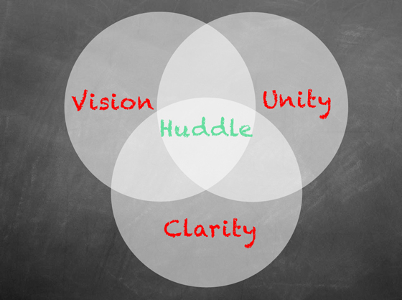

|  |
| --- |
| **EINSTEIN MEDICAL CENTER HOSPITAL LABORATORIES** |
| X EMCP  EMC-EP |

# LABORATORY HUDDLE MINUTES CHECK-IN

|  |  |  |  |  |
| --- | --- | --- | --- | --- |
| **Laboratory Huddle Date:** | **6/25/18** |  | | **The purpose of the huddle is to:**   1. Team member shares their number one priority of the day and important updates. 2. These meetings keep team members informed of important information, help hold people accountable, and allow for sharing of collective intelligence. 3. This is not the time to solve problems, however sharing issues or priorities with the team will lead to sharing of ideas and solutions by others once the meeting is over. |
| **Days Since Last Lab Huddle:** | 180 days | |  |
| **Section:** | **Blood bank** | |  |
| **Reporting Lab Staff Name(s)** |  | |  |
|  | |  |
|  | |  |

|  |  |
| --- | --- |
| **Good News to Share:** |  |
| **Recognition:** |  |
| **Staffing Issues:**  Follow up from last meeting: | * The point person is the Recording nurse as of now. * Dr. Kaplan and Trauma Coordinator were notified that we do not use the term MTP for bleeding patients. It was explained that ONLY the blood bank can activate the MTP. * Trauma coordinator is working on the large amount of people in the trauma bay during traumas. |
| **New news:** | * **Trauma has announced that the term for Exsanguination may be changed to Massive Transfusion protocol “MTP”. This was told to them during their inspection (survey). Our physicians requested to keep the term Exsanguination. I will let you know the final decision. Regardless of the term we would continue to give the 6 rbcs, 4 plasma and 1 platelet.** * **Dr. Bala & Pettina will look into when blood is expected to be ready after the Red alert has been called. (1 hour before cut time?) Pettina emailed Donna Mcgill 6-25-18.** * **When there is an issue with a physician, nurse, etc. document the name and patient’s information so that Pettina/ Dr. Bala can address the issue.** * **There are still issues with runners picking up blood for emergencies (emergency release, exsanguinations) without a yellow slip. Pettina will implement a documenting system and review monthly as a quality indicator.** * The yellow slip or paper/sticker with patient information is **required** in exchange for blood products. * However, use your **BEST** judgement and assess the level of urgency, you may allow the runner to call and write down the patient’s information (**they must write it, not blood bank staff**) BUT make this a **rare** case, do not allow this as a routine practice but **DEMAND THAT A YELLOW SLIP IS BROUGHT BACK!** * Dr. Bala and Pettina will back you up with this as it is a patient safety precaution. * **How many trauma patients can the trauma bay have at once under normal circumstances? -Pettina emailed Janine 6-25-18** |
| **Instrument / Equipment Issues:**  **NA** |  |
| **Specimen Related Issues – Patient ID Errors:**  **NA** |  |
| **Processing / Reporting Delays:**  **NA** |  |
| **Customer / Patient Complaints:**  **NA** |  |
| **Facilities / Environmental Issues:** |  |
| **Other:** |  |