**Chemistry Downtime Interface Instructions**

The Cerner iBus interface is used to connect lab instruments, bedside monitors, and RxStations to AECIS and periodically needs to be updated. It may be down at times during these updates.

These instructions are needed for the staff to be able to start and stop the interface, resend results through the interface, and to change the direction of the interface from production to test and test to production.

1. **Start and stop the instrument interface:**
2. In IM, Choose System, then Status
3. Choose EMCM Abbott 1 or Abbot 2 as applicable
4. Right click will allow Start or Stop selected Connections.
5. **How to resend results through the interface:**

If testing is performed on the instrument before a sample is logged into EMCM CP, the sample will need to be resent to the LIS after its status is changed to “in-lab”.

1. First, In-lab the accession number.
2. In Specimen Management, use Workspace drop down box and choose EMCM ALL Tests

This WORKSPACE will allow you to search 24 hours of samples.

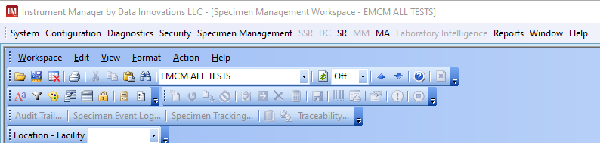

1. Select the “FIND” binocular icon (under the word “Format”) to open up the “FIND” box. It will appear on the right-hand side on the page. Use the drop down to set the “Field” to “Specimen ID” and enter the accession number in the Find What” box. Click “Find Next”

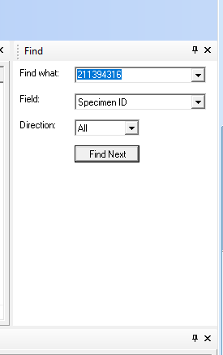

If you choose the binocular icon and the find box opens but accession ID does not appear in the “field” drop down, close “find” and reopen it, until the accession ID option appears in the drop down menu. If the accession number you are searching for ran on the instrument, it will appear on the IM Specimen Worksheet that you have open.

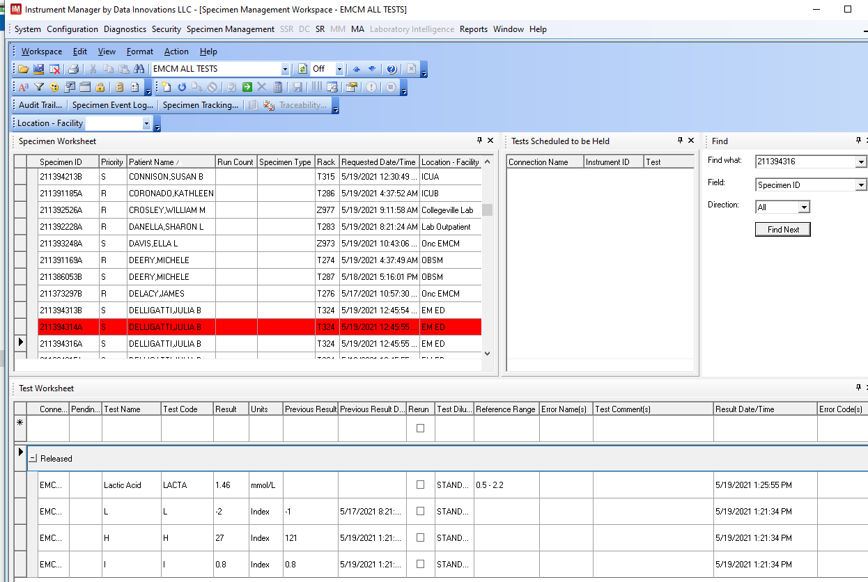

Clicking Find next again moves the Specimen worksheet to the next result with the same accession number (there may be multiple since there may be A,B,C versions of the acc. ID).

Right click on the “Released” result below on the test worksheet and select ACTION, then SEND TO HOST and then YES. This will resend a Released result to CERNER. **ONLY RELEASED RESULTS can be resent to the LIS. Canceled and rejected results cannot not be retransmitted in this manner.**

NOTE: If there is no result with the proper accession number present, you get the following error SEARCH STRING NOT FOUND:

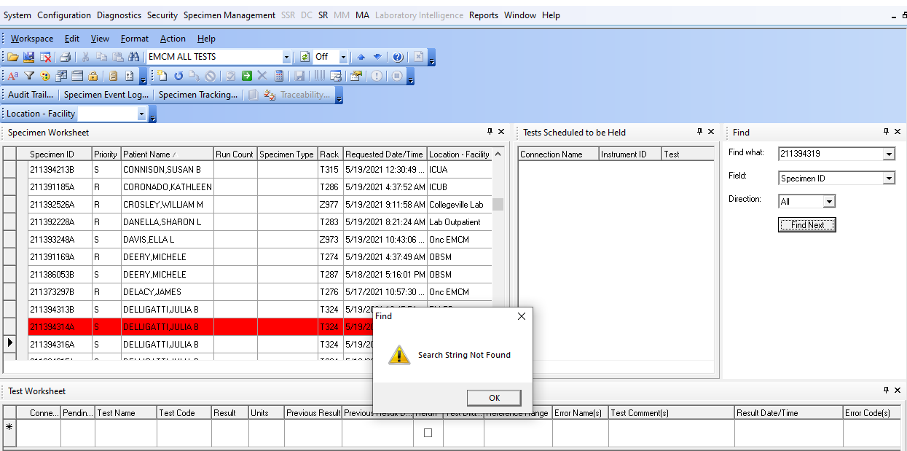

This occurs when:

1. The sample has not read/run on the instrument (yet) with the proper accession number.
2. The search criteria in the WORKSPACE is too narrow (you should not use “find” if your workspace is sorted to EMCM held tests or Held and partial)

There are many workspaces that can be used to search – remember that the broader the search, the longer IM will take to find the specimen. EMCM ALL TESTS is usually the only option a tech will need to find a result. All other options will slow down IM substantially.

Results that have been archived (usually after 20+ days) cannot be modified or retransmitted from IM.

1. **How to change the direction of the interface from production to test or test to production:**

Production is the environment, or area, that we work in.

Test is made up of Build, Cert, and Mock. Each of these environments is used at various times to finally put a test into production where we are using it.

With the Abbott Allinity instruments that we will eventually have, this is a process that Techs must know how to do. Right now, it is handled through the “back end” which is the Lantronix box on the analyzer that connects to Instrument Manager.

During a downtime, if there are questions, please call the Help Desk at 215-456-8033