EINSTEIN MEDICAL CENTER Montgomery- CHEMISTRY
subject: cHEMISTRY STAFF MEETING/UPDATE
ATTENDEES: Chemistry Department
date: minutes Sent to all cHEM techs Via MediaLab 11/9/2023

CATEGORY | TOPIC | ANNOUNCEMENT / UPDATE | DISCUSSION
General CHEMISTRY  Updates  HOSPITAL / LAB NEWS | Test Volumes 2023  New Analyzers  Goals  TAT  Noise  Pay Scale & Shift Differential Evaluation  Competancy and Continuing ED  OnPoint Reporting Summary  Lab Vacancies  Labcorp | Jan 2023 Feb 2023 March 2023 Apr 2023 May 2023 June 2023  106575 96633 106513 100880 106931 100625  July 2023 Aug 2023 Sept 2023 Oct 2023 Nov 2023 Dec 2023  90616 95071 95743 96109  Validation of the Alinities is complete. Go-Live WAS 10/17/2023. We also have autoverification on.  Again, thank you to everyone who helped with the instrument validation. Those who did the work-primarily Allan, as well as those who covered in one way or another so this could happen.  Thank you AGAIN!  GOALS FOR OUR DEPARTMENT INCLUDE THE FOLLOWING:  - Turn Around Times for Chemistry October 2023  - ED BNP: 68.8% resulted in <41 minutes of receipt (Target >85%)  - ED BMP: 74.6% resulted in < 31 minutes of receipt (Target >85%)  - ED Trop: 71.2% resulted in < 35 minutes of receipt (Target >85%)  - Improve TAT with placement of Alinities  - There are many exception reports that show we are not being careful when calling critical results.  This statement is directly from the CAP:  COM.30000 Critical Result Notification.  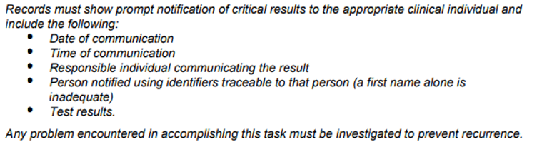  - QC must be completed AFTER calibrations.  - Calibrations must be logged the same way as the Architects.  - Do not call Jose, our Abbott Service engineer after 7:30 PM. He offers a courtesy to us so we can text and call, but we cannot abuse this.  - Read and sign the communication log when you arrive. Once again, CAP expects this.  - We will be getting a new Iron reagent – there were issues with the current one.  - hsTROP will be here in December or January. There will be training for this assay. Collecting, running and resulting will be very different. It is highly sensitive and a patient coming into the ER can be diagnosed with a cardiac event within 2-3 hours.  - If there is anything you would like me to present at the Supervisor’s meeting, please reach out. It is important to follow the chain of command. I will take concerns directly to Pettina or at the meeting.  - Please remember that a TROP result that is the same as the last one is NOT “trending towards normal”. It must be called.  - Barcode labels for controls may be made using the Alinity. We hope to have Francine and Ho learn how.(if they don’t already know!)  - You MUST read and sign all entries in the communication log.  - The CAP Inspection window opens 12/13/2023 till 3/13/2024  - All “top hats” (pour over cups) MUST be labelled! We had twin babies not labeled and they had add-ons – all perfect ways to mis-identify.  We’ve been asked to keep our voices down and noise to a minimum in the hallway outside the lab.  This is being worked on – no need to be discouraged if you don’t hear anything soon.  Please be sure yours is completed ASAP.  For October, there were 11 OnPoint reports which involved the lab in some way.  8 were external events, meaning the root cause of the problem did not involve the lab. The majority of them were specimen labeling issues.  2 of the events were problems that involved the CHEM lab directly  - A lactate tube, gold top and green were sent at the same time but only the  lactate was performed. All were in-labbed. The patient was redrawn.  - An erroneous acetaminophen was resulted on an ER patient because the  QC was run before the calibration. The Calibration was done using the  wrong material and there was no post calib QC to show there was an error.  The patient was treated and suffered a reaction.  _____________________________________________________________________  Two perdiem positions remain open: both on 2nd shift.  One FT position in cytology.  There is now a SOP that includes STAT testing for LabCorp | July is first month without outpatient volume.  UPDATE  UPDATE  Critical result notification.  CAP Requirement  Reminders  Update

