EINSTEIN MEDICAL CENTER
CORE LAB – Chemistry/HEMATOLOGY

subject: CORE LAB STAFF MEETING
ATTENDEES: UYEN TRAN, CHRIS LAGORE, ANIL SAMUEL, ngoc lU, KIM BENZ, PETER ZAGOREOS, ALICIA DANIELS, MONICA KWON, ASMA SIDAT, JOELLE GUAGLIONE, ARIANA MOYETT, KAREN CHAPPELLE, MICHELE HINDS, DEAN TO, MYRA MCINTOSH, SUE GOODWIN, COURTNEY LE, ALLEN DU, SHANICE BOBB
date: 1.30.2024
HAPPY NEW YEAR!
AGENDA
CATEGORY | TOPIC | ANNOUNCEMENT / UPDATE | DISCUSSION
CAP INSPECTION | Inspection Results | CAP inspection completed Tuesday, January 9, 2024.  - Chemistry – One deficiency regarding Osmometer semi-annual correlation.  - Urinalysis – One deficiency regarding reference ranges.  - Hematology – No deficiencies  REMINDERS:  - Date, initials, open and expiration dates needed on all reagent, supplies, calibrators, and QC.  - Checking lot numbers should be routinely performed. | Discussed
TECHNICAL CHEMISTRY | Troponin TAT | - Last meeting on 11/21/2023, we discussed not meeting TAT for September or October:  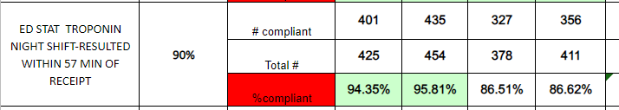  - TAT met for November 2023 (92.08%) and December 2023 (92.84%).  - Reminders:  - Second shift to leave i2000 #2 online and third shift to take instrument down for maintenance.  - If samples are spun offline, third shift tech should be mindful of spinning samples in the centrifuges and loading sample for HIL on the Alinity and Troponin on the i2000 #1 in a timely manner.  - If samples were placed on the track by CP tech, third shift tech should be checking Lane 5 or the output lanes on the track for samples to front load on the i2000 #1 instrument. | Discussed
TECHNICAL HEMATOLOGY | Coagulation TAT | - Turnaround time met for Stroke STATs and ED STATs.  - We are still struggling to meet TAT for STAT Hep Nomo samples.  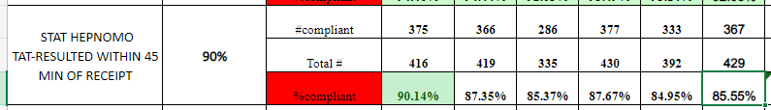  - Reminders:  - Techs should be checking pending logs for outlier specimens that do not autoverify.  - Specimens with a >mMax error should be removed from the instrument and checked manually. If specimen has no clot, >mMax result should be confirmed on the instrument so the number crosses over to Cerner. Tech then needs to verify result in Cerner with a footnote.  - Procedure states re-run analysis needed. However, the instrument performs an auto dilution when PTT results are >240 so re-run analysis is not technically required. Mary to follow-up with Dr.Bhat to have that statement removed when Dr. Bhat returns from vacation. | Discussed
GENERAL CHEMISTRY/ HEMATOLOGY UPDATES | Time and Attendance  Lunches and Breaks  Cell Phones | - Employees may swipe in up to six (6) minutes prior to the start of the scheduled shift or swipe out to six (6) minutes prior to the end of the scheduled shift. This is not a grace period that excuses late arrivals or early departures. Employees are expected to be at the workstation and ready to begin work at the start of the shift.  - Incidental OT is being reviewed by senior leadership for all departments. Mary needs to approve any additional time needed to clock in early or clock out late.  - Lunch times- Dayshift please follow the schedule. Schedule is posted on the board above the Chemistry daily checklist binder. Breaks are to be 15 mins and only if work and staffing allows. Lunches are 45 minutes. Remember missed breaks should be approved by a supervisor. All employees are now receiving the same lunch deductions and must follow the 45 min lunch schedule as discussed. This was discussed at the last three meetings and employees on day and night shift are still not adhering to the 45-minute lunch break.  - Attendees asked if there was anything preventing employees from not following the break schedule and there were no responses.  - Cell phone use is prohibited in the laboratory. | Discussed  Mary emphasized that it is hard to promote teamwork when you are working with someone who is abusing their break times.  Mary enforced following the break schedule once again.
MISLABELED SPECIMEN PROCESS |  | If a mislabeled specimen is identified, please perform the following steps:  - Cancel the specimen as mislabeled and notify the floor.  - If the patient has labs from other departments from the same draw, notify the other departments.  - An IQE must be created in MediaLab and an OnPoint event must be reported. If time is an issue, please create the IQE event in MediaLab and the Supervisor will take care of OnPoint report.  - Notify Supervisor immediately via e-mail or leave a copy of IQE in Supervisor’s door.  - Supervisor to communicate mislabeled specimen to QA Manager and Hospital Safety. | Briefly Discussed – Staff already aware of process
SAFETY | Review of IQE/OnPoint Events  Ergonomic Assessment  Follow-up  Safety Concerns? | - November 2023 – No Reported Events  - December 2023 –  1. NICU patient had an elevated bilirubin level of 13.7 that was not reported to the clinician and delayed phototherapy. Specimen received in the lab 12/2/23 at 7:13 and result posted to the chart at 8:01. Neonatal bilirubin result was not critical and does not warrant a call to the clinician. No deviation from procedure present. Turnaround time met.  2. 15-month-old patient in the ER with Tylenol ingestion and possible Acetaminophen toxicity. Sample “in lab” for hours. When following-up with the lab at 5:45 pm, we were told no result because the instrument is down for maintenance. At this point, the mother is insisting on leaving AMA before the Tylenol result is received. Specimen received on evening shift when instrument is down for maintenance/QC. TAT delay and service excellence issue.  - Ergonomic Assessment performed on two days (10/17/2023 & 11/1/2023). The following recommendations were made for the lab:  - Educate employees on performing micro-breaks throughout the day to offset musculoskeletal strain from sitting at the computer and/or microscope. Staff received “ERGO BREAK” handout.  - Offer keyboard palm rests for computer workstations to reduce the risk of contact stress. Mary to purchase palm rests through Staples when budget allows.  - Continue to offer footrests to staff who prefer to use them. These footrests promote neutral seated position with feet supported. Mary asked attendees if anyone prefers to use footrests. Mary to purchase footrests for interested employees.  - No safety concerns addressed by staff. | Discussed  When performing maintenance/QC on instrumentation, try to complete pending STAT tests as soon as possible. When QC for one specific assay is completed (Ammonia, BHOB, Aceta, etc.) you may run those pending tests before instrument goes back online to get the results out.
EMPLOYEE ISSUES | Competency  CON ED and Electronic Assignments | - Please remember it is your responsibility to provide the supervisor with all necessary documentation for your competency. Lines one and four need to have direct observation of you performing those tasks on that specific bench. By signing your initials, you are stating you watched that individual perform the duties correctly as it is instructed in the procedure. Please remember a direct observer for competency must hold a four-year degree (AD01-027 New Employee Orientation).  - Lead Techs will still provide staff with unknown samples at the beginning of the month for those samples that are stable. Employees must have competency completed prior to the end of your assigned month.  - Failure to complete any annual compliance will result in accountability actions.  MediaLab/MedTraining/MyJeffHub/Competencies: You must complete the assignments on time. These are all a part of the annual eval. We should not have to remind anyone numerous times. Clarification to the Admin Procedure- It is for the employee’s calendar year.  Ex: if you are hired in February you can collect paperwork from February to February. | REMINDER
ENTERPRISE/ HOSPITAL/  LAB NEWS | Wellness Credits Program  COVID Reminders  Educational Opportunities | - Complete program requirements between April 1, 2023 – March 31, 2024 to earn $15 per pay credit in the following plan year.  - More information on the myJeffHub My Benefits community  COVID-19 Update  We are beginning to see increases in COVID and other respiratory illnesses and want to provide some reminders to help reduce the risk of patients and staff becoming ill as we head into the “back to school” and fall season:  - If you have new respiratory symptoms, please test for COVID before coming to work  - If you test negative for COVID but still have mild symptoms and feel well enough to work — please wear an earloop mask until symptoms have improved.  - This helps to reduce the risk of any respiratory illness from spreading.  - If you have been exposed to COVID and are asymptomatic, you can continue to work while wearing a mask for 10 days from the day you were exposed consistent with CDC guidance.  - You also need to self-test on day 2 and day 5.  - If you test positive for COVID, with or without symptoms, you are still required to contact the COVID intake form available on Employee Self-Service.  - MLT to MLS Pathway and Graduate Certificates offered through Jefferson College of Health Professions.  - Mary provided educational opportunities information to all staff via e-mail 11/22/2023.  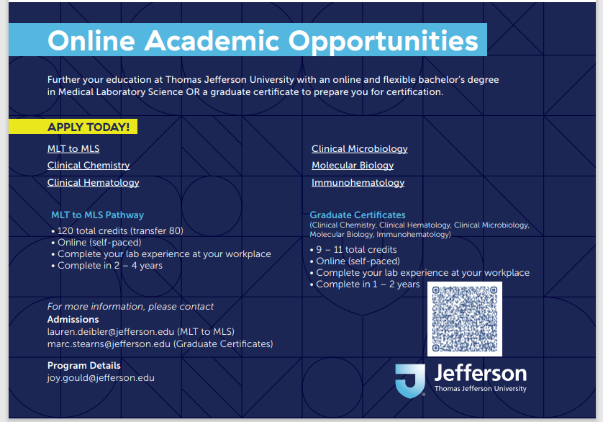 | REMINDER
HUMAN RESOURCES | Open Positions | - Open positions are posted monthly in the hallway on the former continuing education board. All three sites are posted. Please check out the board if you or someone you know is interested. | REMINDER
EMPLOYEE/  PEER RECOGNITION |  | - No recognition feedback given to Supervisor
EMPLOYEE QUESTIONS/ CONCERNS/  SUGGESTIONS |  | 1. Height adjustable cart needed for bulk supplies like sheath reagents. Mary to search and purchase cart needed to avoid heavy lifting for techs.  2. Specimens not reading on the track for specific locations – SPUE, SPUS, AMB1.  - Question: Is there anything IT can do for this issue and locations? Mary to follow-up with Cerner.  - Lead tech discussed that orders are canceled by the DMS if specimens are not received after 72 hours.  - Question: Can specimens be canceled and reordered in Cerner? Yes, but when reordering samples the correct collection information needs to be added in Department Order Entry. If collection information is not accurate, the provider may not be able to find what they are looking for.

