EINSTEIN MEDICAL CENTER Montgomery- CHEMISTRY
subject: cHEMISTRY STAFF MEETING/UPDATE
ATTENDEES: Chemistry Department
date: minutes Sent to all cHEM techs Via MediaLab

CATEGORY | TOPIC | ANNOUNCEMENT / UPDATE | DISCUSSION
General CHEMISTRY  Updates  HOSPITAL / LAB NEWS | Test Volumes 2023  New Analyzers  Goals  Critical Values  Exception Reports  GENERAL  REMINDERS  OnPoint Reporting Summary  Lab Vacancies  LabCorp  Reminders | July 2023 Aug 2023 Sept 2023 Oct 2023 Nov 2023 Dec 2023  90616 95071 95743 96109 100596 100996  Jan 2024 Feb 2024  107473 N/A  Installed and running, still waiting on approval to begin hsTROP. April 17 is go live date.  GOALS FOR OUR DEPARTMENT INCLUDE THE FOLLOWING:  - Please do not mention accession #’s in your result comments. These are used only by the lab. If the RN sees “see new accession #”, they will not know exactly what that is. Instead, indicate that there will be a re-draw or “see next specimen drawn”.  - If a specimen does not give an appropriate result and it is grossly lipemic – it is best to report “unable to result due to gross lipemia” rather than give an “approximate”value. Sometimes dilution works on these, not always.  - I have seen comments that indicate that an RN requested that we remove results. This is fine but we need to know why. Put it in the comments.  - The new IRON 2 Reagent is correlated and on the analyzers. (Thank you, Allan)  - Please place a minimum of 1 pending log on my door every shift. If you are only doing one, make it end of shift.  - If a survey is on the counter and the previous shift did not have time to complete, please complete it. These specimens are to be treated as patient specimens and submitting results is part of that process.  - Nothing belongs in the top bin on the main desk except the Communication Log, the Send out Log and the Hemolyzed Specimen Log.  These are reminders regarding Critical Values: Information: directly from Procedure CM03-009:  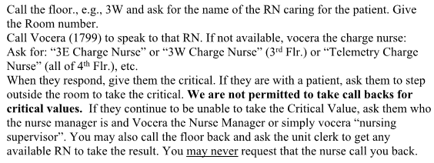The Clinical staff and our Pathologists choose very carefully when a result is critical. You may not wait till a nurse calls you back – find a charge nurse or supervisor or another RN who can take this information immediately.  Additionally, there are many exception reports that show we are not being careful when calling critical results. NOTE: This statement is directly from the CAP: COM.30000 Critical Result Notification  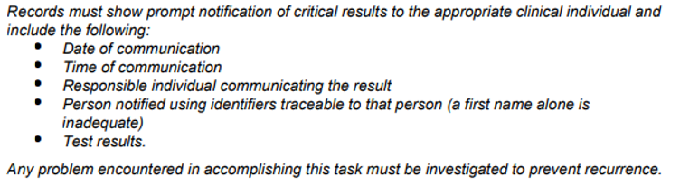  OTHER EXCEPTION REPORT ERRORS:  Please remember that a TROP result that is the same as the last one is NOT “trending towards normal”. It must be called.  - Do not forget to throw out the old fluids in the Walk-In  - In the past, when EVS mopped the floors, the water set off an alarm that stopped the tanks from filling. There are white discs that resemble hockey pucks near the millipore systems. They detect any water on the floor and trip and alarm to stop flooding. The instruments will then run only until the current water is used up. There is a reset button on the wall to correct this. You may also need to do a cuvette wash when this happens if all the water is used up.  - QC must be completed AFTER calibrations.  - Do not call Jose, our Abbott Service engineer after 7:30 PM. He offers a courtesy to us so we can text and call, but we cannot abuse this.  - Read and sign the communication log when you arrive. Once again, CAP expects this.  - If there is anything you would like me to present at the Supervisor’s meeting, please reach out. It is important to follow the chain of command. I will take concerns directly to Pettina or at the meeting.  - All “top hats” (pour over cups) MUST be labelled! We had twin babies not labeled and they had add-ons – all perfect ways to mis-identify.  For January and February, there were 6 OnPoint reports each month. There were only 2 in January that involved Chemistry (one mislabeled specimen and one issue with delayed results) and 1 in February, again re: a mislabelled specimen were PPID was not used.  _____________________________________________________________________  Two positions remain open in CP  A PRN Tech position on 2nd shift  A PT Tech position on 1st shift Hematology  The FT 3rd shift position has been filled by Robert Crain, our student who just completed Micro training and will be in Chemistry in April..  The SOP for collecting STATS for LabCorp has changed several times. Please be sure to check your rmail for the latest update. At this time, I believe it is sufficient that the Physician only is called.  - Please don’t forget to fill out the engagement survey.  - The “Wellness” deadline (to save money on health insurance) is 3/31 Access your wellness portal at myibxtpabenefits.com (select “Health & Well-Being” then “Earn Rewards”). | July 2023 is first month without outpatient volume.  UPDATE  UPDATE  Critical result notification.  CAP Requirement  UPDATE  UPDATE  Update  UPDATE

