Blood Bank Staff Meeting 3.28.24

- FDA reportable event/ IQEs/OnPoints:
  - 1 FDA reportable event
    - None
  - IQEs:
    - BB1:
      - Out of temperature due to the switch on the circuit tripped.
      - The alarm did not go off as the equipment was shut off.
      - Emergency power did not kick in as there was no power outage.
      - Issue detected during daily temperature recording.
      - Many products were wasted.
      - Resolution – Equipment now plugged into a separate outlet to avoid the switch from tripping.
      - DO NOT PLUG IN more than one piece of equipment in an outlet.
  - OnPoint:
    - 1 Discrepant information
    - Wastage of blood products
    - Jr. / Sr. / I / II/ III with the patient’s name
      - If the chart label does not match the Cerner label, ask the nurse to re-print the chart label.

- Inspection:
  - Inspection outcome: See attached for more information.

- Employee Engagement Survey 2024:
  - The last day to submit your survey is March 29th.

- Exsanguination:
  - You MUST document the time of the EP activation.
  - You MUST issue products in the Cerner prior to releasing them.
  - If accidentally, any unit is not issued in Cerner prior to its release, you MUST backdate the issue date/time so that the correct date and time is captured within Cerner.
  - Do you have any suggestions to make our process better in capturing these details? If so, please submit your suggestions to me.

- Uncrossmatched Blood Release form:
  - You must request the physician/resident to sign the emergency release form prior to releasing uncrossmatched blood.
    - The only exception is the true emergency.
  - When uncrossmatched blood is released without the physician’s signature, please DO NOT accept any forms that are not signed by the physician/resident.
    - Request the runner to go back and have the physician sign the form.
    - Prior to sending the runner back, be sure to make a copy of this form if you do not already have it.

- Saline:
  - Tracking saline lot # and the expiration date.
    - Still an issue.
      - What works for everyone?
        - Suggestions?

AABB Nonconformance # 1:
Standard
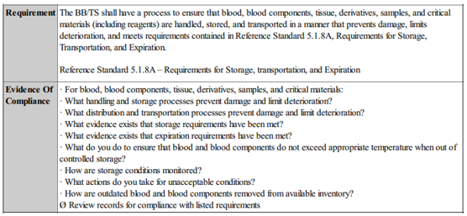

Inspector’s Response:
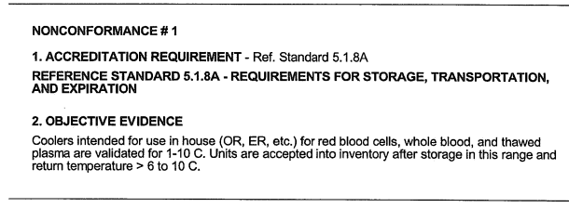

Response to AABB: Challenge
We challenge this deficiency. The coolers in our institution are validated 1-10°C since they are used to transport (not storage) blood products within the institution. Per AABB Technical Manual (20th Edition, pg. 522), the transport storage temperature range is 1-10°C.

AABB Nonconformance # 2:
Standard
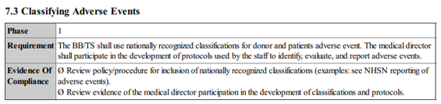

Inspector’s Response:
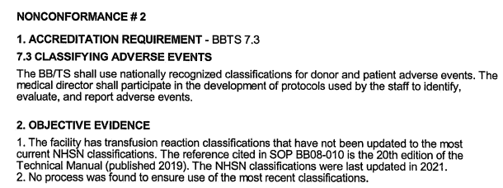

Response to AABB: Challenge

Our transfusion reaction policy was based on the 20th edition of the AABB Technical Manual. However, the new edition of the AABB Technical Manual (21st edition) has come out and we will update our policy to reflect the changes outlined in the 21st edition.

The inspector stated that the NHSN classifications for transfusion reactions were last updated in 2021 and the 21st edition of the AABB Technical Manual captures those changes. However, when reviewing these changes on NHSN site, it was noted that the NHSN classifications have been last updated in February of 2023 and the 21st edition of the AABB Technical Manual does not capture those changes. Our policy will be updated to show the most recent classification as described in the 21st edition of the AABB Technical Manual and the NHSN classifications of the transfusion reactions which were last updated in February 2023.
CAP Nonconformance # 1:
Standard
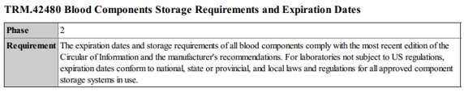

Inspector’s Response:
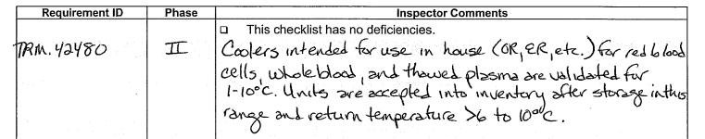

Response to CAP: Challenge

We challenge this deficiency. The coolers in our institution are validated 1-10°C since they are used to transport (not storage) blood products within the institution. Per AABB Technical Manual (20th Edition, pg. 522), the transport storage temperature range is 1-10°C.

CAP Nonconformance # 2:
Standard
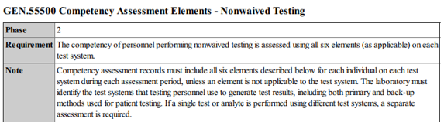
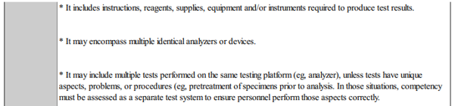
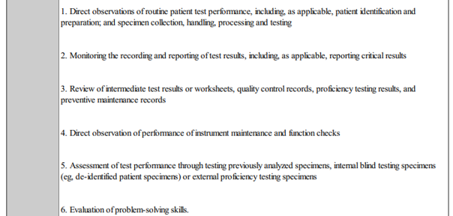
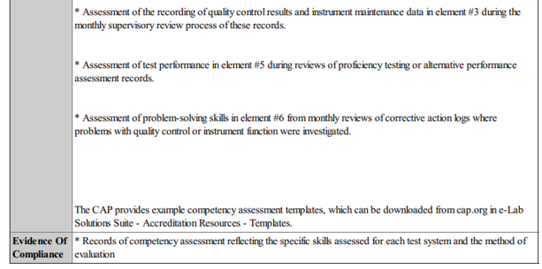

Inspector’s Response:
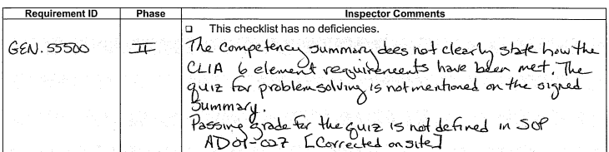

Response to CAP: Challenge

We challenge this deficiency. The CLIA 6 element requirements are listed in our document. A problem-solving quiz is also attached with our competency form. This is a subjective deficiency by the inspector according to her policies. Note that the standard does not define what should be on the “Summary Page”. We believe that we are compliant with this requirement. Please see Section J. of our policy, competency form, supporting worksheets, and a problem-solving quiz attached.

CAP Nonconformance # 3:
Standard
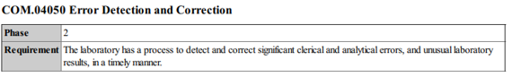

Inspector’s Response:
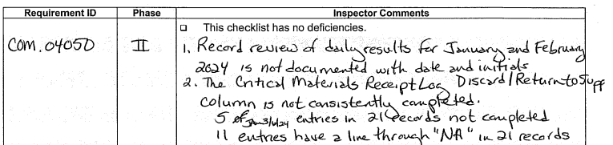

Response to CAP: Challenge

- The policy will be updated to reflect the requirement of documenting the reports with initial and date. An audit will be carried out to ensure the daily reports are initialed and dated.
- The Critical Materials Receipt Log policy will be updated with the following:
  - The form must be filled out completely; no blanks are permitted.
  - The lead tech/supervisor must review the log to ensure the form is fully completed.
  - The lead tech/supervisor must initial and date the log once review is performed and form is found to be fully completed.

