EINSTEIN MEDICAL CENTER
CORE LAB – Chemistry/HEMATOLOGY

subject: CORE LAB STAFF MEETING
ATTENDEES: MONICA KWON, HANNA HOWARD, ARIANA MOYETT, NGOC LU, ASMA SIDAT, LAUREN ALKINS, ANIL SAMUEL, JOELLE GUAGLIONE, SHANICE BOBB, CHIAMAKA NWOGU, KIM BENZ, ALICIA DANIELS, CHRIS LAGORE, COURTNEY LE, KAREN CHAPPELLE, ABDOU AOUTA, SUE GOODWIN, THOMAS TAT, ANNETTE DAWSON, DEAN TO
date: 11.20.2024
AGENDA
CATEGORY | TOPIC | ANNOUNCEMENT / UPDATE | DISCUSSION
TECHNICAL CHEMISTRY | High Sensitivity Troponin  Critical Value Documentation  Quality Control  Calibrations | - High Sensitivity Troponin Live 5/8/2024.  - What is in the way of us meeting Hospital TAT?  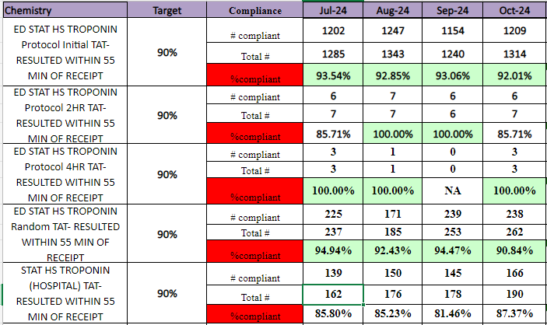  - We have not achieved 100% Compliance since April 2024.  - Critical values missing callback documentation – Jul (1), Aug (4), Sept (5), Oct (4).  - Please be sure to document critical callback information before releasing results.  - Please be sure to add critical callback documentation for ALL critical values when there are multiple critical values for a specimen.  - QC flags (L, H) need to be addressed with troubleshooted by techs.  - Need to pay attention to QC being missed especially for QC with numerous assays: IAP, IMM, CHEM, etc.  - Techs need to refer to calibration curves when QC results appear to be erroneous or when there are QC failures.  - TDM Assays: We are seeing frequent recalibrations for tests like Carb, Phenobarb, Valproic Acid. Bad calibrations being produced when you load new reagents on the instruments with old low volume reagents on board. Let old reagent run out before loading a new reagent or discard old reagent <20 tests before loading and calibrating a new reagent.  - Again, look at previous calibrations curves when you run into QC trouble. Calibration may pass but it does not mean it was a good calibration. | Discussed  Troponin Hospital TAT:  1. Delay from CP in-lab to track  2. Delay in Verifying <3 results. Can this be auto verified? Mary to consult with Troponin group to discuss.  3. Not keeping up with the pending log. Specimens may not be recognized by the track and sitting in the output lanes.  Shanice discussed the BUPQ issue from 10/29/2024. Calibration passed but QC was not running as it normally would. Result: Bad reagent. Two patient samples performed and released as Positive. Testing performed on new reagent when received 11/4/2024 and results were Negative.
TECHNICAL HEMATOLOGY | PAT Anemia Reflex Panel  Critical Value Documentation  MCV Delta Documentation  Body Fluid Crystal Reporting | - New Orders:  1. CBC PAT Only  2. CBC w Diff PAT Only  3. H&H PAT Only  ***Retic counts should be added to PAT specimens with one of these three orders that meet the criteria. There have been two instances to date that retic counts were added to a PAT specimen that was not the correct order for the reflex panel.***  - Platelet critical values specifically are often released as the count was verified but the critical callback documentation is missing. Please make sure all critical callback documentation is present before releasing results.  - Dayshift – Because there is one tech on Sysmex and one on Diffs, you can consult with your counterpart to verify a call was made to relay the critical result to the patient’s caregiver.  - Please be sure to add critical callback documentation for ALL critical values when there are multiple critical values for a specimen.  - MCV delta should be investigated and footnoted prior to releasing results.  - It is unacceptable to release a MCV delta result stating that IV fluids or transfusions weren’t received.  - If an MCV delta cannot be explained based on the patient’s state, we should be requesting a second sample for confirmation.  - Reminder: When crystals are present, the type of crystals should be reported, as well as whether they are intracellular or extracellular per the policy. | Discussed  While PAT specimens may have the pink/red line on the tube label, we need to pay attention to the order on the tube.  Mary to review MCV criteria with IT for the PAT Anemia Reflex Panel.
GENERAL CHEMISTRY/ HEMATOLOGY UPDATES | Time and Attendance  Lunches and Breaks  Cell Phones | - Employees may swipe in up to six (6) minutes prior to the start of the scheduled shift or swipe out to six (6) minutes prior to the end of the scheduled shift. This is not a grace period that excuses late arrivals or early departures. Employees are expected to be at the workstation and ready to begin work at the start of the shift.  - Incidental OT is being reviewed by senior leadership for all departments. Mary needs to approve any additional time needed to clock in early or clock out late.  - Lunch times- Dayshift please follow the schedule. Schedule is posted on the board above the Chemistry daily checklist binder. Breaks are to be 15 mins and only if work and staffing allows. Lunches are 45 minutes. Remember missed breaks should be approved by a supervisor. All employees are now receiving the same lunch deductions and must follow the 45 min lunch schedule as discussed. This was discussed at the last four meetings and employees on day and night shift are still not adhering to the 45-minute lunch break.  - Cell phone and headphone use is prohibited in the laboratory. Please see AD03-004 Use of Personal Electronic Devices policy on MediaLab. | Discussed
MISLABELED SPECIMEN PROCESS |  | If a mislabeled specimen is identified, please perform the following steps:  - Cancel the specimen as mislabeled and notify the floor.  - If the patient has labs from other departments from the same draw, notify the other departments.  - An IQE must be created in MediaLab and an OnPoint event must be reported. If time is an issue, please create the IQE event in MediaLab and the Supervisor will take care of OnPoint report.  - Notify Supervisor immediately via e-mail or leave a copy of IQE in Supervisor’s door.  - Supervisor to communicate mislabeled specimen to QA Manager and Hospital Safety. | REMINDER
SAFETY | Annual Fire Safety Training  Review of IQE/OnPoint Events  Safety Concerns? | It is time for our annual Fire Safety Training. Everyone must attend the mandatory training. Please plan to attend one of the following training sessions:  - Tuesday, November 26th at 3:15 p.m.  - Friday, November 29th at 7:30 a.m.  - Wednesday, December 4th at 11:00 a.m.  - Sunday, November 24th - please see Tanya Bilyj  - Sunday, December 1st - please see Kim Toms  - Sunday, December 8th - please see Michelle Wright  If you are unable to attend one of the scheduled training sessions, please see me to schedule your training.  - September 2024 – A urine was sent to EMCP for osmolality testing for an EMCM patient. After a delay in testing, the lab at EMCP was called to follow-up. According to the tech, they "could not find the specimen". A new order was placed, urine poured off and sent again for testing. Osmo specimens being transferred from EMCM to EMCP during Osmometer downtime at EMCM. EMCP received a phone call from EMCM on evening shift 9/8/2024 looking for Osmolality results on a patient specimen they sent to us. Abbott pending log printed 9/9/2024 at 1:00 a.m. and 7:18 a.m. do not show that the specimen was transferred to EMCP. Lead tech Ngoc Lu e-mailed lead tech A. Eustace to inform him of the discrepancy. A. Eustace replied that he would send the specimen to us. New specimen received at EMCP 9/9/2024 at 17:09 and resulted in the LIS at 17:56. Supervisor notified of specimen delay.  - October 2024 –  - For the date of 10/21/2024, multiple lab delays and urinalysis delays for ED testing. Screen8 and CBC from 10/21/2024 both received at 18:29. Trop HS Protocol received at 18:32. CBC resulted at 18:44 and within STAT turnaround time. Screen8 and Trop HS specimens not received by the chemistry track until 22:04. Instrument Manager middleware shows Screen8 results at 6:59 pm and Trop result at 7:06 pm. Because the results did not post to Cerner until it was read by the track it is likely that there was an IT issue where the track did not recognize the patient label.  - The patient AST value was so high that the instrument was unable to calculate and reported the AST value as <3 on two specimens from the same patient. Hep Func Panel specimen Acc# 24-302-0655 received in the lab 10/28/24 at 4:44 and AST result from instrument <3. Result crossed over into Instrument Manager properly. Lead tech looked at the patient's chart to see history of previous results and noticed the AST level has been trending upward since 10/24/2024. Lead tech also noticed the previous specimen from 10/27/24 (Acc# 24-301-2817) had an AST value of <3. Instrument Manager shows error flags for AST for both specimens requiring manual dilution. Lead tech pulled both specimens and repeated AST testing with a manual dilution. Result 10445 was obtained with the dilution on the current specimen. Result 13464 was obtained with the dilution on the previous specimen. Both results corrected in the system by lead tech. Both results called to and read back by A Divins/CC4S on 10/28/2024.  No safety concerns | Discussed
EMPLOYEE ISSUES | Competency  CON ED and Electronic Assignments | - Please remember it is your responsibility to provide the supervisor with all necessary documentation for your competency. Lines one and four need to have direct observation of you performing those tasks on that specific bench. By signing your initials, you are stating you watched that individual perform the duties correctly as it is instructed in the procedure. Please remember a direct observer for competency must hold a four-year degree (AD01-027 New Employee Orientation).  - Lead Techs will still provide staff with unknown samples at the beginning of the month for those samples that are stable. Employees must have competency completed prior to the end of your assigned month.  - Failure to complete any annual compliance will result in accountability actions.  MediaLab/MedTraining/MyJeffHub/Competencies: You must complete the assignments on time. These are all a part of the annual eval. We should not have to remind anyone numerous times. Clarification to the Admin Procedure- It is for the employee’s calendar year.  Ex: if you are hired in February you can collect paperwork from February to February. | Discussed  Mary to follow-up with employees with outstanding competencies
ENTERPRISE/ HOSPITAL/  LAB NEWS | Wellness Credit  JeffHub Learning Assignments  Workday Launch  Campus Currency Transition | Eligible employees who complete the program requirements within the designated timeframe will receive $15 each pay period.  - Deadline: March 31, 2025 to earn the wellness credit for the July 1, 2025 to June 30, 2026 plan year.  - Jefferson’s Code of Conduct and Ethical Behavior DUE 12/20/2024  - Compliance: 37.5% Complete  - Employee Self-Service Launches December 20, 2024.  Workday Essentials for Employees eLearning issued in MyJeffHub Learning. Please complete prior to Workday Launch.  - Effective Monday, December 16, 2024, Jefferson Einstein Philadelphia Hospital and Jefferson Elkins Park will transition from the QuickCharge payment system to Jefferson’s Campus Currency. Campus Currency will allow employees to pay for purchases at the cafeteria, mobile vending sites and pharmacy.  - Campus Currency is a pre-loaded payment method requiring employees to load money into an account prior to use. Employees can fund the account through payroll deduction or via the Campus Currency App, using a credit card. Campus Currency is linked to the Jefferson Photo ID Badge. Employees will be able to pay for items at any Jefferson location that accepts Campus Currency.  - December 6, 2024 – Last day to use QuickCharge  - December 16, 2024 - First day to use Campus Currency  - December 20, 2024 - Last paycheck for any QuickCharge payroll deductions  - GET Mobile App – The first day to load funds will be December 16, 2024 (please note loading may not yet be available)  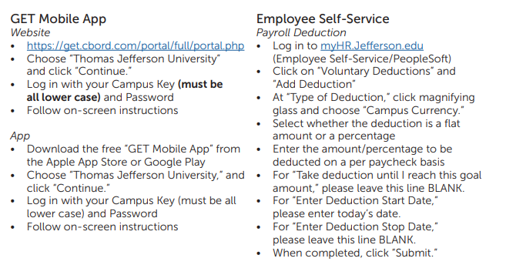 | Discussed
EMPLOYEE/
PEER RECOGNITION

EMPLOYEE QUESTIONS/ CONCERNS/  SUGGESTIONS |  | - Empty reagent and supply boxes left in the lab and store room should be placed in the trash room. This is not the lead tech’s job. This is everyone’s job.  - Adopt-a-Family: Lab will be supporting former employee Janice Baker and her family. Mary will be collecting for a gift card. See 11/15/2024 e-mail.  - On-call Supervisor: Please do not distribute a Supervisor’s personal cell phone number to staff members outside of the lab. If there is an issue off hours or on the weekends, staff should take the name and number of the outside lab member and call the supervisor with all the information. The Supervisor will return the phone call.  - ED: Staff reported issues with calling critical results and cancellations to the emergency room. Critical call line works but is not answered. When calling the main line, techs are placed on hold for several minutes or are bounced around to other pods. | Mary met with the ED on 11/21/2024 to address concerns. See 11/25/2024 e-mail follow-up.

