JEFFERSON EINSTEIN HOSPITAL
CORE LAB – Chemistry/HEMATOLOGY

subject: CORE LAB STAFF MEETING
ATTENDEES: EMILY PROULX, JOELLE GUAGLIONE, CHIAMAKA NWOGU, LAUREN ALKINS, ASMA SIDAT, ARIANA MOYETT, ALICIA DANIELS, HANNA HOWARD, NGOC LU, VESNA DUKLESKI, CHRIS LAGORE, ABDOU AOUTA, DEAN TO, KAREN CHAPPELLE, SHANICE BOBB, SUSAN GOODWIN, THOMAS TAT, LOURDES SANTIAGO, DEBORAH TODD
date: 4.10.2025
AGENDA
CATEGORY | TOPIC | ANNOUNCEMENT / UPDATE | DISCUSSION
CRITICAL VALUE NOTIFICATION | ED Critical Results Telephone Process New Pilot  (Effective 3/12/25)  Tiger Text    Critical Result Notification Documentation | 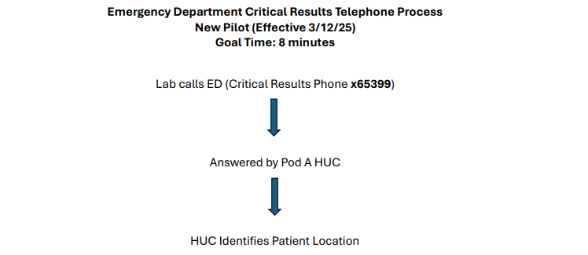  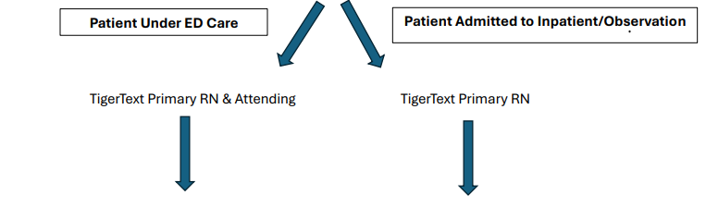  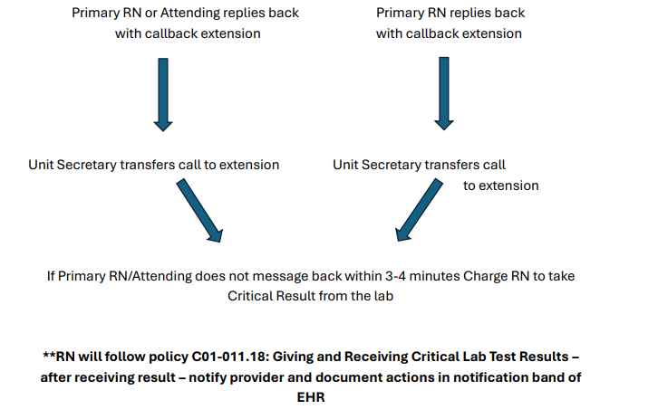  - Tiger Text is to be used ONLY to communicate with a caregiver that the laboratory has a cancellation and/or critical value that needs to be communicated and a call to the lab is needed. It is against Laboratory policy to communicate a result via Tiger Text.  - All critical results should be reported with the following documentation: First initial and last name of the RN or physician who took the result, date, time and verifying tech’s intials. | Discussed
TECHNICAL CHEMISTRY | Abbott Alinity Sample Probe Crashes & Cleaning  Critical Value Documentation | - The sample probe should be cleaned daily proactively to prevent buildup on the probes, probe crashes, and replacing of probes.  - This can be done when you take the instrument down for maintenance and are replacing the Acid Wash and Detergent solutions in the back of the instrument. Simply pull the probe towards you and wipe the probe with gauze and water. You must home the probe back to the position in was in before and press it down slightly so that it is aligned correctly.  - ALCI#1 – Daily maintenance already includes a step to clean the sample probe because we run whole blood HgbA1c on this instrument. However, when performing this step, the probe is seated on top of the wash cup and may be hard to clean well. We should be following the probe cleaning above for this instrument as well.  - When a probe needs to be changed, ensure that you are checking inside the instrument for spills, residue, left over gel, etc. This past weekend we changed 2 samples probes on the same instrument. When the second probe was changed it was identified that there was gel in the probe’s path and the wash cup on the instrument.  - Communication log – Please record issue, instrument, ticket number (if applicable) and tube & test was found when a sample probe crashes. This will help us identify if it is one particular kind of sample causing this issue (ex: Troponin).  - 100% Compliance for January & March 2025.  - February 2025 – (2) Critical values missing callback documentation.  - Please be sure to document critical callback information before releasing results.  - Please be sure to add critical callback documentation for ALL critical values when there are multiple critical values for a specimen. | Discussed  Techs requested that the KTR Taco & Cyclo critical results be treated similarly to Paley Nbil critical results and not warrant a call each time a critical is received. Mary to follow-up with Dr. Bhat.
TECHNICAL HEMATOLOGY | Body Fluid  Reporting Changes  PAT Anemia Reflex Panel  Critical Value Documentation  MCV & Platelet Delta Documentation  Body Fluid – Cytology Correlation (Dayshift) | - Automated Fluids = Report TC, WBC, RBC.  - If TC & WBC counts are relatively similar than you should not see “Other” cells in the differential.  - If TC & WBC counts are not similar you should have “Other” cells when performing the differential.  - Manual Fluids = Report TC & RBC. N/A WBC.  - TC will include lining cells, suspicious cells, etc. TC is not specific to white blood cells only.  - “Other” cells = Lining cells, Suspicious cells, Malignant cells  - If “Other” cells are reported, Comment: “Pathology review pending”  - New Orders:  1. CBC PAT Only  2. CBC w Diff PAT Only  3. H&H PAT Only  - Folate reflex testing has been added to Scenario 3: Hgb <12.0 & MCV >/= 105.0  - Mary working with IT to have Retic count included as the initial order. This will prevent tech errors in the event we miss adding the Retic count when the Hgb <12.0 criteria is met.  - 100% Compliance for January & February 2025.  - March 2025 – (2) Critical values missing callback documentation.  - Please be sure to document critical callback information before releasing results.  - Please be sure to add critical callback documentation for ALL critical values when there are multiple critical values for a specimen.  - Platelet critical values specifically are often released as the count was verified but the critical callback documentation is missing. Please make sure all critical callback documentation is present before releasing results.  - Dayshift – Because there is one tech on Sysmex and one on Diffs, you can consult with your counterpart to verify a call was made to relay the critical result to the patient’s caregiver.  - MCV & Platelet deltas should be investigated and footnoted prior to releasing results.  - It is unacceptable to release an MCV delta result stating that IV fluids or transfusions weren’t received.  - If an MCV delta cannot be explained based on the patient’s state, we should be requesting a second sample for confirmation.  - Please make sure that you are checking to see if this report is available daily. This is listed as one of the duties of the Special Heme bench tech daily. | Discussed
GENERAL CHEMISTRY/ HEMATOLOGY UPDATES | Time and Attendance  Lunches and Breaks  Cell Phones | - Employees may swipe in up to six (6) minutes prior to the start of the scheduled shift or swipe out to six (6) minutes prior to the end of the scheduled shift. This is not a grace period that excuses late arrivals or early departures. Employees are expected to be at the workstation and ready to begin work at the start of the shift.  - Incidental OT is being reviewed by senior leadership for all departments. Mary needs to approve any additional time needed to clock in early or clock out late.  - Lunch times- Dayshift please follow the schedule. Schedule is posted on the board above the Chemistry daily checklist binder. Breaks are to be 15 mins and only if work and staffing allows. Lunches are 45 minutes. Remember missed breaks should be approved by a supervisor. All employees are now receiving the same lunch deductions and must follow the 45 min lunch schedule as discussed. This was discussed at the last four meetings and employees on day and night shift are still not adhering to the 45-minute lunch break.  - Cell phone and headphone use is prohibited in the laboratory. Please see AD03-004 Use of Personal Electronic Devices policy on MediaLab. | REMINDER
MISLABELED SPECIMEN PROCESS |  | If a mislabeled specimen is identified, please perform the following steps:  - Cancel the specimen as mislabeled and notify the floor.  - If the patient has labs from other departments from the same draw, notify the other departments.  - An IQE must be created in MediaLab and an OnPoint event must be reported. If time is an issue, please create the IQE event in MediaLab and the Supervisor will take care of OnPoint report.  - Notify Supervisor immediately via e-mail or leave a copy of IQE in Supervisor’s door.  - Supervisor to communicate mislabeled specimen to QA Manager and Hospital Safety. | REMINDER
SAFETY | Review of IQE/OnPoint Events  Safety Concerns? | - January 2025 – No OnPoint Events  - February 2025 –  - Chemistry –  - ED reported Screen8 took 4.5 hours to result and required multiple tubes. First Screen8 Mg Phos (Acc# 25-041-4470) ordered in Cerner for 2/10/25 13:13 shows PPID/PAID collection performed by AXB934 at 13:36 but tube never received in the lab. Second Screen8 Mg Phos (Acc# 25-041-6099) order in Cerner 17:19 shows PPID/PAID collection performed by AXB934 at 17:29 but specimen not received in the lab until almost an hour later at 18:23. Specimen received on the chemistry track at 18:30 and majority of results released at 19:01 with the exception of the critical Sodium level and BUN level that required a dilution. Critical Sodium level was reported at 19:47 to T. Hopman by performing tech. Total lab turnaround time from received to verified was 84 minutes. No deviation from laboratory policy present. Delay expected on lab side when repeat testing indicated for dilution protocol.  2. ED reported several urinalysis delayed hours causing dispo delays in the ED. Would take up to 2+ hours for urinalysis to result. Acc# 25-051-0834 PPID collection performed 2/20/25 at 3:13. Specimen received in-lab at 4:06. Review of the analyzer shows that the specimen was analyzed at 4:21. Results not released until 6:33. Spoke with verifying tech this morning. Tech stated she was working in the Chemistry department and received a phone call from the ED regarding this sample. She checked that the sample was performed, reviewed the analyzer print out for flags, and released the results. Delay due to Hematology tech being on lunch break as only one tech covers Hematology and Urinalysis on night shift. Service-related issue.  - Hematology – Unable to log into TEG manager from computer in OR 6, resulted in delayed results and potential harm of delayed correction of coagulopathy of patient. TEG Manager is accessible from any Einstein computer using Google Chrome or Internet Explorer by typing egrap-tegman1 in your search bar. Checked user's credentials and he has been listed as a user in the system since 8/2023. No other reports provided to the lab that TEG Manager was not functional on day of report.  No safety concerns | Discussed
EMPLOYEE ISSUES | Competency  CON ED and Electronic Assignments | - Please remember it is your responsibility to provide the supervisor with all necessary documentation for your competency. Lines one and four need to have direct observation of you performing those tasks on that specific bench. By signing your initials, you are stating you watched that individual perform the duties correctly as it is instructed in the procedure. Please remember a direct observer for competency must hold a four-year degree (AD01-027 New Employee Orientation).  - Lead Techs will still provide staff with unknown samples at the beginning of the month for those samples that are stable. Employees must have competency completed prior to the end of your assigned month.  - Failure to complete any annual compliance will result in accountability actions.  MediaLab/MedTraining/MyJeffHub/Competencies: You must complete the assignments on time. These are all a part of the annual eval. We should not have to remind anyone numerous times. Clarification to the Admin Procedure- It is for the employee’s calendar year.  Ex: if you are hired in February you can collect paperwork from February to February. | REMINDER
CAP INSPECTION | 2024-2025  CAP Inspection | - CAP On-Site Inspection window will open in December 2025 through March 2026.  - Please be mindful of proper PPE, the importance of open and expiration dates on reagents and solutions, recording results on manual logs correctly, etc. | Discussed
ENTERPRISE/ HOSPITAL/  LAB NEWS | Overtime & Incentive Shift Bonus  Coming Down the Pipeline | - Saturday, August 2nd will be the last time the Incentive Shift Bonus is offered for the department. OT will also be void after this date. MedPro employees expected to be trained and working on night shift by mid-July.  - EPIC go-live expected September 2026  - New coagulation instruments ACL TOPS 570 expected in 2025.  - Upgraded Sysmex instrumentation expected in 2026.  - New chemistry instrumentation expected in 2027. | Discussed
EMPLOYEE/
PEER RECOGNITION

EMPLOYEE QUESTIONS/ CONCERNS/  SUGGESTIONS |  | Peripheral Smears for the CAC –  - Add ons being received Friday or Saturday night with a request for smear for next morning’s specimen. This contributes to delay because we do not have the specimen and it is received during the morning workload. Currently, night shift techs passing the Add on orders to day shift staff when they do not have the specimen. Mary to follow-up with Dr. Bhat to see if it is acceptable to provide a peripheral smear on the specimen currently available in the lab.  - Add ons are completed by CP staff before giving the orders to Hematology. However, the actual peripheral smear may not be ready for several hours later based on specimen availability. Perhaps dayshift should be completing these Add on order. Mary to follow-up with Vanessa regarding this change in workflow.

