JEFFERSON EINSTEIN PHILADELPHIA HOSPITAL
CORE LAB – Chemistry/HEMATOLOGY

subject: CORE LAB STAFF MEETING
ATTENDEES: aNNETTE dAWSON, ARIANA MOYETT, CHIAMAKA NWOGU, ROSE ANN MANABAT, NGOC LU, ASMA SIDAT, KAYLA-SHAY ORUSKA, JAME MATTHEW FLORES, ROGINE REYES, MONICA KWON, JORIZA SANCHEZ, YAO AMEWOA, ALLEN DU, COURTNEY LE, GAUTHAMI VACHALAM, KAREN CHAPPELLE, DEBBIE TODD, SUSAN GOODWIN
date: 3.19.2026
AGENDA
CATEGORY | TOPIC | ANNOUNCEMENT / UPDATE | DISCUSSION
CRITICAL VALUE NOTIFICATION | ED Critical Results Telephone Process New Pilot  (Effective 3/12/25)  Tiger Text    Critical Result Notification Documentation | 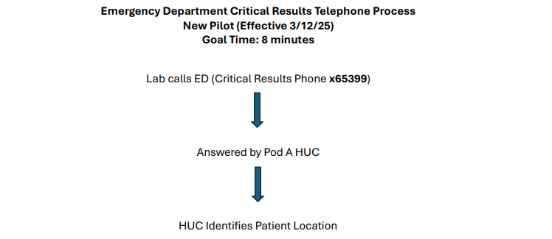  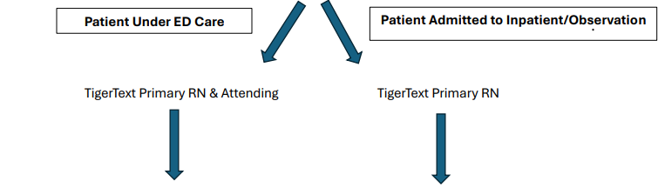  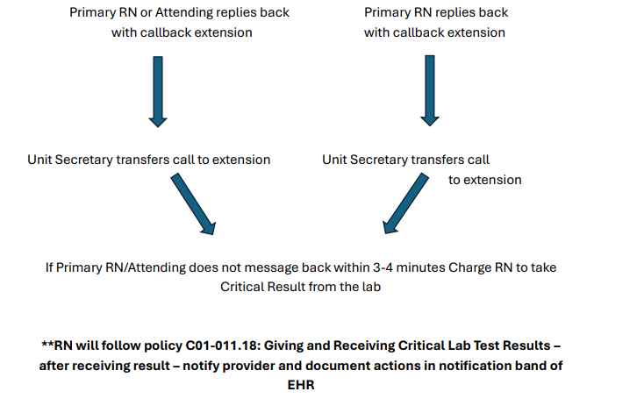  - Tiger Text is to be used ONLY to communicate with a caregiver that the laboratory has a cancellation and/or critical value that needs to be communicated and a call to the lab is needed. It is against Laboratory policy to communicate a result via Tiger Text.  - All critical results should be reported with the following documentation: First initial and last name of the RN or physician who took the result, date, time and verifying tech’s initials. | Discussed  Mary and Joelle met with ED leadership 3/19/2026 to discuss ongoing concerns.  Cancellations:  ED leadership requested that when calling with a cancellation you state that upon the initial phone call so the HUC can take the cancellation.  Critical Values:  ED leadership to remind HUCs of correct process and escalating to charge nurse if no response from RN & Attending via TigerText.
TECHNICAL CHEMISTRY | Critical Value Documentation  Receiving Reagents/Supplies  New Lots of Calibrators/QC  Maintaining Reagents/Supplies Onboard Instruments  New Reagents/  Validations | - January 2026 – (1) Critical value missing callback documentation.  - February 2026 – (5) Critical values missing callback documentation.  - Please be sure to document critical callback information before releasing results.  - Please be sure to add critical callback documentation for ALL critical values when there are multiple critical values for a specimen.  - Please be mindful of the correct critical callback documentation to be used – L&D Mg <8.0, Ped Clinic Bili, Troponin trending down, etc.  - It is the responsibility of ALL techs to receive delivered reagents and supplies in the laboratory. The Laboratory Receiving Log should be completed accurately with the received date, product, quantity, lot number, expiration date, and receiving tech’s initials.  - All reagents and supplies received should be stored according to the manufacturer requirements. If there are reagents and/or supplies in the hallway that are temperature sensitive, and you are not able to get to them during your shift, they should be placed in the walk-in for the next shift.  - Please be mindful when opening new lots of calibrators and quality control. DO NOT open a new lot if the current lot is still on the shelf. If a new lot of calibrator is opened, the lot needs to be defaulted on all applicable instruments. If a new lot of quality control is opened, the lot needs to be defaulted on the instrument and in Cerner.  - Lead techs take the time to place “New Lot” stickers when applicable for all inventory. This takes time and is done to your advantage!  - It is the responsibility of the tech performing maintenance/QC on the instrument to make sure there are enough reagents and supplies onboard for 24 hours or until the next time maintenance/QC is performed. However, be mindful of which reagents you are “loading up”. You may want to double up on tests within the Screen8 panel, but if there are 10 Complement C3 or Prolactin tests remaining onboard, you may hold off on loading a new reagent due to low test volumes.  - There should always be two Acid Probe Wash reagents onboard each instrument.  - Abbott Sigma Strong Reagents – We have transitioned to the new formulations of Lactic Acid and Phosphorus. We still need to move to the new formulations of the following reagents: ALT, AST, GGT, Total Protein, and Uric Acid. There are significant differences in reference ranges from current formulations.  - NT-proBNP – BNP being moved to the Alinity instruments pending completion of IT build. In the interim, we will be ordering 100T kits of BNP for the Architect which can be used on the i2000 #2.  - HAVAG – Reagent to be updated in the beginning of April. No significant changes between new formulation and current formulation.  - Urinalysis Instrument – In aligning with the enterprise and transitioning to EPIC, we will be changing how we report the urine dipstick from qualitative results (Small, Mod, Large, etc.) to numeric results (1+, 2+, 3+). The timeline is not established currently. | Discussed
TECHNICAL HEMATOLOGY | Body Fluid QC  Reporting Changes  PAT Anemia Reflex Panel  Critical Value Documentation  MCV & Platelet Delta Documentation  CAC Peripheral Smears  Bone Marrow  TEG 6s | - Manual Body Fluid Log = Report TC, RBC.  - Manual Fluids = Report TC & RBC. N/A WBC.  - TC will include lining cells, suspicious cells, etc. TC is not specific to white blood cells only.  - “Other” cells = Lining cells, Suspicious cells, Malignant cells  - If “Other” cells are reported, Comment: “Pathology review pending”  - New Orders:  1. CBC PAT Only  2. CBC w Diff PAT Only  3. H&H PAT Only  - CBC w Diff PAT Only issue with Diff not performing on the instrument – Cerner resolution: If Diff is not performed, print accession label “B” and label the specimen with label “B”. Diff should perform.  - 100% Compliance for January 2026  - February 2026 – (1) Critical values missing callback documentation.  - Please be sure to document critical callback information before releasing results.  - Please be sure to add critical callback documentation for ALL critical values when there are multiple critical values for a specimen.  - Platelet critical values specifically are often released as the count was verified but the critical callback documentation is missing. Please make sure all critical callback documentation is present before releasing results.  - Dayshift – Because there is one tech on Sysmex and one on Diffs, you can consult with your counterpart to verify a call was made to relay the critical result to the patient’s caregiver.  - MCV & Platelet deltas should be investigated and footnoted prior to releasing results.  - It is unacceptable to release an MCV delta result stating that IV fluids or transfusions weren’t received.  - If an MCV delta cannot be explained based on the patient’s state, we should be requesting a second sample for confirmation.  - The peripheral blood smear order is now available in Cerner.  - IT is still working on changing the order from a gold top tube to lavender.  - Regarding add-ons, when the physician places the add-on order, CP staff will add the peripheral blood smear to the most recent CBC in the system. Once its added, you will be able to see the order on the Heme Man pending log.  - CP will bring the hematology tech the add-on paper with the label for the order.  - It is the special bench techs responsibility to prepare the peripheral blood smear if it is not available already and complete the order in Cerner.  - Completed slides should be sent to the CAC unless specified otherwise in the add-on order.  - When receiving bone marrow slides, you may see an additional EDTA tube with a chart label submitted by a physician.  - Do not create an order for the EDTA tube. This tube should be used to create the peripheral blood smear that should be submitted with the stained bone marrow slides.  - There is a rack located in the hematology fridge labeled “Bone Marrow (Lavender Top” to store the sample after smear preparation.  - Global Hemostasis-HN Cartridge. Pending go-live date 4/14/2026.  - The Citrated: K, KH, RTH, FFH assay cartridge is intended to be used in patients where heparin/heparinoids may be present and who are at an increased risk of coagulopathy.  - The Global Hemostasis HN cartridge will replace the TEG Citrated panel currently in use.  - All TEG panels, with the exception of Platelet Mapping, will no longer be submitted for pathology review. Result interpretation will be performed within TEG Manager for physician review. | Discussed  Question:  If a TEG specimen is marked as unknown in the Sysmex system, how will the physician be able to view the trend and results in TEG Manager?  Joelle spoke with Jenna, Haemonetics Clinical Specialist, who explained that if a TEG specimen appears as “unknown” in the system, it means the patient is unregistered; however, physicians can still access the patient’s trends and results in TEG Manager by searching using the patient’s MRN number.
GENERAL CHEMISTRY/ HEMATOLOGY UPDATES | Time and Attendance  Lunches and Breaks  Cell Phones | - Employees may swipe in up to six (6) minutes prior to the start of the scheduled shift or swipe out to six (6) minutes prior to the end of the scheduled shift. This is not a grace period that excuses late arrivals or early departures. Employees are expected to be at the workstation and ready to begin work at the start of the shift.  - Incidental OT is being reviewed by senior leadership for all departments. Mary or Joelle needs to approve any additional time needed to clock in early or clock out late.  - Lunch times- Dayshift please follow the schedule. Schedule is posted on the board above the Chemistry daily checklist binder. Breaks are to be 15 mins and only if work and staffing allows. Lunches are 45 minutes. Remember missed breaks should be approved by a supervisor. All employees are now receiving the same lunch deductions and must follow the 45 min lunch schedule as discussed. This was discussed at the last four meetings and employees on day and night shift are still not adhering to the 45-minute lunch break.  - Cell phone and headphone use is prohibited in the laboratory. Please see AD03-004 Use of Personal Electronic Devices policy on MediaLab. | REMINDER
MISLABELED SPECIMEN PROCESS |  | If a mislabeled specimen is identified, please perform the following steps:  - Cancel the specimen as mislabeled and notify the floor.  - If the patient has labs from other departments from the same draw, notify the other departments.  - An OnPoint event must be reported.  - Notify Supervisor immediately via e-mail or leave a copy of OnPoint in Supervisor’s door.  - Supervisor to communicate mislabeled specimen to QA Manager and Hospital Safety. | REMINDER
SAFETY | Review of IQE/OnPoint Events  Safety Concerns? | - January 2026 –  - Chemistry –  - Nurse called the lab inquiring about the patient's Potassium results. Patient had a Screen8 (Acc# 26-012-1455) performed on 1/12/26 at 9:30 with a Potassium result of 5.5. The next lab draw for Potassium (Acc# 26-012-5286) was a result of 4.5 at 15:39. Potassium was repeated (Acc# 26-012-5866) and the result was 5.4 at 16:02. Nurse Anna Psillos told chemistry tech K. Benz 1/13/26 that the 4.5 result was incorrect and the wrong patient was collected. Tech consulted with Chemistry manager and results were removed for that specimen. Reviewed with NP Psillos who saw a 1.0 drop in residents K level and suspected inaccurate reading, she requested a repeat lab which was found to be accurate. Mis-ID by floor  - Surgery had pulled additional fluid from JP tube, nursing not made aware. Fluid was put in urinal, unlabeled at bedside. RN later went to bedside assuming the urinal was filled with urine as the color was consistent with urine. UA and nephro panel sent. Later nurse bladder scanned pt and it was large volume in bladder and RN said to wife, "that's a lot of urine for having a full urinal", Wife of pt noted that it was not urine and it was from when the doctor had taken fluid from abdomen. MD notified, lab notified to cancel resulted labs. Mis-ID by floor  - Hematology –  - BF Cell Count not sent for Path review. Cytology report is positive for malignancy. The error was discovered when reviewing the body fluid to cytology correlation report. OnPoint submitted internally. Slide reviewed with performing tech for employee education. | Discussed
EMPLOYEE ISSUES | Competency  CON ED and Electronic Assignments | - As we transition to EPIC in September 2026, all competencies will be set-up earlier for employees with the expectation that competencies are completed by August.  - Please remember it is your responsibility to provide the supervisor with all necessary documentation for your competency. Lines one and four need to have direct observation of you performing those tasks on that specific bench. By signing your initials, you are stating you watched that individual perform the duties correctly as it is instructed in the procedure. Please remember a direct observer for competency must hold a four-year degree (AD01-027 New Employee Orientation).  - Lead Techs will still provide staff with unknown samples at the beginning of the month for those samples that are stable. Employees must have competency completed prior to the end of your assigned month.  - Failure to complete any annual compliance will result in accountability actions.  MediaLab/MedTraining/Workday/Competencies: You must complete the assignments on time. These are all a part of the annual eval. We should not have to remind anyone numerous times. Clarification to the Admin Procedure- It is for the employee’s calendar year.  Ex: if you are hired in February you can collect paperwork from February to February. | Discussed
ENTERPRISE/ HOSPITAL/  LAB NEWS | Wellness Credit  Annual Mandatory Required Education (AMRE)  Coming Down the Pipeline | - Eligible employees who complete the program requirements within the designated timeframe will receive $15 each pay period.  - Deadline: March 31, 2026 to earn the wellness credit for the July 1, 2026 to June 30, 2027 plan year.  - 2026 Annual Mandatory and Required Education (AMRE) and Code of Conduct Training Deadline is June 14, 2026.  - Document Control  - MediaLab to PolicySTAT transition ON HOLD. MediaLab contract extended through March 2027.  - Instrumentation  - Coagulation – Teg 6s – Global Hemostasis-HN Cartridge: Pending go-live date 4/14/2026  - Hematology – Sysmex XN-3100  - Main Lab – Equipment delivery 3/24/2026  - Cancer Center – Equipment delivery 3/30/2026  - Chemistry – Roche expected in 1st QTR 2027  - Informatics  - EPIC – Go-live Saturday, September 26, 2026  - CCV Phase 3 Validation Testing: 5/25/2026-7/3/2026  - Schedule  - Transition to MySchedule – All employee schedules will be completed in 12-week increments. No update. | Discussed
EMPLOYEE/
PEER RECOGNITION

EMPLOYEE QUESTIONS/ CONCERNS/
SUGGESTIONS

