**TITLE: Ordering and Receiving Tests in LCC**

PRINCIPLE: To ensure all staff can properly order tests into Soft and to receive all specimens into Lab

# STEPWISE PROCEDURE:

1. **Written order from physician/floor**
2. **Log in to Soft**
3. **Go to order entry** 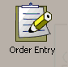
4. **Type in patient information, you may type in name or you may choose to type in the billing number or Medical Record number.**

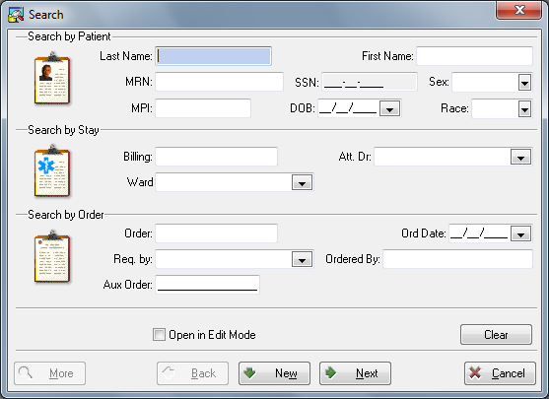

1. **If you choose to use Name or Medical Record number you will have to make sure you choose the correct visit. If you use the billing number you will have only that visit appear. Choose “new” then “new order”to add another order.**

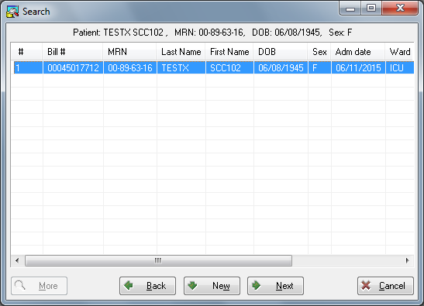

1. **Ordering box will appear. If you know the ordering code, SOFT or Quest you can enter here (black arrow). You can also use the Keypad by checking the box in front of test needed, (red arrow), or you can search the test menu for the test by hitting “insert” and whe screen comes up typing in the test you are searching for, (purple arrow).**

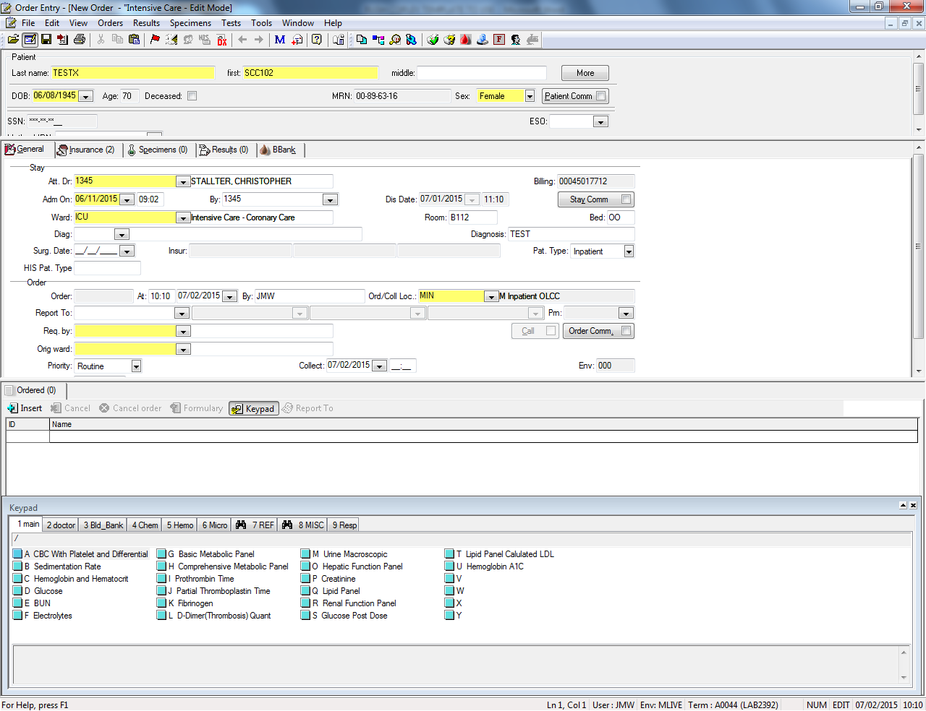

1. **Pm box, (black arrow) is for faxing results to Nonstaff physicians.**

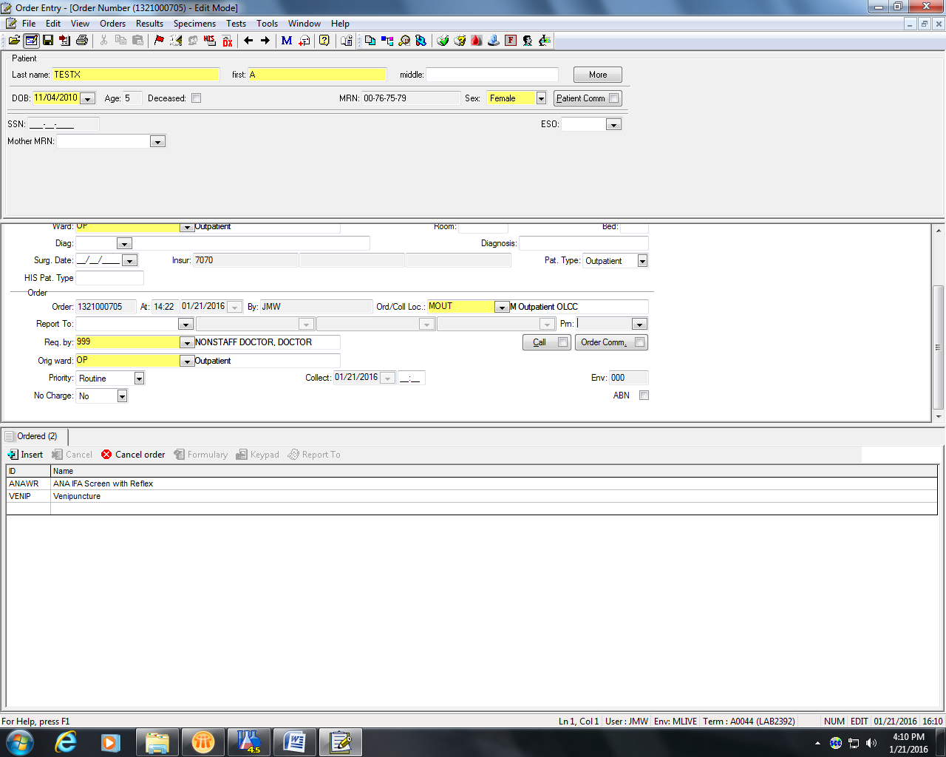

1. **Click on drop down arrow of box and select modem**

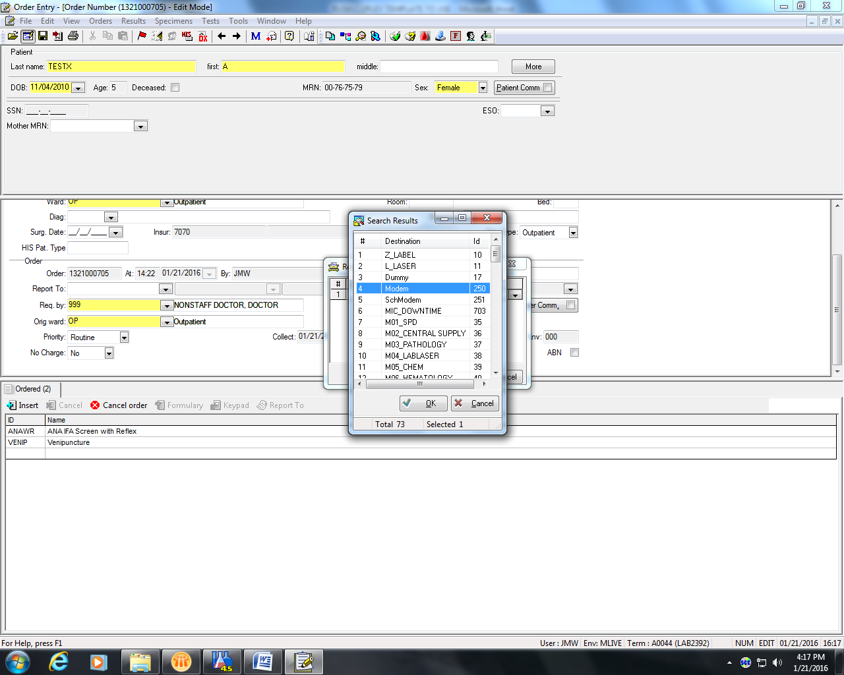

1. **Bottom middle type in phone fax number in this format 9,1 area code (black arrow) and number and hit OK (red arrow)**

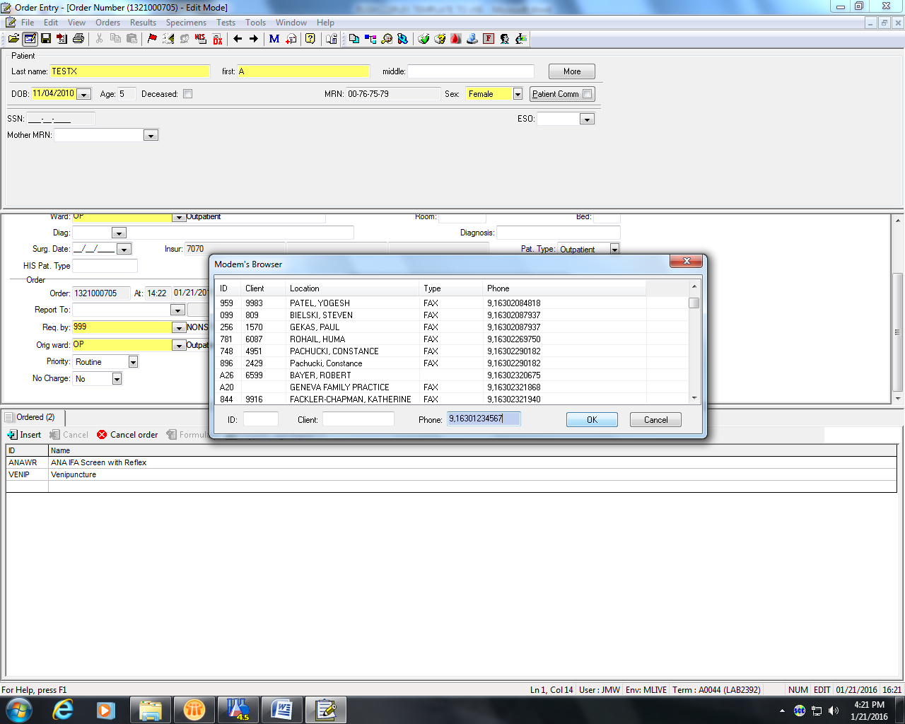

1. **Check number to make sure it is correct (black arrow) and repeat steps if more then one fax number is needed. Hit OK (red arrow). Fax number(s) will now auto fax when testing is completed and verified.**

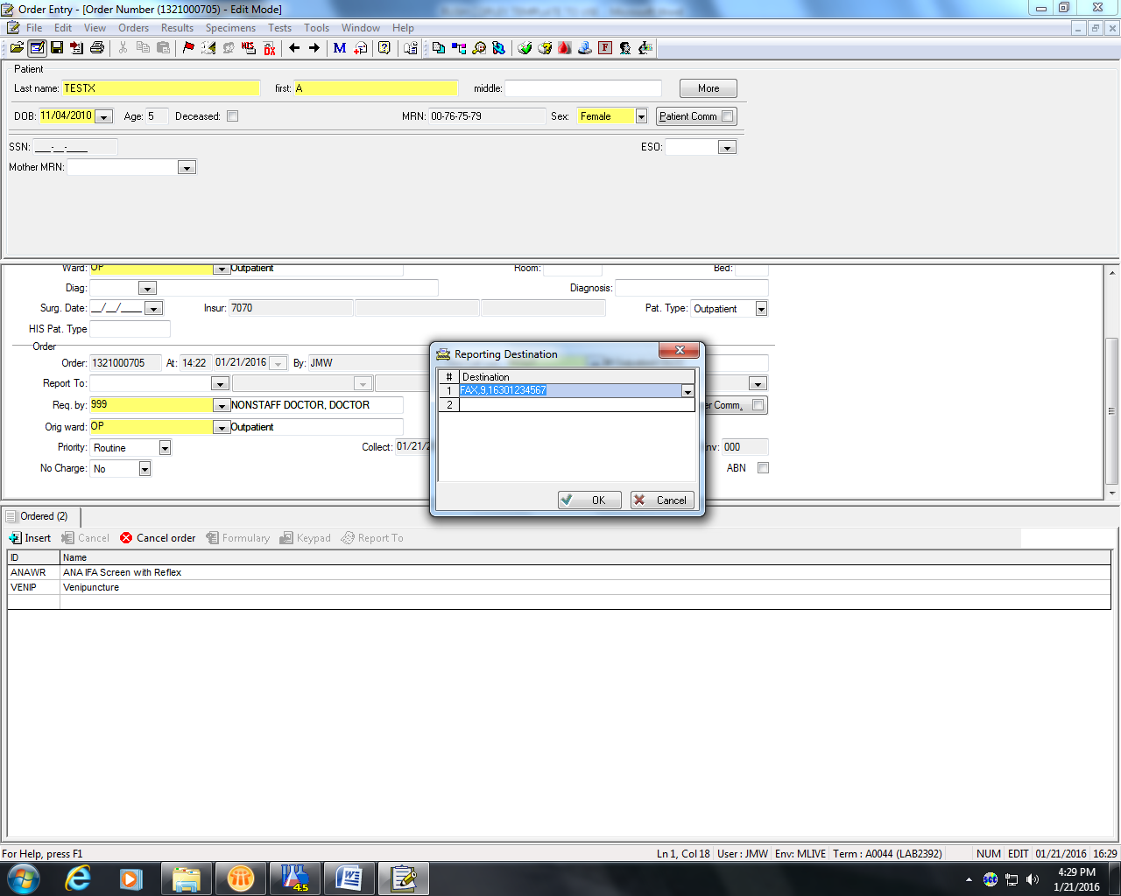

1. **When ordering is complete hit the save button (black arrow)**

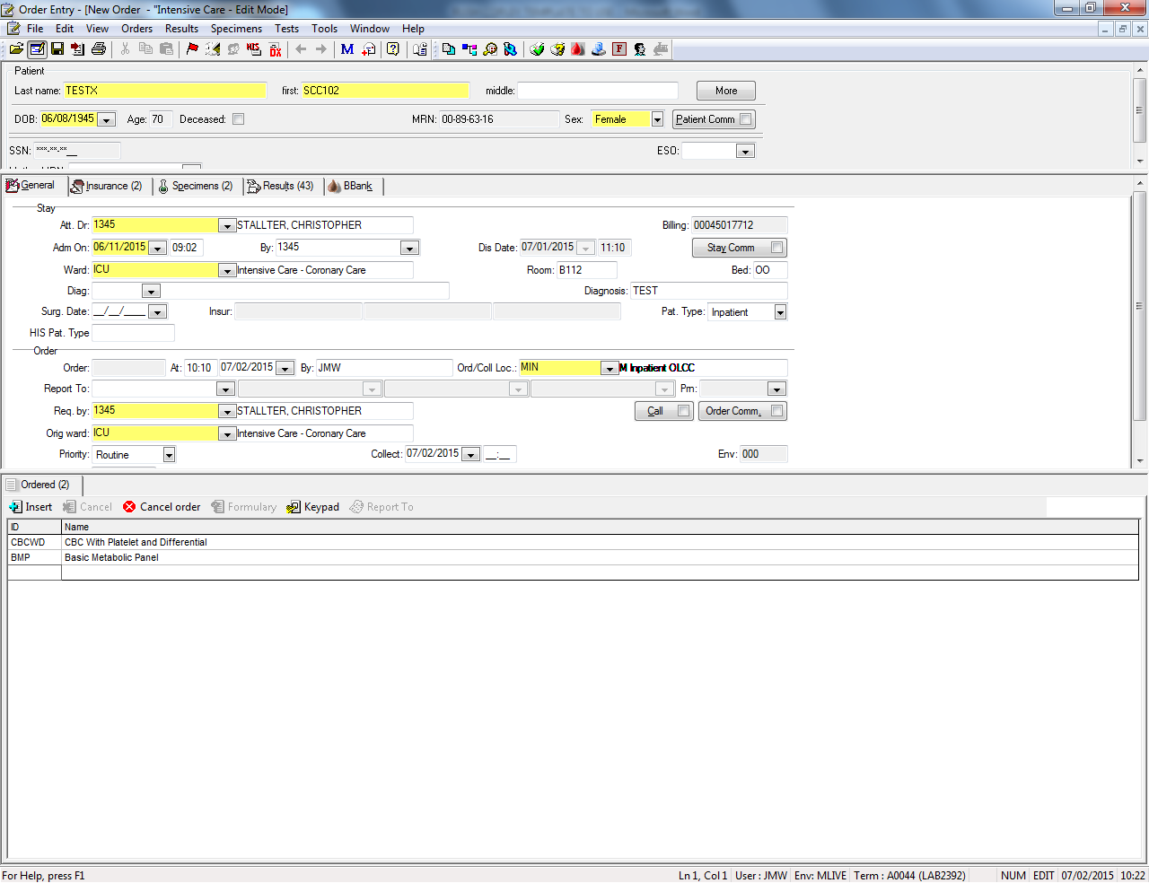

1. **Collect specimens from patient if in the Outpatient Center using Soft ID and send to lab for receiving.**
2. **If specimens have already been collected and tests just needed to be ordered, example cultures that came from surgery, order tests as stated above.**
3. **Choose Receiving ICON, (black arrow), or Phlebotomy from the Tree (red arrow), or the task bar (purple arrow). Under the tree or task bar choose “receiving” from the drop down menu (blue arrow).**

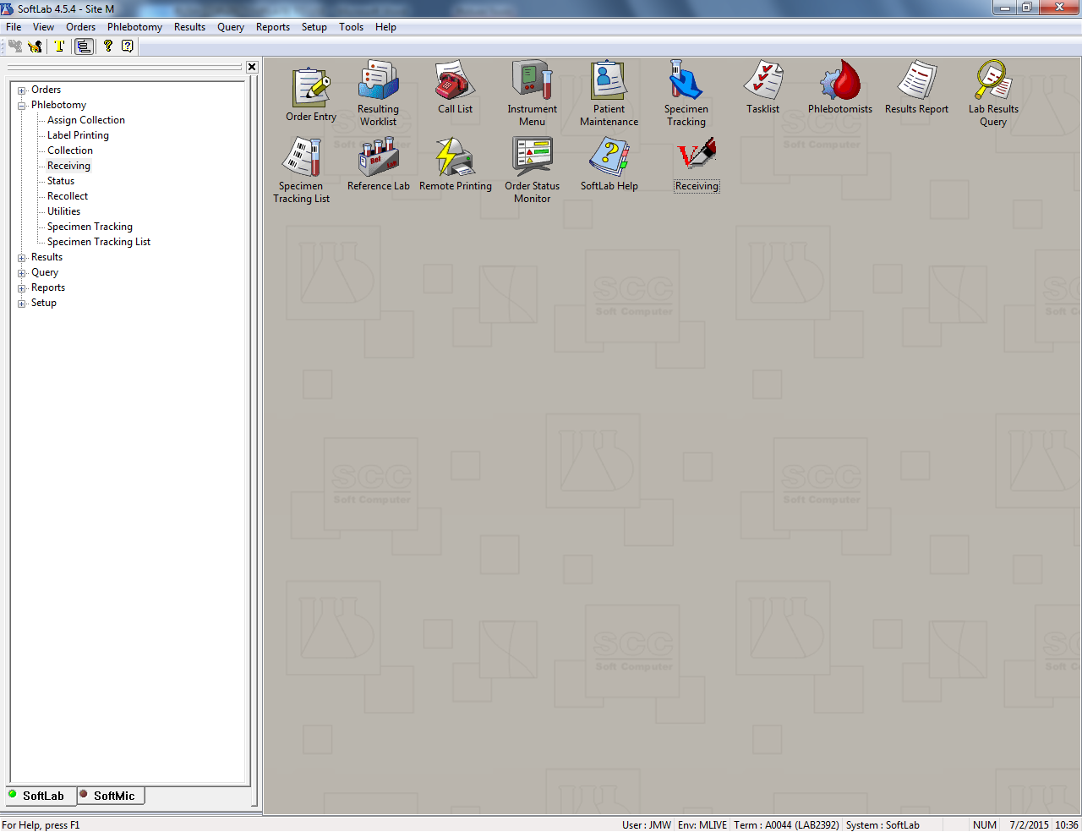

1. **On this screen if you have more then one test to receive in make sure that Batch receiving is checked (black arrow).Make sure curser is flashing in the box that says Order (red arrow). Scan each specimen tube bar code until all specimen tubes have been scanned. Note – make sure correct label is on tube – example CBC on lavender tube.**

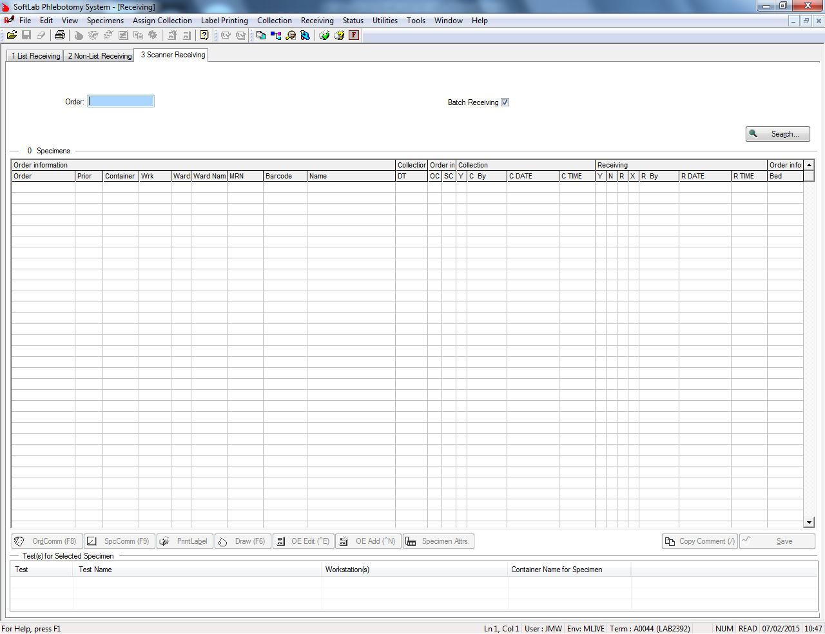

1. **Scanned tubes will present on list as each tube is scanned. When all tubes have been scanned click on “Receive in All” tab (black arrow). All specimens will then be received into the lab.**

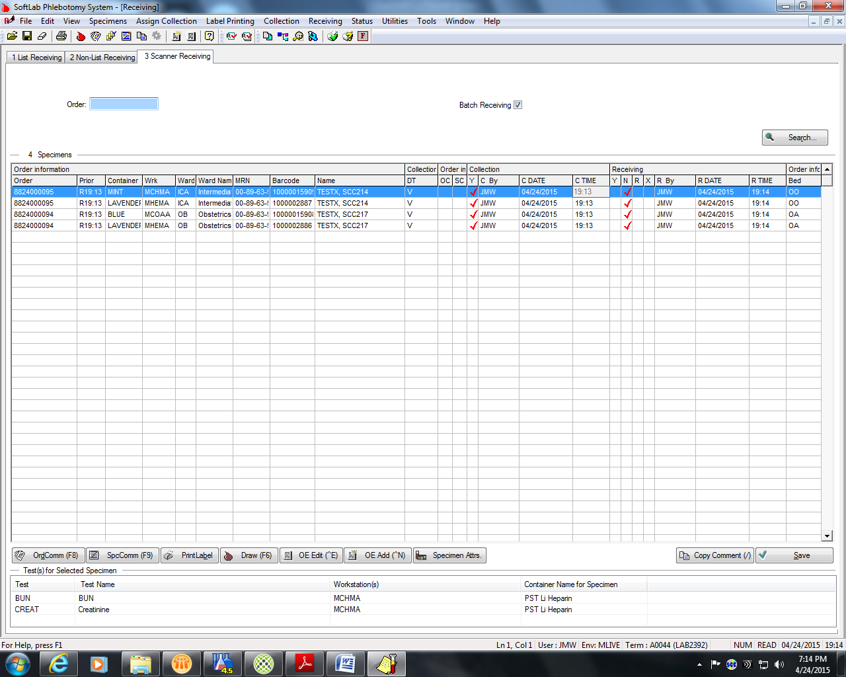

1. **Deliver all specimens to the appropriate Laboratory Departments.**

**REFERENCE: Super User Training and SOFT Gen Lab Training Guide**

H:\RUSH-Procedure Template.doc