**TITLE:** Scanning of Non-InterfacedReferral Testing

*PRINCIPLE: Scan original document from referral labmaking it viewable in the electronic medical records*

# Personnel: LCC Staff and Phlebotomists

**STEPWISE PROCEDURE:**

Choose order entry

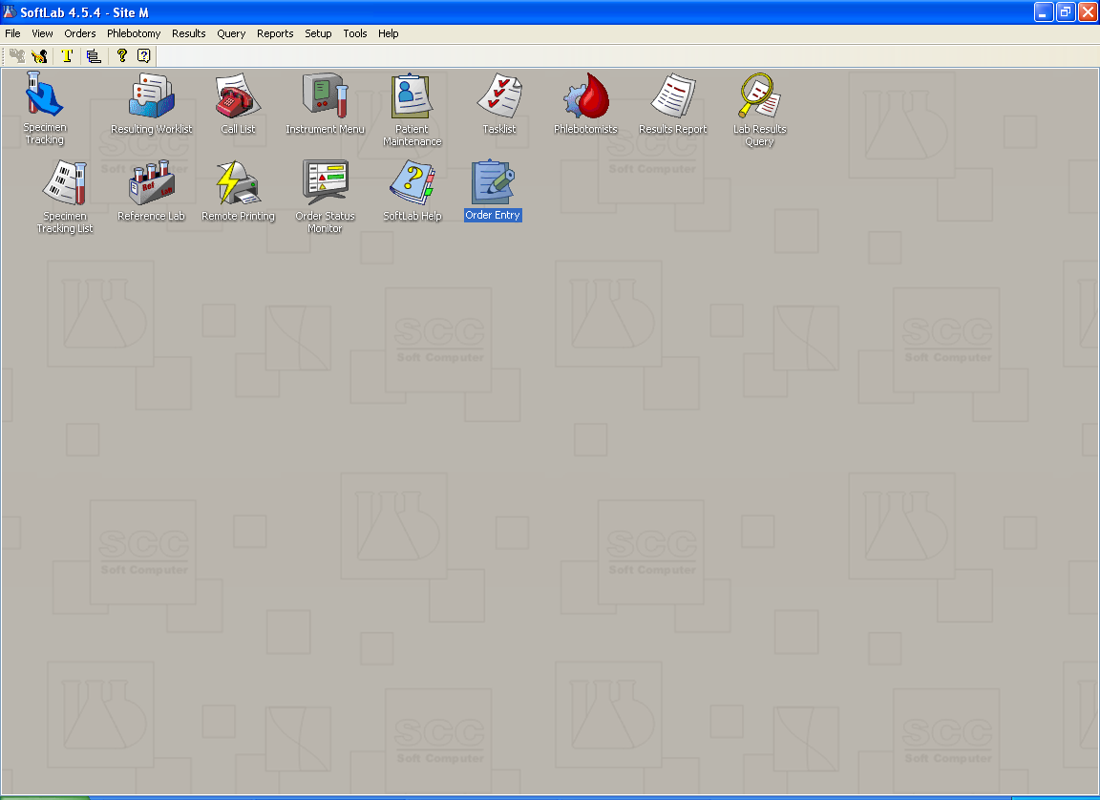

Enter Patient Name

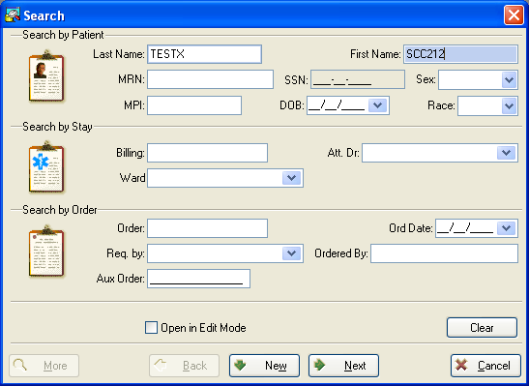

Choose correct patient

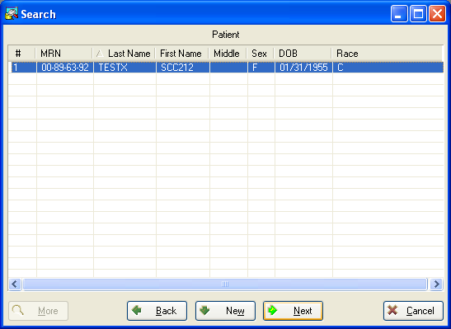

Choose Correct Order

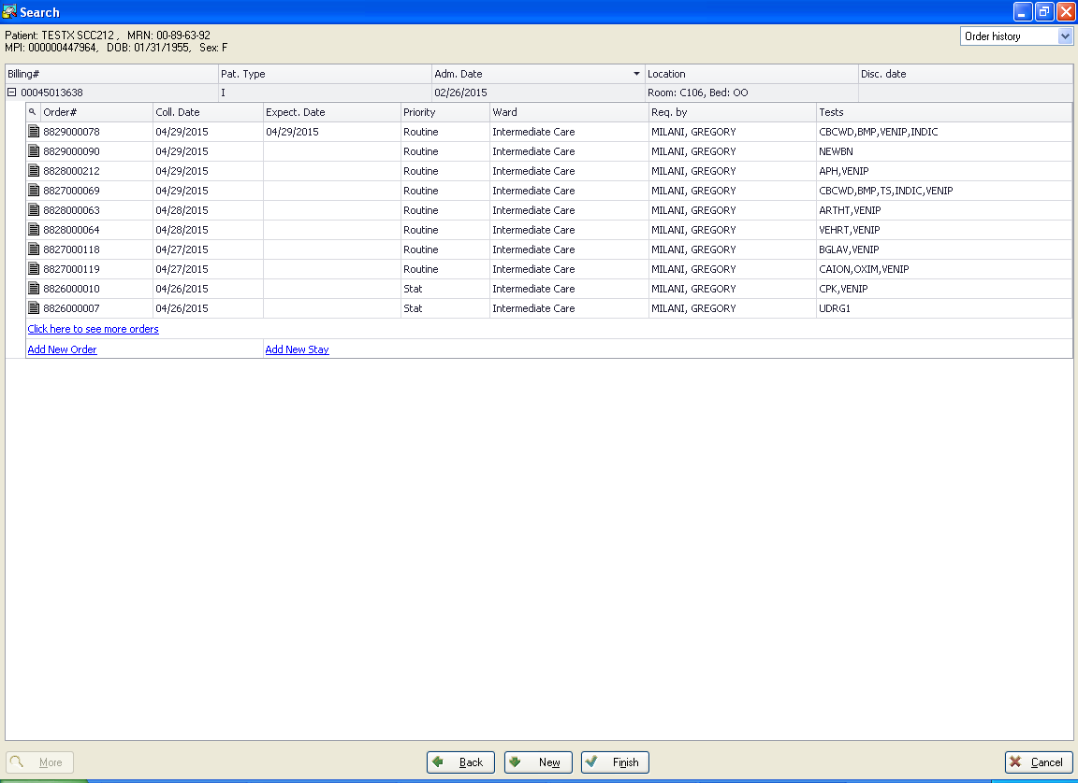

Choose Soft Media – Black Arrow

Soft Media will appear on bottom of screen – Red Arrow

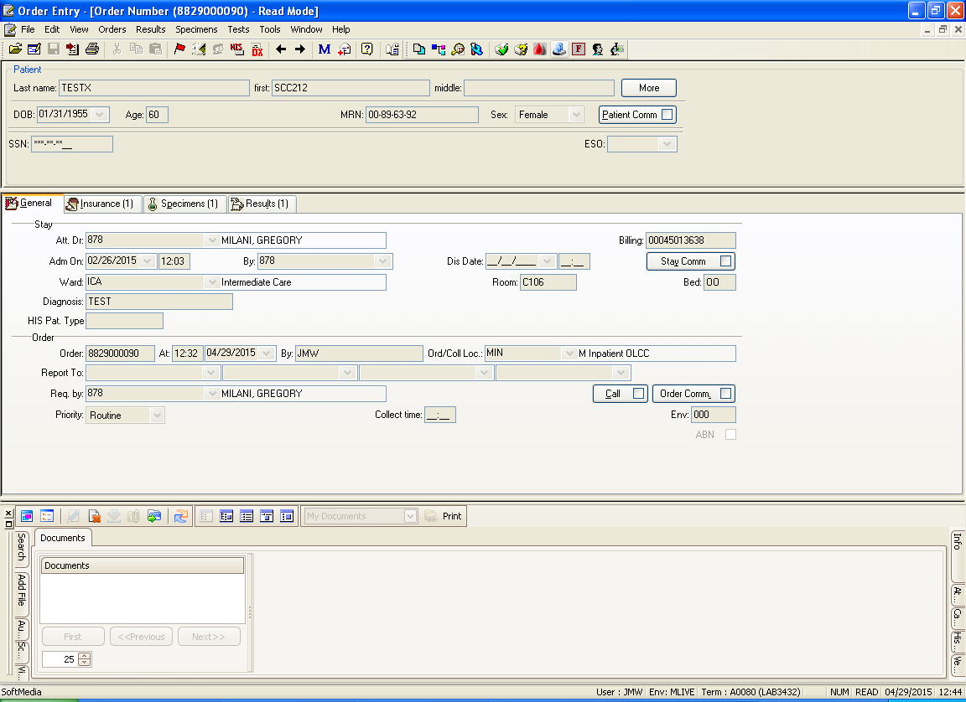

Choose Scanning

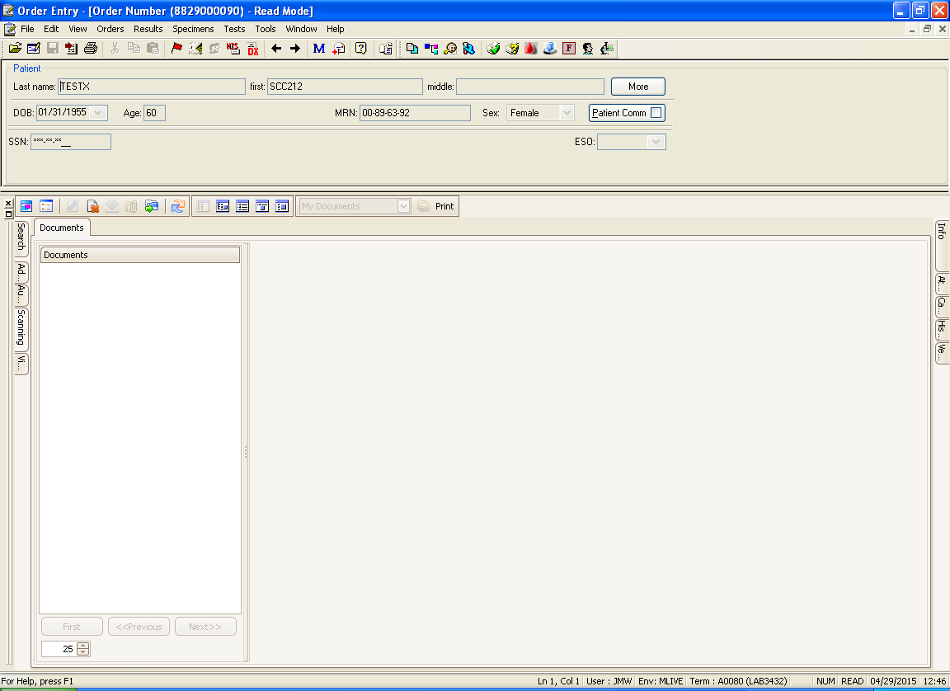

Choose Template

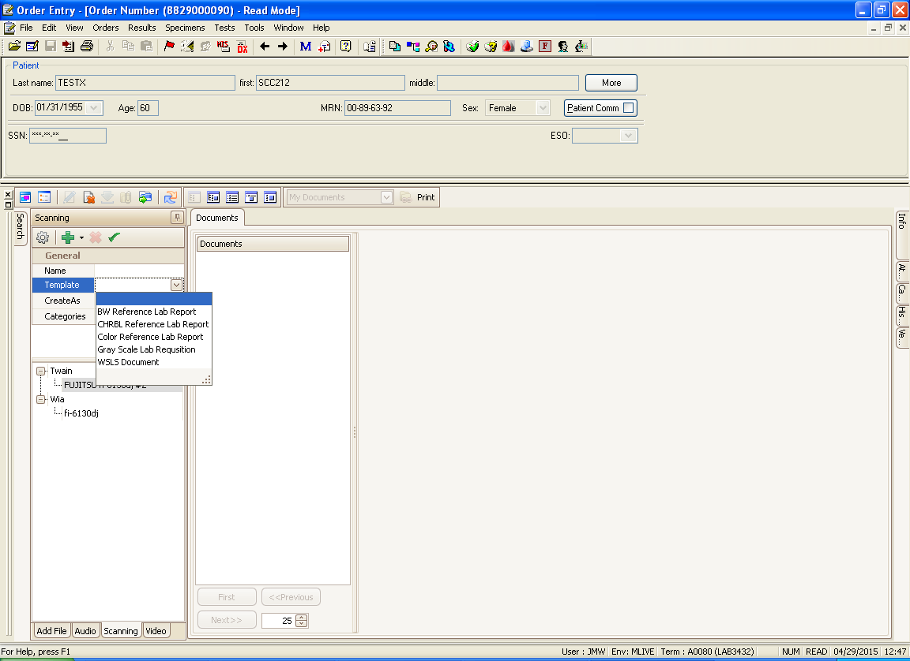

Enter Test Code (black arrow) and Highlight Printer (red arrow). Place report to be scanned on scanner and click on green checkmark. Document will now scan.

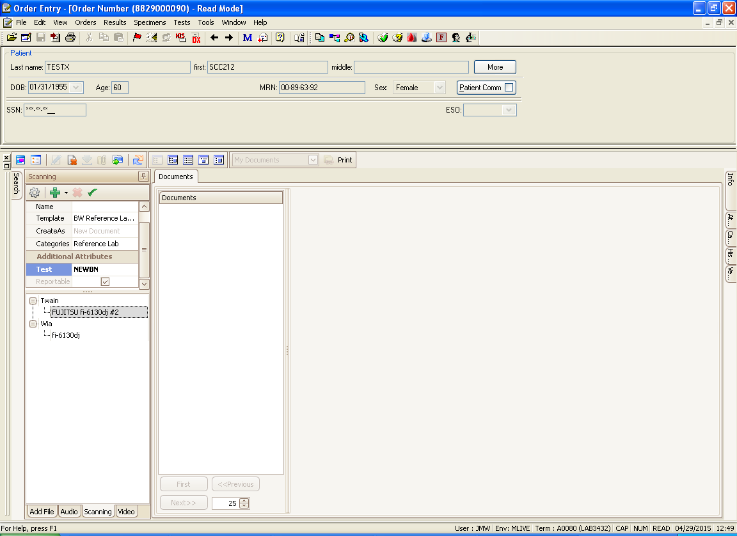

Scanned Document

Click on “Link Document”

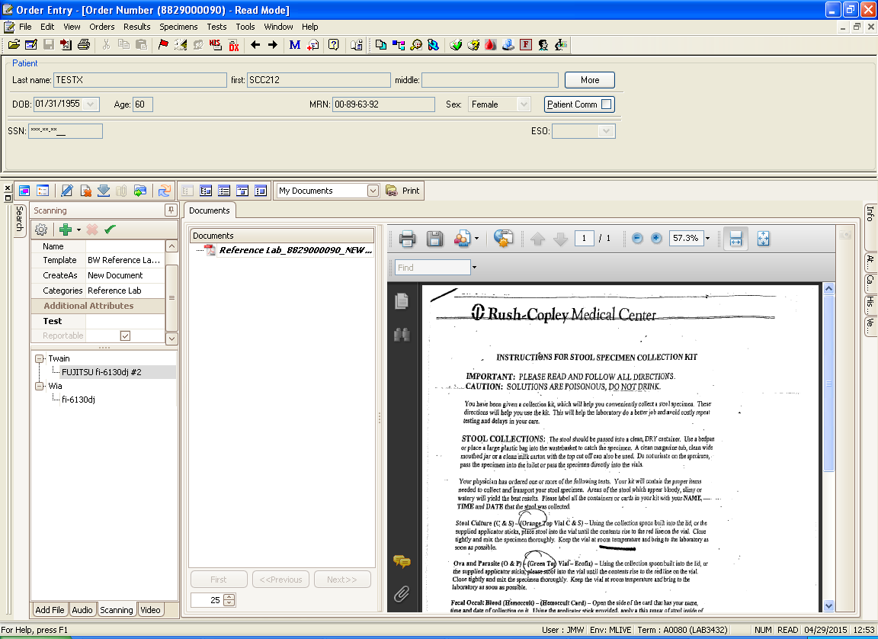

Go back to main menu with Soft Icons. Choose Resulting Worklist.

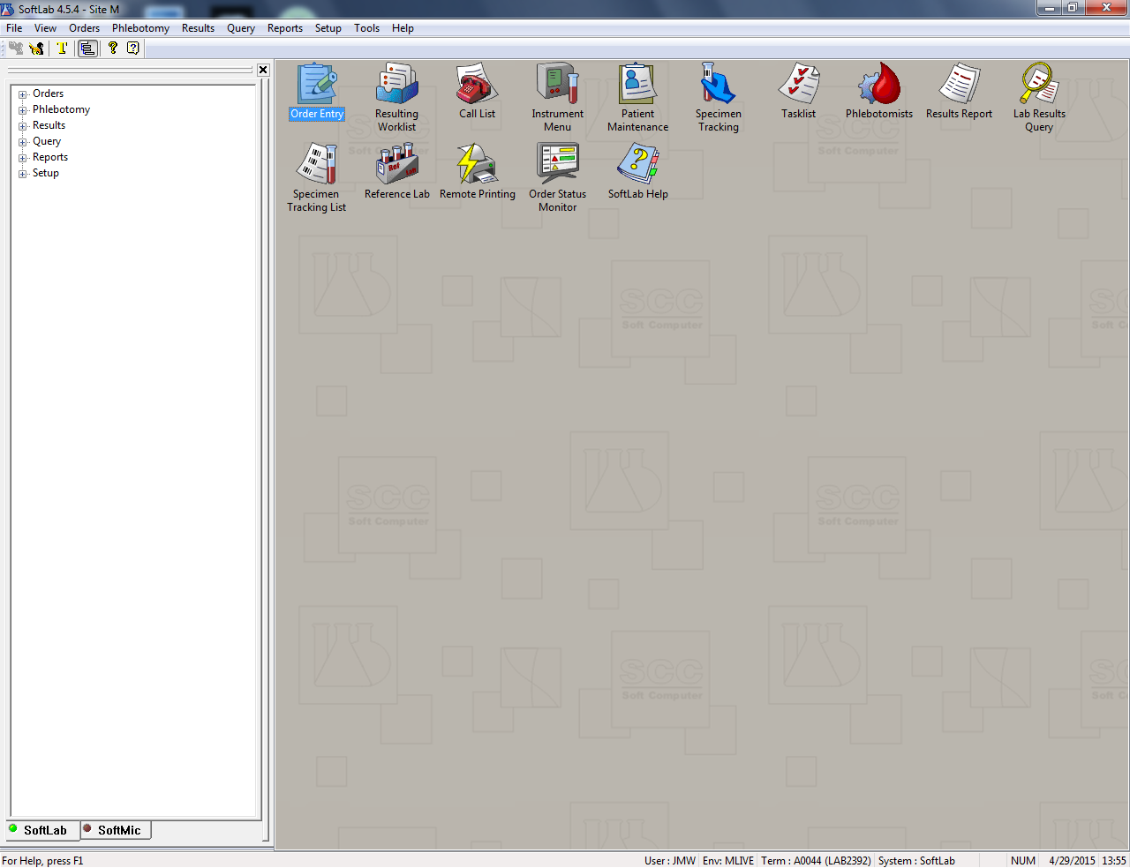

Choose Template – This template is based on where the specimen went to be tested, and in the search criteria put in your date range of your reports.

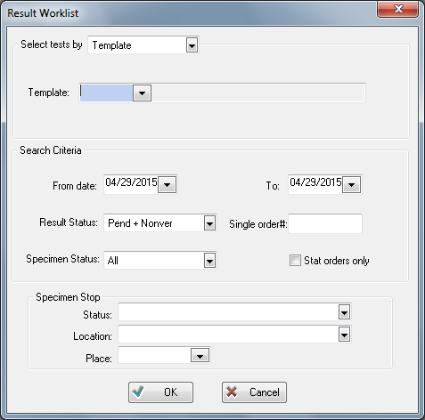

Verify Specimen - Black Arrow

Remember specimen result must be scanned before verifying result.

Save Specimen – Red arrow

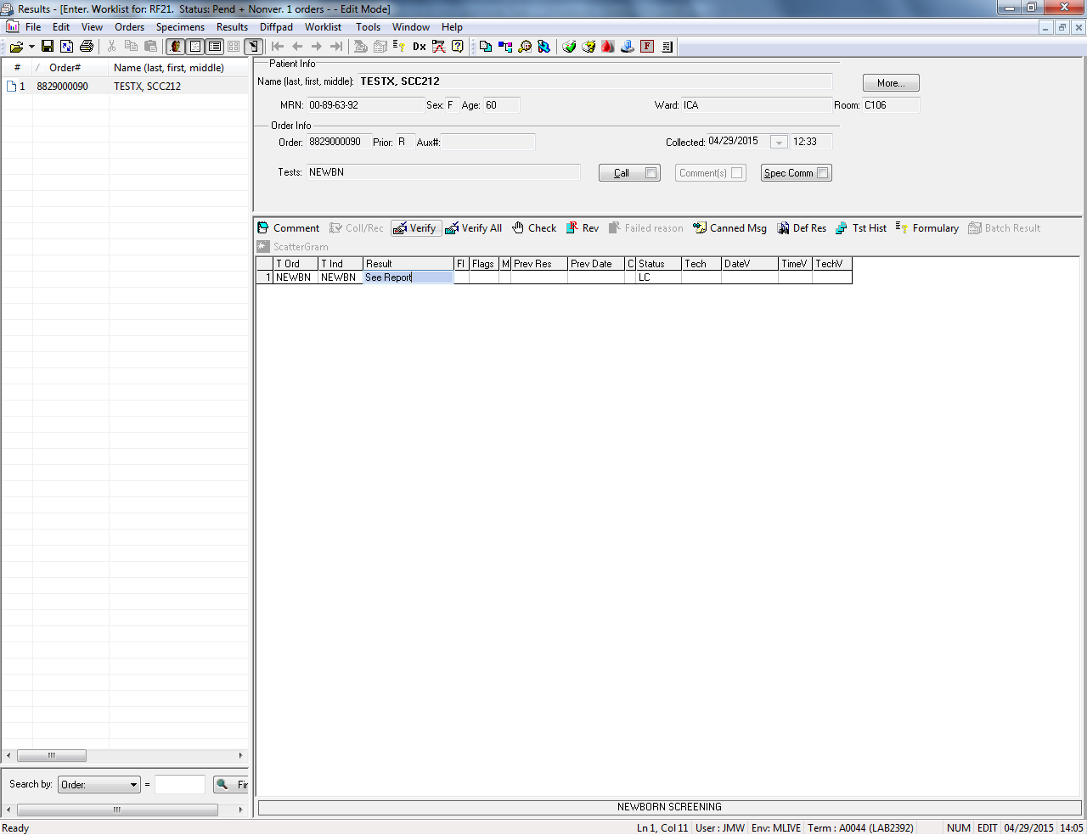

Click on OK

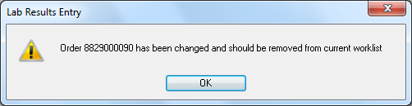

SCM View of Scanned Document

SCM will have a hyperlink they can click on to see the test result, black arrow

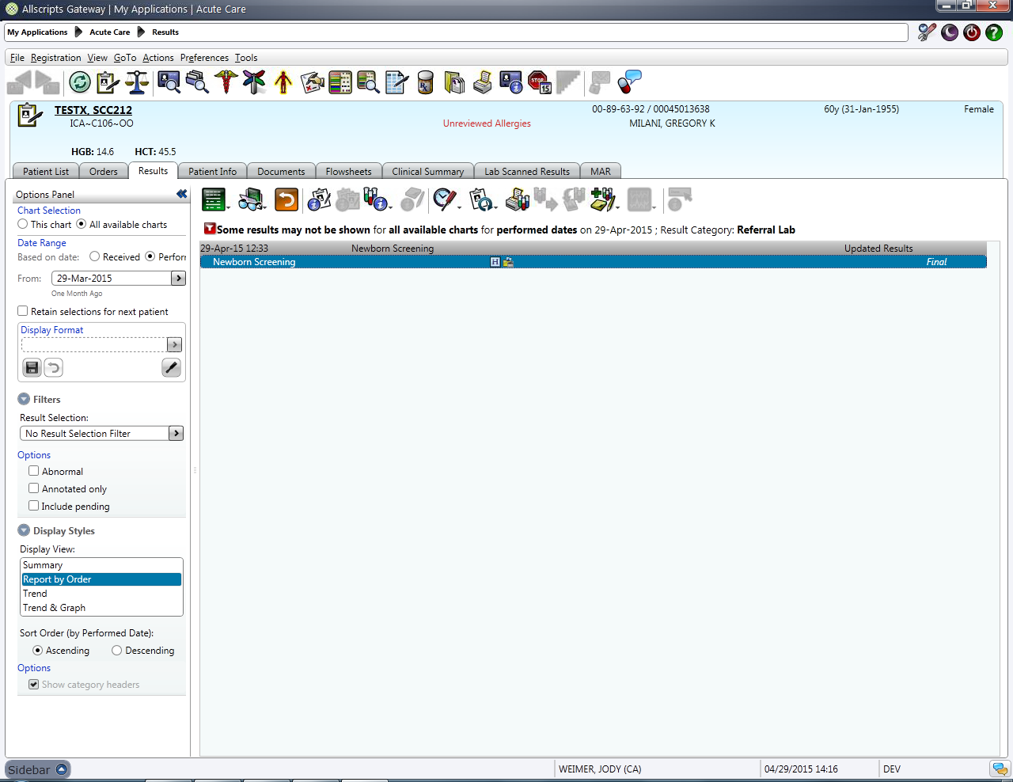

Scanning is now complete.