**TITLE:**Complete Urinalysis Using the Cobas u411

PRINCIPLE:

Urine samples are analyzed for chemical and cellular content. Chemical content is detected by a urine dipstick. The presence of a chemical in a urine is indicated in change in color on the dipstick. The dipstick can be read visually or by mechanical means. Cellular content is given by the technologist who looks at the urine microscopically when needed. Urine results are standardized by using the same tube and slide system for each specimen.

**CLINICAL SIGNIFICANCE:**

Macroscopic urinalysis is a screening test utilized to help rule out or identify infection and to provide information regarding the status of carbohydrate metabolism, kidney and liver function and acid-base balance.

### PERSONNEL:

###### Medical Technologists

## SPECIMEN COLLECTION/TREATMENT:

Random or clean catch, freshly collected urine sample. If a specimen cannot be examined within 2 hours of collection, it must be kept refrigerated. Remember to warm urine to room temperature before testing.

**If a urine pedibag comes from ER** please run the urinalysis, even though the specimen is not optimal. The ER understands that the specimen is not appropriate but are looking for information that might help them with the diagnosis for a patient who cannot tell them how they feel. Put a disclaimer on the accession to comment that the specimen is not optimal for testing. If a microscopic is required, the technologist may do a microscopic examination but again place a disclaimer on the results. Use comment – Specimen inapp. – Run per client.

**Urine specimens obtained by catherization in pediatric patients** will arrive in the lab in a sterile tube or sterile cup (not the typical yellow and grey tubes) When you receive one of these sterile tubes, please pour off a small amount of urine into a plastic conical tube to be used for the dipstick testing. Retain specimen in the original sterile cup for subsequent culture set up.

If an sub-optimal specimen is received contact the patient’s nurse or ordering physician. If the treating physician desires the results, run sample. Put a disclaimer on the accession to comment that the specimen is not optimal for testing. If a microscopic is required, the tech may do slide, but again place a disclaimer on. Use comment – Specimen inapp. – Run per client.

Rejection Criteria for Urine Specimens Include the Following:

a. Leakage

>Specimens with lids not tightly secured and which have leaked into the

biohazard bag will be rejected.

b. Transport/Storage

>Specimens not transported as directed precludes accurate analysis.

>Specimens not refrigerated prior to transport when transport is greater

then 2 hours post collection precludes accurate analysis.

c. Contaminates

>Specimens contaminated with feces, menstrual flow or barium may

preclude accurate analysis

d. QNS

>Specimens of less than 8 ml precludes accurate analysis and will not be rejected but

needs qualifying comments within the procedural text indicative of volume effect.

### EQUIPMENT & REAGENT:

Kova tubes, slides & cover slips, caps and pipettes

Roche Chemstrips 10 UA

###### Microscope

Cobas u411

Ictotest

Clinitest

BD yellow urine collection tubes.

## QUALITY CONTROL:

ALTA Level I & Level II Controls will be run once a day. Enter these results into the LIS Quality Control Program. See Quality Control Urinalysis Procedure for more information.

Once any of these controls are run on a particular day that will be sufficient for any other patients run that day.

If you need to open a new bottle of multistixes or new bottle of Ictotest or Clinitest tablets, please run a control to check those reagents before use. Enter these results into the LIS Quality Control Program.

See Quality Control in Urinalysis Procedure No. 4840-UA-4 for more information.

CALIBRATION:

Calibration is based on the measurement of a calibration strip with known reflectance values and is performed to compensate for the variance of this reflectance over time.

The Roche CHEMSTRIP Calibration Strips are standard strips with defined reflectance characterics. During the calibration, the reflectance values of the Roche Calibration Strip are compared to an Internal Calibration strip as well as the reflectance values generated during the previous calibration.

When large variations between these values are detected, an error message is generated.

At initial calibration, two consecutive calibration strips must be measured since there are no stored calibration values in a new Cobas u411 Urine analyzer.

After initial calibration, calibrate the Cobas u411 Urine Analyzer every 4 weeks.

The date and time of the latest successful calibration will be printed. If the instrument fails

calibration, the Cobas u411 will not operate and an error message appears.

See Cobas u411 Calibration Procedure 4840-UA-1003 for more information.

## STEPWISE PROCEDURE:

1. When a urine is received in the Laboratory, receive it through the Laboratory Information System.

2. All urines are to be refrigerated until they are ready to be processed if

processing will take longer than 2 hours. Warm urine to room temperature

before testing.

1. Do not expose sample to direct sunlight

4. Do not add any preservatives to the sample

1. Mix the urine thoroughly.
2. Urine Chemistry Analyzer is ready for routine operation. Carefully read this section

before beginning any testing.

**CAUTION: Do not use anything pointed or hard to make selections on the touch** **screen**. A pencil eraser works well.

### A. Starting the analyzer

**To start the Cobas u411** analyzer

___________________________________________________________

*The power switch is located on the rear of the analyzer. The OFF position is represented by O.*

*_________________________________________________________________________________*

1. Turn the power switch to the ON

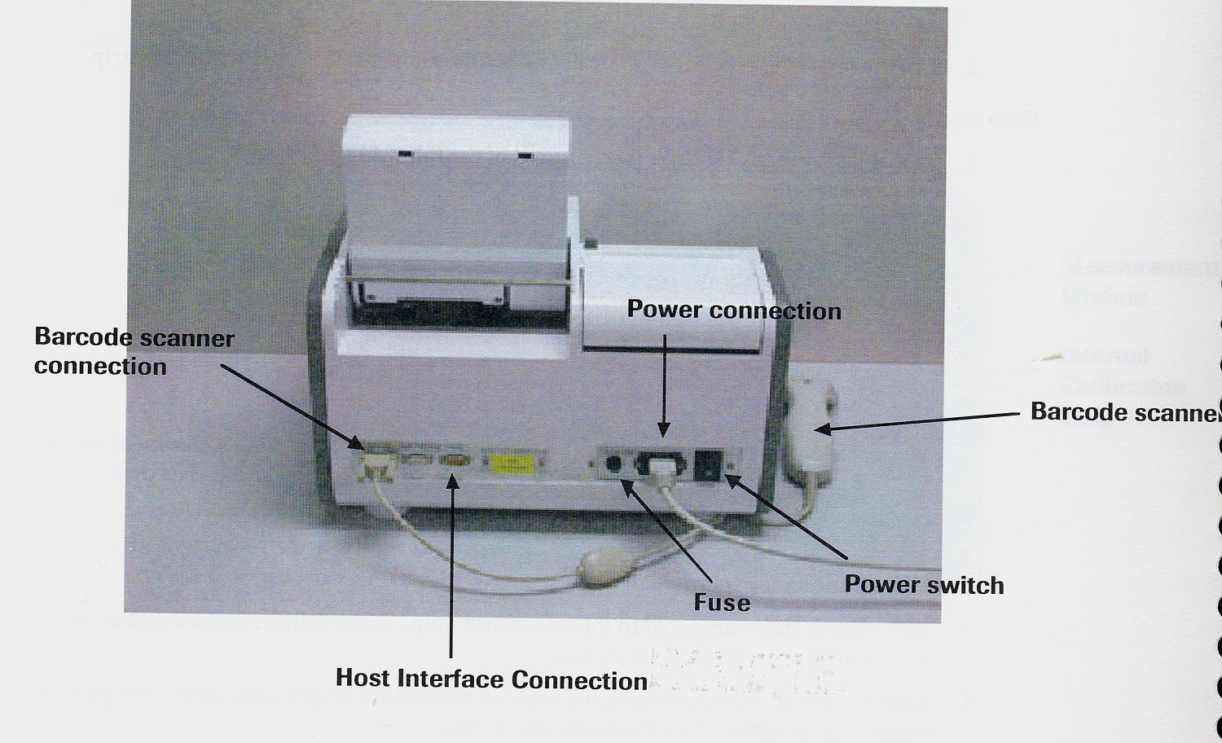

The [Login] screen appears after you switch the Cobas u411 analyzer on.

The analyzer is initialized and enters into the stand-by state.

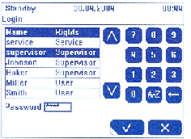

[Login] screen

.

* 1. Enter the password (aura) and confirm your entry by pressing √ twice.

The [Overview] screen id displayed.

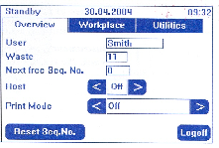

Overview screen

The overview screen displays important information, e.g. user, next available sequence number, host status, and print mode.

* Host: By pressing **< or >** you can change the host status.
* Print Mode: By pressing **< or >** you can change the print mode:

• Automatic result printout is performed if you select:

All

Abnormal

Sieve

Sieve and Abnormal

Normal

No automatic result printout is performed if you select:

Off

If the host status is <On> and any print mode except <Off> is selected, the results will be printed and sent to the host automatically.

* Reset the sequence number.

All results must be reported before you can reset the sequence number

3. Touch the workplace tab.

The anayzler is now ready for samples

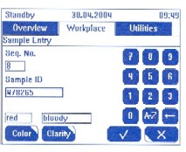

Enter information for the new sample on this screen

Seq. No. The next free sequenence number is displayed in this field

Sample ID The sample ID is displayed in this field. You can either enter the

sample ID manually or scan it with a barcode scanner.

Color This button calls up the Color screen.

Clarity This button calls up the clarity screen. You can assign a

color to a sample here.

###### **2. Analyzing samples**

1. Enter the <Sample ID> using the touch screen keyboard or barcode scanner.
2. If requested, enter the data for color and clarity.

For more information see *To enter the color and clarity of a sample section of this procedure.*

1. Store the sample data by pressing √.

4 Remove the test strip from the vial and close the vial with the

vial cap containing the desiccant.

5 Always dip all test pads of the test strip completely in the sample

and wipe off excessive urine on the edge of the sample tube.

You can now position the test strip on the test strip tray for

analysis.

6 The sample is drawn into the analyzer for analysis.

7 The next available sequence number will automatically be used for

the sample.

**Do not remove a test strip after you have positioned it on the test strip tray!**

When the analyzer has recognized the test strip, a new sequence number (e.g.23) is assigned to it

*If you remove the test strip and then put it back, the next sequence number (24) will be assigned to the test strip. The previous sequence number (23) will nevertheless be processed and consequently produce a T-Flag.*

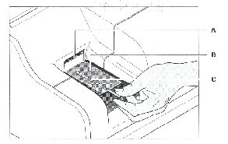

**A** Test strip sensor **C** Test strip

**B** Area for test strips on the test strip tray.

**________________________________________________________________________**

**Do not open the front cover of the analyzer during the analysis of the test strips!**

*If you open the front cover, processing of the test strips is interrupted. The results of all test strips in process are lost*

8. Repeat steps 1 through 7 for the next samples.

If the host status is <On> and any print mode except <Off> is selected,

the results will be printed and sent to the host automatically.

You can also view the results of the analyses on the [Sample Results] screen from the [Workplace] tab.

### 4. To enter the color and clarity of a sample

You have to enter the clarity of the sample.

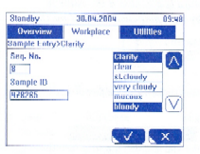

[Sample Entry>Clarity] screen

**2.** Select the clarity of the sample using the ∧ or ∨

**3.** Apply your selection by pressing √

This closes the screen and displays the selected clarity on the [Sample

Entry] screen.

Clarity can also be entered via [Sample Result] screen or via [Sample List] screen.

The analyzer determines the color of the sample using the compensation pad on

the test strip.

If you want to enter the color of the sample manually, you have to enable the

corresponding function.

The analyzer can be set in such a manner that the sequence numbers automatically start

again with 1 after the date has changed.

The analyzer cannot reuse a sequence number until the results have either been printed or

transmitted to the LIS. In this case, an error message will appear on the screen. When

this happens, you must either print the results or transmit them to the LIS before

continuing. If the host status is <On> and any print mode except <Off> is selected, the

results will be printed and sent to the host automatically.

You can view the results of the analyses on the [Sample Results] screen

1. **Abnormals:**

The compension pad assists in the prevention of false positives when a urine sample is strongly colored.

If urine is grossly bloody, enter the color as RED and the apppearanace as BLOODY.

All abnormal color results will auto verify.

NOTE: Routine examination of urine consists of a macroscopic examination or urine screen, utilizing the Roche Chemstrip 10.

A microscopic urinalysis is to be performed when the leukocyte esterase, nitrite, blood, or protein tests are positive at small levels or above, the appearance is cloudy or turbid, or the color is any color other than colorless, straw, yellow or amber. In these cases, microscopic must be performed, as well as a macroscopic.

1. If the above screen is negative the urinalysis will auto verify through the LIS.

See Reporting Results section of this procedure for complete information on result reporting. If a microscopic is indicated, the discern function of the Laboratory Information system will automatically order the test.

9 Using the BD vacutainer tube or a Kova tube.

10. Spin down the urine for 5 minutes at 1800 r.p.m.

11. Remove the tube from the centrifuge being careful not to disturb or dislodge the

sediment.

12. Insert KOVA Petter into the tube. Push the KOVA Petter to the bottom of the

tube until it seats firmly( at the 1ml graduation)

13. Decant and discard the urine while the KOVA Petter is locked in

position in the tube. This will retain 1ml of urine sediment at the bottom of the

tube.

14. Withdraw the KOVA Petter from the tube.

15. Using the KOVA Petter, gently resuspend the sediment until a homogeneous mixture is

obtained.

16. Label each section of a Kova slide with a number corresponding to the specimen number.

17. Deliver one drop of sediment into the corner of the well using a transfer pipette.

Capillary action will uniformly fill the chamber.

18. Blot off excess urine from the slide. If not all areas of the slide have been

used the unused areas can be utilized later.

19. Scan 10 fields of an area on the slide, use low power and record the results for the

following elements:

1. Report as none seen for negative or give an average number of casts per field using low power. Identify types of casts on high power (hyaline, granular, WBC, etc.).

Example: 2-4 Hyaline casts

4-8 Granular casts

1. Check for mucus – Report as:

* none seen for negative
* few for 1 to 5 per field
* mod for 5 to 10 per field
* marked for 10 to 50 per field
* packed for numerous cells per field.

1. Check for amorphous – Report none seen for negative. If present, and report the same as mucus.
2. Check for crystals – When present report the same as mucus.

Example: Many Calcium Oxalate

20. Scan 10 fields using high power and report the following:

a. WBC’s & RBC’s - Record as none seen for negative if none are seen

in 5 fields. If they are present, report in the same manner as casts.

Example: 4-8 WBC

1. Check for epithelium – Report as: none seen for negative

* few for 1 to 5 per field
* mod for 5 to 10 per field
* marked for 10 to 50 per field
* packed for numerous cells per field.

1. Evaluate bacteria, motile tirchomonads, yeast, parasites, fungus, and fat. Comment on budding or mycelial forms of yeast.
2. Report motile trichomonads, yeast, parasites, fungus, and fat as present, if seen.
3. Report bacteria on STAT urines only. Use the terms few, mod, marked and packed in the same manner as epithelium cells.

f. Do not report sperm unless specifically requested to do so by the attending

physician

**NOTES:** Be sure to correlate microscopic results with chemical results

from the dipstick. For example: the presence of WBC cast with

a positive protein or presence of RBC with a positive blood.

Urine specimens from a female through the age of 12, where there is trichomonas and/or sperm noted on the microscopic, there will be another microscopic sample prepared from the original sample. If the findings are the same, they will be confirmed by a second technologist. It is acceptable to request a new specimen before reporting any results. Do not share suspect results with the physician until the results are verified and resulted in the LIS.

21. Place original container with remainder of urine sample in appropriate rack to be held for 24

hours.

## REPORTING RESULTS:

## All results will be auto verified with the exception of critical glucoses

**When a microscopic is indicated**

1. Login into Soft
2. Choose resulting Worklist
3. Choose Site M as your test site
4. Chose urinalysis MLAB template
5. Search Criteria

Dates: Today’s date

Result Status: Pend + Nonver

Specimen Status: Received

1. Click OK
2. Next Urine Result will appear
3. Enter microscopic results
4. Attach the comment “ short sample: results may be affected” to all samples where the volume was less than 8 ml.
5. Click Verify

See example Urinalysis Report for reference ranges.

## PROCEDURAL NOTES:

1. Pregnancy tests - Pour off an aliquot into a labeled tube and give to Serology.

2. Drug Screen - Spin down specimen. Pour off the supernatant into a

labeled tube and give to Chemistry.

### INTERFERING SUBSTANCES

See Roche Chemstrip 10 package insert for interfering substances.

### REFERENCES

Cobas u411 Operator Manual 2009-2013

Software Version 3.2 3.3

Roche Diagnostics

Indianapolis, IN. 46250-0457

SCC Computer Systems

Clearwater, Florida

S:Laboratory P&P/Urianlysis/4840-UA-26 ch