**TITLE: Processing Interfaced Quest Referred Labs**

**PRINCIPLE: Testing not performed at Rush Copley Laboratory**

**Personnel: LCC Staff and Phlebotomists**

**STEPWISE PROCEDURE:**

1. **When specimens arrive in the send out processing area, ALL specimens must be received into send outs following same procedure as receiving into LCC. After receiving all specimens, a pop up box for printing aliquot labels will appear, click on OK. Labels will print on the Zebra printer in the send out area. Only specimens that require a pour off will print labels**

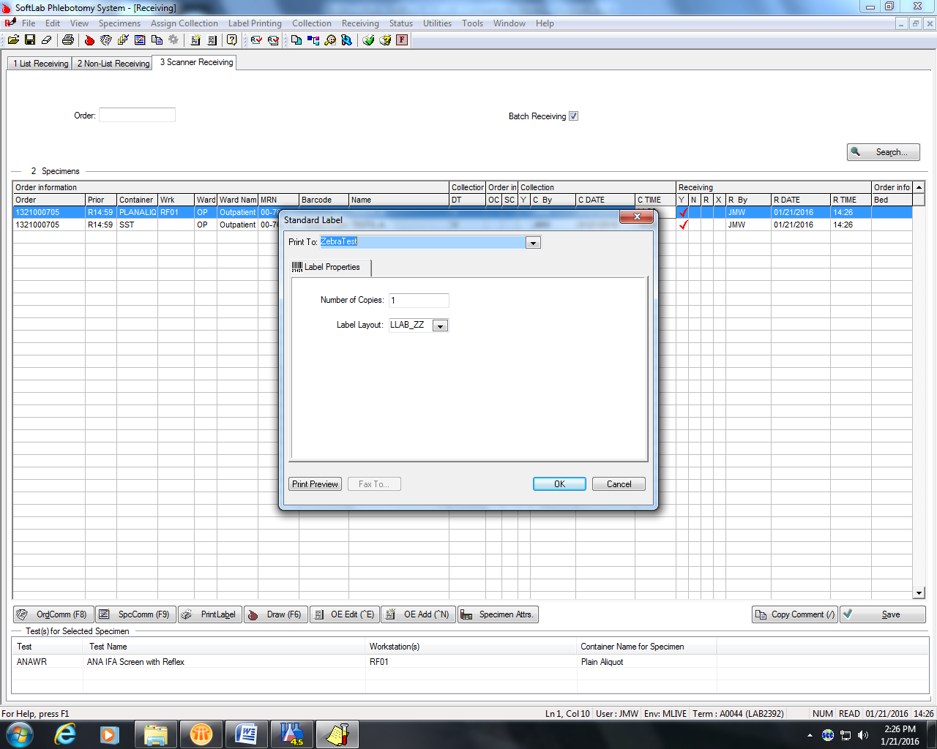

1. Label your aliquot tubes and pour off correct specimen tube into aliquot container.
2. Create send out Manifest:
   1. Click on result tab
   2. Go to reference lab and click
   3. Click on new on tool bar (looks like a white single sheet of paper)
   4. Go to “Creation Template” and choose appropriate site from drop down box.
   5. Go to “Barcode” box on bottom left, make sure curser is flashing in box.
   6. Begin scanning all send out tubes that are being sent to appropriate site chosen above. This includes the aliquot tubes you have poured off and specimens that may be sent in original tube they were drawn in, Example – Lead.
   7. After all specimens have been scanned in click on box lower right bottom, “Sent to Ref. Lab”
   8. A pop up box will appear that says “Do you want to save the tasklist?” click on yes. A pop up will appear that tells you the tasklist number, click on OK.
   9. Another pop up box will appear for Reference Lab Manifest that is your printer choice. On line that says “Print to:” make sure it says lablaser 1, number of copies 2, and Manifest Layout: RLAPM. Hit OK.
   10. Pop up will appear that will tell you how many specimens were found, hit OK.
   11. This will now send your manifests to the printer you have chosen. Separate you lists by temperature, put specimens associated with lists in transport bag with one copy of manifest. Be sure bag is marked with correct temperature and place in proper temperature area for Quest pick up.
   12. Second Manifest copy is placed in log book.