## TITLE: Automatic Release of O-Neg Blood in Emergent Situations

## PRINCIPLE:

When blood is released before completion of the crossmatch, a statement must be signed by the physician or someone authorized to sign on the physician’s behalf, indicating that responsibility is accepted for the transfusion of blood without awaiting the completion of compatibility testing.

**CLINCIAL SIGNIFICANCE:**

When blood is urgently needed, the patient’s physician must weigh the risk of transfusing uncrossmatched or partially crossmatched blood against the risk of delaying transfusion until compatibility testing is complete. The risk that the transfused unit might be incompatible may be judged to be less than the risk of depriving the patient of oxygen-carrying capacity of that transfusion.

### PERSONNEL

Medical Technologists

### REAGENT PREPARATION & EQUIPMENT

1. Blood Utilization Cooler
2. Ice Packs
3. Hemo Temp II Indicators
4. Bubble Wrap
5. Biohazard Bag
6. Blood Unit Tag

## SPECIMEN COLLECTION:

### Refer to policy 4840-BB-100

### QUALITY CONTROL

Temperature Monitoring for Trauma Coolers #7180-ECY-1011

Biosynergy Multiple Block Heater Preventive Maintenance and Operation #7180-ECY-1012

**STEPWISE PROCEDURE:**

**GIVE THE ECY STAFF THE UNITS OF BLOOD WITH A LIME GREEN UNCROSSMATCHED STICKER AND HEMOTEMP LABEL ATTACHED TO UNITS. GIVE THE EMERGENCY TAG THAT IS PRE-ATTACHED TO EACH UNIT WITH THE BLOOD. NURSING WILL FILL OUT PATIENT INFORMATION. COMPLETE THE ISSUING OF UNITS IN SOFT AFTER THE UNITS ARE GIVING TO THE EMERGENCY DEPARTMENT BY USING THE XEROXED COPIES TO SCAN.**

When a hemodynamically unstable patient is identified RCHC Yorkville Lab will dispense 2 units O Negative packed RBC. The ECY staff will let the Lab know when this occurs.ECY staff will place a Transfuse O Negative blood order for Emergent Red Blood Cells (RCT). This order will allow the emergency release in Soft.

**No Blood Bank Transfusion Request (pink slips) are required for this release.**

**If 0 Rh- negative blood is not available, the technologist will communicate with the physician and/or RN caring for the patient. If unable to speak directly to RN and/or Physician, another Physician or RN shall be notified. The name of the individual(s) to whom the information is given will be recorded on the Blood Bank Requisition by the technologist.**

1**.** Complete the following steps to dispense a product in an emergency situation (screenshots at the end of procedure if needed):

1. Inventory
2. Product Orders Service
3. Em_Issue
4. Enter Last Name, First Name; or F-3 By Order
5. Select Patient and current stay if they have multiple choices
6. Esc-Quit, to remove patient caution window
7. At the order number field, hit enter
8. **IF** Patient has had previous transfusions, select the correct **products** from the correct order number and date, if not move on to step 9
9. **IF** Patient History has not been reviewed Soft will prompt to do so, click Yes.
10. F12-Review. Comment box “Patient’s History reviewed with Date, Time, and Tech initials. History reviewed?” Yes
11. “Antibody screen test has not been performed from the current sample. Electronic crossmatch is impossible. Continue?” Select Yes
12. If patient has no historical ABO/Rh, system may display: “Patient ABO Rh is unknown. Continue units selection?” Select Yes
13. Scan in unit Number and product code for applicable unit(s) or hit F7 to select units from inventory
14. F-12 Accept
15. “Select these units?” Yes
16. “Xmatch Status requested unless proved compatible. Select?” Yes
17. Edit Issue Date and Time, if needed
18. Select Condition Code from drop down menu
19. Select the ward (Yorkville ED) in “Issue To” field.
20. Edit Ward, if necessary
21. F-12 Accept to save
22. “Save changes?” Yes
23. **IF** patient has historical ABO/Rh, system may display: “List of units eligible for electronic xmatch. Perform electronic xmatch?” Yes
24. Enter Exception comment or F-5 to select from canned messages
25. F-12 Accept
26. “Save exception comment?” Yes
27. Select number of labels needed
28. Select printer for labels
29. Can attach label to unit

2. Print Emergency Transfusion Tag or **give a blank Emergency Tag for each unit (WHAT ECY WANTS)**

1. Inventory
2. Product Order Services
3. Print
4. Enter patient Last Name, First Name; or F3 by Order
5. Esc from caution box
6. Select Unit(s)
7. F12-Accept
8. Print
9. Select printer

###### 3. Affix a HemoTemp II Indicator to each of the units

4. **Note that the blood is being released uncrossmatched by placing a bright lime green “NOT CROSSMATCHED/PARTIALLY CROSSMATCHED” sticker on the blood bag.**

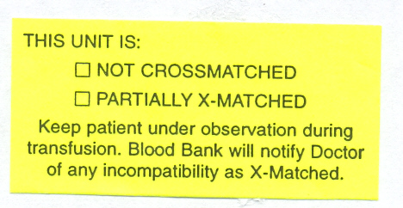

5. Put units into a biohazard bag and wrap in bubble wrap. Place the units in one of the numbered blood utilization coolers. Have an ice pack on the bottom of cooler; place the wrapped units on top of this ice pack and another ice pack on top. Therefore sandwiching the blood units between the two ice packs. Put Emergency Tags into front pocket of cooler bag.

Write with a Sharpie on the ‘return by’ label that is attached to the cooler, with the return time (two hours from dispense) for the blood if not used. When coolers are returned use alcohol wipe to remove the time.

RETURN BY:

6. Take units to the Emergency Center.

7. Hemodynamically unstable patients will be drawn according to the Automatic Release of O-neg Blood at Rush Copley Emergency Center, Yorkville (RCEC-Y) and the Blood Bank procedure no.4840-BB-100, ORDERING BLOOD AND OTHER COMPONENTS.

8. The blood bank tube will be sent with the patient to the RCMC Main Lab to have testing

performed there. Let the Main Lab Blood Bank know that this will be coming.

9. If LIS is down use the LIS Blood Downtime Log (see example) to fill out patient name, blood unit number, date/time issued and initials of tech. This information will need to be entered into LIS when it is available. Give a blank Emergency Tag printout for each unit to the ECY Staff so they can fill out vitals.

**DO NOT RELY ON PREVIOUS BLOOD BANK RECORDS, BLOOD**

**GROUP CARDS FROM OTHER FACILITIES OR ORGANIZATIONS,**

**OR ID TAGS, BRACELETS OR DRIVER’S LICENSE FOR BLOOD**

**TYPE**

THE PHYSICIAN AND/OR RN WILL BE NOTIFIED BY THE RCMC MAIN LAB

IF PRIOR UNCROSSMATCHED UNIT(S) DISTRIBUTED ARE

FOUND TO BE INCOMPATIBLE UPON BEGINNING BLOOD GROUPING

AND TYPING. THE NOTIFICATION WILL SPECIFY THAT THE UNIT

BEING TRANSFUSED NEEDS TO BE STOPPED

NOTE: The downtime Transfusion Tag should stay with the patient’s chart and will be scanned in by medical records

NOTE: The emergency room staff assumes all responsibility for positive patient identification during an emergency release

### REPORTING RESULTS

Report all results through the Laboratory Information System.

REFERENCES

Trauma Committee, January 2005

AABB Technical Manual, 16th Edition, 2008.

Standards for Blood Banks & Transfusion Service 25th edition, 2008.

SCC Computer Systems

Clearwater, Florida

Select Patient and current stay if they have multiple choices

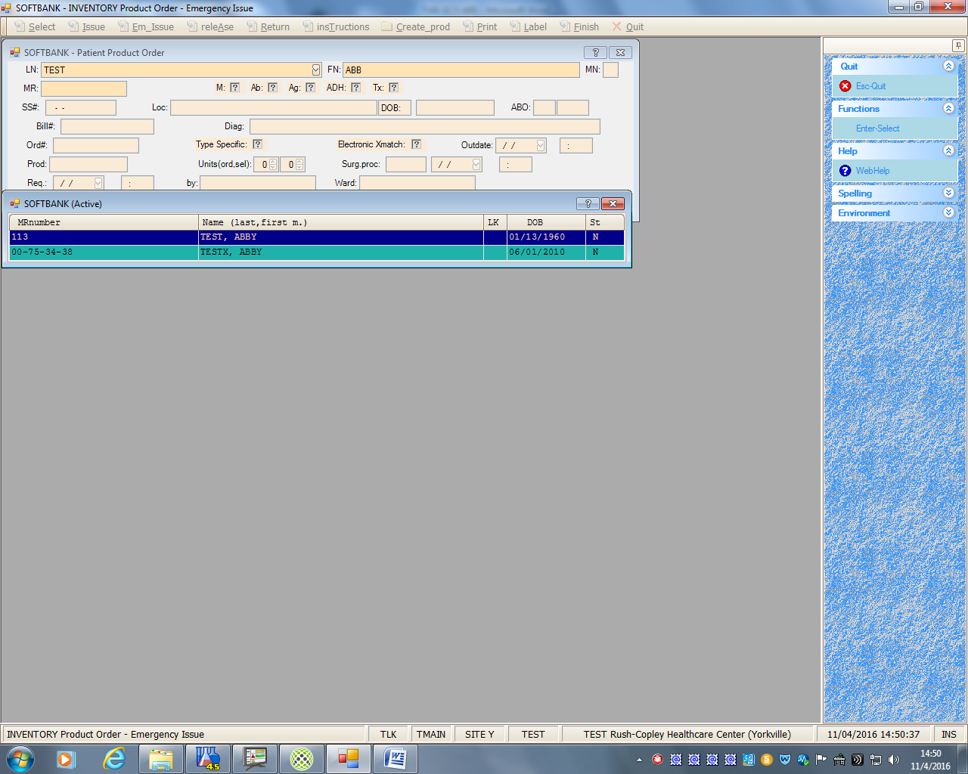

Esc-Quit, to remove patient caution window

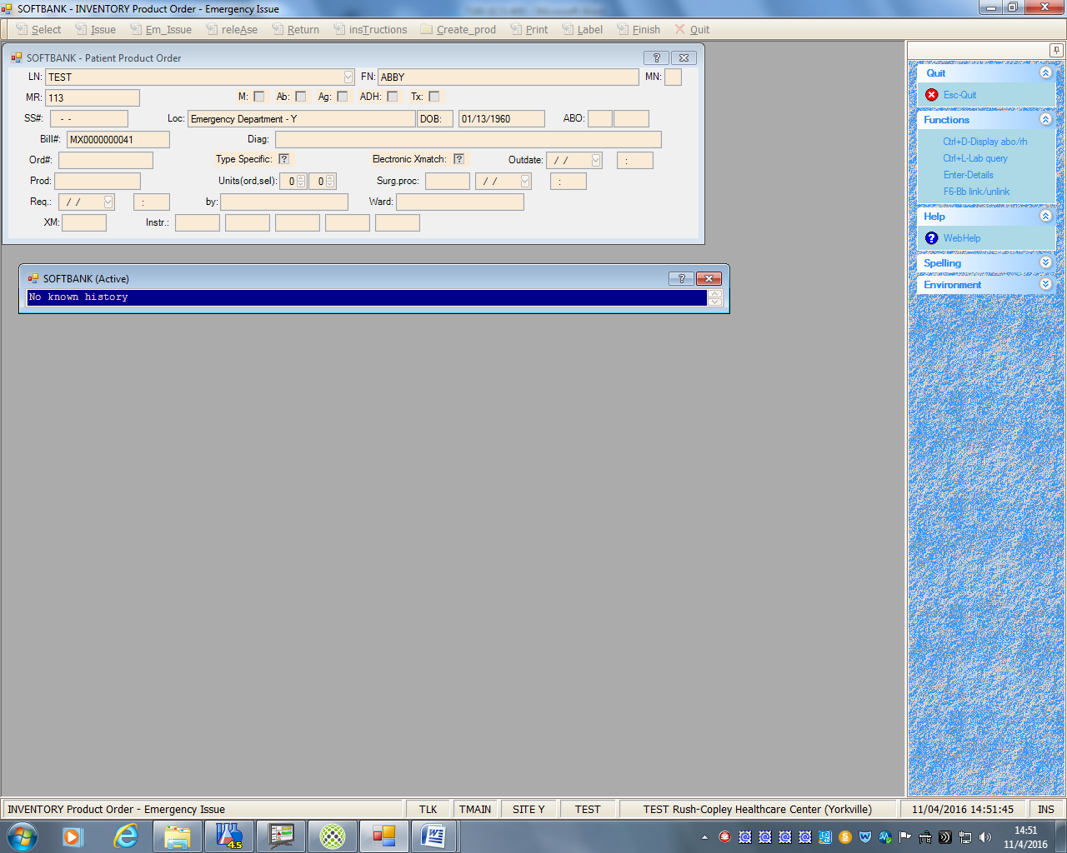

**IF** Patient has had previous transfusion select the correct **products** from the correct order number and date, if not move on to next step

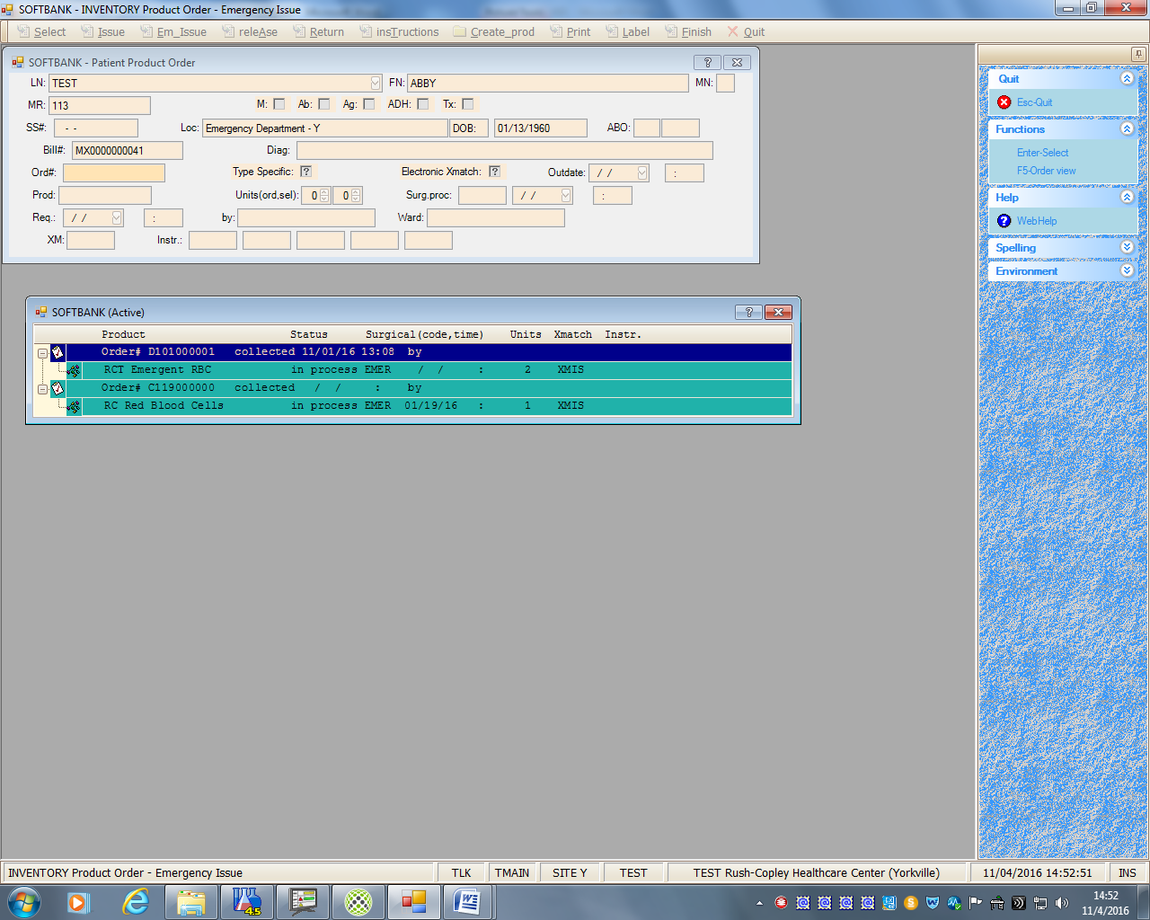

**IF** Patient History is not reviewed. Yes to review it

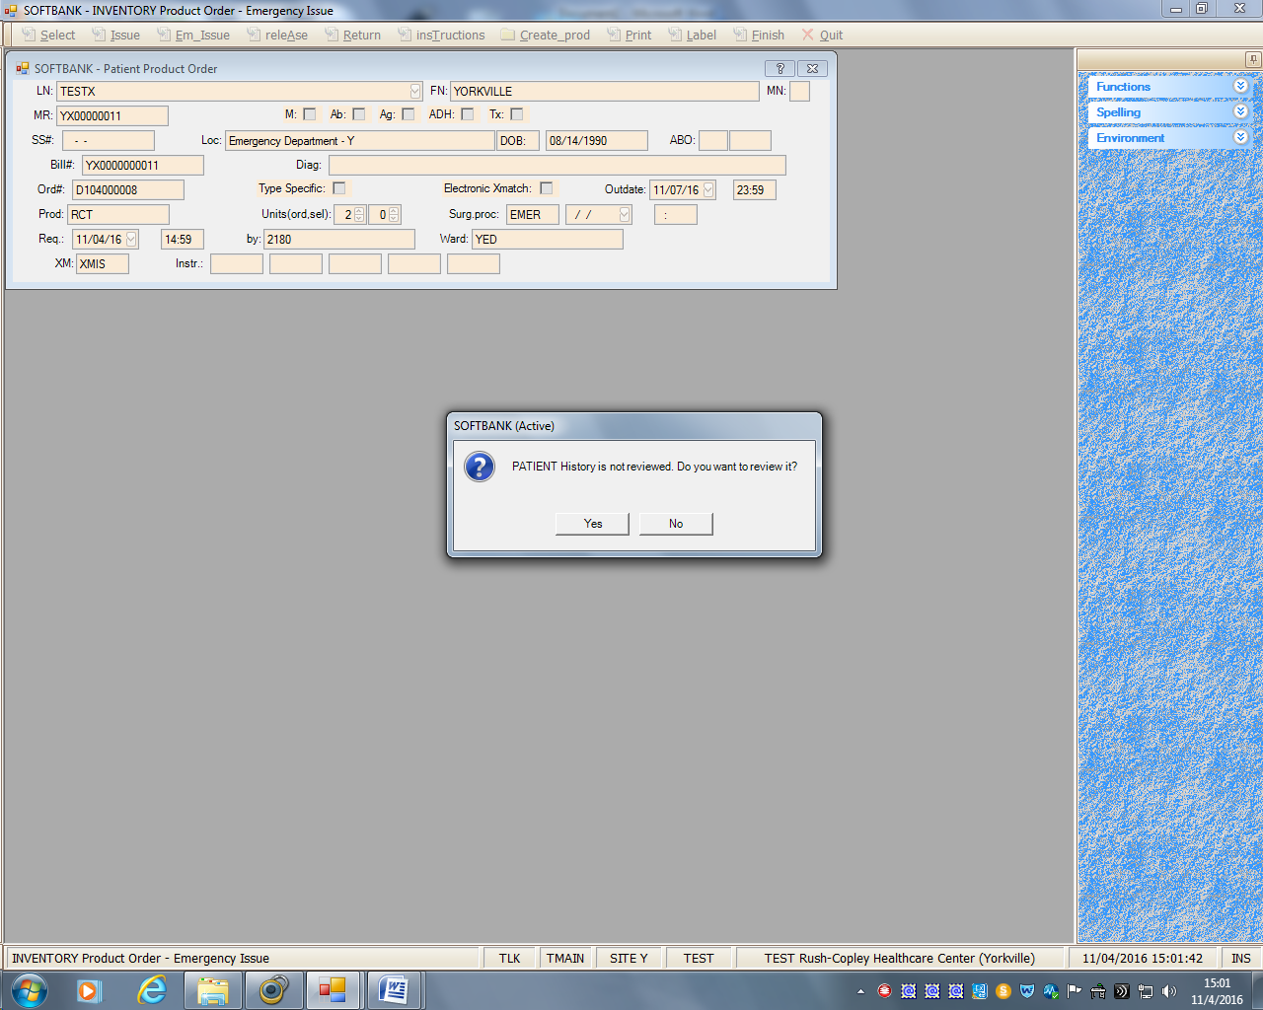

F12-Review 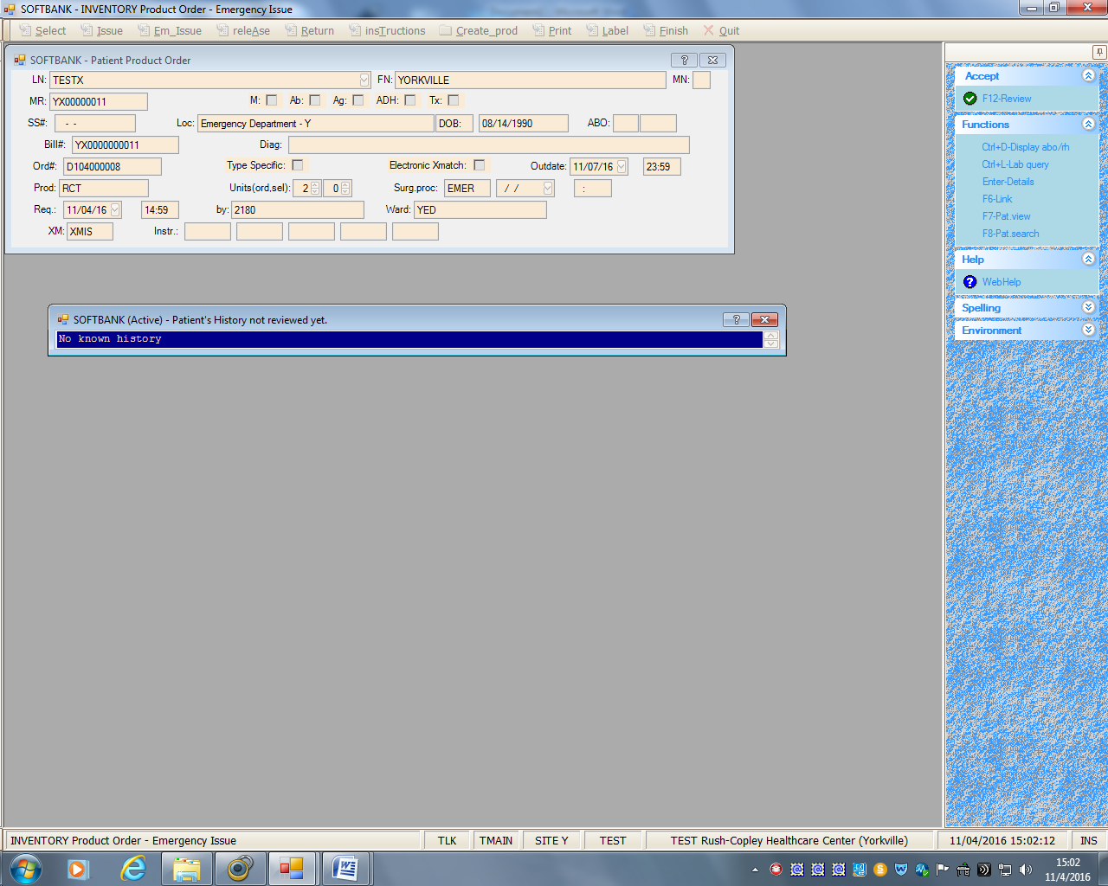

Comment box that history was reviewed- Yes

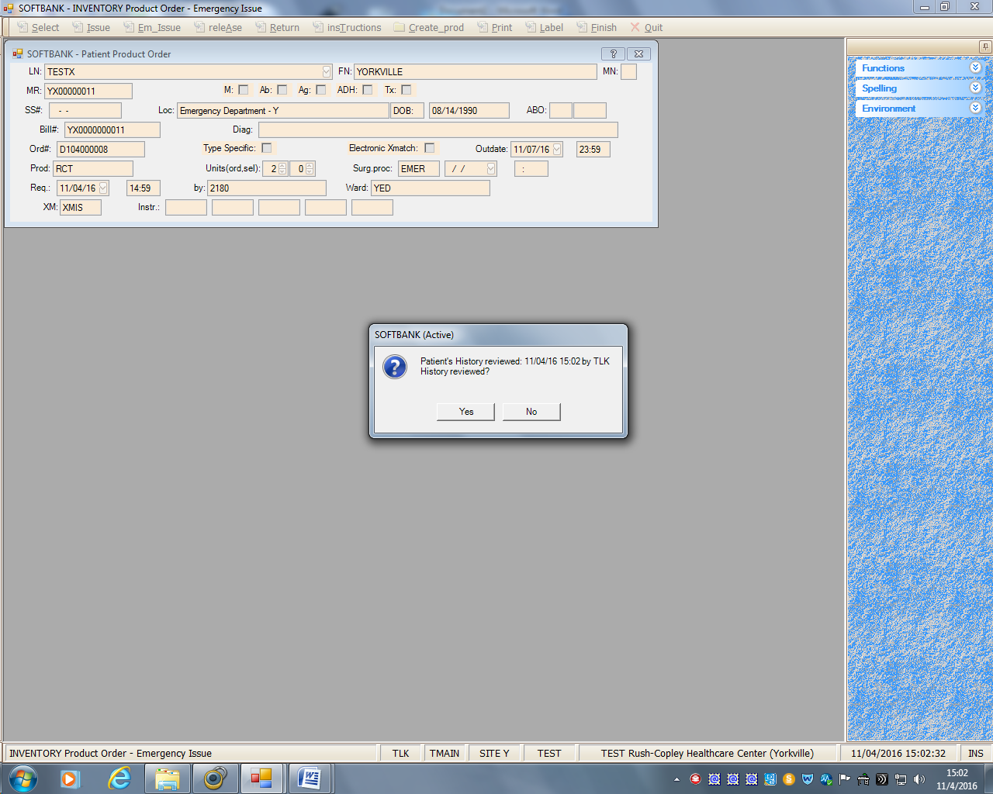

Antibody screen test has not been performed from the current sample. Electronic crossmatch is impossible. Continue? Yes

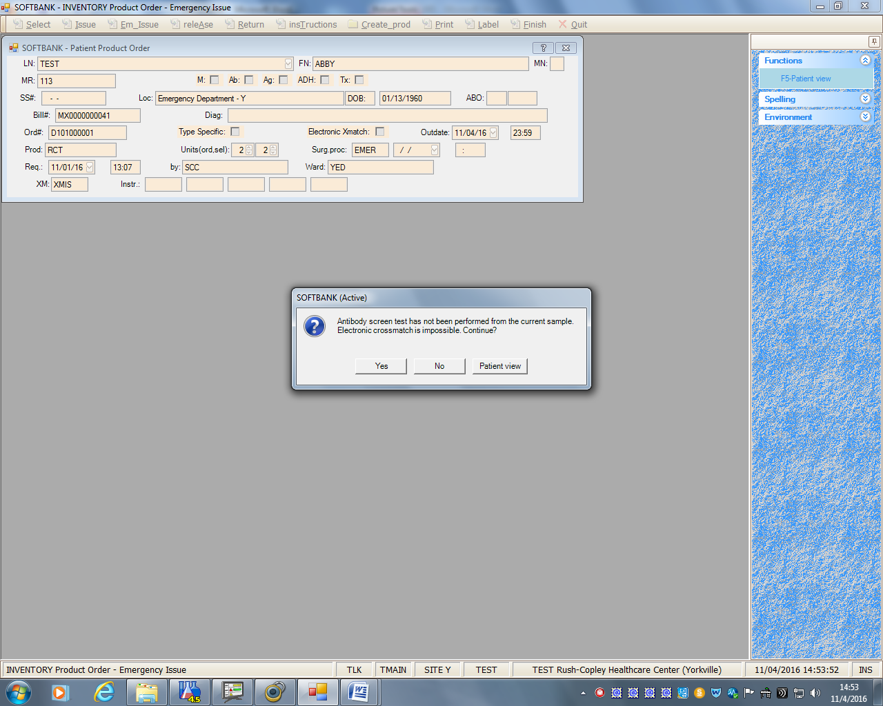

Patient ABO Rh is unknown. Continue units selection? Yes

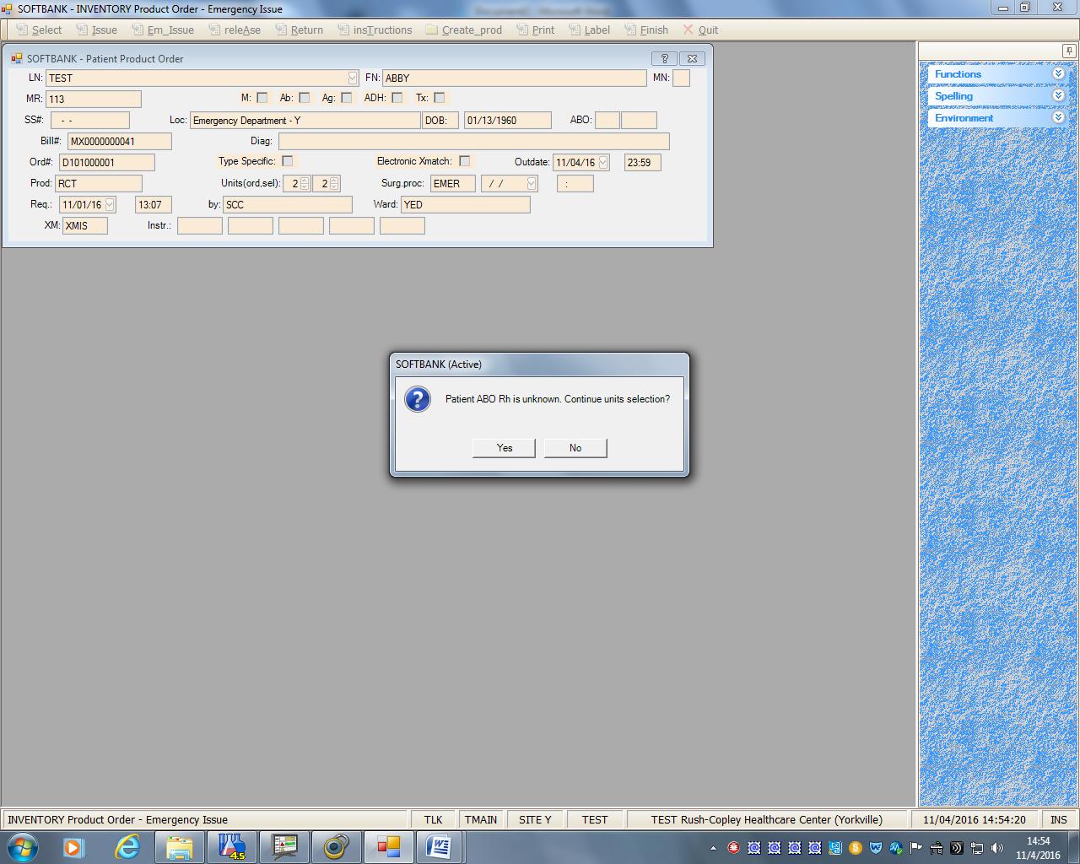

Select these units- Yes

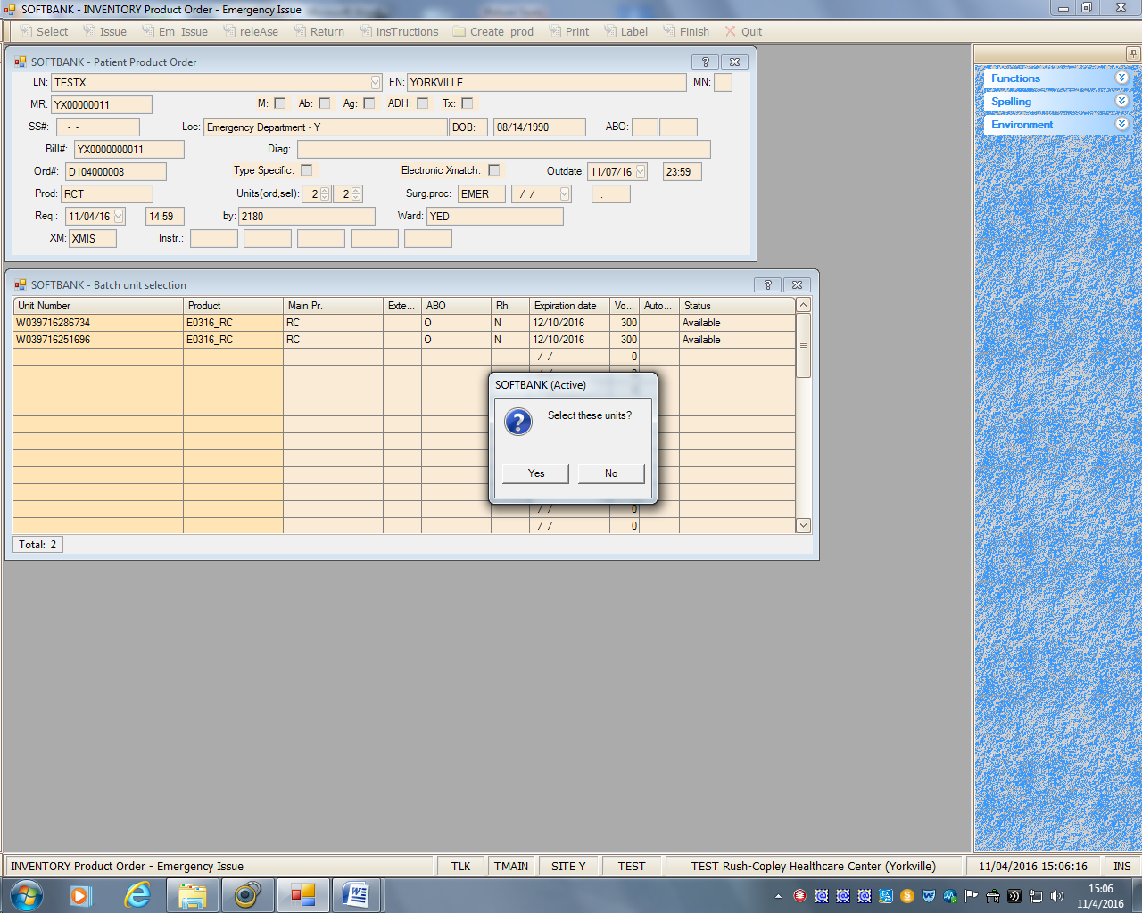

“Xmatch Status requested unless proved compatible. Select?” Yes

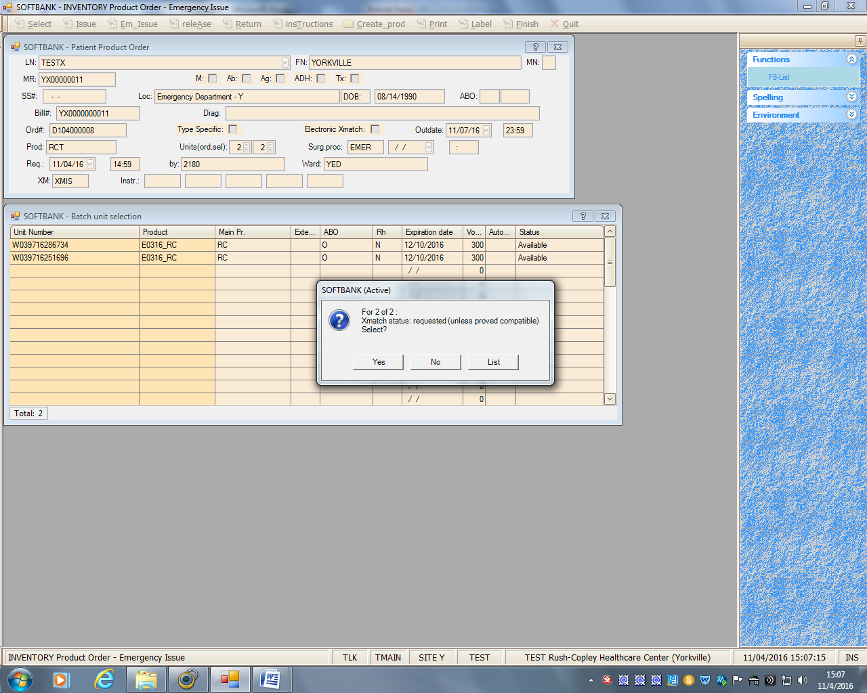

Edit Issue Date and Time, if needed. Select Condition Code from drop down menu. Select the ward (Yorkville ED) in “Issue To” field. Edit Ward, if necessary. F-12 Accept to save

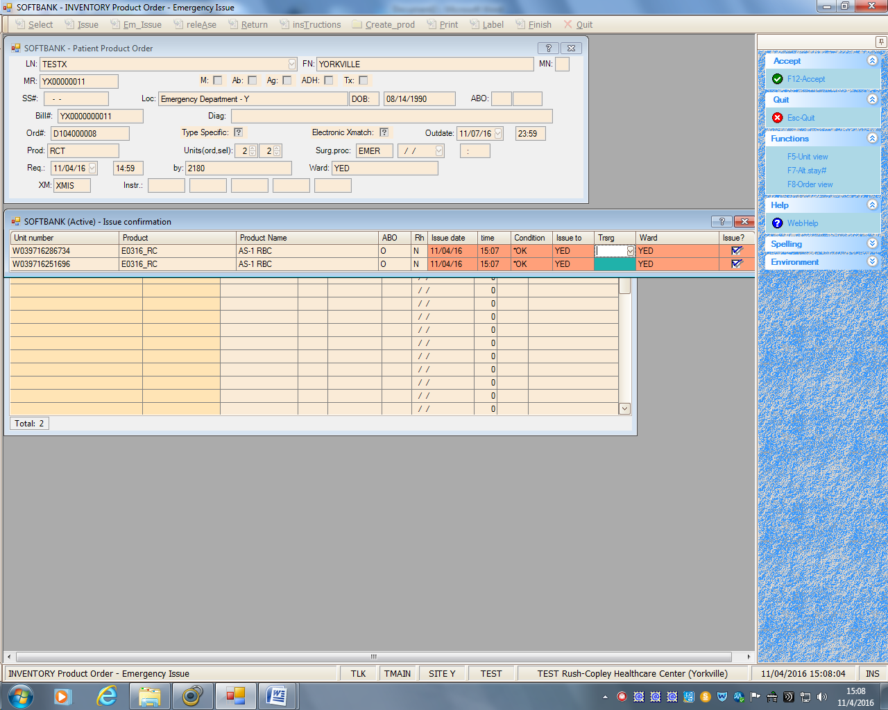

Enter Exception comment or F-5 to select from canned messages

