## TITLE: TEG Quality Control

PRINCIPLE:

Negative and positive controls should be run to check on the performance of all testing and on the instrument operation. Controls are run every eight (8) hours when testing is performed and/or per manufacturer’s recommendation in the same manner and by the same personnel as the patient testing. When instrument not in use, run controls once a week on Friday.

Testing controls provides confidence that all reagents are reacting and being read properly. Errors resulting from user techniques can also be detected.

**CLINICAL SIGNIFICANCE:**

The use of quality control materials is indicated as an objective assessment of the precision of methods and techniques in use and is an integral part of good laboratory practices. Two levels of control are available to allow performance monitoring within the clinical range.

### PERSONNEL:

Medical Technologists.

**SPECIMEN COLLECTION/TREATMENT**:

Patient Preparation: No patient preparation necessary.

Type of Specimen: Commercial Teg QC material

Handling Precautions: Handle the same as clinical specimens

## REAGENT PREPARATION:

### Materials provided

* 1 vials (1 mL each reconstituted) of Level I and Level II lyophilized control (animal citrated plasma).
* 1 vial (1 mL each) of diluent water.
* 1 vial (1 mL) of 0.2 M calcium chloride

**Reagent Preparation**

1. Allow the control vial(s) to reach room temperature.
2. Make sure the control is on the bottom of the vial. You may need to tap the vial a few times.
3. Remove the cap of the lyophilized control.
4. Into one vial of Level I and one vial of Level II lyophilized control slowly pour 1 vial of diluent water(1 mL), provided. Make sure no water drips out.
5. Screw the cap back on to the vial of the control.
6. Shake the vial vigorously and then let it stand for 5 minutes at room temperature.
7. Shake the vial vigorously and let stand for 5 more minutes.
8. DO NOT INVERT OR SHAKE BEFORE USE. May cause bubbles that will affect your results.

**Reagent Storage**

Each reconstituted control is viable for 2 hours at room temperature.

Storage temperature: 2°C - 8°C, unopened vials stable to expiration date.

**Other Material**

* TEG Hemostasis Analyzer attached to a computer running TEG Analytical Software (Source: Haemoscope).
* Plain disposal cups and pins (Source: Haemoscope).
* 20ul pipette
* 340ul pipette

## STEPWISE PROCEDURE:

We recommend you perform this procedure on one TEG analyzer – two columns at a time.

1. In the TEG screen , select a channel and click on the pull down arrow (--N) for

Level I or Level II. Run Both Level I and Level II on both channel 1 and channel 2.

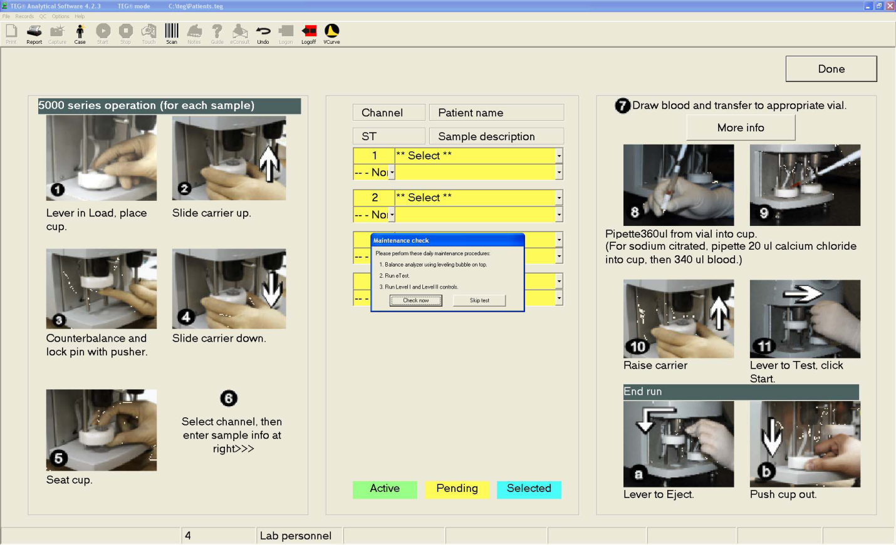

2. Under “Select”, choose a lot number from the list. Click to automatically fill in the

Name field.

3. Load a plain cup and pin into each TEG analyzer column.

4. Disposable cups and pins have crush lines built into them so that they fit snugly into the

cup wells and onto the spindle tip. The disposable cups and pins are for single use only

because the crush lines are spent after the first use

5. Prepare reagents as described above.

6 .Invert the vial 5 times.

7. Pipette 20 µl of 0.2 M calcium chloride into each TEG cup.

8. Pipette 340 µl of reconstituted control into each cup.

9. Immediately slide the carrier up and move the lever to Test.

10. Start the test in the TEG Analytical Software by selecting F10

You will know that the sample has started when the background for the channel number

changes to green, and the cursor moves to the next channel.

|  |  |
| --- | --- |
| **Color** | **Indicates that the channel is…..** |
| Yellow  (Pending) | Available for activation |
| Blue  (Selected) | Selected for activation, data entry, or data acquisition |
| Green  (Active) | Is running an active sample and data is being collected for the sample |

11. Run until MA is finalized.

12. A sample will terminate automatically when the end-of-run conditions specified for the

program have been met (see your Site Administrator for more information).

If you need to end a sample earlier, select a channel from the Main toolbar in either the

Main screen or TEG screen, and click the Stop icon (1) or press F11 on the keyboard.

13. Click “Done” to return to the Main screen

**RESULTS:**

For the TEG unit to acceptably pass the QC (Quality Control) test, R, ANG, and MA Must be within range.

If any value is out of range, refer to the Biological Controls section of the Troubleshooting Guide in the User Manual.

Failure to achieve these results may be an indication of product deterioration, TEG analyzer or procedural problems. Check the temperature. If the temperature appears correct, re-try using a fresh vial of the lyophilized control and fresh calcium chloride.

If the results are still abnormal, contact your local service representative.

Do not report any patient results until the parameters are within their appropriate ranges.

Control ranges may change based on lot number

### PROCEDURAL NOTES:

Limitations

Sources of reagent error:

* Controls should be stored between 2º – 8º C
* Do not freeze the controls

Sources of procedural error

* Reconstitution – The full vial of diluent water must be poured into the vial of lyophilized control
* Timing – Do not use controls if they have been reconstituted for more than 2 hours.

**References:**

Haemoscope

6231 W Howard Street

Niles, IL 60714 USA

[www.haemonetics.com](http://www.haemonetics.com)

S:Laboratory P&P/Blood Bank/TEG/4840TEG-101/ch03/05/12