TITLE: CMS Sure Vue ASO (Quantitative)

PURPOSE:
The rheumagen ASO latex reagent is a suspension of polystyrene latex particles of uniform size coated with streptolysin-O. Latex particles allow visual observation of the antigen-antibody reaction. When a serum containing antistreptolysin-O is mixed with the rheumagen ASO latex reagent, the uniform appearance of the latex suspension will convert to a clear agglutination. This change occurs because the antistreptolysin-O present in the serum reacts with the streptolysin-O coated latex particles, forming a web between them.

NOTE: When rheumagen ASO latex reagent is mixed with a serum if the serum contains 200 IU/L or greater of antistreptolysin-O, a clear agglutination will appear.

CLINICAL SIGNIFICANCE:
The group A- B-hemolytic streptococci produces various toxins that can act as antigens. One of these exotoxins is streptolysin-O that was discovered by Todd in 1932.
A person infected with group B-hemolytic streptococci produces specific antibodies against these exotoxins; one can be an aid into the diagnosis of acute rheumatic fever and post-streptococcal glomerulonephritis.
The usual procedure for the determination of the antistreptolysin titer is based on the inhibitory effect that the patient’s serum produces on the hemolytic power of a pretitrated and reduced streptolysin-O. However the antigen-antibody reaction occurs independently of the hemolytic activity of streptolysin-O. This property enables the establishment of a qualitative and semiquantitative test for the determination of the antistreptolysin-O by agglutination of latex particles on slide.

PERSONNEL
Medical Technologists

REAGENT & EQUIPMENT

Materials Required
1. Normal Saline (0.9% NaCl)
2. Test Tubes
3. Automatic pipettes
4. Timer
5. Rotary Shaker

Materials Provided
1. Rheumajet ASO latex reagent
2. Disposable Slides
3. ASO Titer Control
This preparation has been standardized by the hemolytic method to the WHO International Standard for Antistreptolysin-O. Once reconstituted with 0.5 mL of distilled water the ASO concentration in IU/mL is indicated on the vial label.
Contains thimerosal 0.02%.

The ASO T- control is intended for IN VITRO diagnostic use.
Each donor unit used in the preparation of this material was tested by an FDA approved method for the presence of the antibody to HIV as well as for hepatitis B surface antigen and was found to be negative.

WARNING: POTENTIALLY BIOHAZARDOUS MATERIAL
Because no test method can offer complete assurance that human immunodeficiency virus (HIV), hepatitis B virus, or the infectious agents are absent, this material should be handled at the Biosafety Level 2 as recommended for any potentially infectious human serum or blood specimen in the Centers for Disease Control/National Institutes of Health manual.

PREPARATION
To reconstitute the lyophilized material, remove the cap and the rubber stopper from the vial, add 0.5 mL of distilled water and replace the rubber stopper. Allow reconstituted material to stand for 5 minutes before using. Prior to use, gently rotate the vial.

STORAGE
The ASO T- control will remain stable through the expiration date shown on the label if stored between 2 and 8 degrees C. Do not use after the expiration date shown on the vial label. Once reconstituted it can be used for 15 days if stored between 2 and 8 degrees C. For longer periods the control should be distributed into 100ul aliquots and stored at -20C. No length of time for storage at –20C is given by the manufacturer; therefore we have chosen a six month expiration date for this control when stored at –20C. Freeze and thaw only once.
Although the ASO T-control contains preservatives it remains sensitive to contamination. Handle with necessary precautions. Discard if it becomes contaminated.

SAMPLE COLLECTION
Use fresh serum. If the test cannot be carried out on the same day, the serum may be stored between 2-8C for up to eight days after collection. For longer periods the sample must be frozen (-20°C). the manufacturer gives no length of time for sample storage at –20C.
It is not necessary to inactivate the serum. As in all serological tests, hemolytic, lipemic or turbid serum must not be used. Do not use plasma.

CALIBRATION
None indicated

QUALITY CONTROL
The ASO T-control should be run each time semiquantitative tests are performed.
The ASO-T control should be handled as a serum specimen following the test procedure stated in this procedure.

The obtained concentration should be within one dilution of the concentration indicated on the vial label. If results obtained are not within one dilution of the ASO concentration indicated on the vial label, the test should be repeated. If results remain discrepant, the reagent should not be used and the Sr. Tech contacted.

Enter all QC results in the Quality Control Program in the LIS.

B. SEMIQUANTITATIVE TECHNIQUE
1. Allow reagents and samples to reach room temperature (20 to 30°C).
2. Preparation of two-fold serial dilutions of the serum on the slide
by placing 50 ul of normal saline on slide sections 2 through 6.
3. Using an automatic pipette, place 50ul of the serum onto slide
section 1 and 50 ul directly into the drop of normal saline on slide
section 2.
4. Using the same pipette take in and release several times the mixture
made on section 2 and transfer 50 ul of the mixture to section 3.
Repeat in this manner serially through section 6, discarding 50 ml
from section 6.
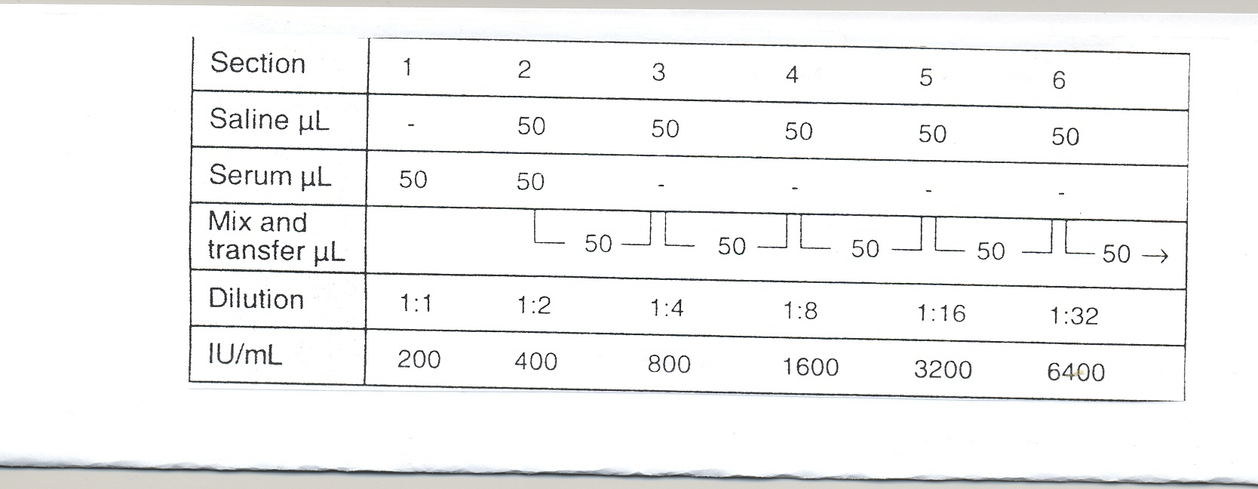

6. Gently shake the reagent vial and add one drop of reagent to each section.
7. Mix both drops using a stirrer covering the whole surface of the slide section.
8. Gently rotate the slide for 2 minutes manually or on a rotary shaker
set at 80-100 rpm.
9. Look for the presence or absence of agglutination after the aforementioned period of time.

REPORTING RESULTS

1. Report all results through the Laboratory Information System.
Refer to the LIS Procedure Manual for complete instructions.
2. Titer results are reported in IU/ml units accordingly to the chart found in the semiquantitative section of this procedure. (200, 400, etc).

INTERPRETATION OF RESULTS
The approximate titer will correspond to the highest serum dilution that still presents a clearly visible agglutination.

LIMITATIONS
Results should be read 2 minutes after the mixing of the reagents on the slide. A reading obtained after this period of time may be incorrect. Existence of prozone at high titers has not been encountered.

EXPECTED VALUES
Although normal values can vary with age, season of the year and geographical area, the “upper limit of normal” antistreptolysin-O titers for preschool children is less than 100 IU/ml and in school age children or young adults is usually between 166 and 250 IU/ml. IN any case, the average can be established at less than 200 IU/ml. Because of this variation, titers above the upper limits may be indicative of a streptococcal infection, but only a two dilution rise in titer between acute and convalescent state specimens should be considered significant. Following acute streptococcal infection, the antistreptolysin-O titer will usually rise after one week, increasing to a maximum level within 3 to 5 weeks and usually returning to the preinfection levels in approximately 6 to 12 months.

INTERFERING SUBSTANCES
See Sure-Vue ASO package insert for interfering substances

REFERENCE
CMS Sure Vue Package Insert BioKit 06/15
I-10/15

S:Laboratory P&P/Serology/4840-IM-101/ch/11/21/05

