## TITLE: Sure-Vue-Mono

## PRINCIPLE:

The monogen reagent is a suspension of polystyrene latex particles of uniform size coated with highly purified Paul-Bunnel antigen from bovine red cell membranes. The degree of purity of the antigen is such that monogen only reacts with infectious mononucleosis heterophile antibodies. For this reason, "differential" absorptions are not necessary.

Latex particles allow visual observation of the antigen-antibody reaction. If infectious mononucleosis heterophile antibodies are present in the serum or plasma, the latex suspension changes its uniform appearance and a clear agglutination becomes evident.

### CLINICAL SIGNIFICANCE:

Infectious mononucleosis is an acute infectious disease of viral etiology. The most frequent symptoms are fever, sore throat, tender lymphadenopathy, anorexia, malaise, headache and myalgia. Splenomegaly occurs in most patients. A macular, maculopapular or petechial rash occurs in up to 50% of the cases, but such rashes occur most commonly in patients who have been treated with ampicillin.

The complications of infectious mononucleosis include secondary bacterial pharyngitis, rupture of the spleen, autoimmune hemolytic bacterial pharyngitis, rupture of the spleen, autoimmune hemolytic anemia, autoimmune thrombocytopenia, myocarditis, hepatitis and central nervous system involvement with meningoencephalitis or transverse myelitis. Fatal fulminate infectious mononucleosis or acquired hypogammaglobulinemia is rarely seen.

### REAGENTS & EQUIPMENT:

1. Normal saline (0.9% NaCl) [for semiquantitative technique]

2. Automatic pipettes

3. Timer

4. Rotator

1. Disposable Stirrers
2. Sure Vue Mono Kit containing
3. **Latex reagent:**

Suspension of polystyrene latex particles coated with Paul-Bunnell antigen in a buffer.

Contains sodium azide 0.1%

1. **Positive Control:**

Rabbit IgG anti-Paul-Bunnell antigen diluted in buffer.

Contains sodium azide 0.1%.

1. **Negative Control:**

Non reactive diluted human serum.

Contains sodium azide 0.1%

### SAMPLE COLLECTION

Serum:

Use fresh serum collected by centrifuging clotted blood. If the test cannot be carried out on the same day, it may be stored between 2 and 8 C for up to 8 days after collection. For longer periods the sample must be frozen (-20C).

Plasma:

Collect blood into a tube containing anticoagulant (EDTA). Other anticoagulants have not been evaluated. Centrifuge to separate plasma from cellular elements. Test the specimen within 24 hours of blood collection.

Do not use hemolyzed or contaminated samples.

**QUALITY CONTROL**

1. The latex reagent should be tested with each of the controls, positive and negative, each

day the test is performed.

2. Both controls should be used following steps 4 through 7 of the Qualitative Technique.

3. The reaction between the positive control and the reagent should show a clear agglutination, different from the uniform appearance of the negative control. If no agglutination takes place, the test should be repeated, and the senior tech should be notified

if a positive reaction is not detected.

1. Record these control results in the Laboratory Information System. Refer to the LIS Procedure Manual for complete instructions.

### STEPWISE PROCEDURE

(QUALITATIVE)

1. Allow reagents and controls to reach room temperature.

2. Gently shake the reagent vial to disperse and suspend the latex particles. Vigorous shaking should be avoided.

3. Place 50ul of serum or plasma in one section of the disposable slide.

4. Place a drop of reagent next to the drop of serum or plasma.

5. Mix both drops together using a stirrer covering the entire surface of the slide

section.

6. Gently rotate the slide for 3 minutes on a rotary shaker set at 80-100 rpm.

7. Look for the presence or absence of agglutination after the 3 minute time period.

### INTERPRETATION OF RESULTS

QUALITATIVE - The presence of agglutination indicates a clinically significant concentration of infectious mononucleosis heterophile antibodies in the serum or plasma.

POSITIVE REACTIONS:

3+ large clumping with clear background

2+ Moderate clumping with fluid slightly opaque in background

1+ Small clumping with opaque fluid in background

NEGATIVE REACTIONS:

No visible clumping, uniform suspension

### RESULTS

Report all results through the Laboratory Information System. Refer to the LIS Procedure Manual for complete instructions on result entry.

QUALITATIVE: Negative = None Detected

Positive = Detected

Titers on Mono's will no longer be done automatically on positive screening results. The comment **"If titer required, please contact the lab"** will need to be added to the screening test.

**LIMITATIONS:**

Results should be read 3 minutes after the mixing of the reagents on the slide. A reading obtained after this period of time may be incorrect.

As with all diagnostic assays, the results of the Sure-Vue-Mono assay should be interpreted in light of the clinical symptoms shown by the patient. Occasionally, detectable levels of heterophile antibodies are late in developing in patients symptomatic for infectious mononucleosis. If symptoms persist, it is recommended to repeat the assay in several days. Although titers of heterophile antibodies have little relation with the severity of the infection, the semi quantitative procedure can be used to follow the evolution of the disease.

A titer is performed according to the semi quantitative procedure.

SEMIQUANTITATIVE

1. Allow reagents and controls to reach room temperature.
2. Place 50 ul of normal saline on slide sections 2 through 6.
3. Using an automatic pipette, place 50 ul of serum or plasma on slide section 1 and 2.
4. Using the same pipette, take in and release the serum or plasma and the normal saline in section 2 several times until they are well mixed.
5. Take 50 ul of the mixture made on sections and transfer it to section 3.
6. Repeat steps 4 and 5 to obtain a thorough mixing of reagents, transferring 0.050 ml form section 3 to section 4 and so on, in succession, through section 6, discarding the last 50 ul.
7. Gently shake the vial of latex reagent placing a drop of it on sections 1 through 6 of the slide containing the different serum or plasma dilutions.
8. Mix both drops with a stirrer covering the whole surface of the slide section.
9. Gently rotate the slide 3 minutes on a rotary shaker set of 80-100 rpm.
10. Look for the presence or absence of agglutination after 3 minutes.

|  |  |  |  |  |  |  |
| --- | --- | --- | --- | --- | --- | --- |
| Section | 1 | 2 | 3 | 4 | 5 | 6 |
| Saline ul | - | 50 | 50 | 50 | 50 | 50 |
| Sample ul | 50` | 50 | - | - | - | - |
| Mix and transfer |  |  |  |  |  |  |
| Dilution | 1:1 | 1:2 | 1:4 | 1:8 | 1:16 | 1:32 |

### INTERPRETATION OF RESULTS

SEMIQUANTITATIVE - The approximate titer corresponds to the highest serum or plasma dilution that still presents a clearly visible agglutination.

### RESULTS

Report all results through the Laboratory Information System. Refer to the LIS Procedure Manual for complete instructions on result entry.

### LIMITATIONS

Results should be read 3 minutes after the mixing of the reagents on the slide. A reading obtained after this period of time may be incorrect.

As with all diagnostic assays, the results of the monogen assay should be interpreted in light of the clinical symptoms shown by the patient. Occasionally, detectable levels of heterophile antibodies are late in developing in patients symptomatic for infectious mononucleosis. If symptoms persist, it is recommended to repeat the assay in several days.

**INTERFERING SUBSTANCES**

See Sur-Vue Mono package insert for interfering substances information.

### REPORTING RESULTS

Through the LIS: Qualitative-Report as non-detected or detected.

Semi-Quantitative - Report dilutions as above. (1:1, 1:2, etc)

### REFERENCE

BIoKit, S.A. Barcelona - Spain

Package Insert

06/15 I-11/15

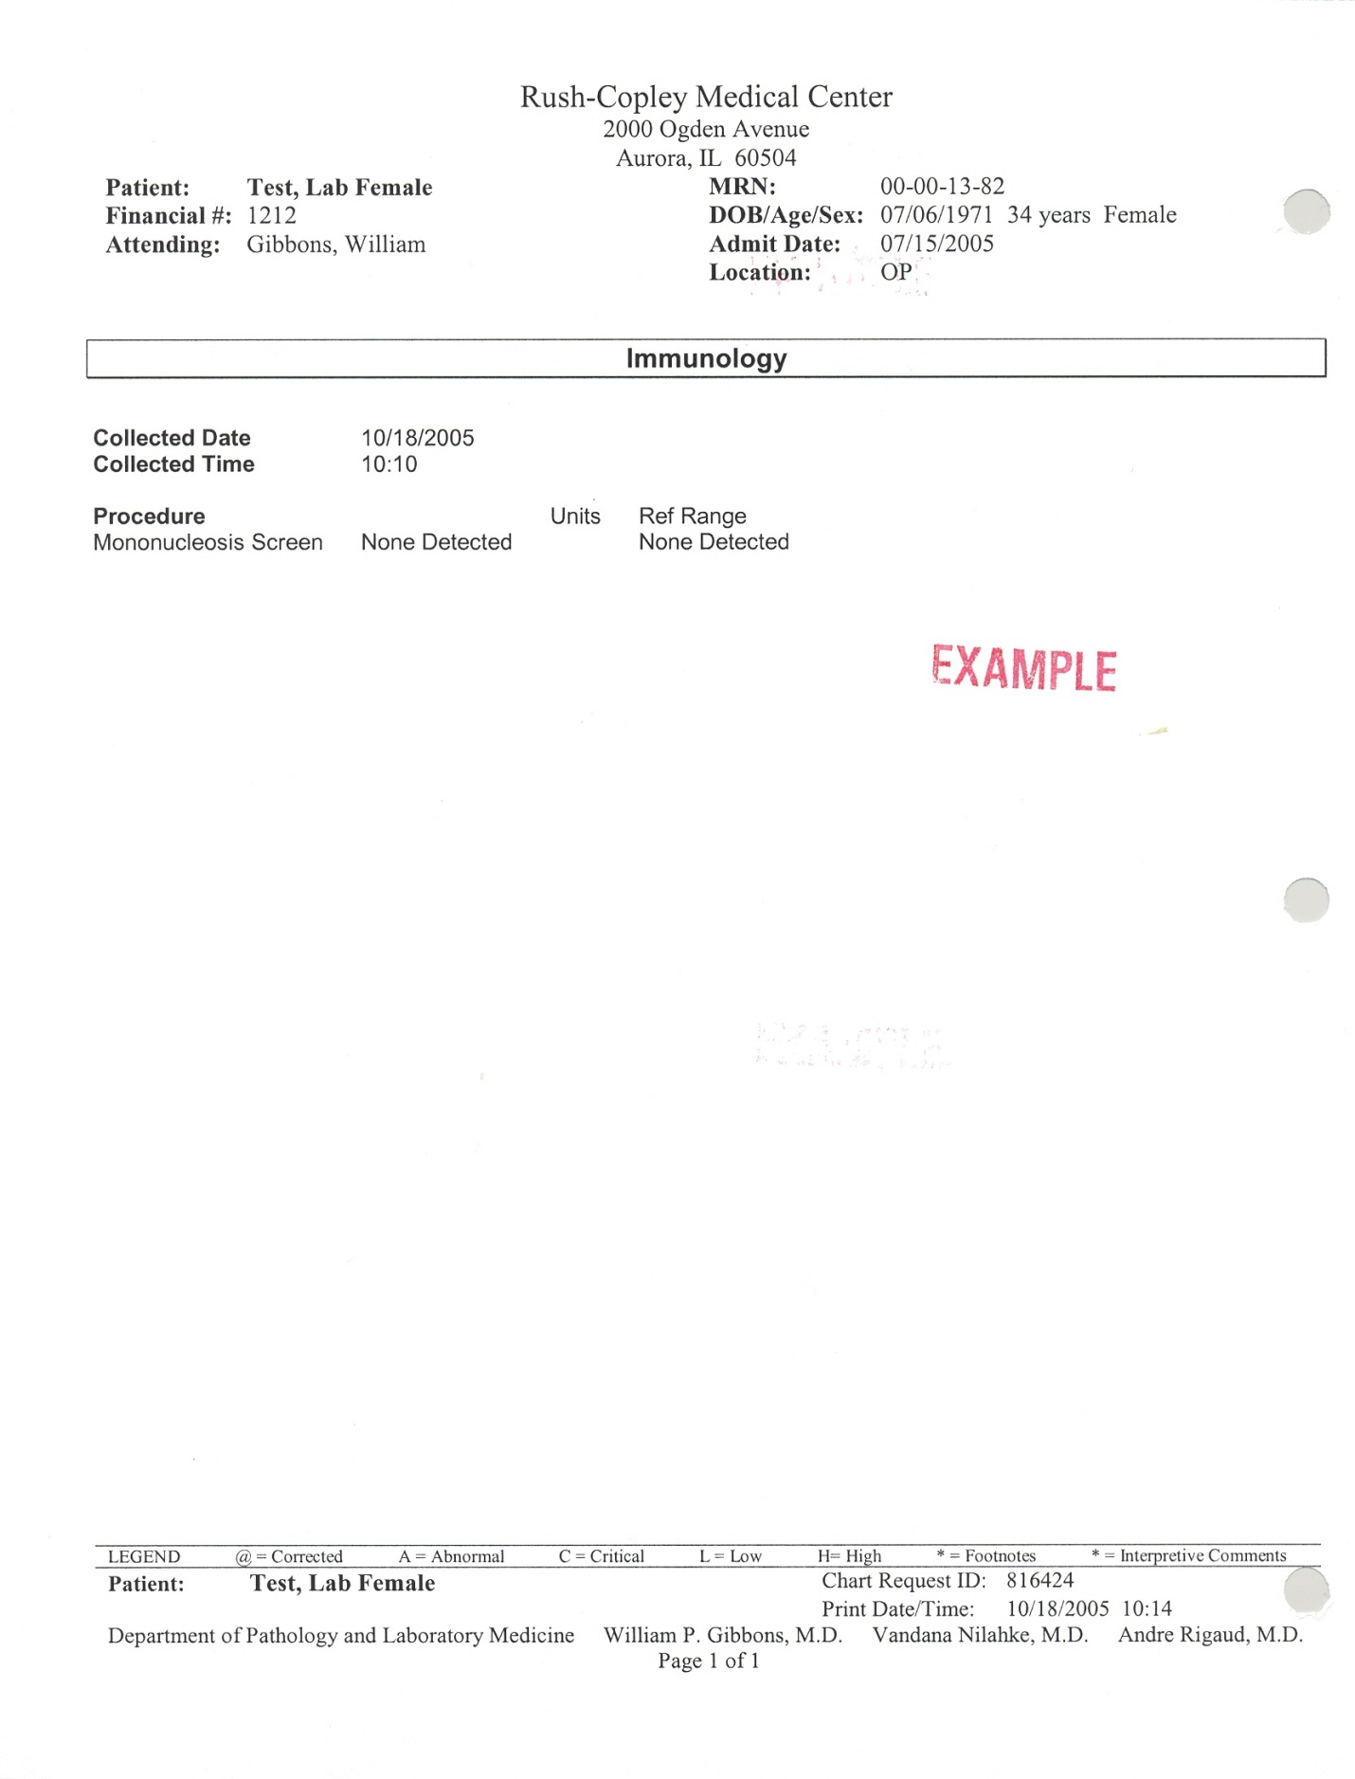

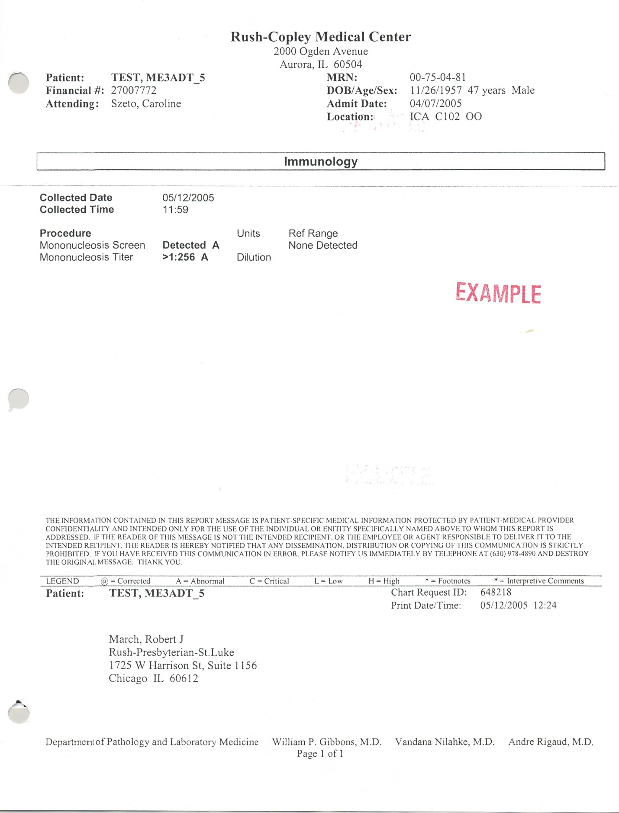

S:Laboratory P&P/Serology/4840-IM-105/ch10/04/11