## TITLE: RHEUMAGEN RF (Qualitative)

## PURPOSE:

The rheumagen RF latex reagent is a suspension of polystyrene latex particles of uniform size coated with human immunoglobulin. Latex particles allow visual observation of the antigen-antibody reaction. When a serum containing rheumatoid factor is mixed with the rheumagen RF latex reagent, the uniform appearance of the latex suspension will convert to a clear agglutination. This change occurs because the rheumatoid factor present in the serum reacts with the IgG coated latex particles, forming a web between them.

NOTE: When rheumagen RF latex is mixed with the serum, if the serum

contains approximately more than 10 IU/mL rheumatoid factor, a

clear agglutination will appear. Results are expressed in International

Reference Preparation of Rheumatoid Arthritis Serum (World

Organization).

### CLINICAL SIGNIFICANCE:

The term rheumatoid factor evolved from the observations of Waaler and Rose, who noted that serum from a high proportion of patients with rheumatoid arthritis agglutinated sheep erythrocytes sensitized with specific rabbit antibodies. Rheumatoid factor is now defined as a group of closely related antibodies specific to antigenic determinants on the Fc fragments of human or animal immunoglobulin G. They commonly belong to the three major classes of immunoglobulins.

A positive latex test, indicating the existence of rheumatoid factor, may be decisive for the diagnosis of rheumatoid arthritis in patients with inflammatory arthritis.

### PERSONNEL

Medical Technologists

## SPECIMEN COLLECTION/TREATMENT

Use fresh serum. If the test cannot be carried out on the same day, the serum may be stored between +2 and +8°C for up to 8 days after collection. For longer periods the sample must be frozen (-20°C). As in all serological tests, hemolytic, lipemic or turbid sera may cause incorrect results and should not be used. Do not use plasma.

### EQUIPMENT AND REAGENT PREPARATION

Materials Required

1. Automatic pipettes
2. Timer
3. Rotator
4. Disposable stirrers

Materials Provides

1. Rheumagen RF latex reagent. Suspension of human IgG coated polystyrene latex particles in a buffer. Contains sodium azide 0.1%.
2. Positive Control, prediluted. Diluted human serum containing more than 10 IU/mL of rheumatoid factor. Ready to use.
3. Negative Control, prediluted. Diluted human serum containing less than 10 IU/mL of rheumatoid factor. Ready to use. Contains sodium azide 0.1%.
4. Disposable slides

NOTE: Above reagents should be stored at +2 and +8°C. DO NOT FREEZE.

### QUALITY CONTROL

1. The latex reagents should be tested with each run of controls, positive and negative, included in the kit prior to each set of determinations.
2. Both controls should be used following the steps of the Qualitative Technique.
3. The reaction between the positive control and the reagent should show a clear agglutination, different from the uniform appearance of the negative control. If no agglutination takes place, the test should be repeated. If there is still not positive reaction, contact the Sr. Tech.
4. Enter all Q.C. Results in the Quality Control Program in the LIS

Refer to the LIS Procedure Manual for complete instructions.

### STEPWISE PROCEDURE

1. Allow reagents and samples to reach room temperature (20 to 30º C).
2. Gently shake the reagent vial to disperse and suspend the latex particles.

Vigorous shaking should be avoided.

1. Place 50 µl of the patient serum in one section of the disposable slide.
2. Place a drop of the reagent next to the drop of serum.
3. Mix both drops together using a stirrer covering the entire surface of the slide section.
4. Gently rotate the slide for 2 minutes manually or on a rotary shaker set at 80-100 rpm.
5. Look for the presence or absence of agglutination after the 2 minute time period.

### INTERPRETATION OF THE RESULTS

* The presence of agglutination indicates a content of rheumatoid factor in the serum equal to or greater than 10 IU/mL.
* The absence of agglutination indicates a content of rheumatoid factor in the serum of less than 10 IU/mL.

**RESULTS**

Report all results through the Laboratory Information system. Refer to the LIS Procedure Manual for complete instructions.

### Negative = None Detected

Positive = Detected

### LIMITATION

Results should be read 2 minutes after the mixing of the reagents on the slide. A reading obtained after this period of time may be incorrect. Existence of prozone at high titers has not been encountered.

A titer must be ordered and performed on all positive RA screens.

A titer is performed according to the semi quantitative procedure (See Procedure #4840-IM-109).

I**NTERFERING SUBSTANCES**

See Rheumagen RF package insert for interfering substance information

### REFERENCE

Sure Vue Package Insert

06/15

I-09/15

BioKit, USA Inc.

Barcelona, Spain

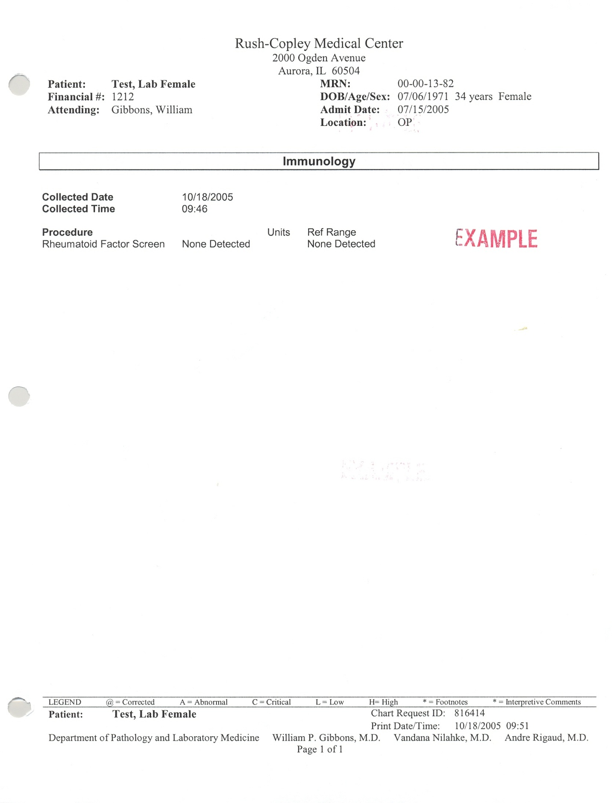

S:Laboratory P&P/Serology/4840-IM-108/ch /11/21/05