## TITLE: RHEUMAGEN RF (Semi-Quantitative)

## PURPOSE:

The rheumagen RF latex reagent is a suspension of polystyrene latex particles of uniform size coated with human immunoglobulin. Latex particles allow visual observation of the antigen-antibody reaction. When a serum containing rheumatoid factor is mixed with the rheumagen RF latex reagent, the uniform appearance of the latex suspension will convert to a clear agglutination. This change occurs because the rheumatoid factor present in the serum reacts with the IgG coated latex particles, forming a web between them.

NOTE: When rheumagen RF latex is mixed with the serum, if the serum

contains approximately more than 10 IU/mL rheumatoid factor, a

clear agglutination will appear. Results are expressed in International

Reference Preparation of Rheumatoid Arthritis Serum (World

Organization).

### CLINICAL SIGNIFICANCE:

The term rheumatoid factor evolved from the observations of Waaler and Rose, who noted that serum from a high proportion of patients with rheumatoid arthritis agglutinated sheep erythrocytes sensitized with specific rabbit antibodies. Rheumatoid factor is now defined as a group of closely related antibodies specific to antigenic determinants on the Fc fragments of human or animal immunoglobulin G. They commonly belong to the three major classes of immunoglobulins.

A positive latex test, indicating the existence of rheumatoid factor, may be decisive for the diagnosis of rheumatoid arthritis in patients with inflammatory arthritis.

### PERSONNEL

Medical Technologists

## SPECIMEN COLLECTION/TREATMENT

Use fresh serum. If the test cannot be carried out on the same day, the serum may be stored between +2 and +8°C for up to 8 days after collection. For longer periods the sample must be frozen. As in all serological tests, hemolytic, lipemic or turbid sera may cause incorrect results and should not be used. Do not use plasma.

### EQUIPMENT AND REAGENT PREPARATION

Materials Required

1. Normal saline (0.9% NaCl)

2. Test tubes

3. Automatic pipettes

4. Timer

5. Rotator

1. Disposable stirrers

Materials Provides

1. Rheumagen RF latex reagent

2. RF Titer Control

3. Disposable slides

This preparation has been standardized by a latex turbidimetric method to the WHO International Reference Preparation of Rheumatoid Arthritis Serum. The RF concentration in IU/mL is indicated on the vial label.

Contains 0.1% sodium azide.

### PRECAUTIONS

The RF-T control is intended for IN VITRO diagnostic use.

Sodium azide has been reported to form lead or copper azide in laboratory plumbing which may explode on percussion. Flush drains with water thoroughly after disposing of fluids containing sodium azide.

Each donor unit used in the preparation of this material was tested by an FDA approved method for the presence of the antibody to HIV as for hepatitis B surface antigen and was found to be negative.

WARNING: POTENTIALLY BIOHAZARDOUS MATERIAL.

Because no test method can offer complete assurance that human immunodeficiency virus (HIV), hepatitis B virus, or other infectious agents are absent, this material should be handled at the Biosafety Level 2 as recommended for any potentially infectious human serum or blood specimen in the Centers for Disease Control/National Institutes of Health manual.

STORAGE

The RF T-control will remain stable through the expiration date shown on the label if stored between 2 and 8 degrees C. Do not use after the expiration date shown on the vial label. Although the RF T- control contains preservatives it remains sensitive to contamination.

Handle with necessary precautions. Discard if it becomes contaminated.

### QUALITY CONTROL

The RF T-control should be run each time semi quantitative tests are performed.

The RF T-control should be handled as a serum specimen following the test procedure stated in

this procedure for quantitative technique.

The approximate concentration of rheumatoid factor in the RF T - control will correspond to the highest dilution which still presents a clearly visible agglutination.

Results should be read 2 minutes after the mixing of the reagents on the slide. Prolonged time in reading may lead to incorrect results.

The obtained concentration should be within the limits stated in the LIS Quality Control program. If results obtained are not within this limit, the test should be repeated. If results

remain discrepant, the reagent should not be used and the reagent manufacturer technical services should be called.

Enter all QC results into the Quality Control Program in the LIS.

Refer to the LIS Procedure Manual for complete instructions.

### STEPWISE PROCEDURE

Allow reagents and samples to reach room temperature (20 to 30º C).

Preparation of two-fold serial dilutions of the serum on the slide (see the descriptive diagram for the technique):

-Place 50 µl of normal saline on slide sections 2 through 6.

-Using an automatic pipette, place 50 µl of the serum onto slide section 1 and 50 µl directly into

the drop of normal saline on slide section 2.

-Using the same pipette take in and release several times the mixture made on section 2 and

transfer 50 µl of the mixture to section 3. Repeat in this manner serially through section 6,

saving 50 µl from last section 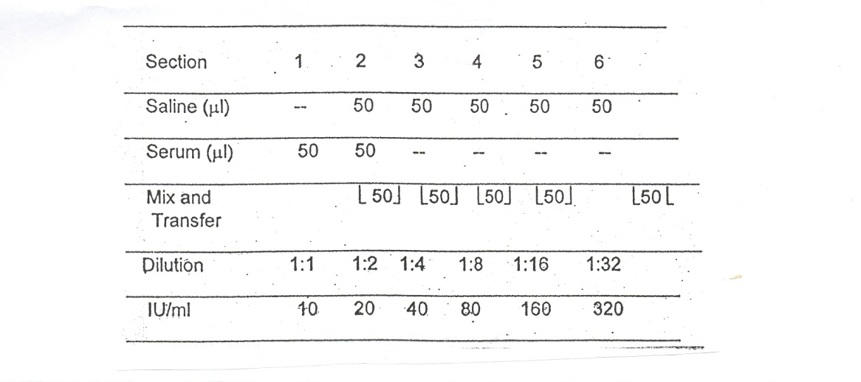

-Gently shake the reagent vial and add one drop of reagent to each section.

-Mix both drops using a stirrer covering the whole surface of the slide section.

-Gently rotate the slide for 2 minutes manually or on a rotary shaker set at

80-100 rpm.

-Look for the presence or absence of agglutination after the aforementioned

period of time.

### INTERPRETATION OF THE RESULTS

The approximate titer will correspond to the highest serum dilution that still presents a clearly visible agglutination (see diagram).

**RESULTS**

Report all results through the Laboratory Information system. Refer to the LIS Procedure Manual for complete instructions.

Report Iu/mL result in accordance with titer results.

### LIMITATION

Results should be read 2 minutes after the mixing of the reagents on the slide. A reading obtained after this period of time may be incorrect. Existence of prozone at high titers has not been encountered.

I**NTERFERING SUBSTANCES**

See Rheumagen RF package insert for interfering substance information

### REFERENCE

SureVue RF Package Insert

06/15

I-09/15

BioKit USA Inc.

Barcelona, Spain

