## TITLE: Rapid Plasma Reagin

## PURPOSE:

The ASI RPR (rapid plasma reagin) Card Test for Syphilis is a qualitative and semi-quantitative non-treponemal flocculation test for the detection of reagin antibodies in human serum and plasma as a screening test in syphilis serology. These materials are intended to be acquired, possessed and used only by health professionals.

The ASI RPR Card Test is an 8-minute macroscopic nontreponemal flocculation test to be used for the detection of reagin. The microparticulae carbon RPR antigen enhances the visual discrimination between reactive and nonreactive results. The reagin-type antibody binds with the antigen that is composed of a complex of cardiolipin, lecithin and cholesterol particles with activated charcoal; the result of this antigen-antibody reaction is macroscopic flocculation.

**CLINICAL SIGNIFICANCE**

Treponema pallidum, the etiological agent of syphilis, induces the production of at least two types of antibodies in human infection anti-treponemal antibodies that can be detected by FTA-ABS antigen, and anti-nontreponemal antibodies (reagin) that can be detected by RPR antigen.

### PERSONNEL

All Medical Technologists

### REAGENTS & EQUIPMENT

1. Carbon Antigen - 0.003% Cardiolipin, 0.020 - 0.022% Lecithin, 0.09% Cholesterol, Charcoal (activated as visual enhancer, Phosphate buffer, Thimerosal preservative, and stabilizers.

2. Controls (Reactive, Weak Reactive, Nonreactive) - Human serum or defibrinated plasma, with 0.1% Sodium Azide as preservative.

3. 3 ml Dropping Bottle

4. 20-Gage Dispensing Needle (60 drops/ml)

5. RPR Test Card (10-Well)

6. 0.05 ml Disposable Stirrer Pipettes

7. Volumetric pipette to deliver 0.05 ml

8. Saline (0.9% NaCl Solution)

9. Serum nonreactive to syphilis, in 0.9% saline, for diluting specimens reactive at the 1:16 dilution in the semi-quantitative procedure.

10. Mechanical rotator set at 100 +/- 5 rpm and circumscribing 3/4 inch diameter, with humidity cover.

11. Timing Device, minute and second capability.

1. Disposable syringe, 1 or 3 ml, accuracy of +/- 5%.
2. HANDLING AND PROCEDURAL NOTES

1. In order to obtain reliable and consistent results, the instructions in the package insert must be strictly followed. Do not modify the handling and storage conditions for reagents or samples.

2. ASI RPR test cards are plastic coated and specifically designed to be used with RPR antigen. In handling take care not to fingermark the card areas, as this may result in an oily deposit and improper test result. When spreading specimen within the confines of the circle area, avoid scratching the card with the stirrer pipettes. If the specimen does not spread in the test area or spreads outside the test area, use another test circle.

3. The needle assembly must be thoroughly washed in distilled or deionized water and air-dried after each shift; do not wipe the needle dry. Place the needle back into the plastic sleeve. Do not remove bottle tip when washing the needle assembly. Let the assembly air-dry. Before next use make sure that no large water droplets remain in the dropping bottle by shaking the bottle and squeezing it.

1. The needle should deliver 60 +/- 2 drops of antigen suspension per milliliter when held in a vertical position and must be checked when a new kit is opened. To perform accuracy check on the needle, attach the needle to a sterile 1 or 3 ml syringe. Fill the syringe with the antigen suspension and, holding the syringe in a vertical position, count the number of drops delivered in 0.5 ml. Dispense the drops into the plastic aliquot bottle. The needle is considered satisfactory if 30 +/- 1 drops are obtained in 0.5 ml. Record these checks in the dispensing bottle/needle section of the Serology Quality Control Book.

If control patterns cannot be reproduced or the antigen drop does not

fall cleanly from the tip, repeat needle accuracy, and check if needle does not deliver proper

drop volume, replace with new verified needle.

5. Do not use past the expiration date indicated on the kit.

Do not interchange components of one kit with those of another kit.

Discard the needle and bottle when the kit is exhausted.

### STORAGE INSTRUCTIONS

Store all reagents at 2 - 8 degrees C in an upright position when not in use. Do not freeze reagents. Pipettes and cards do not require refrigeration. Carbon Antigen may be stored for up to one month in the dropping bottle at 2-8C; in this case, the needle must be cleaned at the end of each use using a syringe or pipette.

### INDICATIONS OF DETERIORATION

1. Turbidity or precipitation in controls is indicative of deterioration and the component should not be used.

1. Bacterial contamination of reagents or specimens may cause false positive results.

### SPECIMEN COLLECTION AND STORAGE

1. Use heated and unheated serum samples, and plasma specimens containing EDTA, CPD or CPDA-1 as anticoagulants. Plasma specimens should be from tubes or blood units which have been collected with adequate volume to provide the appropriate proportions of specimen to anticoagulant.

2. Samples should be free from bacterial contamination, hemolysis, or lipemia.

1. Serum samples should be tested within 5 days of collection and stored at 2-8 C. Samples

that require longer storage periods must be removed from the red cells and may be

stored at 2- 8 degrees C for 5 days or at -20 degrees C or below until testing.

4. Plasma samples stored longer than 5 days should not be used in the assay because of the potential for false reactive results.

5. If necessary before testing, centrifuge the specimens at a force sufficient to sediment cellular components.

6. This test should not be used for testing spinal fluids.

**QUALITY CONTROL:**

1. Control with graded reactivity should be included in each test run to confirm optimal reactivity of the antigen. If control samples do not yield the expected response, the assay should be considered invalid and the assay repeated. If the repeat assay does not elicit the expected results for the control samples, discontinue use of the kit and contact the Senior Tech.
2. Enter all QC results in The Quality Control program in the LIS

Refer to the LIS Procedure Manual for complete instructions.

### TEST PROCEDURE

A. **PREPARATION FOR THE ASSAY**

1. Allow all reagents and samples to warm to room temperature (20-30 degrees C) before use. Remove reagents from foam holders. Do not heat reagents in a water bath.

2. All reagents are ready for use as supplied. Gently mix the reagents before use; avoid foaming.

3. Vigorously agitate the CARBON ANTIGEN for 20-30 seconds before each use in order to ensure homogeneity.

B. **ASSAY PROTOCOL - QUALITATIVE**

1. Using a stirrer pipette, dispense one free-falling drop (0.05 ml) of serum or plasma sample onto a circle on the test card. Use a fresh stirrer pipette for each sample. When using the stirrer pipette, keep it in a vertical position to ensure accurate delivery. Repeat by adding one free-falling drop of REACTIVE, WEAK REACTIVE or NONREACTIVE control from the dropper vials supplied. Note the location of each sample by using the numbers located below and to the right

of each circle.

2. Using the flat end of the stirrer pipette, spread the sample over the entire area of the test circle. Do not scratch the surface of the test area.

3. Attach the needle to the dropping bottle. Mix the CARBON ANTIGEN suspension well. Squeeze the dropping bottle and draw a sufficient volume of the antigen suspension into the bottle. Dispense several drops into the dropping bottle cap to make sure the needle passage is clear.

1. Prior to dispensing carbon antigen, agitate the dropping bottle for a few seconds

to ensure reagent homogeneity. Dispense one free-falling drop of the antigen suspension onto each sample while holding the bottle in a vertical position. DO NOT RESTIR the sample and the antigen. Aspirate any antigen from the bottle cap.

5. Place the card on an automatic rotator and cover to maintain humidity. Rotate at

100 +/- 5 rpm for 8 minutes.

Following rotation, a brief hand rotation and tilting of the card (3-4 times) should be performed to aid in differentiating nonreactive from minimally reactive results.

6. Immediately read results macroscopically in the “wet” state under a high intensity

light source.

7. Remove and wash the needle at the end of each test run.

### ASSAY PROTOCOL - SEMI-QUANTITATIVE

1. Using a stirrer pipette (or other accurate volumetric pipette capable of delivering 0.05 ml), dispense one free-falling drop of saline onto circles to be numbered 2 to 5. DO NOT SPREAD.
2. Using the stirrer pipette (or other accurate volumetric pipette capable of delivering 0.05 ml), dispense one free-falling drop of serum or plasma sample onto circle 1 on the test card. DO NOT SPREAD.
3. Using an accurate volumetric pipette, dispense 0.05 ml of the test sample onto circle 2. Insert the tip of the pipette into the resulting mixture and mix by carefully drawing the mixture up and down in the pipette 5 or 6 times. Avoid any bubble formation.
4. Transfer 0.05 ml of the mixture in circle 2 to circle 3 and mix. Repeat this serial dilution procedure to circle 4 and then to circle 5; discard 0.05 ml form this last circle. Circles 1 through 5 now represent a dilution series as follows:

Circle 1 2 3 4 5

Dilution 1:1 1:2 1:4 1:8 1:16

1. Using the flat end of the stirrer pipette spread the diluted samples over the entire areas of the test circles, starting at circle 5 (highest dilution). Repeat the spreading procedure in circles 4 through 1.
2. Attach the needle to the dropping bottle. Mix the CARBON ANTIGEN suspension well. Squeeze the dropping bottle and draw a sufficient volume of the antigen suspension into the bottle. Dispense several drops into the dropping bottle cap to make sure the needle passage is clear.
3. Prior to dispensing carbon antigen, agitate the dropping bottle for a few seconds to ensure reagent homogeneity.
4. Dispense one free-falling drop of the antigen suspension onto each

sample while holding the bottle in a vertical position. DO NOT RESTIR the sample and

the antigen. Aspirate any antigen from the bottle cap.

1. Place the card onto the automatic rotator and cover to maintain humidity. Rotate at 100+ 5 rpm for 8 minutes. Following rotation, a brief hand rotation and tilting of the card (3-4 times) should be performed to aid in differentiating nonreactive from minimally reactive results.
2. Immediately read results macroscopically in the “wet” state under a high intensity light source.
3. Remove and wash the needle at the end of each test run.

### SAMPLES WITH TITERS GREATER THAN 1:16

1. Prepare a 1:50 dilution of nonreactive serum in saline. This is to be used for making 1:32 and higher dilutions of samples to be titered. Dispense 0.05 ml of this solution onto circle labeled 2 through 5. DO NOT SPREAD.
2. Prepare a 1:16 dilution of test sample by adding 0.1 ml of serum to 1.5 ml of saline. Mix thoroughly. Dispense 0.05 ml of this diluted sample onto circles 1 and 2. DO NOT SPREAD.
3. Mix the solution on circle 2 by drawing the solution up and down 5 or 6 times into the tip of a volumetric pipette. Avoid any bubble formation.
4. Transfer 0.05 ml of the mixture to circle 3 and mix as above. Continue the serial dilution through circle 5 and discard 0.05 ml from this last circle after mixing. Circles 1 through 5 represent a dilution series as follows:

Circle 1 2 3 4 5

Dilution 1:16 1:32 1:64 1:128 1:256

1. Proceed with the test as described in Steps 5-9 under the Semi-Quantitative Test Protocol.
2. Continue with additional dilutions as required until an end-point titer is reached.

**INTERPRETATION OF RESULTS:**

###### Interpretation of Results – Qualitative

1. A reactive result is indicated by the presence of aggregates in the center or periphery of the test circle, ranging from slight to marked and intense.
2. A nonreactive result will give a smooth gray appearance within the test circle or a button of non-aggregated carbon particles in the center of the circle, showing none of the clumping characteristic of a reactive result.
3. Results for the qualitative test should be reported only as Reactive or Nonreactive, regardless of the degree of reactivity. Minimal to moderate reactivity should always be reported as Reactive.
4. Confirm reactive results by retesting the sample using the semi-quantitative procedure.

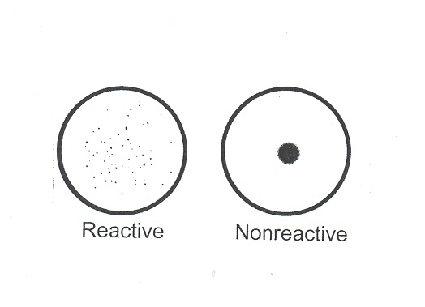

1. Interpretation of results – Semi-Quantitative

1. The highest dilution in which visible aggregation occurs is the end-point titer 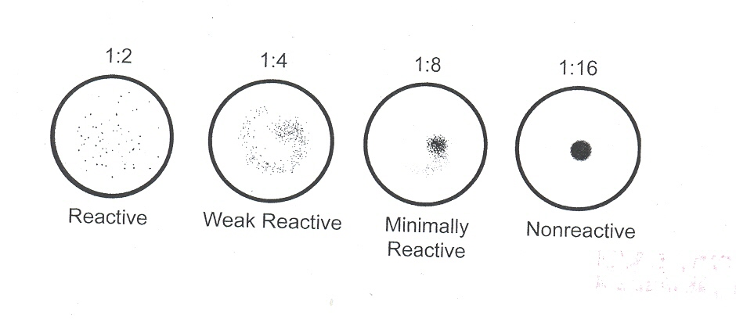

**REPORTING RESULTS:**

Report all results through the Laboratory Information System. Refer to the LIS Procedure Manual for complete instructions.

Negative Results = NR

Weakly Routine Results = RX

Positive Results = RX

Titer results are reported in terms of the highest dilution giving a reactive result. See following example. Attach coded comment no. 14 (positive RPR sent to state) and process sample for send out according to Serology procedure #4840-IM-111.

|  |
| --- |
| 1:1 1:2 1:4 1:8 1:16 Report |
| R N N N N Reactive 1:1 dilution |
| R R R N N Reactive 1:4 dilution |
| R R R R N Reactive 1:8 dilution |

**LIMITATIONS OF THE PROCEDURE:**

1. Prozone reactions occur in patients with secondary syphilis. False negative nontreponemal test results, arising from prozone, are also seen in incubating primary and in late syphilis. The nonreactive pattern is slightly granular or “rough” with specimens exhibiting prozone. When this pattern is exhibited, a dilution of the specimen should be prepared. Titer the diluted specimen until end-point is reached or until no reactivity is observed. All tests exhibiting a rough appearance should be further evaluated.
2. Biological false positive reactions occur occasionally with the CARBON ANTIGEN. Such reactions sometimes occur in samples from individuals with a history of drug abuse, or with diseases such as lupus erythematosus, malaria, vaccinia, mononucleosis, leprosy, viral pneumonia, and after smallpox vaccinations.
3. Pinta, yaws, bejel and other treponemal diseases produce positive reactions in this test.
4. Contaminated, lipemic, or grossly hemolyzed sera should not be used because of the possibility of nonspecific reactions.
5. Reaction times longer than specified might cause false positive results due to a drying effect.
6. Reactive RPR test samples should be substantiated using a confirmatory test as recommended in the Manual of Test for Syphilis.
7. In accord with all diagnostic methods, a final diagnosis should not be made on the results of a single test, but should be based on a correlation of test results with other clinical findings.

EXPECTED VALUES AND PERFORMANCE CHARACTERISTICS

1. The ASI RPR Card Test is evaluated for equivalence, in its pattern of reactivity, against the CDC Reference RPR.
2. A total of 1209 samples were tested by the ASI RPR Card Test in comparison with the Hynson, Westcott and Dunning (HWD) product. The following results were obtained. There was 99.2% overall agreement between the two products. Among the 9 samples found to be nonreactive in the ASI test, 7 were also confirmed negative by the RGA-ABS test

ASI RPR TEST

Reactive Nonreactive

Reactive 462 9

HWD RPR TEST Nonreactive 1 737

**INTERFERING SUBSTANCES:**

See ASI RPR Card Test Package Insert for interfering substance information.

**REFERENCES:**

###### ASI RPR Card Test for Syphilis Insert, 03/16

Arlington Scientific, Inc. Arlington Texas 76011

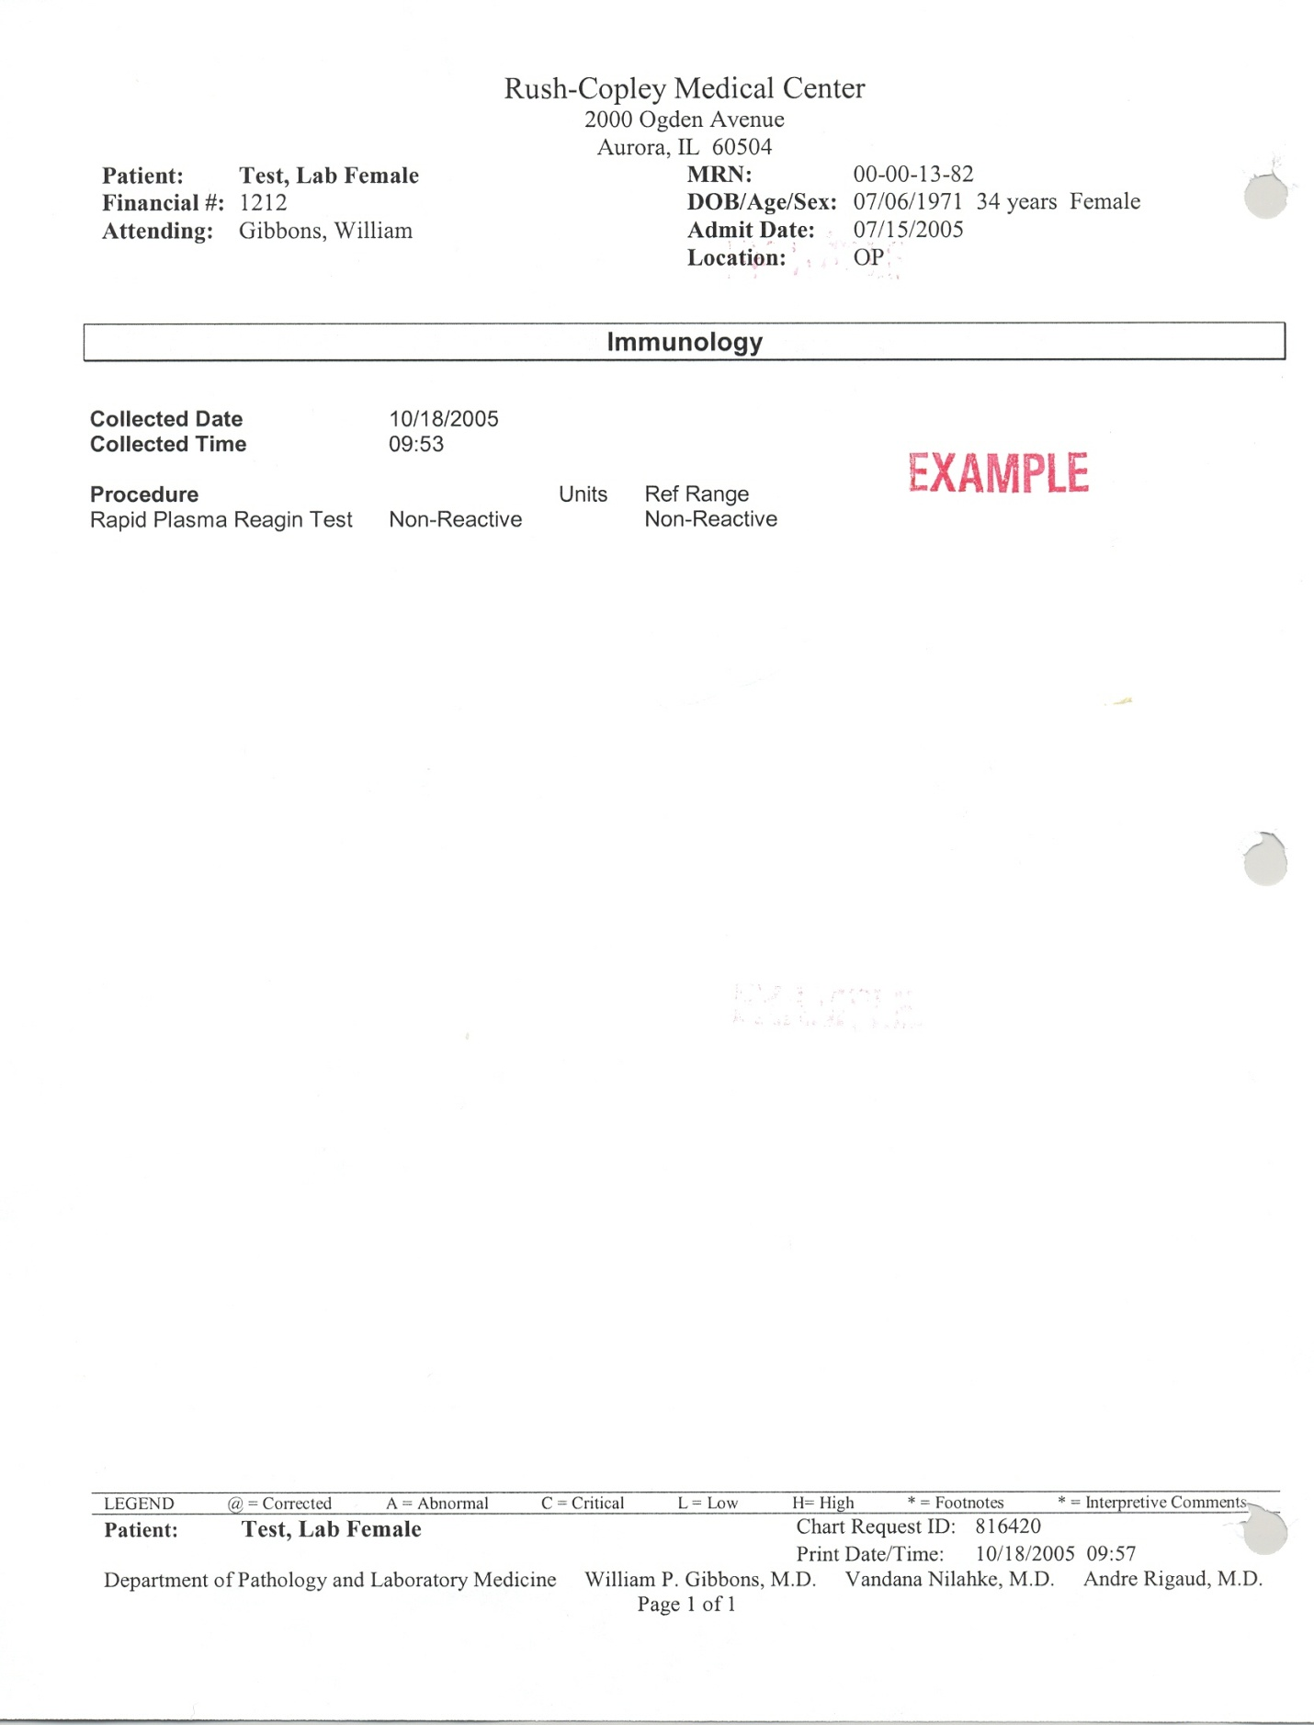

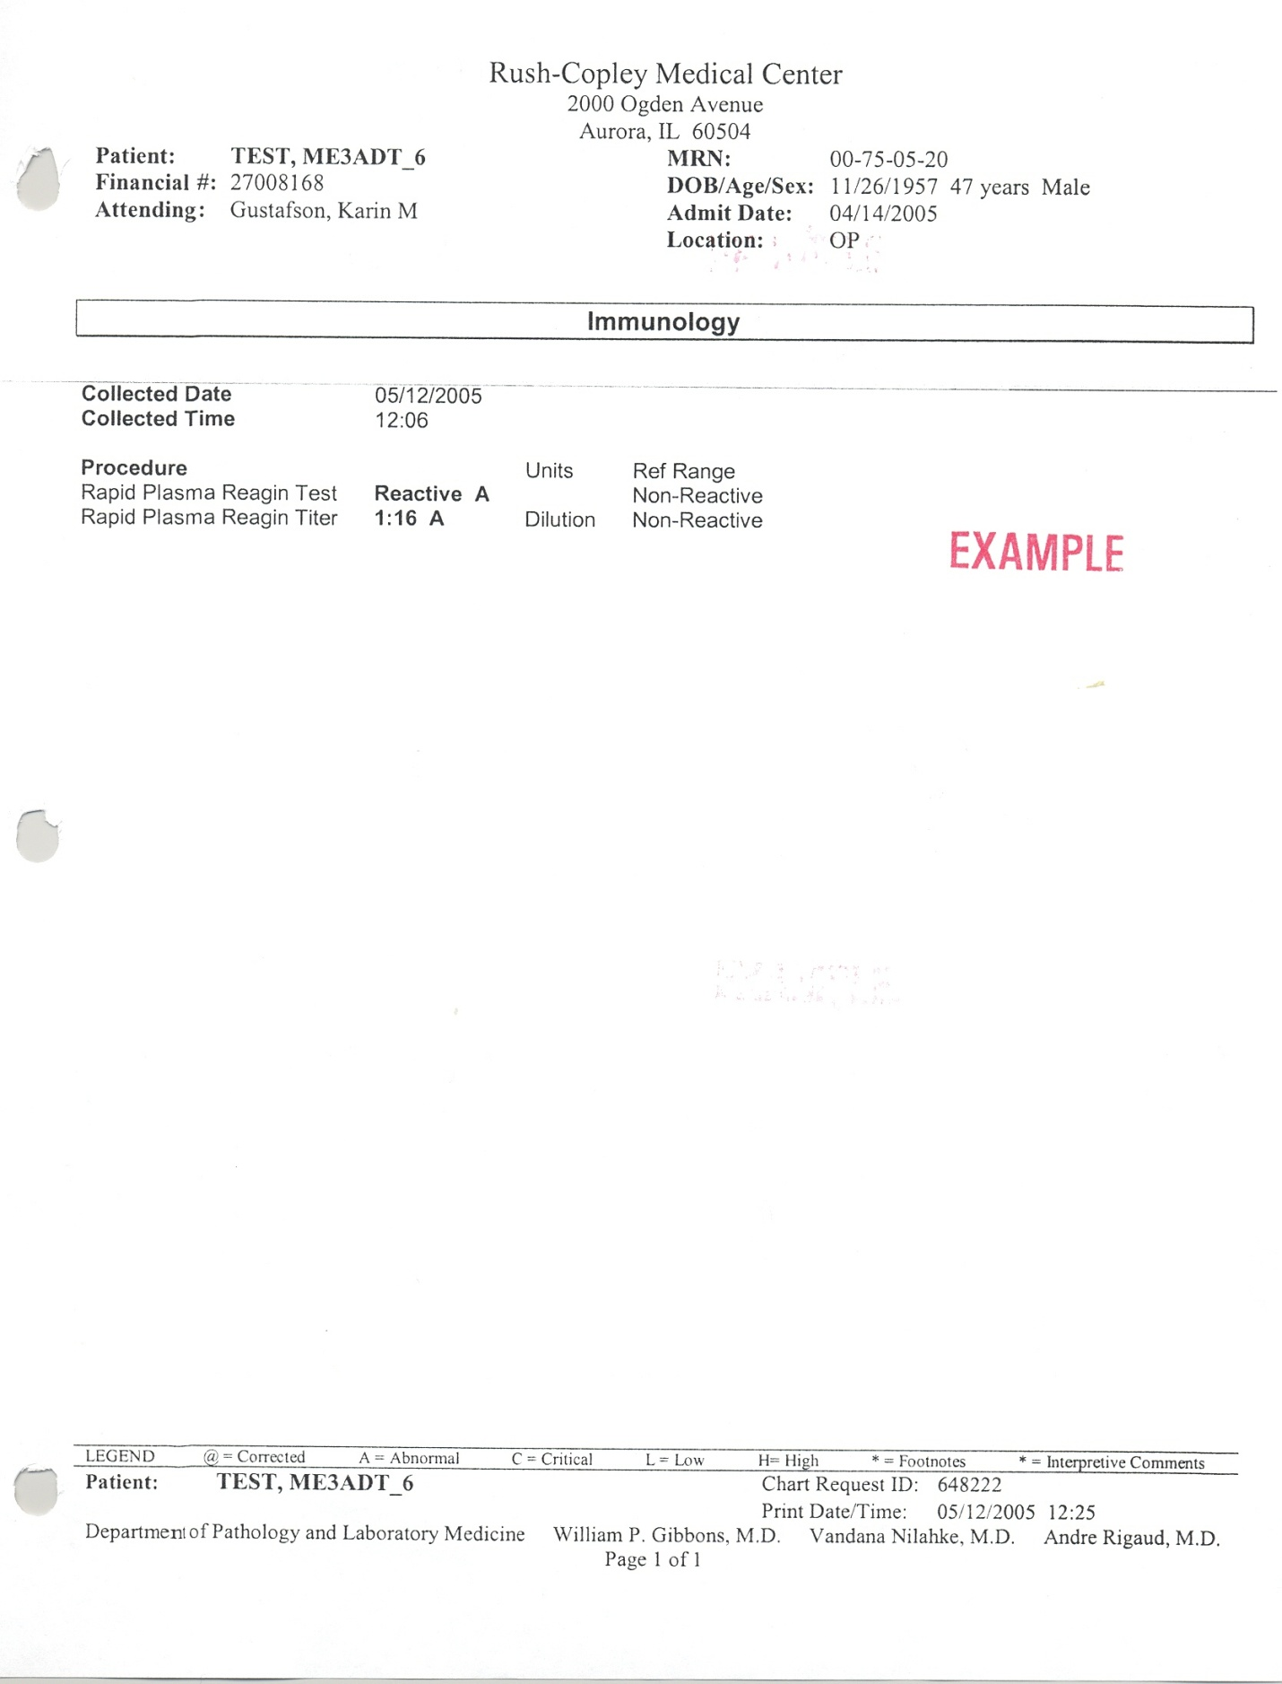S:Laboratory P&P/Serology/4840-IM-110/ch/11/21/05