TITLE: Compatibility Test

PRINCIPLE: The purpose of crossmatching is to prevent transfusion of incompatible red cells. Testing the patient’s serum with donor red cells is required because it is the best available way to detect antibodies that might damage transfused red cells and cause hemolytic transfusion reactions. A compatible crossmatch will verify in most instances that donor’s red cells are ABO compatible with the patient.

CLINICAL SIGNIFICANCE: The purpose of pretransfusion testing is to select blood components that will not cause harm to the recipient and will have acceptable survival when transfused. If performed properly, pretransfusion tests will confirm ABO compatibility between the component and the recipient and detect most clinically significant unexpected antibodies.

PERSONNEL: Medical Technologists

SPECIMEN COLLECTION/TREATMENT:
No special preparation of the patient is required prior to specimen collection. Blood collected with or without an anticoagulant may be used. (Red top tube or pink top tube).
The blood sample should be tested as soon as possible after collection. If a delay occurs, store sample at 2 C to 8 C. Sample can only be used for 3 days from collection time.

REAGENTS AND EQUIPMENT:

See individual procedures

CALIBRATION:

None indicated

QUALITY CONTROL:
Negative antiglobulin tests should be controlled with a product such as Coombs Control Cells. This reagent consists of group O red blood cells sensitized with IgG antibody. SoftID provides positive patient and specimen identification at the point of care. This effective lab software solution enhances patient safety by accurately identifying the patient and the appropriate lab test and ensuring that patient lab specimens are correctly bar coded and labeled.

STEPWISE PROCEDURE:
- If the antibody screen is negative, and there is a historical ABORh group in the LIS or the
ABORh typing is performed twice during the current admission; an electronic crossmatch will be performed by the LIS.

An immediate spin crossmatch will only be done if two ABORh typing are not present in the LIS.

- When the antibody screen is positive or patient has a positive antibody file, the antiglobulin phase of the cross match must be done, in addition to the immediate spin crossmatch.
Donor units whose cells are known to be negative for previously identified patient
antibodies must be used.

ELECTRONIC CROSSMATCH:
An electronic crossmatch is an acceptable method for detecting ABO incompatibility when the following criteria are met:
- The LIS system has been validated on-site to make sure only ABO compatible red blood cells and components have been selected for transfusion.
- The patient has 2 ABO typings on file.
- The LIS system contains the unit number, component name, ABO group and Rh, the confirmed ABO group on the unit, recipient’s name/medical record number/ABO and Rh and antibody screen results.
- Accurate data entry which requires the technologist to verify results before sending information and the use of bar coding for units.
- The LIS system contains alerts to notify the user of discrepancies between donor ABORh on the unit label and those determined by the confirmation testing. It also alerts to ABO incompatibility between the recipient and donor. The LIS will not allow electronic crossmatching if there is a discrepancy between the current typing results and historical typing results or if the patient has a clinically significant antibody.
- The screen shots following this procedure are the data entry entry verification for electronic crossmatch. They are the verification of correct data entry and LIS computer alerts used to prevent issuance of blood components when discrepancies exist.

CALCULATIONS: None indicated

REPORTING RESULTS:
- Report all results through the Laboratory Information System. Refer to the Blood Bank Computer Manual for complete instructions.
- Anytime a “least incompatible or incompatible” unit is to be set up for a patient, the attending physician must be contacted and a written order supplied to the Blood Bank.
- For STATS call the floor and notify them when blood is available. Note on the order to transfuse; person spoken to and unit called for clarification later if necessary.
- Cap patient sample and place in the daily rack. Samples are saved for 21 days in the Blood Bank refrigerator.

INTERPRETATION:
The donor is considered compatible if there is no hemolysis or agglutination in the crossmatch. If in any step of the procedure, any or all of the tubes show hemolysis and/or agglutination, there is the possibility that an unexpected antibody is present in the patient’s serum and further testing is indicated. See Blood Bank Procedure Book #4 for Antibody Work-up procedures to follow.

No units may be released for the patient, until the cause of the hemolysis and/or agglutination is resolved.

REFERENCE:
AABB Technical Manual 16th Edition, 2008.
Standards for Blood Banks and Transfusion Service 25th Edition, 2008

SCENARIO #1: Patient only has one ABORh type on file, electronic crossmatch not allowed.
Review patient history with all testing. This prompt will always appear.
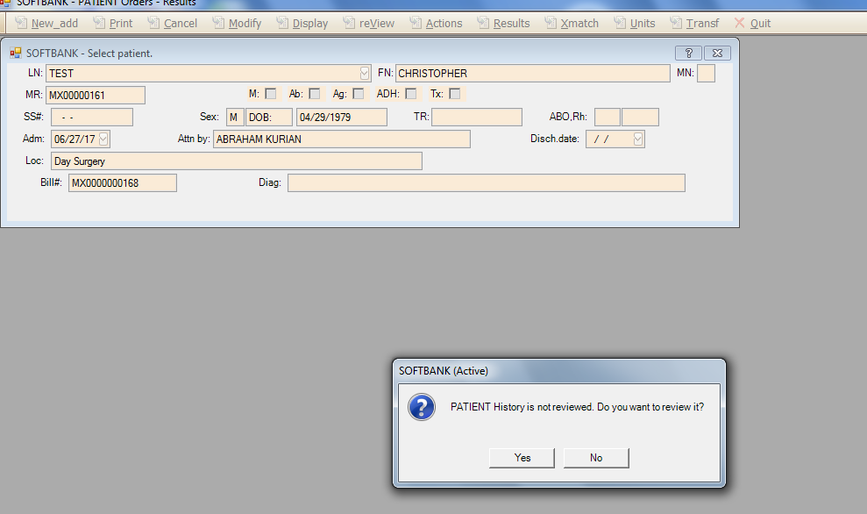

History displayed
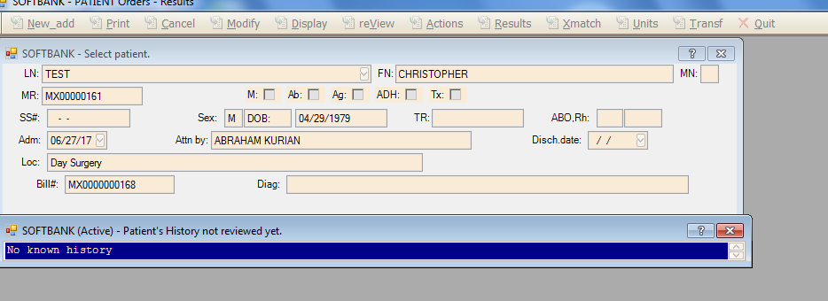

History marked as reviewed
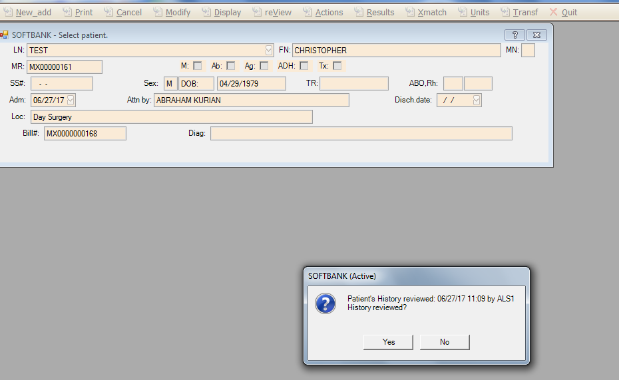

At unit selection, electronic crossmatch is impossible because patient has not been typed 2 times
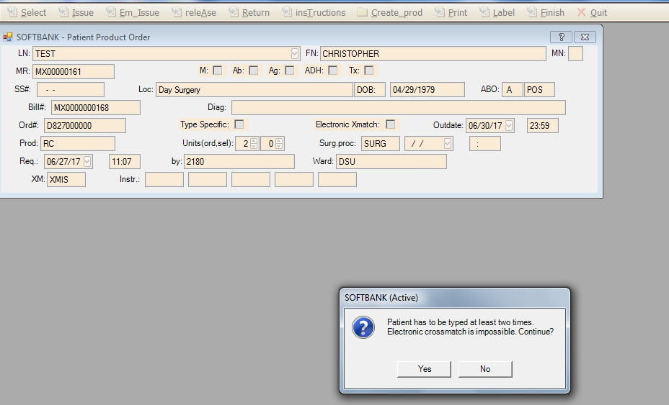

SCENARIO # 2: Unit selected is not confirmed, electronic crossmatch not allowed.
History is displayed.
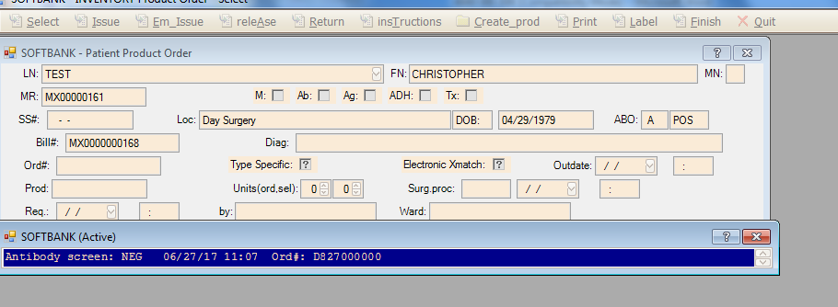

Electronic Crossmatch is impossible, no unit recheck (retype) has been done.
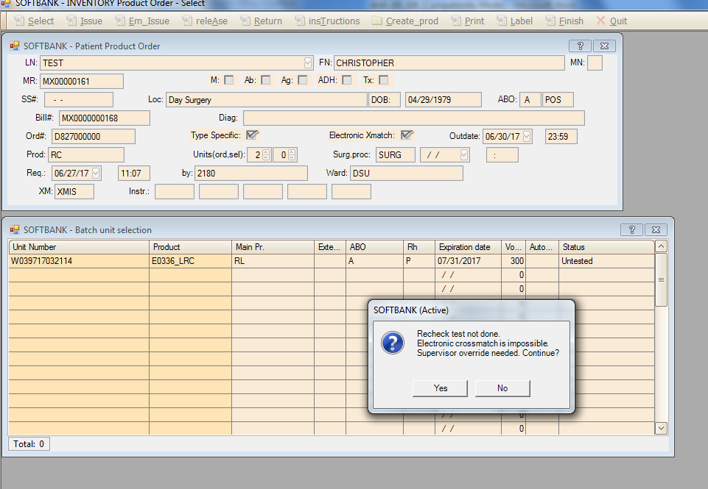

SCENARIO #3: Patient has a historical clinically significant antibody and the current screen is negative, electronic crossmatch is not allowed.
History is displayed.
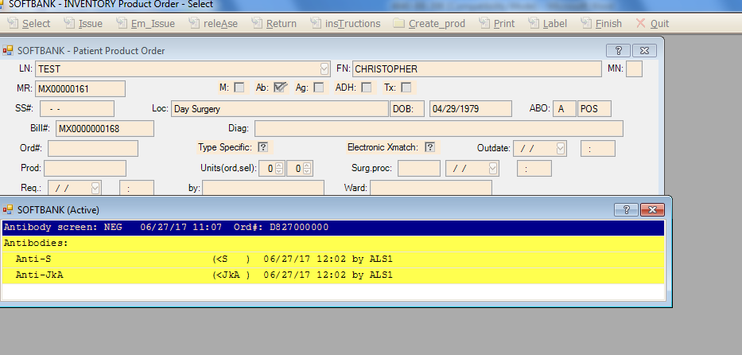

Electronic crossmatch is impossible.
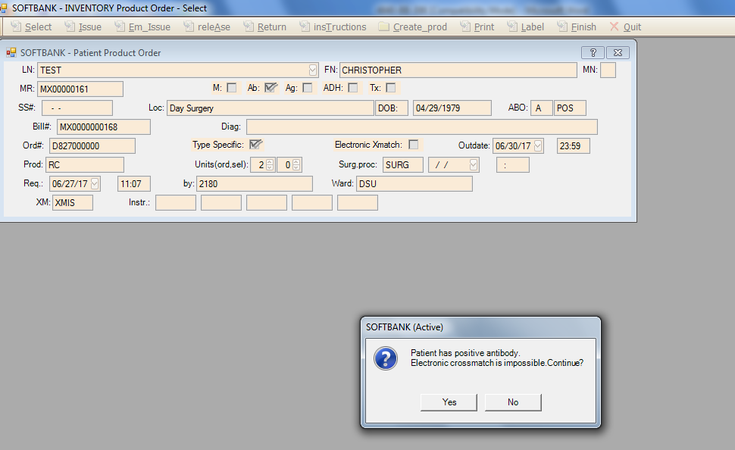

SCENARIO # 4: Patient has a positive antibody screen, electronic crossmatch is not allowed.
Patient has a historical antibody on file.
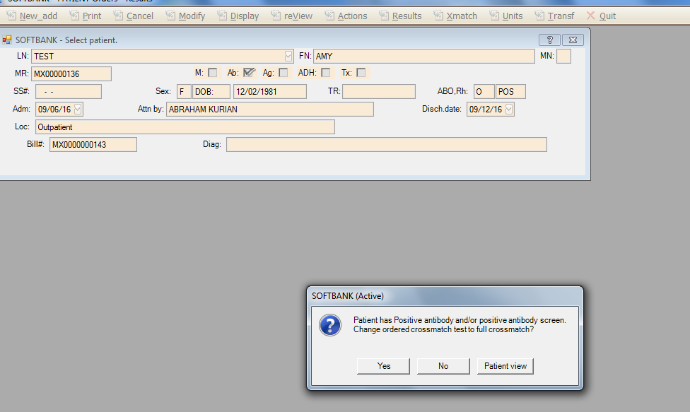

Electronic Crossmatch is impossible.
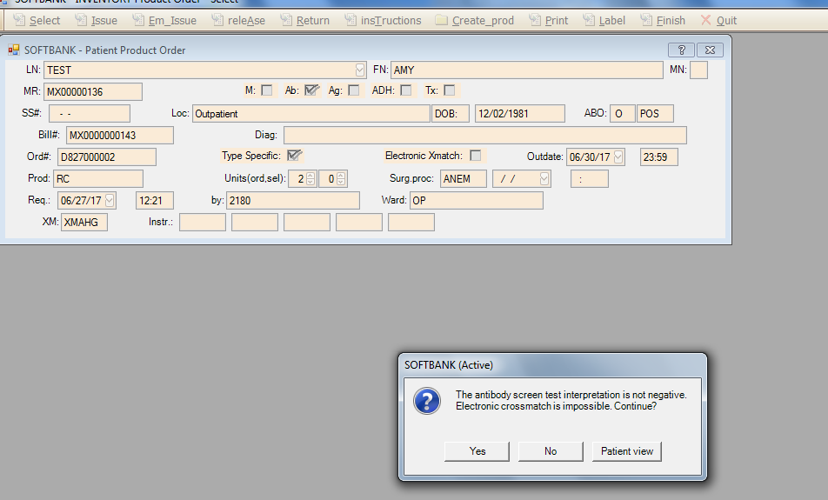
SCENARIO #5: An outdated specimen is used for the crossmatch, electronic crossmatch is not allowed.

Outdated specimen, electronic crossmatch is impossible.
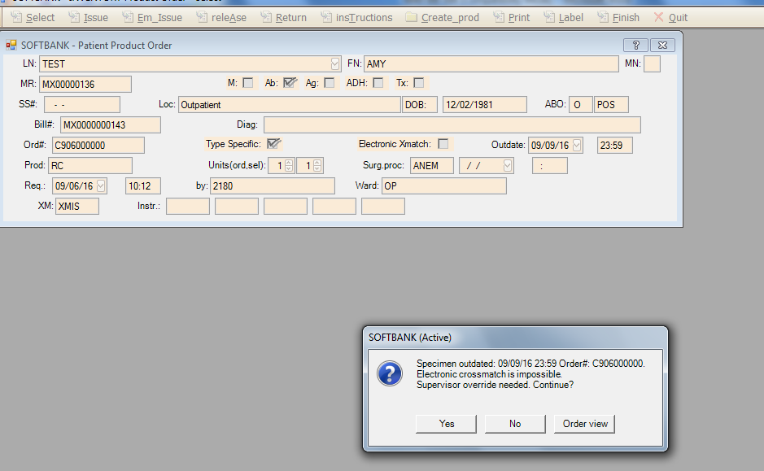

SCENARIO # 6: Patient has discrepant ABO results on file, electronic crossmatch not allowed.

Patient is historically O pos, now typing as an A pos.
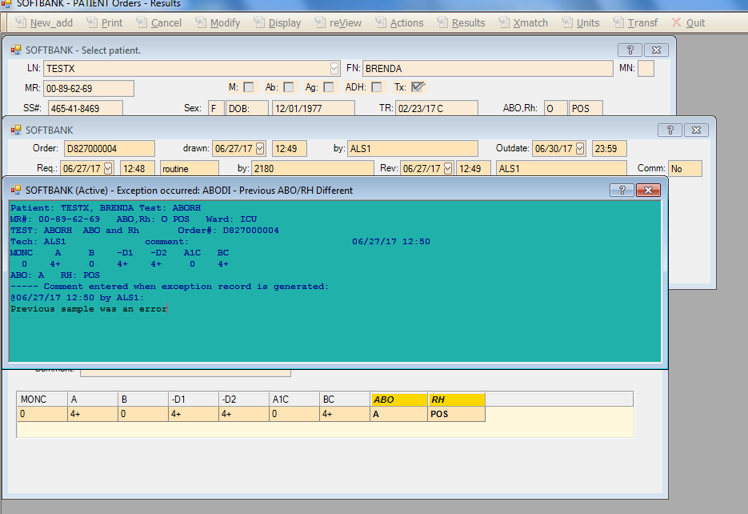

Override done by Supervisor only for changed blood type.
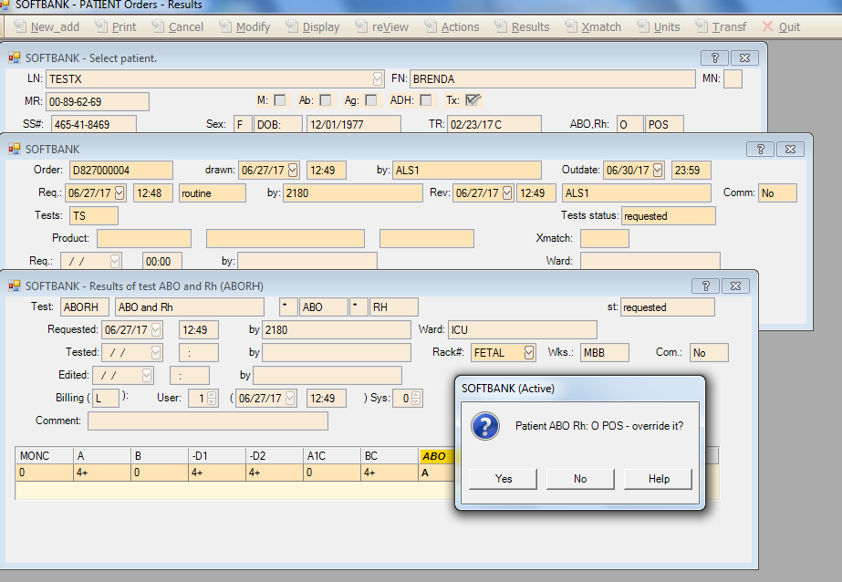

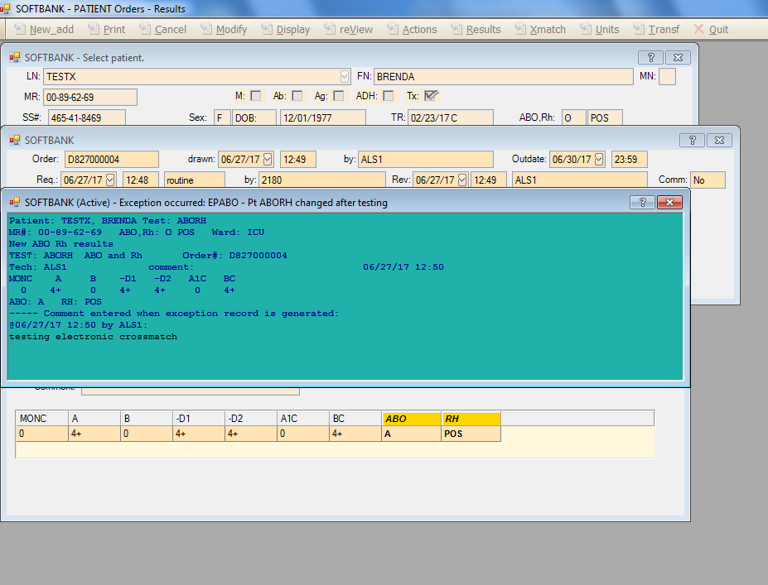

Discrepancy is now part of the patient’s record.

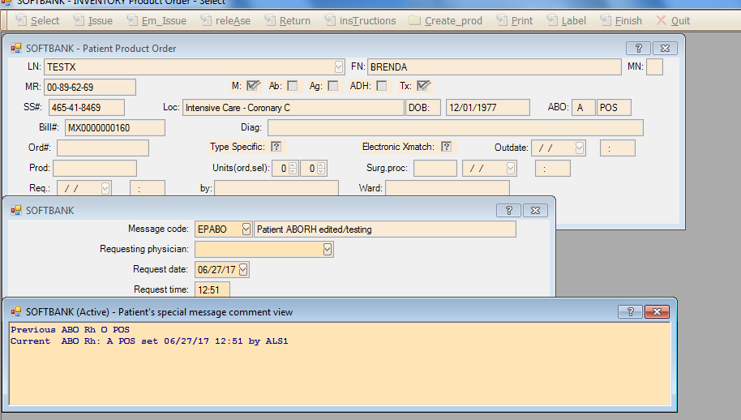

Patient will need another sample to confirm the change in blood type.

