TITLE: Exchange Transfusion

## PRINCIPLE:

Exchange transfusion, originally used almost exclusively as treatment for hemolytic disease of the newborn, has recently been advocated as adjunctive therapy for a variety of life-threatening diseases affecting newborns including respiratory distress, disseminated intravascular coagulation (DIC) and sepsis. The procedure carries a mortality rate of approximately 1% and there may be substantial morbidity. Exchange transfusion is often quantified (e.g., two-volume, single-volume) to reflect the effect on the infant’s total blood volume. In H.D.N. it is desirable to crossmatch with the mother’s serum, if available for the first exchange. The mother’s serum is the specimen of choice, since the offending antibody is present in a higher titer in her serum than in the infant’s serum.

CLINICAL SIGNIFICANCE

Exchange transfusion is the indicated treatment for severe HDN. Removing the baby’s plasma reduces the load of accumulated bilirubin and the number of unbound antibody molecules. Replacement with donor plasma restores albumin and any needed coagulation factors. Antibody-coated cells, whose destruction would further raise the bilirubin load, are removed and replaced with red cells compatible with the maternal antibody.

### PERSONNEL

Medical Technologists

### SPECIMEN

In order to transfuse an exchange unit without a Type, Screen & Crossmatch on the baby: these items must be present

1. A Cord Blood Order w/ Results linked to the baby’s mother (when resulting the cord blood you will be asked for Mother’s MRN to “Link” the Mom/Baby.
2. A Maternal Profile or Type and Screen on Mother (Done before the cord blood is resulted)
3. A Exchange product order
4. Negative antibody screen on mom

No special preparation of the patient is required prior to specimen collection. Draw **two** lavender micro-containers for this procedure from the baby. See Ordering Blood and Other Components Procedure No 4840-BB-100 for complete details on drawing samples for Blood Bank Orders. The blood sample should be tested as soon as possible after collection. If delay occurs, store sample at 2 C to 8 C. Sample can only be used for 3 days from collection time.

### REAGENT PREPARATION & EQUIPMENT

### Plasma Thawer

Balance and other supplies (located in second overhead bin in the Blood Bank)

See Compatibility Test Procedure No. 4840-BB-312 for other possible needed supplies

### 

### CALIBRATION

None needed

**QUALITY CONTROL**

SoftID provided positive patient and specimen identification at the point of care. This effective lab software solution enhances patient safety by accurately identifying the patient and the appropriate lab test and ensuring that patient lab specimens are correctly bar coded and labeled.

NOTE:

When an exchange transfusion is requested by the nursery.

The needed red blood unit (see below for unit specifications)

can only be ordered if a current antibody history is available for the patient.

### STEPWISE PROCEDURE

**DO STEPS IN ORDER TO PREVENT CONFUSION**

I. **MATERNAL PROFILE**

1. Check record for a mother’s ABO, Rh typing and antibody screen done during the delivery hospital stay.
2. If no results are found, have a Maternal Profile ordered and drawn on the mother.

See Procedure No. 4840-BB-610 for more information if needed.

II **Cord Blood**

Perform an ABO and Rh typing, Direct Coombs and Antibody Screen (if indicated, heelstick specimen only) on baby’s sample.

###### III**. TRANSFUSION ORDER**

To notify the laboratory, place an Exchange Transfusion Order through the Sunrise Order System.

1. Gather all necessary labels,
2. **If no maternal profile is available**, **two** lavender micro-containers need to be drawn for this crossmatch from the baby.

* IF YOU ARE DRAWING THE PATIENT, Go to the patient’s room.
* Draw patient in accordance with Procedure No. 4840-LCC-312, SoftID
* Send blood sample and all the paperwork to the Laboratory.
* ***Blood bank orders without appropriate documentation will not be accepted by the Blood Bank.***
* Perform an ABO and Rh typing, and Antibody Screen on this baby’s sample.
* If no cord blood results exist, perform a direct coombs test.
* Add on additional testing orders to the Transfuse Neonatal RC Order as needed.

1. If the initial antibody screen on the mother or baby is negative, it is unnecessary to crossmatch donor red cells for the initial or subsequent transfusions, provided that the cells are O negative. Repeat testing may be omitted for the remainder of the neonatal period during any one hospital admission.
2. If the initial antibody screen on mom’s maternal profile or baby’s sample, demonstrates clinically significant unexpected red cell antibodies these antibodies must be identified and units shall be prepared for transfusion that do not contain the corresponding antigen and such units shall be crossmatched, using methods that include the antiglobulin test.

###### See Blood Bank Procedure Book for more information on antibody identification.

An AHG (Coombs) crossmatch needs to be added to the Neonatal Transfusion. Report out the AHG crossmatch so that the tags contain the AHG results.

See Blood Bank Procedure Book for more information on antibody identification.

**III. CALCULATIONS**:

1. Use the neonatal total exchange calculation worksheet to

determine the amount of thawed plasma to be added to the RBCs for a

final product with the desired hematocrit of 45%-55%.

(See Example)

There is a short cut on the Serology Terminal desk top for this calculation

worksheet.

**Babies weighing more than 2.8 Kg will require two red blood cell units**

**to be ordered from Heartland.**

**(Volume of RBC from calculation greater than 250ml or total volume greater**

**than 550ml.)**

2. Print worksheet and file in Exchange Transfusion Calculations Binder.

1. **SELECTION OF BLOOD: done after antibody screening results obtained:**

**A. Neonatal Exchange Units will be prepared from an O Negative RBC (See**

**following requirements) and an AB CMV Negative Thawed Frozen Plasma.**

**B. Donor blood selected for all exchange transfusions including those for**

**low birth weight should:**

1. Lack red cell antigens corresponding to the maternal antibodies, if indicated
2. Be less than five days old.
3. Be negative for Hemoglobin S (Sickle Cell Negative)
4. Be negative for CMV.
5. Be Irradiated
6. Be leukoreduced
7. Call Heartland Blood Center to order the unit (630-892-7091).
8. Unit can be placed on crossmatch shelf in anticipation of transfusion.

V.  **PREPARATION OF UNIT:**

**Confirm with NICU that unit is still needed before reconstituting**

1. Turn balance on 30 minutes before use.
2. Weigh red blood cell unit
3. Weigh empty exchange bag
4. Zero scale

To reconstitute the RBCs:

a. Weigh the empty exchange transfusion bag.

b. Aseptically spike the red blood cell bag and transfer the required

mls of red blood cells.

c. Clamp tubing. DO NOT SEAL

d. Remove spike from red blood cell bag.

e. Dispose of the remainder of the red blood cell bag in the biohazard

waste.

f. Using the same cannula, aseptically spike the thawed plasma bag and

transfer the required mls of thawed plasma into the exchange bag.

g. Clamp the tubing.

h. Mix well the contents of the exchange bag.

1. Heat seal to close tubing.
2. Affix the O Negative type label to the front of the unit.

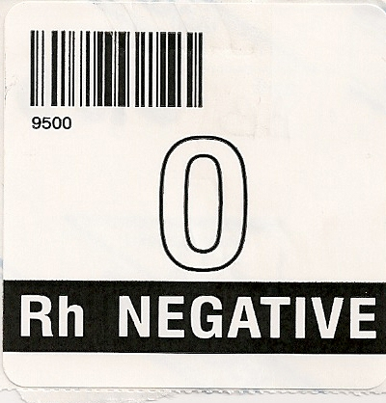

1. Affix ISBT Label to the front of unit.

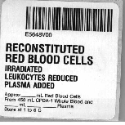

l. Fill in required data and affix pool label (found in blue bin with other labels) to front of unit.

Reconstituted Exchange has an expiration of 24 hours.

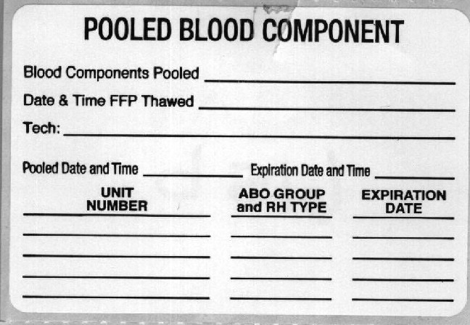

m. Affix a sickle cell negative and CMV negative label to the unit.

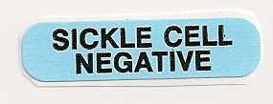

1. Use Modification Application to prepare exchange unit
   1. Thaw FP24 unit- inventory>edit>cr prod>change
   2. Pool FP24 and RBC unit using exchange pool function

Enter FP24 unit (product code) on first line then RBC (product code) on second line

* 1. Enter exchange unit volume from Exchange Calculation Sheet
  2. Enter Exchange unit type as “O negative”
  3. Record pooled unit number
  4. Place ISBT Label on unit (from roll of ISBT numbers in cabinet)
  5. Prepare Pooled Blood Component Label and Reconstituted RBC label and place on unit
  6. Place O negative, CMV negative, irradiated, sickle cell negative labels on unit
  7. Place unit in the refrigerator until ready to transfuse.

1. **COMPATIBILITY TESTING:**

Not indicated unless mother or baby has positive antibody screen

### NOTE:

**REMEMBER: IF YOU ARE EXCHANGING A BABY WITH O CELLS**

**HE MAY TYPE AS AN O PERSON, NOT AS HIS TRUE TYPE.**

**DISPENSING:**

. Unit is signed out like all other units

See Procedure No. 4840-BB -400 for more information

### REFERENCES

Current Edition of the AABB Technical Manual

Current Edition of the AABB Standards for Blood Banks& Transfusion Service

**Computer Entry:**

1. Receive a unit of RBC’s

O Negative

Expiration Date (unit less than 5 days old)

CMV Negative

Irradiated

Leukoreduced

Sickle Cell Negative

Negative for Maternal Antibodies (If indicated)

1. Perform ABORh typing on the RBC unit
2. Prepare exchange unit using the Exchange Unit Calculation Sheet
3. Use Soft Bank Inventory Edit function to prepare exchange unit
4. Thaw FP24 unit- inventory>edit>cr prod>change

b. Pool FP24 and RBC unit using exchange pool function

Enter FP24 unit on first line then RBC on second line

c. Enter exchange unit volume from Exchange Calculation Sheet

d. Enter Exchange unit type as “O negative”

e. Record pooled unit number

f. Place ISBT Label on unit (from roll of ISBT numbers in cabinet)

g. Prepare Pooled Blood Component Label and Reconstituted RBC label and place on unit

h. Place O negative, CMV negative, irradiated, sickle cell negative labels on unit

1. Select Newly Created Exchange unit for the baby:
2. Inventory>Product Service Orders>Select
3. F-3 By Order to scan; or enter Last Name, First Name
4. Patient history window appears for review
5. Escape
6. F-12 Accept
7. Enter order number
8. Pop up appears, review, and Escape
9. Select Order
10. F-12 Accept
11. Patient History Window appears for review------YES
12. Unit Select Screen appears
13. Enter Unit Number, Product Code
14. F-12 Accept
15. Pop-up appears “Do you accept the choice?”, Yes
16. Save Changes?, Yes
17. Select printer M30_Zbloodbank (blood bank tag) to print crossmatch label
18. Order, Perform and Result AHG xmatch, if antibody screen on mom or baby is positive.
19. Issue Unit to Patient.

**Note: If the unit requires a full AHG crossmatch due to mom or baby antibodies. Perform and result this prior to issuing.**

**Table 1.** Amount of Plasma to be added to CPDA –1 or CPD PRBC Unit

To have a customized Whole Blood Unit with a 45% Hematocrit

|  |  |  |
| --- | --- | --- |
| Weight CPDA-1  PRBC (grams) | Weight Plasma to  Be Added (grams) | Approx. Volume  Final Product (mL) |
| 215 | 93 | 293 |
| 220 | 95 | 300 |
| 225 | 96 | 305 |
| 230 | 101 | 315 |
| 235 | 103 | 322 |
| 240 | 105 | 329 |
| 245 | 106 | 334 |
| 250 | 111 | 343 |
| 255 | 113 | 350 |
| 260 | 114 | 356 |
| 265 | 117 | 364 |
| 270 | 119 | 370 |
| 275 | 123 | 379 |
| 280 | 124 | 385 |
| 285 | 126 | 391 |
| 290 | 130 | 400 |
| 295 | 131 | 406 |
| 300 | 135 | 414 |
| 305 | 137 | 421 |
| 310 | 140 | 429 |
| 315 | 141 | 434 |
| 320 | 145 | 443 |
| 325 | 147 | 450 |
| 330 | 149 | 456 |
| 335 | 151 | 463 |
| 340 | 154 | 470 |
|  |  |  |

