**TITLE: Review of QC Results, (TQC)**

**PRINCIPLE:** To maintain a system whereby all QC is reviewed in a timely manner and consistently throughout the department. All numerical as well as alpha QC results are reviewed as a part of the ongoing department Quality Management Program to assure accurate results for the quality of patient care and to comply with governing agencies for the Laboratory.

**PERSONNEL:** Sr. Tech’s, Designees

**STEPWISE PROCEDURE:**

1. Open TQC module
2. Choose “**Review**”, then “**Review Worklist**”. Review worklists have been set up by our TQC build team for each department to utilize an easier means of searching data and to keep track of the data in a uniform manner.
3. Choose the worklist you want, (example) “**COAGQCREV**” (Coagulation Daily QC Review)
4. Click on “**Search Criteria for Selected Worklist**”
5. Put in the date range you want to look at and click on **Search**, the system default only goes back a few days.
6. All results in that date range come up, if there are outliers in yellow or red; at the right side of the page, click on “**Graph Report**” and then at the lower left side, click on “**Interactive Output**”.
7. A graph comes up and at the upper left side of the screen, all the data plot choices are displayed for you to choose and look at one parameter at a time.
8. Choose one parameter at a time and review the outliers individually, click on the item box and open the result up to see what was done to rectify the outlier and then decide if you want to “**Include**” or “**Exclude**” those results in the statistics.
9. Put in an “**Action**” if that box pops up and then click on “**Save**” and continue reviewing the outliers.
10. Close out the “**Graph Report**” tab at the upper left side and it takes you back to the Review Worklist screen. *If there were no outliers, then go to next step, #11*.
11. Click on “**Select All**” at the bottom of the page.
12. Click on the “**Review Orders**” tab at the right side, Click on the **Level 1** reviewed by button.
13. Choose your “**Action**” of **Reviewed** and say **Ok**.
14. The worklist will have green check marks by all the QC result lines that have been reviewed.
15. In the “**Status**” column, you will see there is a “**RV1**” by each line along with other letters. This indicates that they have been reviewed.
16. Then close out that worklist and choose “**Review Worklist**”, “**Daily Coag QC Review-Not Verified”** (as an example).
17. Click on “**Search Criteria**” at the bottom of the screen
18. Change your dates as desired, and click on “**Search**”

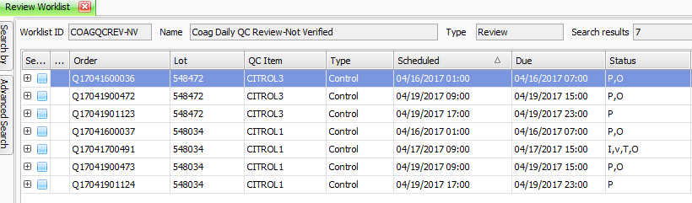

1. Any “**Pending and Overdue**” orders for QC will be on this list. There should only be current day orders, if there are other orders, investigate why they are on the list and cancel if they are duplicates etc. Document with an action for any that are going to be cancelled.
2. Only the remainder of the current day should be on this list. Clean out the orders that should NOT be there and leave the current day orders for QC.
3. Review the remainder of the worklists for your designated area.

The action of “**Reviewing Orders**” electronically puts the person logged into the system as the one whom has reviewed the QC results from that worklist for those dates.

Daily QC review is not printed out; it is all electronically reviewed and documented by the system. Monthly QC is printed and submitted to vendors for peer group comparison.

**References:** 1**.** TQC webinars during build, 2014-2015

2. Super User training, 2014