**Title: Test ID Build- Setup: Collection Instructions**

**Principle:** To provide specimen collection instructions for the test build in Soft LabMic.

**Personnel:** LIS analyst, Build Team

**Stepwise Procedure:**

Instructions used in Test Setup on the Specimen Tab are defined in “Settings/Definitions” under the Setup section on the main screen.

* Choose “Definition” tab
* SoftLab
* General
* Collecting Instructions

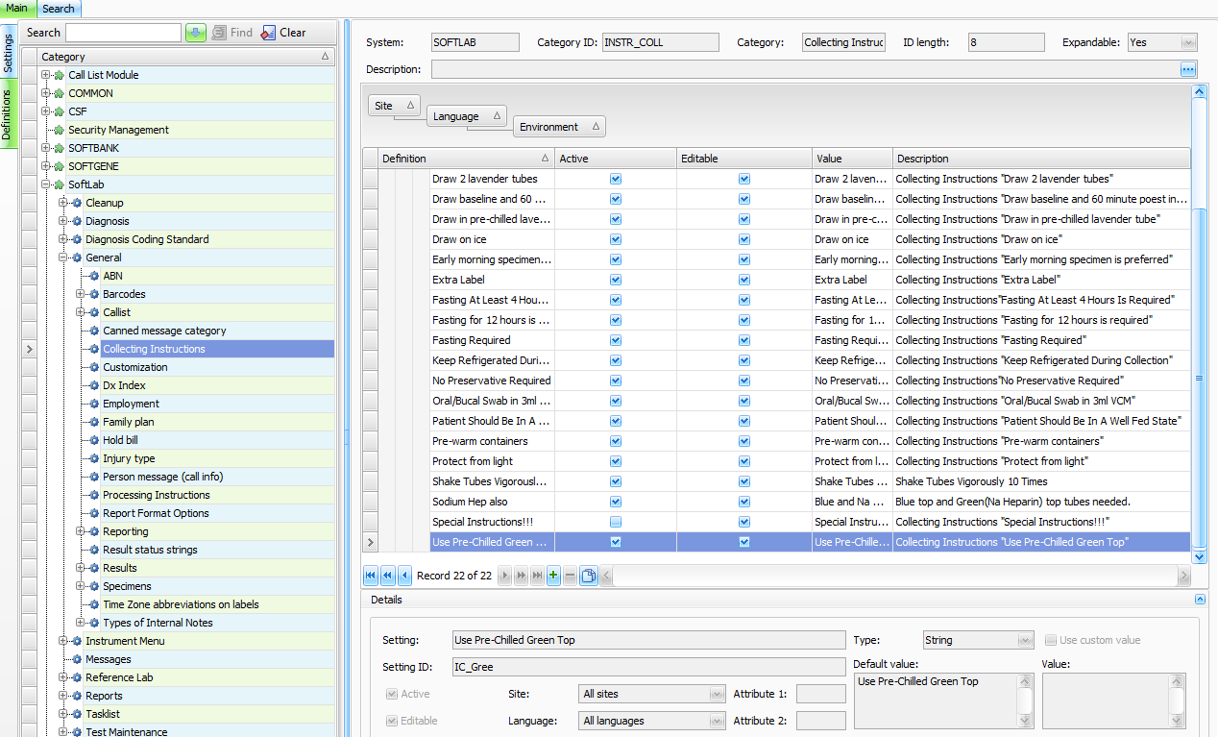

* Choose “Edit” at the top of the screen.

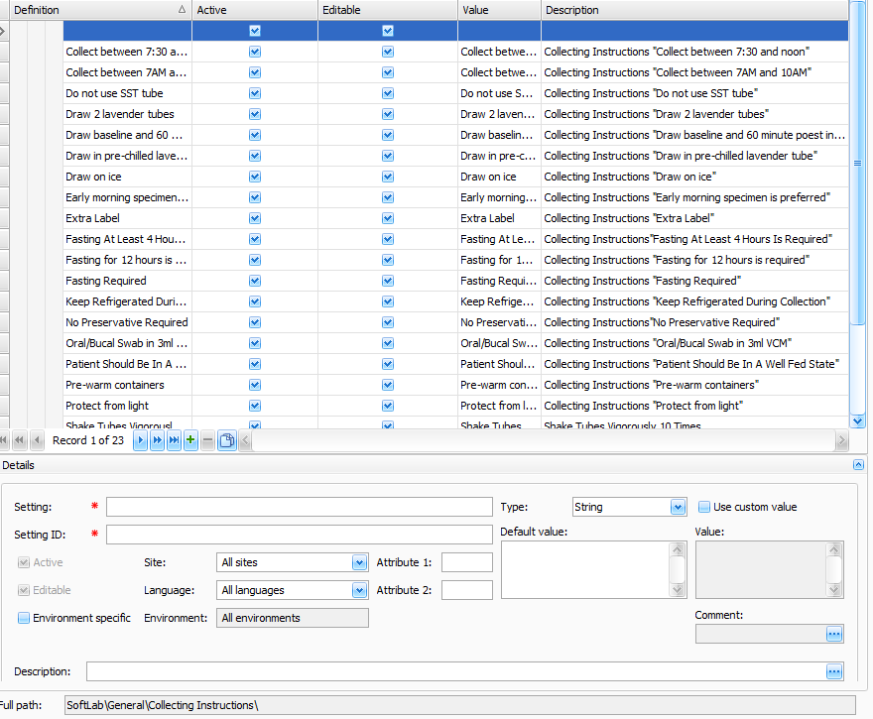

* In the “Details” section, 2 fields open up for editing.
* They have a red * by each field.
* “Setting”- type in the collecting instruction that you need to build. Tab through fields, you can check the box for “Use Custom Value” or Use Default Value as the default.
* At “Setting ID” – put in a short description; most start with **IC_xxxxx**
* IC for Instruction Collecting and then the underscore and up to about 5 characters to describe your instruction. See above example of “Use pre chilled green top”.
* Type in the same instruction in the “Default Value” box.
* Or, type the instruction in the Use Custom Value box if you checked that box.

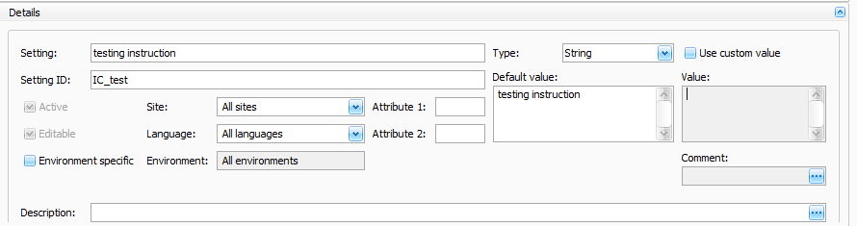

* Now, Save if you are finished or Cancel at this point (at the top of the screen).
* You can reload, to see the new list and instruction you just created.

In the Test ID build, your instruction will be available to choose from the drop down box on the Specimen Tab of the build. Putting a Collection Instruction in the build field will define this test id for its own specimen to be drawn.

These instructions are available for viewing from the Soft ID hand held’s; they do not print on the collection labels. These are NOT label comments.

**References:**

Soft LabMic, Version 4.5.4.9.1; SoftLab System Design I, Individual Test Setup