**TITLE: Workstation Redirection**

**PRINCIPLE:** It may be necessary to redirect certain tests or workload to an alternate workstation. Yorkville may need to send certain tests to the Main Lab or vice versa to be run in unusual instances where there are instrument or reagent issues.

**PERSONNEL:** Sr. Tech’s, LIS Analyst

**STEPWISE PROCEDURE:**

1. In Soft LabMic, open up the “Results” tab at the top of the screen.
2. Choose “Workstation Redirection”.

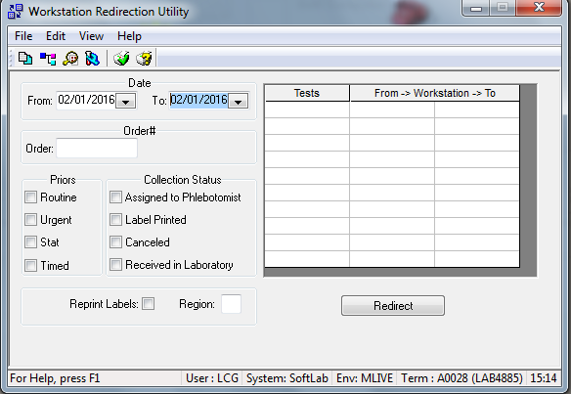

1. Use the “Order” field if it is just for a single sample, or a few samples. It is dangerous to use the date field since every **order** will redirect to another workstation. **Do not use the date fields.**
2. Type or scan in the order number.
3. Choosing a Priority Status is not necessary, nor is the Collection Status.
4. Check to reprint labels for your specimen, so the tubes can be labeled with the correct workstation/instrument.
5. Choose your Test ID that you are redirecting and then from the current Workstaion to the Workstation that will ultimately do the test.
6. Click on “Redirect”
7. A screen comes up that is titled as “Reordering” which displays the Order Number, the Test ID, from Workstation to Workstation and “from container to container” to show you exactly what is being redirected.
8. If this is correct, click on “OK”.
9. Your screen refreshes back to the original screen and a pop-up box says “Redirection complete”. Click on “OK”.
10. In OE, on the Specimen tab, you will see that the workstation for the specimen destination is now displayed.
11. The sample or samples can now be sent to be tested at another workstation.
12. A Specimen Tracking List is used to accompany the samples enroute to their destination.

**References:**

Soft LabMic version 4.5.4.9.1, Help Topics