TITLE: Restrict Login to LIS Applications

PRINCIPLE:
On occasions such as downtimes for system upgrades, it is necessary to restrict logins to the LIS applications. This procedure outlines the steps for restricting logins, as well as providing access to certain administrative users.
PERSONNEL: LIS Analyst, Laboratory Manager, Laboratory Director

STEPWISE PROCEDURE:

- Login to the Security Management Module
- Select “Tools” from the upper toolbar
- Select “Restrict Login To Systems”.
- On the first tab, “Locked Systems”, add the systems that should be locked. Select the green + sign to add a system, i.e. SoftLab, Soft Bank, etc. If you add a system in error, highlight the system and click the red – sign to remove it.
- On the second tab, “Users With Access”, add the users that should have access. Select the green + sign to add a user. If you add a user in error, highlight the user and click the red – sign to remove them. Make sure to designate yourself with Access.
- When you are ready to lock the users from the applications, check the Lock Systems box and the top of the page.

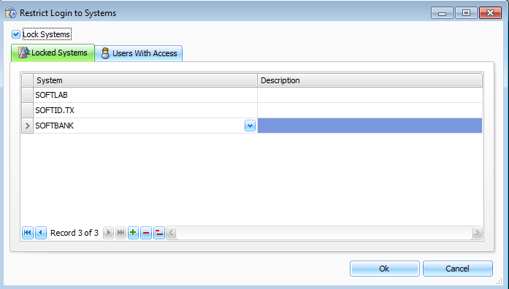
- Click “Ok”. A box will pop up stating your changes have been saved successfully.
- When you are ready to allow users back in the system, login to the Security Management Module.
- Select “Tools” from the upper toolbar.
- Select “Restrict Login To Systems”
- Uncheck “Lock Systems”
- Click “Ok”. A box will pop up stating your changes have been saved successfully.
- Tell the users they can log back into the system.

