TITLE: Viewing Audit Trails and Setup Modifications

PRINCIPLE: To provide guidance for tracking and identifying persons that have added or modified the Laboratory Information System (LIS).

PERSONNEL: LIS Analyst, Senior Medical Technicians, Laboratory Manager, Laboratory Director

STEPWISE PROCEDURE:

In the event a modification to a record or system setup has occurred, details of the change and who made the change can be found in specific areas of the LIS.

Identifying changes or access to Patient Records:
- Log into SoftLab
- Go to Tools, then Utilities
- Click View Audit Trail
- The Audit Trail Window will open. Here you can define your search criteria.
  - 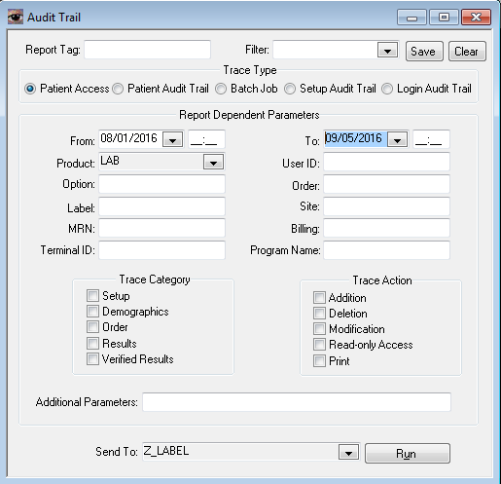
- Once the criteria is defined, Click Run
Identifying changes to System Setup:
- Login to SoftLabMic
- Open the Setup file in question.
- Open the record.
- Click the “Audit” Button
- If any changes were made, the date, time, person, and changes will be listed.

