TITLE: Results Query and Instant Report Printing

PRINCIPLE: To provide guidance for looking up and printing patient results in the Laboratory Information System (LIS).

PERSONNEL: All Laboratory Staff

STEPWISE PROCEDURE:

To look up Patient Results:

- Login to SoftLabMic
- Double click Lab Results Query
- Enter the patient’s information in the search fields. Be mindful of the “Time Range”, as it defaults to One Year.
  - 
  - Click the down arrow to select other range options if necessary.
- Click Query.
- A new window will open returing the results of your Query, select the correct patient by double clicking their name.
- The patient’s visits will display. Click the + sign next to the corresponding admission date to see the orders.
- Highlight the appropriate order by single clicking it. The details and results will display in the window to the right.

To print an Instant Report:

- After highlighting the order, click the “Instant Report” button
- A new window will open where you can select the printer you want to send the report to.

To fax an Instant Report:

- You can also fax from this screen by clicking the “Fax To” button
- If the corresponding Doctor and Fax number are listed, highlight the fax number and click OK. Your fax was sent.
- If the number or Doctor is not listed, click the “Remote Printers” tab
- Enter the fax number in the “Phone” field in the following format 9,1XXXXXXXXXX
  - 
- If the number already exists in the system it will display in the list.
  - Highlight the number and click OK. Your fax was sent.
- If the number that you need to fax to is not listed, assure you entered the number in the phone field correctly and that another doctor’s fax number is not highlighted.
  - 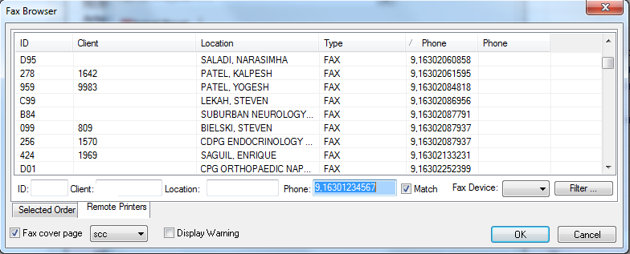
  - Only the number you are faxing to should be highlighted.
  - Click OK. Your fax has been sent.
- For Resending a fax see procedure 4848-LIS-302.
- For viewing confirmation that your fax has been sent successfully, see procedure 4840-LIS-306

- Please note, if a patient or doctor’s office is in need of multiple results, please refer them to the Medical Records Department.

