TITLE: Vitros 350 Operations Procedure

PRINCIPLE: To provide step by step instructions for the daily setup and operation of the Vitros 350’s to ensure malfunctions do not adversely affect analytical results.

SYSTEM COMPONENTS:

SAMPLER HANDLER
The Sample Handler handles and manages all samples prior to processing

The sample trays have up to 10 samples are placed in one of 4 tryas for a maximum of 40 samples. These trays can accommodate varied sizes of collection tubes or sample cups. Sample volume needed for the Vitros MicroSlide assays is very small between 5-11 ul.

The tip supply holds clean tips in a reuaslable tip rack and transports the tips under the sample metering path, where the sample metereing proboscis picks them up. You can load racks through an opening at the front of the analyzer. Each reusable rack holds up to 40 Vitros VersaTips. You can load a maximum of four racks in the tip supply at one time.

The Mixing Cup Arrays move under the metering path for use during on-analyzer dilution. Each array has ten cups. The supply holds up to five arrays at one time.

The diluents tray holds up to eight diluents, four 2.0 mL sample cups, two 5.0 mL bottles, and two 10.0 mL bottles. Frequency of use determines how much diluents you need to add each day. The Diluent Tray Supply is configurable to the laboratory’s needs.

Vitros VersaTips attach to the sample metering system, automatically deposit patient samples onto MicroSlides. This disposable tip is single use to preserve sample integrity and eliminate carryover. A patented Intellicheck technology feature called Smart Metering performs automated checks, detects and reports clots or bubbles for improved results integrity.

SLIDE PROCESSOR
The Sample processor is located between the Sample Handler and the Control Unit. It processes all MicroSlides according to the tests assigned to the sample.

The two slide supplies, located in the slide processor section of the analyzer, are arranged in two concentric rings around the perimeter of the incubator.
• Slide Supply 1 is the outer ring. It holds up to 35 cartridges in openings called nests. Slide Supply 1 is known as the wet supply. Magnesium chloride humidity control packs kept in a chamber below the slide supply helps maintain its humidity between 26 and 40 percent. Cartridges with yellow top labels go in Slide Supply 1.
• Slide Supply 2 is the inner ring. It holds up to 25 cartridges. Slide Supply 2 is known as the dry supply. Desiccant packs kept in a chamber below the slide supply help maintain the humidity at less than 18 percent. Cartridges with white top labels go in Slide Supply 2.

Humidity Control Pack Container holds humidity control packs used to control humidity for Slide Supply 1. Dessicant Pack Container holds desiccant packs used to control humidity for Slide Supply 2.

Slide Disposal Box holds MicroSlides discarded by the analyzer.

Slide Dispensing Area dispenses and transports a MicroSlide to the sample metering position.

Immuno-Rate (IR) Wash Module holds and transports Vitros ImmunoWash Fluid to the wash metering station.

Tip Locator/Transverse Shuttle Positions the MicroSlide for proper metering alignment, shuttles the IR MicroSlide to the IR wash metering station.

Electrolyte Reference Metering Assembly holds and transports Vitros 350 Reference Fluid to the metering station.

Incubator maintains a reaction temperature and holds slides during the incubation period before positioning them over the reflectometer (RT/CM/IR slides) or transporting them to the electrometer (PM slides).

Reflectometer Read Station takes RT/CM/IR slide readings.

Catridge Load Stations accept cartridges into Slide Supplies 1 and 2 by manual or bar code read entry.

Electrometer takes PM Slide readings.

Reflectometer Iris Adjustment Switch adjusts the amount of light emitted from the reflectometer.

Reflectometer Lamp House holds the lamp that generates light for the RT/CM/IR slide readings.

CONTROL UNIT
The Control Unit is located to the right of the Sample Processor. It consists of a display unit and a keyboard. The Control Unit serves as the primary interface between operator and analyzer. All major functions are initiated and monitored at the Control Unit.

The system reports the results on the Results Review screen, the laboratory report, and the patient report (if configured). The system also sends the results to the Laboratory Information System (LIS), if configured.

The status console appears on the first three lines of the screen. It provides information on the operating status of the analyzer and also inclues the SAMPLING target, the analyzer clock (with date and time), and the software version.

Error Informaion
The first line of the status console reports error conditions. When an error occurs, a severity indicator, such as SHUTDOWN, MALFUNCTION, ACTION, OR ATTENTION, is displayed. The number before the severity indicator shows the total number of errors in that category that have occurred since the operator last examined the error log.

The status console also serves as a touch target to bring up error logs. (For more information on severit levels and error logs, see the “Troubleshooting” chapter in the Maintenance and Diagnostics Manual.)

Operating Status
Cartridge Handling messages appear on line two along with laboratory computer messages.

Instrument State
The third line of the status console displays the analyzer operating state and testing status. This line conveys several status messages during analyzer power up. During analyzer operation, the following examples of messages can appear:

READY The system is ready for normal operation

PM INOP The first two letters indicate appropriate analyzer subsystem. In this example, the PM indicates Potentiometric. INOP indicates inoperative.

Sampling Target
The SAMPLING target controls the operation of the sample metering system. The target is divided in half with two selections: ON and OFF.

The ON target displays the originating track number for the TRAY IN PROGRESS.
If you touch the SAMPLING target to OFF during the sampling process, the analyzer will finish the current sample before stopping. Sampling automatically stops when no additional samples are available.

MICROSLIDE TECHNOLOGY
There are two types of MicroSlides used by Vitros Chemistry Systems:
Colorimetric/Rate (CM/Rate) and Immuno-Rate (IR) Slides
Potentiometric (PM) slides

Colorimetric/Rate Slide Path
Colorimetric/Rate (CM/Rate) Slides follow this path through the analyzer in this order
- The slide dispense blade pushes a colorimetric or rate slide from one of the two slide supplies and positions it under the ip locator assembly.
- The proboscis lowers onto the tip locator assembly and deposits the sample on the slide
- The proboscis moves from the tip locator assembly.
- The slide dispense blade pushes the slide into one of the 23 positions on the incubator disk, where the slide incubates for approximately five minutes.
- While the slide incubates, the reflectometer takes slide readings. The readings are sent to the analyzer’s computer for final calcutions of the result.
- The slide is ejected from the incubator and falls into the slide-disposal box.

Immuno-Rate Slides
Immuno-Rate (IR) slides are colorimetric/rate slides that contain antibodies or antigens that bind to the analyte of interest.

Examples of Immuno-Rate assays are:
Digoxin (DGXN)
C-Reactive Protein (CRP)

After initial incubation, immune-wash fluid is added to the Immuno-Rate (IR) slide. The wash fluid spreads onto the slide and removes unbound conjugate from the read area of the slide. Then it introduces a color-forming substrate to reach with the conjugate that remains in the slide read area.

Immuno-Rate Slide Reading
IR slides remain in the IR/CM incubator for five minutes while the binding reaction goes towards equilibrium. The slide is then removed from the incubator and transported to the wash station. The wash fluid, which is also the substrate addition, accomplishes two things:
It removes the unbound conjugate from the read area on the slide.
It introduces a color-forming substrate to react with the conjugate that remains on the slide read area.

Immuno-Rate (IR) Slide Path
Immuno-Rate Slides follow this path through the analyzer in this order
- The dispense blade pushes an Immuno-Rate (IR) slide from one of the two slide supplies and positions it under the tip locator assembly.
- The proboscis lowers onto the tip locator assembly and deposits the sample on the slide.
- The sample proboscis moves from the tip locator assembly.
- The slide dispense blade pushes the slide into one of the 23 positions on the incubator disk, where the slide incubates for approximately 5 minutes before wash. After wash, the IR sldie incubates for approximately 2.5 minutes.
- The slide remains in the incubator while the reflectometer assembly takes slide readings. The readings are sent to the analyzer’s computer for final calculation fo the result.
- The slide is ejected from the incubator and falls into the slide-disposal box.

POTENTIOMETRIC (PM) SLIDE STRUCTURE
The potentiometric assays performed on the system are:
Sodium (Na+)
Potassium (K+)
Chloride (Cl-)

The electrolyte concentration is determined by measureing the potential difference between the sample and reference electrodes.

PM Slide Path

Potentiometric Sldies follow this path through the analyzer in this order
- The slide dispense blade pushes a Potentiometric (PM) slide from Slide Supply 1 and positions it under the tip locator assembly.
- The proboscis lowers the deposists the sample on one side of the slide. Simultaneously the reference fluid metering assembly dispenses and equal amount of reference fluid onto the other side of the slide.
- The sample proboscis and reference metering assembly move from the tip locator assembly.
- The slide dispense blade pushes the slide into the incubator disk, where the slide incubates for approximately two minutes.
- The slide is positioned at the electrometer read station. The assembly lowers two sets of contacts onto the silver portions of the slide; readings are sent to the analyzer’s computer for final calculation of the result.
- The electrometer assembly rises, a shuttle pushes the slide into the slide-disposal box.

Summary of Assays

MicroSlide Assays

Full Assay Name Abbreviation
Acetaminophen ACET
Albumin ALB
Alcohol ALC
Alkaline Phosphatase ALKP
Alanine Aminotransferase ALT
Ammonia AMON
Amylase AMYL
Aspartate Aminotransferase AST
Bilirubin, unconjugated and conjugated BuBc
Blood Urea Nitrogen BUN/EREA
Calcium Ca
Cholesterol CHOL
Creatine Kinase CK
Chloride Cl
Carbamazepine CRBM
Creatinine CREA
C-Reactive Protein CRP
Digoxin DGXN
Direct HDL Cholesterol dHDL
Carbon Dioxide ECO2
Glucose GLU
Potassium K
Lactate LAC
Lipase LIPA
Magnesium Mg
Sodium Na
Phosphorus PHOS
Phenytoin PHYT
Cerebral Spinal Fluid Protein PROT
Salicylate SALI
Total Bilirubin TBIL
Total Protein TP
Triglyceride TRIG
______________________________________________________________________________________

SYSTEM STARTUP AND SHUTDOWN

System Shutdown
The system is intended to remain in operation 24 hours a day. If you need to shut down the system, follow normal shutdown procedures.

Turning Off the Analyzer
If you need to turn off the analyzer, or have been directed to do so by your Customer Support Representive, follow this procedure.
Store unloaded reagents according to their instructions for use.
- Unload VITROS Chemistry Products MicroSlide reagents if the system will be shut down for two hours or longer.
- If Sampling is ON, touch to OFF.
- Remove any partially used cartridges from the slide supplies.
- Empy the cartridge disposal box
- Go to the Cartridge Handling screen, accessible from the Main Menu or by pressing
- Touch ALL CARTRIDGES BY SUPPLY.
- Touch the YES target to unload all the cartridges from slide supply 1.
- Empty the cartridge disposal box after slide supply 1 is unloaded completely
- Touch the CHANGE SUPPLY target to empty slide supply 2.
- Touch the YES target to unload all the cartridges from slide supply 2.
- Empty the cartridge disposal box after slide supply 2 is unloaded completely.
- Touch RETURN until the Main Menu is displayed, then touch SHUTDOWN ANALYZER.
- When prompted, type “Y” for yes, and press the Enter keyon the keyboard. The power-dwon sequence begins. When the sequence is completed, the message “The analyzer has been shut down. Reset or power down is required” is displayed.
- Turn the power switch to O or Off.

NOTE: Be sure to record the date and time you removed the cartridges from the analyzer. Verify performance with QC materials after reloading cartridges that have been removed from the slide supply.

Program Loading/Resetting the Analyzer
To program load or reset the analyzer program:
- Shut down the analyzer by touching the SHUTDOWN ANALYZER target on the Main Menu.
- Type “Y” and press the Enter key on the keyboard when prompted.
- Wait until you see the message, “The analyzer has been shut down. Reset or power down is required.”
- Turn off the analyzer’s main power switch (O or Off). Leave the analyzer turned off for at least two minutes before turning the analyzer back on.
- Turn on the analyzer’s main power switch (I or ON). Wait for the Main Menu to appear (approximately ten minutes).
- Verify that the correct date and time are displayed in the upper right corner of the screen. To correct the date and time, see the “Special Services” section of Chapter 10, “Options,” in the Operator’s Manual, or see the Operator’s Quick Guide.
- The analyzer is now ready for normal operation.

Emergency Shutdown

An emergency shutdown should only be performed if normal shutdown procedures are not available.

Caution: Emergency shutdown may cause a loss of data from the fixed disk or damage to the fixed disk.

- To perform an emergeny shutdown, move the main power switch to the Off position. Wait 10 seconds before attempting to restart the system.
- To restart afetr an emergency shutdown, wait 10 seconds after moving the main power switch to the Off position. Then, move the main power switch to the On position. Follow the steps outlined in System Startup

If system power is interrupted (for example, due to an unintentional power loss), current assay processing is lost; however configuration information may be saved. To energize the system, move the main power switch to the On position. See Power on the system for more information.

Powering on the System

- Make sure the incubator cover and both top covers are closed (interlocked)

- Make sure the analyzer is plugged into a grounded receptacle.

- Move the analyzer’s main power switch to the I, or ON, position. Hold the switch until you hear a click.

- The analyzer will initialize the main systems and display the Main Menu. Wait for the work READY to appear in the status bar (this will take approximately 15 minutes).

Supply Categories

The system includes supplies that require regular loading, unloading, replacement, and maintenance. Supplies are grouped in the following categories:

Reagents:

- VITORS Chemistry Products MicroSlides

Containers:

- Primary Sample containers
- VITROS Chemistry Products MicroSample Cups
- Micro-collection Container Adapters
- VITROS Chemistry Products Pierceable Caps
- Mixing Cup Array

Sample Trays:

- SAMPLE TRAY
- Cup Adapter
- Height Adapter

Tips:

- VITROS Chemistry Products VersaTips
- VITROS Micro Tips

Calibrators:

- VITROS Chemistry Products Calibrator Kits

Quality Control Fluids:

- Bio-Rad QC

Fluids:

- VITROS Chemistry Products BSA
- VITROS Chemistry Specialty Diluent
- VITROS Chemistry Products 350 Reference Fluid
- VITROS Chemistry Products Immuno-Wash Fluid

Range Verifiers:

- VITROS Immunodiagnostic Product Range Verifiers

Bar Code Labels:

- Code Labels (supported only) PSID Bar
- Pre-printed Tray Bar Code Labels

Environmental Supplies:

- VITROS Chemistry Products Humidification Pack
- VITROS Chemistry Products Desiccant Pack
- VITROS Immunodiagnostic Products Reagent Pack Storage Box

Waste Containers:

- Disposable Box Liner (CM/Cup Arrary)

For further information on any of the above supplies, refer to the Operator’s Manual or the individual Instructions for Use (IFU’s)

Vitros Chemistry Products MicroSlides

VITROS Chemistry Products MicroSlides contain reagents in a dry, multilayered form. VITROS MicroSlides are supplied in opaque black cartridges containing 18, 50, or 60 slides for one specific type of assay.

Cartridges are packaged in polyethylene-coated aluminum foil wrappers within a cardboard carton. Both the carton and the cartridge are labeled with the assay identification and manufacturing lot number. The cartons are color-coded to indicate required storage conditions. Use the slides before the date indicated on the carton.

A color coded strip on the top bar code label directs the operator into which SLIDE SUPPLY the cartridge must be loaded. A yellow stripe indicates that the cartridge must be loaded into the SLIDE SUPPLY 1. A white top bar code label indicates SLIDE SUPPLY 2.

- Test Name
- Generation Number
- Coating Number
- Chemistry ID Number
- Lot Number Identifier

The Generation number uniquely defines the chemical formulation and manufacturing ptocess for each assay. It refers to the mathematical formula the system uses to correctly calculate analyste calculation.

The Coating number defines each separate production of a slide generation. A coating may be thought of as a manufacturing event when a certain chemistry is produced.

Within each coating, separate lots are identififed during the manufacturing process. Slide cartridges with the same lot number will have the same chemical charartersitics. Conversely, when lot numbers change, the slides chemical characteristics change and the analyzer must be recalibrated before use.

Prior to use, storage-condition requirements for slide cartridges vary. Refer to the Instructions for Use for the assay for specific requirement.

Note: Discard any slide that becomes separated from the cartridge. Do not re-insert it into the cartridge.

Condition Code descriptions
Each error condition is assigned a three-character code. The first letter of the condition code indicates the subsystem that posted the error. For example, G31 indicates and incubator error because G=incubator. There is a label on the underside of the top right analyzer cover. This label depicts the letter designation for each subsystem and its location in the analyzer.

This error condition code is also linked to the troubleshooting Help screens. Each condition code calls up a unique Help screen.

Error Message
The error message is composed of two or three parts separated by asterisks. The first part of the message identifies the module that is the source of the problem. The second part of the message identifies the location within the module. The final error message component describes the problem.

CALIBRATION

Refer to individual chemistry procedures for calibration information

See Instructions for Use (IFU) for Calibration Kits and/or Chapter 6 in Operator’s Manual for further information.

Select the proper calibrator kit according to Vitros MicroSlide Assay Summary or IFU.

Calibration Reconsitution
- Allow materials to come to room temperature.
- Slowly invert diluents bottle several times to mix.
- Tap lyophilate bottle on the counter several times to dislodge any material adhereing to the stopper.
- Add 3.0 ml of diluents to the corresponding bottle.
- Replace stopper and invert gently.
- Let stand for 30 minutes.
- All calibrators are good for 24 hours once opened.

Calibration Programming
- Touch CALIBRATION PROGRAMMING button
- Type name of desired group
- “Group does not exist. Enter new?” Touch Y, enter.
- Select lot numbers of analytes to be calibrated, touch ENTER button
- Touch DISPLAY KIT LOT NUMBERS button.
- Verify that kit lot number’s match the same kit lot number that will be used for the calibration.
- Load cups into rack according to assignment on the vitros.
- Touch RETURN.
- Touch LOAD GROUP.
- Load the rack onto the track destination.
- Touch GROUP IS LOADED.
- Start analyzer.

Calibration Lot Number Selection
If the calibrator lot number displays as one that you are not using, it needs to be changed on the analyzer.
- Exit out of calibration programming.
- Touch OPTIONS and type in password.
- Touch CALIBRATOR LOT # SELECTION
- Touch the number of calibrator kit that needs to be changed.
- A list of available lot number’s will appear.
- Select the correct lot number.
- Start over with the Calibration Programming

Verifying a Calibration
Verify each calibration by analyzing quality control material that has values assigned for the analyzer and analyte. You should analyze using Performance Verifies and Bio-Rad QC.

The calibration is verified if:
- The quality control results are within the acceptable ranges established by your laboratory
- The analyzer didn’t report any calibration errors

If the Controls are out of range, check for the following conditions:
- Correct instrument maintenance
- Temperature and humidity within specifications
- Consistent calibrator or control reconstitution techniques
- Consistent use and handling of pipettes
- Correct storage conditions for slides and/or calibrators
- Correct time period for calibrator use or on-analyzer storage of slides, reference fluid, and immuno-wash fluid
- Correct calibrator lot number
- Precision within system
- Fresh materials

After checking for the conditions above, run the calibration again. If still fails contact Ortho Clinical Diagnostic Technical Support.

Daily Maintenance and Checks:

Daily Maintenance will be performed by Nightshift

Daily Maintenance Tasks are in Maintenance Log Binder
See Attachment A

Weekly Maintenance will be performed Monday by Dayshift

Weekly Maintenance Tasks are in Maintenance Log Binder
See Attachment B

As-Required Maintenance will be performed by all Techs

As-Requried Maintenance Tasks are in Maintenance Log Binder
See Attachment B

ENTERING/ORDERING PATIENTS/QC

Refer to Operator’s manual Programming Samples Chapter 7.

Daily Quality Control

  - After daily maintenance and the system check are complete, run the daily Quality Control
  - All controls have bar coded tubes or can be manually programmed.
Refer to the Current Quality Control Material and Schedule Procedure (7180-CH-310) in the Vitros 350 Procedure Manual II for the QC to run daily.
  - Load QC material into sample cups QC is ALWAYS run in the micro sample cups with lids.

NOTE:
Refer to Chapter 11 Quality Control in Operator’s Manual.

Quality Control Corrective Action:

Troubleshooting Quality Control

These suggestions for addressing QC shifts assume optimal instrument conditions and that the calibration has met precision and accuracy guidelines.
- Repeat the QC using the same vial of QC material.
- Make sure you are using the correct control product/lot number
- Rerun the QC using a fresh vial of QC material
- Run an alternate control product or a different lot number of the same product
- Compare established QC ranges to peer group
- Run previously reported patient sample for which you have acceptable performance values
- Run patient crossovers (split patient samples).

Reference:

Ortho Clinical Diagnostics Vitros 350 Operator’s Manual

Attachment A
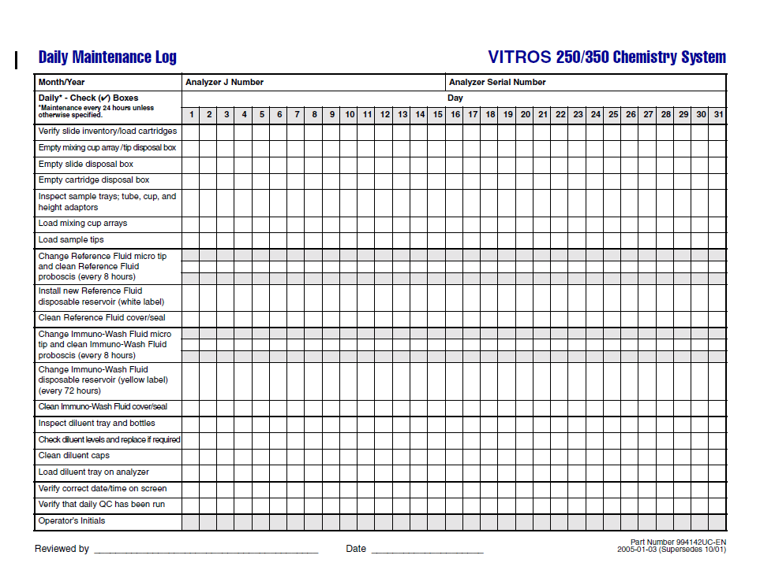

Attachment B

